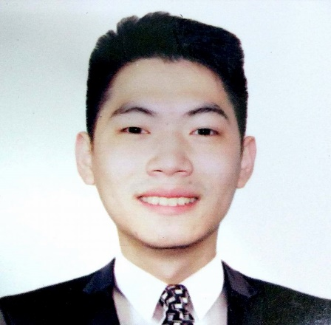**RALPH REINIER COBANKIAT**

976 A Bonifacio St Balintawak

Quezon City;

09176367918

ralph_cobankiat@dlsu.edu.ph

**EDUCATION**

2014-2018 DE LA SALLE UNIVERSITY-MANILA

Bachelor of Science degree in Information Technology.

2001-2014 ST STEPHENS HIGH SCHOOL-MANILA

High School Diploma

**ACADEMIC ACHIEVEMENTS**

1st Honor Dean’s Lister Term 1 AY 2016-2017

1st Honor Dean’s Lister Term 3 AY 2016-2017

1st Placer in Last Programmer Standing Competition

**CO-CURRICULAR ACTIVITIES**

La Salle Computer Society Member AY 2016-2017

Young Entrepreneurs Society Member AY 2017-2018

**TECHNICAL SKILLS**

Has experience with Java, Bootstrap, HTML, Python, and PHP.

Handled Cisco device configuration and topology design in class.

Knowledgeable in Business process modelling, system analysis and design.

**OBJECTIVE**

To gain industry experience as an OJT intern, as well as be able to apply my skills in analysis and design as a business analyst.

**SEMINARS ATTENDED**

*BUSINESS PROCESS MODEL AND NOTATION SEMINAR*

October, 2015 Mary Jane B. Arcilla

Information Technology Department

De La Salle University

*TECHNICAL WRITING SEMINAR*

October, 2015 Marivic Tangkeko

Information Technology Department

De La Salle University

*QA SEMINAR*

December, 2016 Indra Sistemas Corporation

**RESEARCH PROJECTS**

December, 2015 *Sales, Procurement, Inventory System for Croma and Sons General Merchandise*

Contains the documentation for the analysis, design, development and implementation of the Sales, Procurement, Inventory System for Croma and Sons General Merchandise

March, 2017 *Computer Technology Department Management System*

Contains the documentation for the analysis, design, development, and implementation of the Thesis Management System for the Computer Technology department of De La Salle University

**PERSONAL BACKGROUND**

Born on December 21,1996 in Manila, Philippines. Fluent in English and Filipino. Goal-oriented, dependable and responsible.

**REFERENCES**

Available upon Request