*-same feature for both student and professor

Sudent

1. *Create discussion (forum) DONE
2. *Set group meeting (can set to one time only or weekly) NO MEETING YET. DONE
3. *View/search other thesis topics (arranged by specialization, year)(Cannot be downloaded and only FINISHED thesis papers appear) COULD BE DONE, BUT WHY YEAR?(Thesis>Group>Course).DONE
4. *Encode group schedule for the term DONE
5. Sign up with Gmail
6. Create group/Invite members/Ask to join group (Thesis adviser is part of group) DONE
7. Upload document for revision evaluation DONE
8. Upload final document (overrides previous submission) DONE
9. Download Thesis Forms (ex: request for change form, etc) -This is different for every Thesis1, 2, 3 DONE
10. View thesis status --- George DONE

Professor

1. *Create discussion (forum) DONE
2. *Set group meeting (can set to one time only or weekly) DONE
3. \***View/search other thesis topics** (arranged by specialization, year)(Cannot be downloaded and only FINISHED thesis papers appear) DONE
4. \***Encode schedule for the term DONE**
5. Accept group invitation from student DONE
6. **Comment on uploaded submissions (ex: Panel A says….) NONE YET. DONE**
7. **Add specialty to profile DONE**
8. Edit thesis status ---- George DONE
9. *notifications ---george DONE

Thesis Coordinator

1. Create Professor Account DONE
2. Edit Student/Professor account DONE
3. Generate Thesis Monitoring Report DONE
4. Set thesis defense schedule DONE
5. Upload document forms to be downloaded by students DONE
6. Add a specialization field DONE
7. Edit thesis submission (change thesis specialization) DONE
8. Set thesis grade (see screenshot below) DONE
9. Create feature article—George DONE

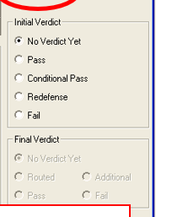

1. Set school year dates (see screenshot below) DONE

