Γιωργος Καραγκουνης

FINAL PROJECT

WORKEARLY

Περιεχόμενα

STEP 1-3 2

STEP 4 2

STEP 5 3

STEP 6 3

# STEP 1-3

I added the dataset to Workbench, I used the following query as seen below and export the csv file..

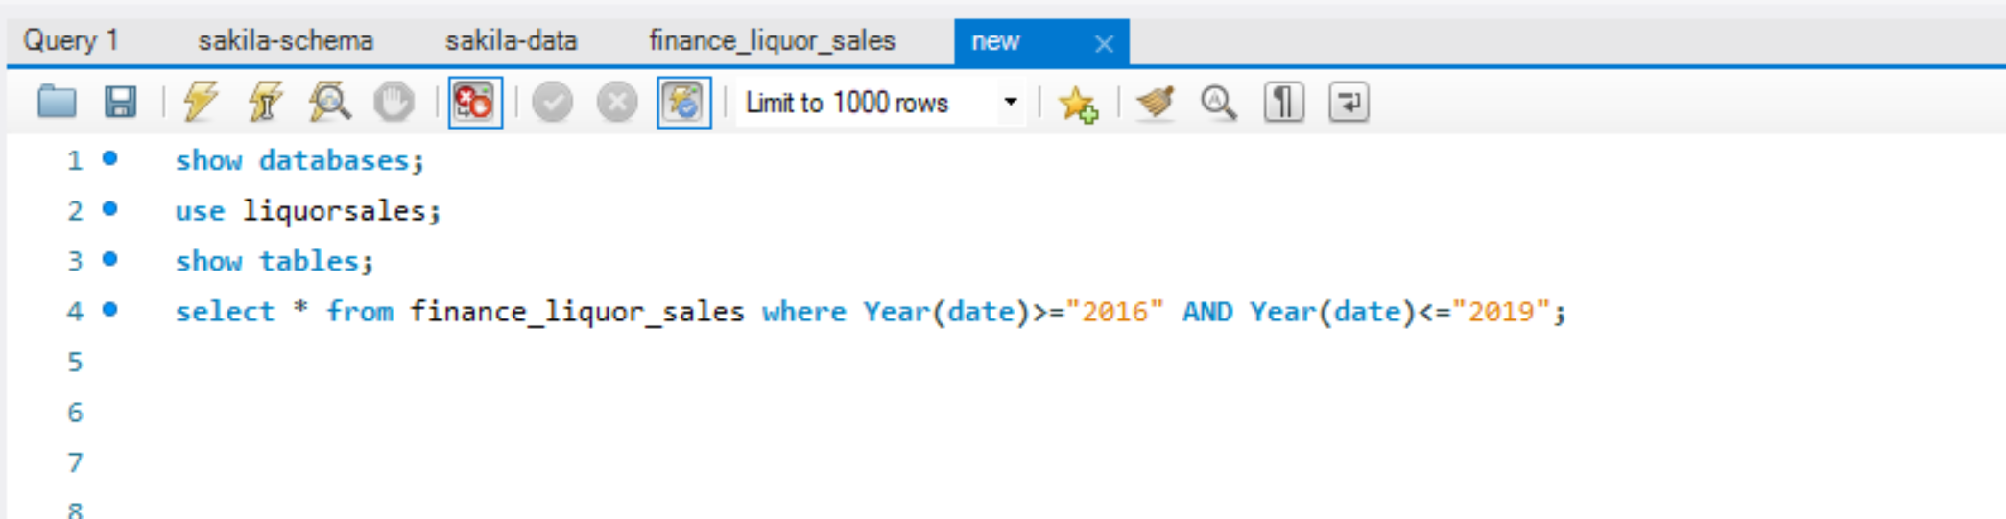

# STEP 4

I used Python and Pandas to Aggregate the CSV data so we can get the most popular item sold based on zip code and percentage of sales per store.

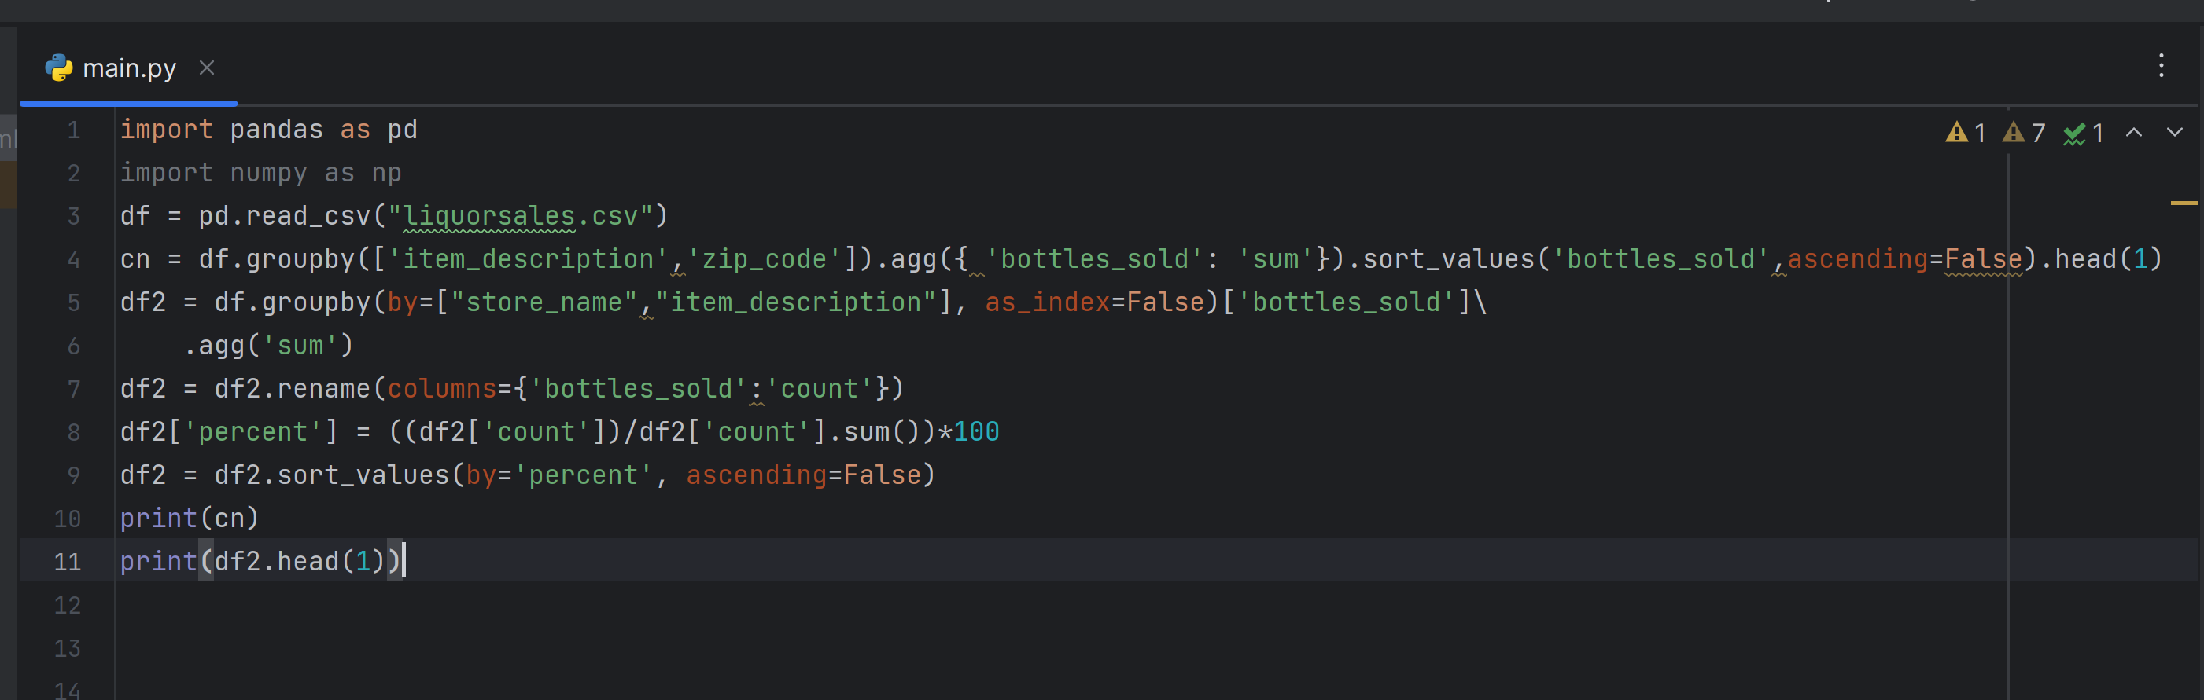

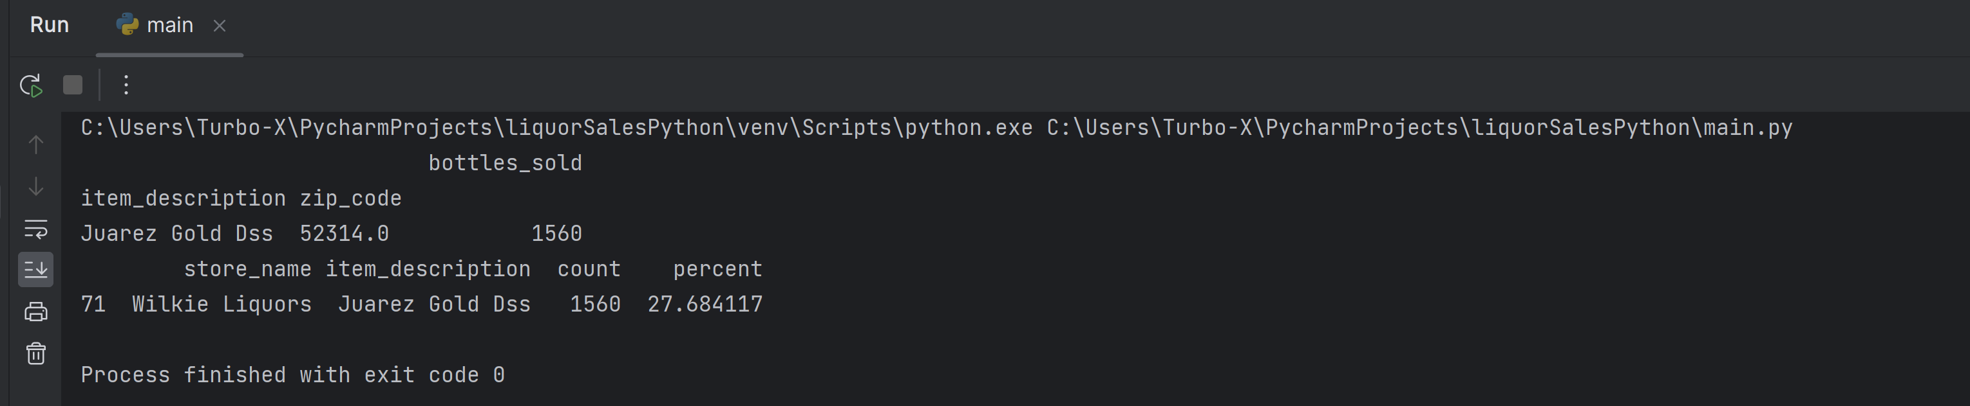

# STEP 5

I used Tableau in the new csv file to present Data and see the result below. The only think that I need to change in order to make the data suitable for processing is to remove the decimal .0 from zip code. I am using spilt method to do that.

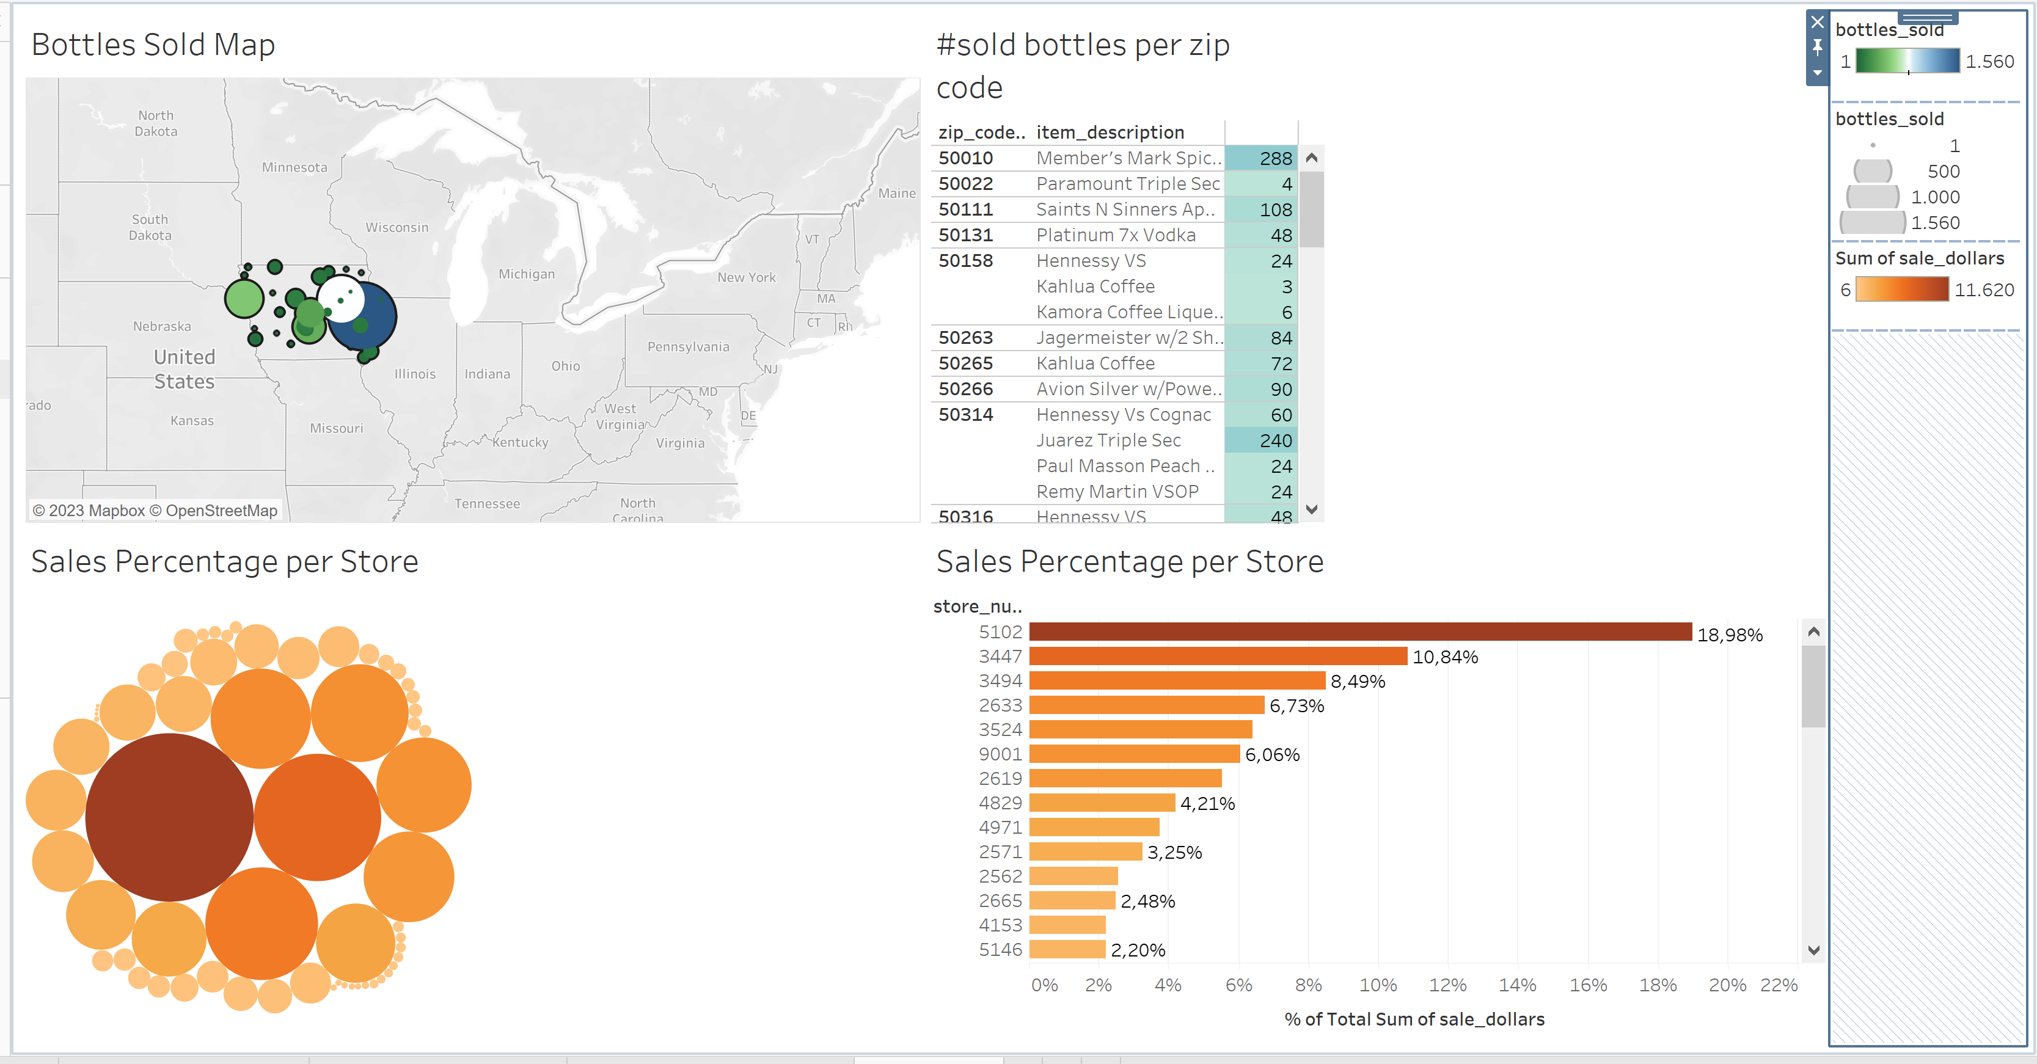

# STEP 6

I didn’t face special difficulties.