Readme

7.3.23

Projects are added using the template HTML Application with Typescript

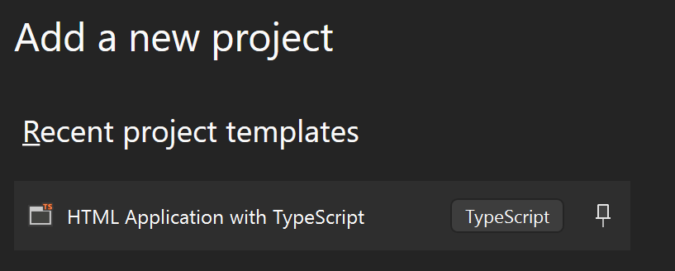

I downloaded that from

<https://marketplace.visualstudio.com/items?itemName=Rich-Newman.TypeScriptHTMLApplicationTemplate2022>

The project works for a while but then it says that class Greeter (in app.ts) is defined more than once. That is because it is picking up the declaration of Greeter from the .js file too. To prevent this one must add a tsconfig.json file. A very simple one makes it impossible to debug the typescript code. I found the following was OK

{

"compileOnSave": true,

"compilerOptions": {

"sourceMap": true

},

"files": [

"app.ts"

]

}

The "sourceMap": true line was vital to have debugging.

There are further config options at <https://www.typescriptlang.org/tsconfig>