FraudShieldAI
Real time fraud detection

Credit card fraud is the unauthorized use of a credit or debit card for purchases or withdrawals, occurring through methods like lost/stolen cards, online theft, and skimming devices.
Credit card fraud detection is crucial for preventing financial losses, protecting customer loyalty, maintaining a business's reputation, and ensuring legal compliance. It safeguards against unauthorized transactions by identifying and mitigating suspicious activity, which protects both businesses and consumers from the direct costs of fraud and the indirect costs of damaged trust and regulatory penalties.

That is why I am building a website that helps detect and prevent fraud actions on credit card transactions
- Using a dataset from Kaggle (Credit Card Fraud detection) , which contains 284807 transactions, 0.17% of which are fraud, heavily imbalanced. (https://www.kaggle.com/datasets/mlg-ulb/creditcardfraud/data)
- Plotted a class distribution to visualize the class imbalance , to visualize “Amount”,” Time” vs fraud occurrences.
MULTIPLE METHODS TO FIX/REDUCE CLASS IMBALANCE (ONE TO BE USED ONLY)
- LightGBM(Light Gradient-Boosting Machine) (balanced)
HOW IT WORKS:
1. Leaf-wise tree growth
2. Histogram-based learning
3.Gradient-Based One-Side Sampling (GOSS)
4.Exclusive Feature Bundling (EFB)
- PROS :
  - Faster training speed and higher efficiency.
  - Lower memory usage.
  - Better accuracy.
  - Support of parallel, distributed, and GPU learning.
  - Capable of handling large-scale data.
Result
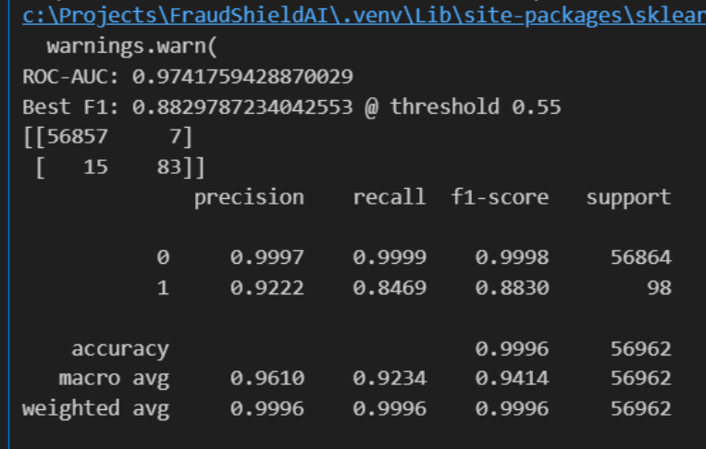

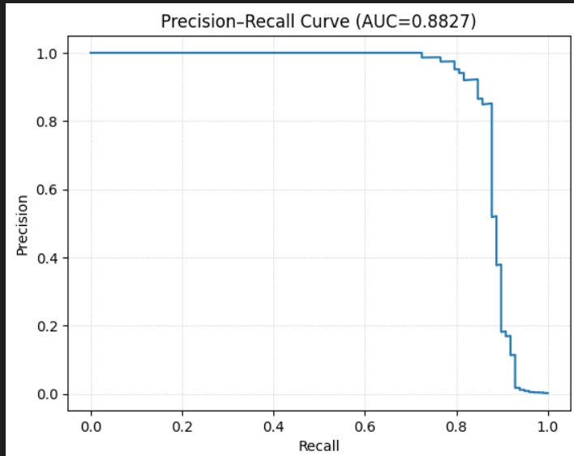

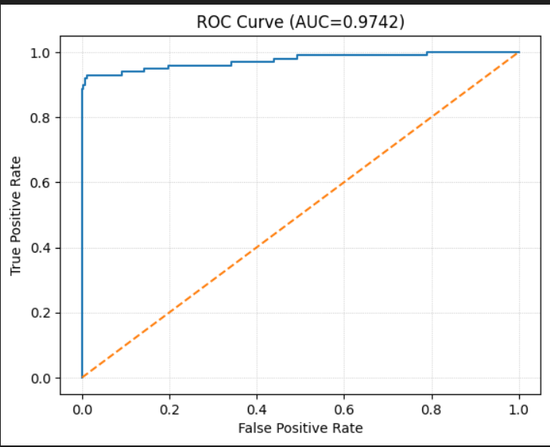
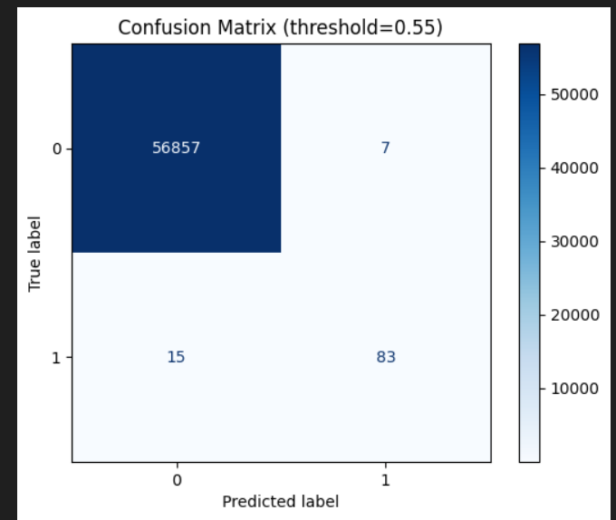
False positives: only 7 out of ~56 800 legitimate transactions → tiny false- alarm rate.
False negatives: 15 missed frauds → recall ≈ 85 %.

Below are SHAP Force Plots

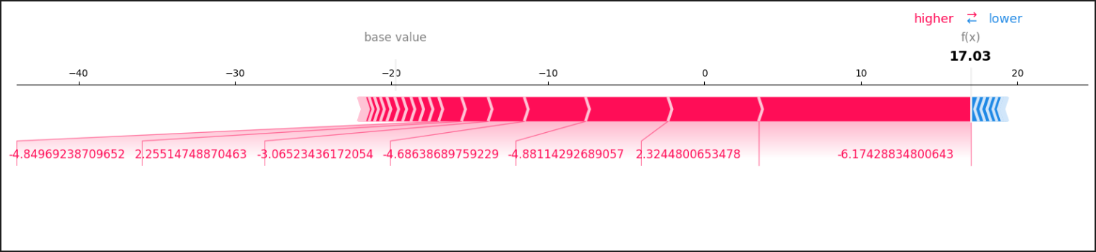example of a fraud case

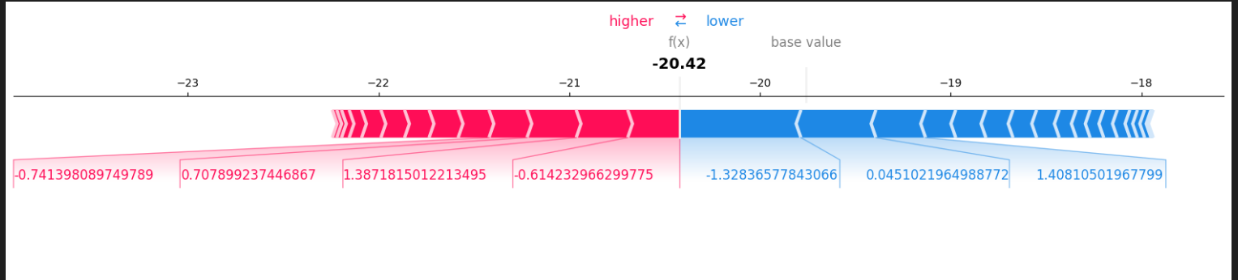example of a legitimate case

- LightGBM learned more complex boundaries: the tree-based structure captures non-linear relations between PCA features and transaction amount/time.
- It kept high recall (still catching ≈ 85 % of frauds) while boosting precision enormously — from barely half of flagged cases being true to over 92 % true frauds.

- .Using class weights Logistic regression to balance the data
Result
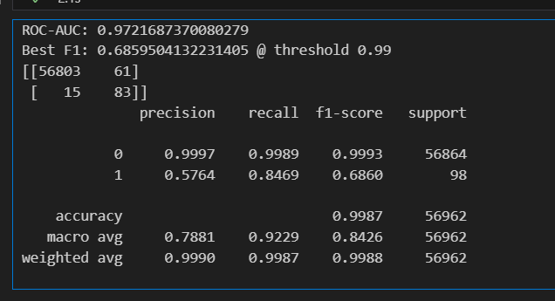
- Using SMOTE (Synthetic Minority Over-sampling) to handle data imbalance, by generating new synthetic samples by interpolating between existing minority class examples, without duplicating the data, to help the model generalize better and prevent overfitting to the majority class
HOW IT WORKS :
1. Find nearest neighbors: identify k nearest neighbors within the minority class
2. Create synthetic samples: generate new synthetic sample by randomly choosing a neighbor and creating a new point anywhere along the line segment connecting the original sample and chosen neighbor
3. Balance the dataset: process is repeated until the minority class has number of sample comparable to that of the majority class

HELPS:
1. Reduce model bias towards the majority class
2. improve model performance by creating a more balanced training data
3. data diverstity
4. avoids overfitting by improving its ability to generalize to new, unseen data.
LIMITATIONS:
1. Overfitting during training process
2. Favorable outcomes in ML process, but questionable translation for practical use
3. Synthetically created sample may belong to a different class
4. Synthetic data may not match the original distribution of the minority class
The SMOTE algorithm can be abstracted with the following pseudocode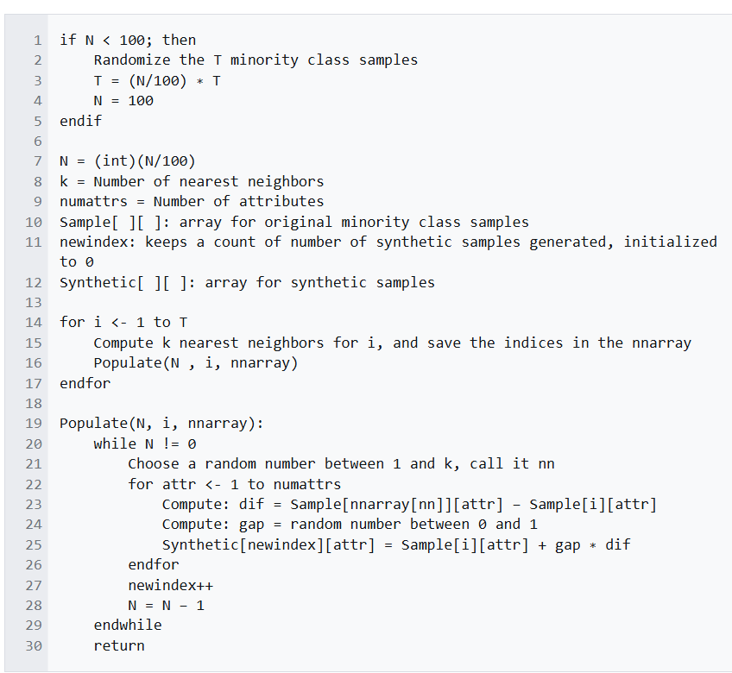
Result is identical to the class weights method

