FraudShield AI — Real-Time Fraud Detection

1. Introduction
FraudShield AI is a real-time credit card fraud detection system designed to identify and prevent unauthorized transactions. The system leverages machine learning and explainability techniques to distinguish legitimate from fraudulent activity.

2. Dataset Overview
Dataset: Kaggle 'Credit Card Fraud Detection' with 284,807 transactions, where 0.17% are fraudulent. Each transaction includes anonymized PCA features (V1–V28), along with Time, Amount, and Class labels.
Exploratory analysis revealed extreme class imbalance. Visualizations of 'Amount' and 'Time' versus fraud occurrences confirmed this imbalance.

3. Class Imbalance Handling
Several methods were tested to mitigate data imbalance:
Method | Precision | Recall | F1 | ROC-AUC | Outcome
Logistic Regression (baseline) | 0.52 | 0.82 | 0.63 | 0.93 | Baseline
Logistic Regression (Class Weights) | 0.5764 | 0.8469 | 0.6860 | 0.9721 | Moderate improvement
SMOTE + Logistic Regression | 0.5764 | 0.8469 | 0.6860 | 0.9721 | Same as class-weights
LightGBM (Balanced) | 0.9222 | 0.8469 | 0.8830 | 0.9742 | ✅ Best performing model
Among all methods, LightGBM achieved the highest precision (0.9222) and F1-score (0.8830), while maintaining excellent recall (0.8469). Thus, LightGBM was chosen as the final model.

4. Model Development
The final model used LightGBM with class_weight='balanced', 600 estimators, 0.05 learning rate, and num_leaves=64. Only 'Time' and 'Amount' were scaled using StandardScaler. The decision threshold was optimized for the best F1-score (0.55).
Confusion matrix shows 7 false positives and 15 false negatives, indicating strong detection with minimal false alerts.

5. Visual Summaries
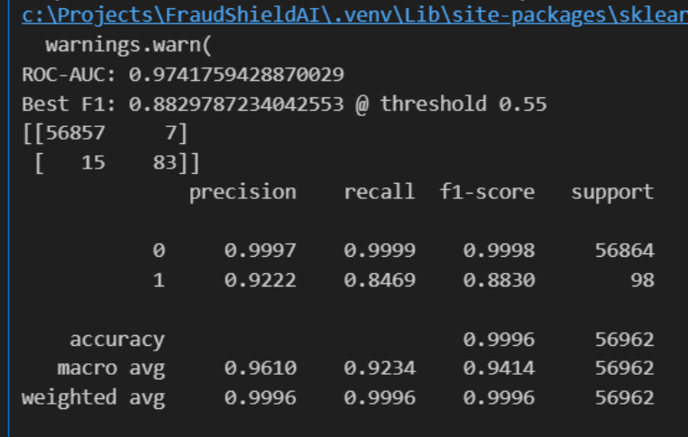
Figure 1 – LightGBM Results Summary

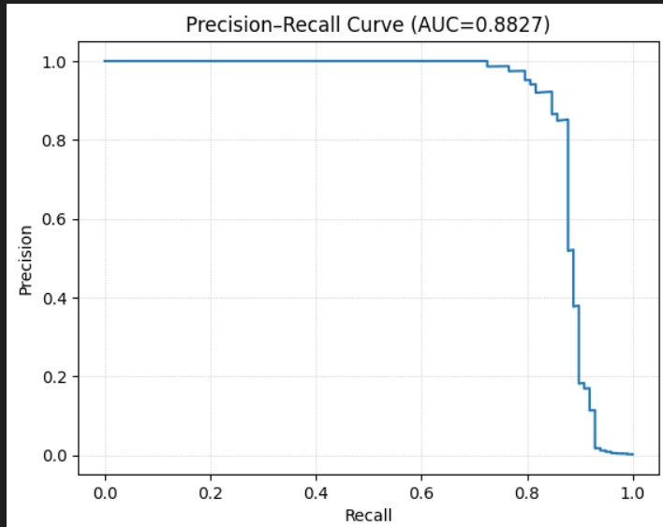
Figure 2 – Precision-Recall Curve (AUC=0.8827)

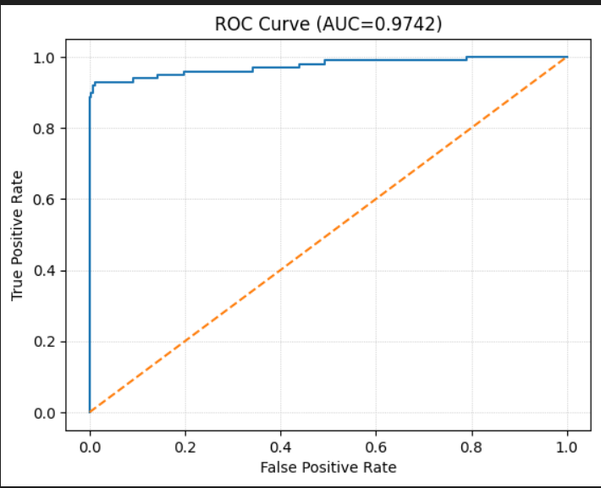
Figure 3 – ROC Curve (AUC=0.9742)

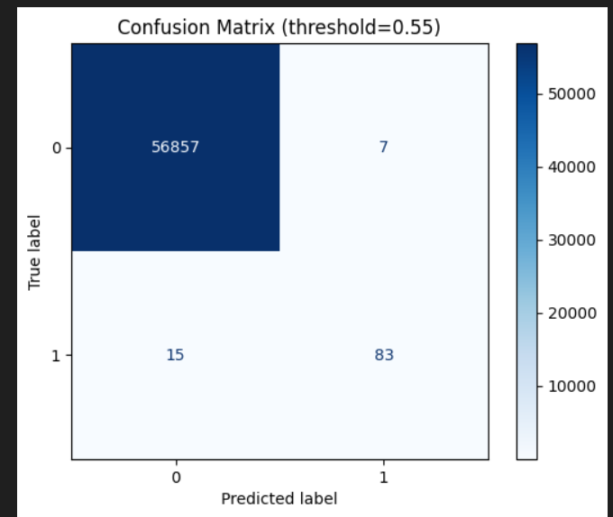
Figure 4 – Confusion Matrix at threshold=0.55

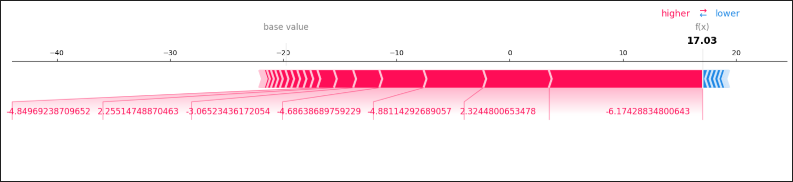
Figure 5 – SHAP Force Plot (Fraud Case)

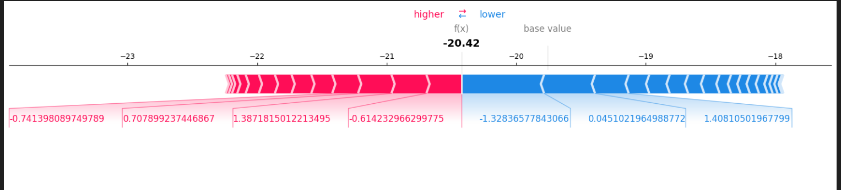
Figure 6 – SHAP Force Plot (Legit Case)

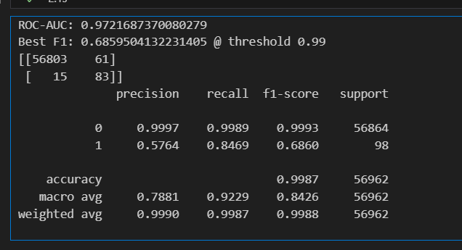
Figure 7 – Logistic Regression (Class-Weights/SMOTE) Results
These visuals demonstrate LightGBM’s strong separability, stability, and interpretability. SHAP visualizations highlight which features drive predictions toward or away from fraud.

6. Deployment and Monitoring
FraudShield AI was integrated with a FastAPI backend and a Streamlit dashboard. Key frontend features include a Top Suspicious table, dynamic threshold control, log/linear histogram visualization, colored risk zones (Safe, Watch, Flagged), and local SHAP explanations for any selected transaction.

7. Future Work

