## horizontal line



Movie.io

22.02.2019

**─**

George Kopti

Sheridan College

Mobile Web Application Development

# 

**Introduction** **2**

**Motivation** **2**

**Project details** **3**

**Deliverables** **3**

**Features** **4**

**Summary and future work** **8**

**References** **9**

# 

# 

# Introduction

The main goal of Movie.io is to that it allows people to review and archivein the comfort of their own house, the aimed solution is to allow people to keep track of the movies they want to watch and update them, also check out new movies that are coming out.

Think of Movie.io as a management application that helps you manage and save movies and view movies of different categories.

# Motivation

Sometimes people get stuck on what movies they want to watch, and they don't have the time to go to the movie theatre, Move.io can solve these problems by providing the user with a lot of interesting movies that they can watch and also helps them pick the movie that is appealing to their interest.

The history behind the problem is that sometimes when friends or family are hanging out they don’t find anything interesting or fun to do, and they decide on watching a movie but they don't know how they are going to decide what movie they are going to pick that all of them are going to agree on that choice of movie, also Movie.io helps you mark certain movies that you liked and want to watch later so that you don't forget to check them out.

This problem was interesting because it is really hard to find a good movie these days and it would be amazing if I had a way of knowing whether a movie is good or bad without wasting 120 minutes of our lives watching that movie.

My application can be used to help people manage their movies.

Movie.io is used for:

* Check movie reviews.
* See and get updates of new movies coming to the theatre.
* Archive and save movies that you would like to watch later.
* And much more.

# 

# Project details

For “Movie.io” application, I used Apache Cordova, which is an open-source mobile development framework. It allows us to use standard web technologies - HTML5, CSS3, and JavaScript for cross-platform development. Applications execute within wrappers targeted to each platform and rely on standards-compliant API bindings to access each device's capabilities such as sensors, data, network status, etc. [1].

To enhance the UI and general user experience, I used Bootstrap, which is a popular framework for building responsive and mobile-first sites and using jQuery to manipulate the DOM, also used a movie API called the movie database that is a good resource of movies, I also used google map API with Cordova’s geolocation to get the nearest theatre.

For the IDE, I used IntelliJ IDEA Ultimate 2018. This software provides support for many web frameworks, additional languages, and technologies and introduces many deployment options. It is the IDE of choice for professional developers who require a complete development environment without the need to search for plug-ins. It provides many unique features such as cross-technology refactoring, dependency analysis, code duplicate search, code coverage, integration with all popular VCS systems, and more. It is also a tool of choice for web developers thanks to its unique JavaScript, HTML, CSS, JSP and other web language editors. This edition is a better choice for commercial usage given that all features are delivered in a complete package.[2]

# Deliverables

The project constructs a responsive mobile web application, Movie.io allows you to review movies, check out newly released movies, check the ratings of movies, save or archive the movie of your choice for later retrieval.

# Features

Here are a few screenshots for how the app looks:

Starting from the Home Page, it contains categories of new movies, top rated movies, and most popular movies.

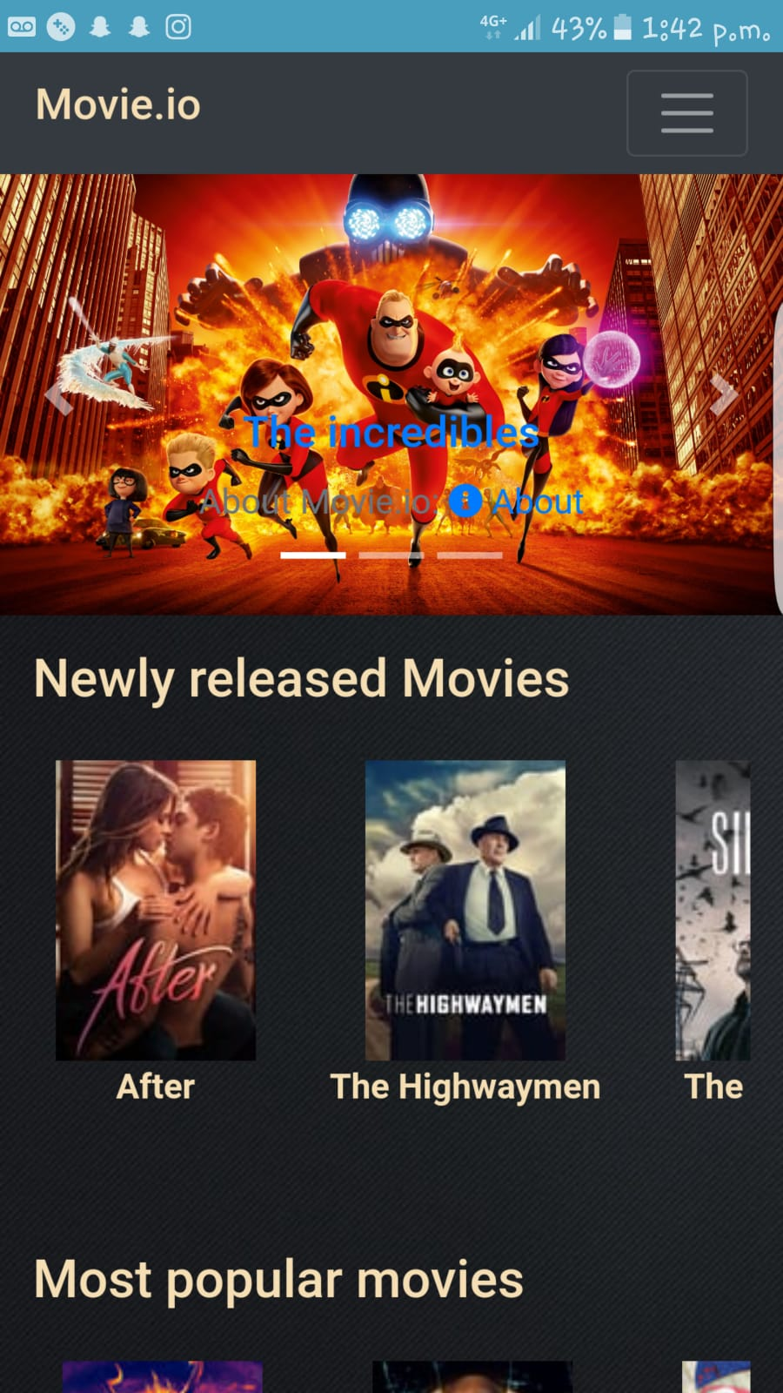

The Search Page helps the user to find desired movies and TV-shows. It also suggests the closest results if actual results are not found.

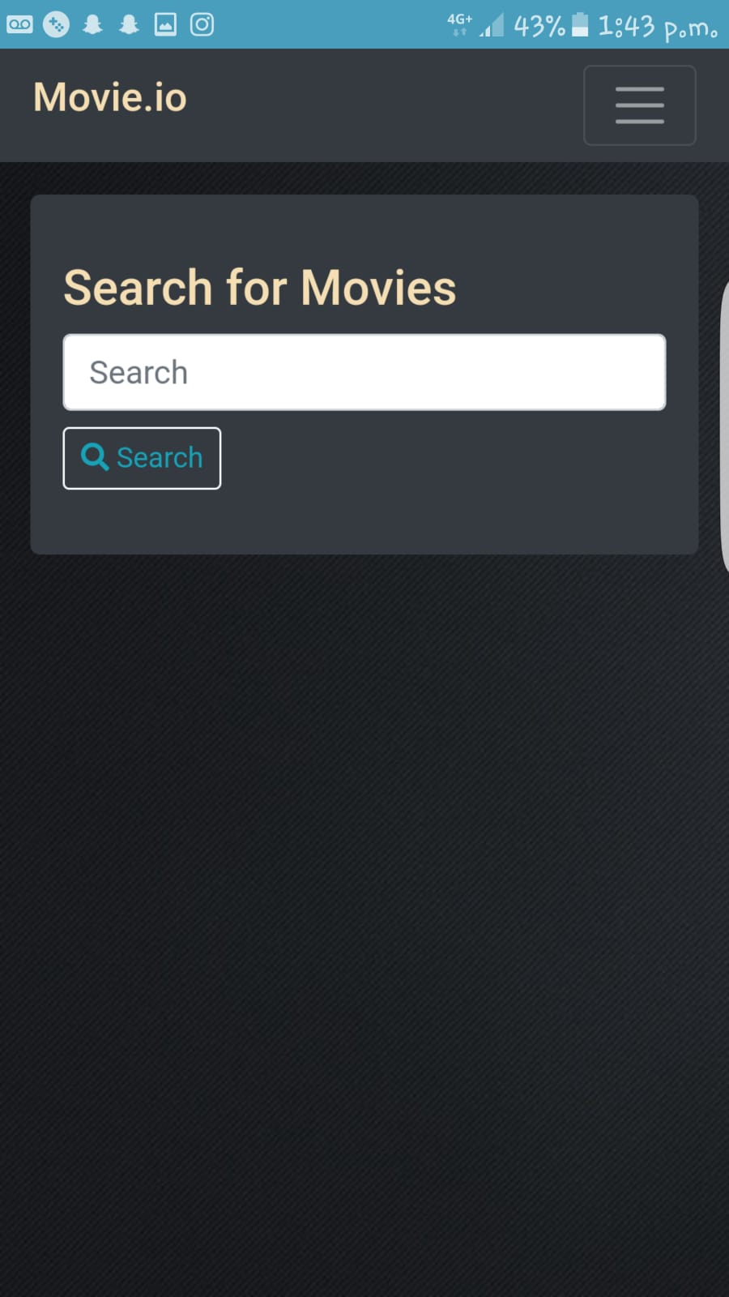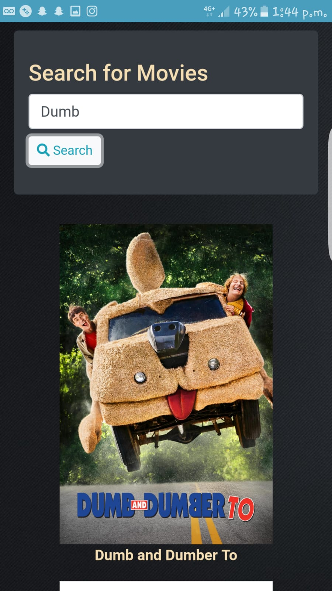

This App also allows the user to save or bookmark movies and TV-shows to watch them later. They can access the entire list of saved items under “My List” and also mark them as “watched” or “not interested”.

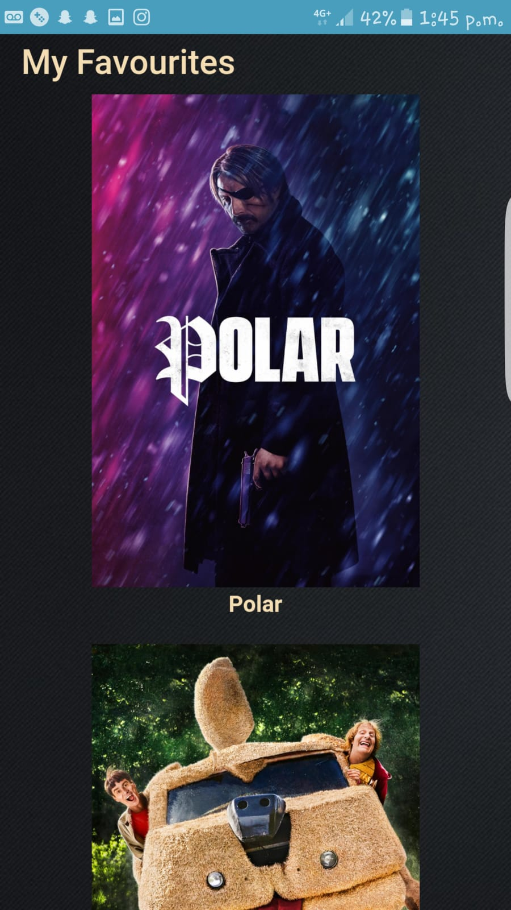

Upon selecting any movie, the app takes you to that movie’s page, where the user can get relevant information about the movie like description, cast, ratings as well as options to save it to list.

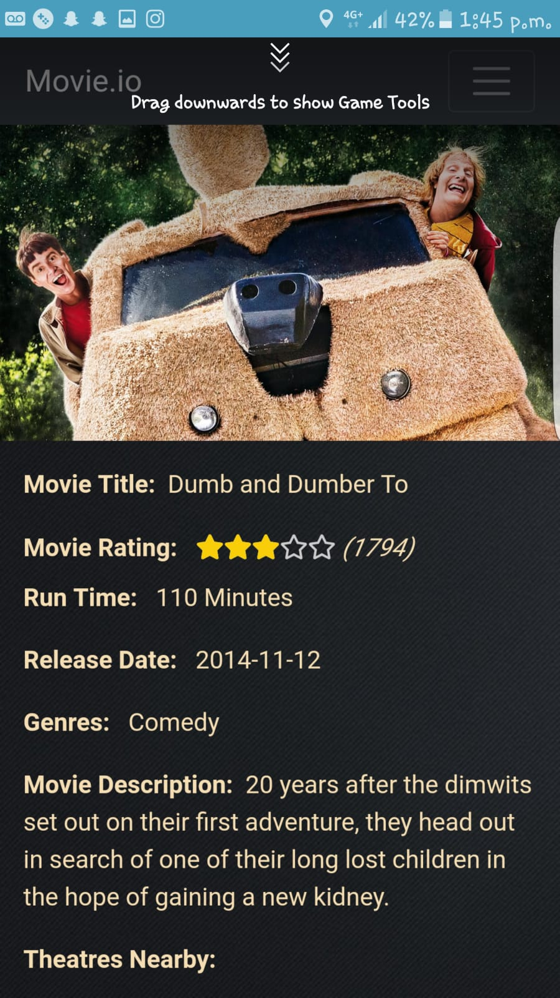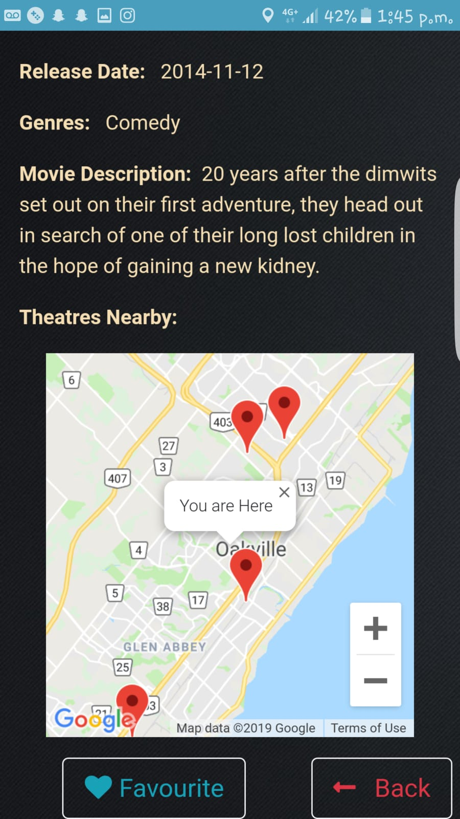

The app also has a few other features that let user change settings and set preferences or get help



# Summary and future work

The main purpose of our application is to bring the power of cinema in your hands. In today’s fast-paced world, everyone deserves to treat themselves with a bit of entertainment. But with all the busy schedules, something like entertainment should be relaxing, and that is exactly what our app is designed for. It gives the user a wide variety of options for non-stop uninterrupted entertainment. It gives the user the freedom to watch anything, anytime, anywhere. They can control what they watch and when they watch to seamlessly transition entertainment into their busy schedules.

Some of the problems I experienced during this project was connecting the API, adding the movie to the favorites database, doing the rating data visualization, and using the geolocation inside the device ready and having the initMap outside the device ready.

Future work for this project could be adding media trailers with each movie so that the user can watch the trailer and gain more information about the movie.

# References

Overview. (n.d.). Retrieved from https://cordova.apache.org/docs/en/latest/guide/overview/index.html

Ultimate Edition vs. Community Edition. (n.d.). Retrieved from https://www.jetbrains.org/display/IJOS/Ultimate Edition vs. Community Edition