RIFS Project Commentary

Introduction

Over the past few months, I have been working on creating a Robotic Interactive Feedback System known as RIFS. Core to the system is the use of a Teensy microcontroller and its associated Arduino IDE software. Physically RIFS is a combination of a motor controlled robotic ‘arm’ which is used to project a very small microphone through the air and an array of speakers and outward facing microphones surrounding it. Software also plays a vital role in the system in processing responses to the data received from the variety of sensors in the system. This is an important part in making RIFS interesting musically and meaningful. Through this commentary I am going to explain my aims in the undertaking of this project, explore the methodology I used in my approach and analyse links to context in terms of aesthetics, creativity, and academic theory. Furthermore, through the context of this project I am looking to answer my research question. How can sonic automata or musical robots be used to explore new ideas of musical creativity beyond the bounds of conventional humanistic musicianship? Finally, I will conclude by conducting a final evaluation of the RIFS project, exploring what succeeded, what the shortcomings were and what I learnt.

RIFS

The aim of my project was to create an autonomous musical robot that is interactive and will work interestingly musically when integrated into a large robotic ensemble. The basic rules in RIFS are as follows. Sound from four outward facing directional microphones is routed into Max/MSP, the software determines which microphone is loudest and signals teensy which using servo motors projects the microphone in this direction. The signal from this teensy microphone is placed in a feedback loop as it is output through the speaker it is positioned by. Due to the fact the ‘loudest’ microphone and its corresponding speaker face opposite directions soon a new microphone/position is actioned.

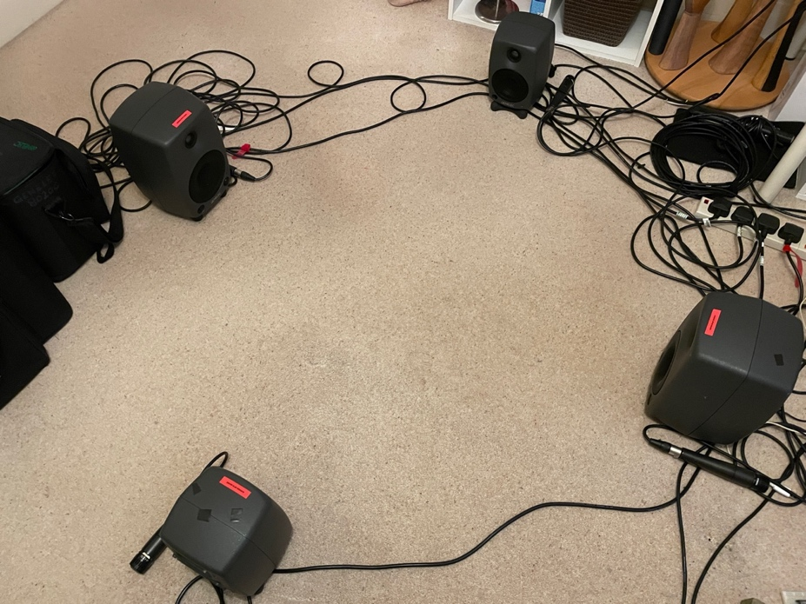

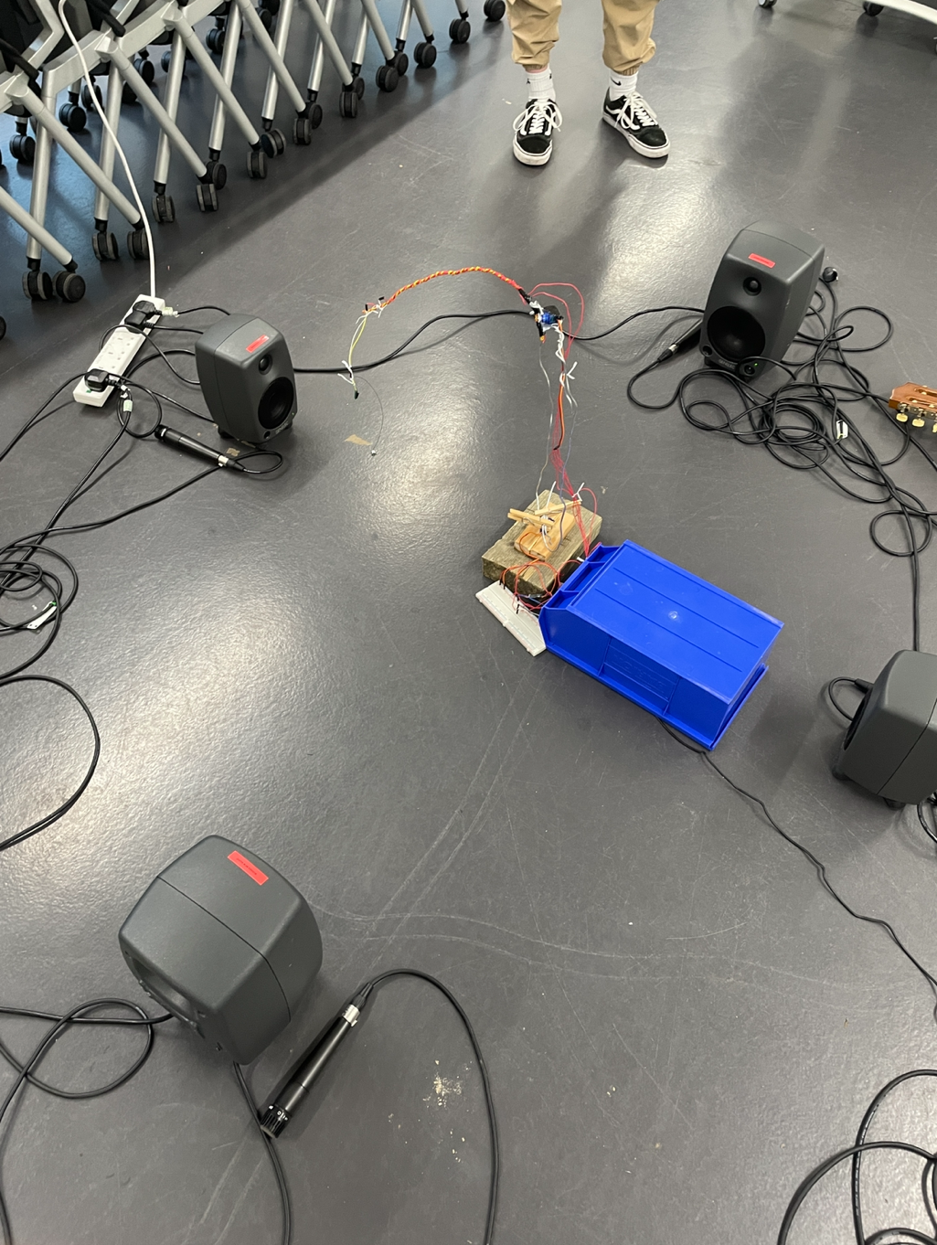

Context

Much of the inspiration for the physical design of RIFS was drawn from a project titled ‘Random Impulse’ created by Dylan Sheridan (2021). Sheridan (2021) describes how ‘a microphone is propelled by an air compressor in a violent and automated choreography’, and that ‘as the microphone strikes the walls and floors, it creates random patters of digital impulses which influence the environment in a rhythmic, thudding chorus’. I was compelled by the fact the microphone has its own changing speed and energy as it is propelled and arcs across the room. The microphone has a projectile profile and is physically being processed by the force of gravity. Furthermore, it’s a repatriation of the idea of a microphone, using it kinetically as a sound making device instead of just a static recording tool. Similar examples of creative kinetic uses of microphones include Steve Reich’s Pendulum Music (Josh Brown, 2015).

These examples particularly relate to my project as the force of gravity is acting on a moving microphone. The movement of microphones through randomly moving/spaced air molecules introduces stochastic processing into these systems and offers ‘possibilities for limited random variation’ (Jones, 1981, p. 45). What this means is that, whilst we know the general path of the microphone through the air from a given point there will be very slight variation. This is due to the randomness of air molecules in the space and their relative resistive forces which act on the microphone. Stochastic processing has excellent potential for adding character to computer generated sounds ‘frequently criticized for sounding… artificial’(Jones, 1981, p. 46). It takes inspiration from the natural world ‘to produce fuzzy edges and to "humanize" computer-generated sounds’ (Jones, 1981, p. 46). Contextual examples of the use of stochastic processes to create music include Iannis Xenakis - Pithoprakta (w/ graphical score) (Pierre Carré, 2017).

Given that my project is an example of sonic automata there is also context related to this. I was particularly inspired by the modular structure outlined in the Musebot Ensemble Manifesto (Brown, Carey and Eigenfeldt, 2015). This influence is evident in the unconventional feedback centric nature of my system which I anticipate will work best as part of an ensemble acting to process the sounds of other sonic automata and creating atmospheric, textured soundscapes. Furthermore, I took inspiration from the methodical experiment-based approach of Yang et al. (2020, p. 4), evident their series of experiments testing different potential components (solenoids or BLDC motors), particularly when linking creative software iterations and the hardware components.

Methodology

One of the primaries aims of my project was for RIFS to be an interactive system so that it could form part of a larger robotic ensemble and interact meaningfully with the other robots. Sonic automata can gain information about their environment using sensors, for instance light and UV sensors. RIFS makes use of outward facing directional microphones as its sensors. This is a pragmatic incorporation of sensors into the system because all of the robots in the ensemble will be making some sort of sound. If other options such as motion sensors were used solely it might limit interaction with the ensemble as for example all the sonic automata may not exhibit any kind of overt detectable movement. Because of my choice of microphones as sensors it allows RIFS to interact and be influenced by every robot in the ensemble; this is a high level of interactivity. The signals from these microphones are routed via a Zoom F4, being used as an audio interface, Logic Pro X and Max/MSP into their respective speakers (which they positioned with). Sound from the environment such as that outputted by other sonic automata is integral to RIFS as it is used as the base sonic material to initiate feedback in the system. Thus is the case that other sonic automata will have a very large impact on the way RIFS sounds at any particular point. This is a high level of interactivity because RIFS is not just using one element of observed sound such as speed or rhythm or identifying pitch, the whole sound of the robotic ensemble, timbre and texture included, will impact on the sounds eradiating from my system.

Also, it is important to note how RIFS will be affecting other robotic instruments in the ensemble. Due to the feedback processed signals consistently being fed through the speakers these signals will disperse throughout the room. Other examples of sonic automata if they have microphone sensors may hear back versions of sounds which they actually initiated. This is a form of data feedback itself and depending on the algorithm of a particular musical robot could influence its sound creation. These interrelationships can quickly compound and become complex; I think through this the value RIFS can bring to a robotic ensemble is clear.

Another of the aims of my project was to create meaningful and musical sound. Feedback can be extremely unpleasant when out of control, therefore it was vital I had the right functionality in my code so that unwanted peaks were quelled but there was sufficient levels of feedback for interesting things to occur musically. For this I needed a specific programming solution and created an encapsulated ‘Safety Protocol’ function in my Max/MSP patch. This function is used independently for each microphone/speaker pair and takes the rms value from the microphone as input. The function uses an if statements to determine if the input exceeds ’10’, if so after a 200ms delay the gain slider is reduced (a message ‘100’ is banged into the slider value). This also bangs through to another delay and subsequent message that re-maximises the gain slider after another 250ms. Functionally this acts as automatic volume reduction which attenuates the signal when it starts to get out of control. The key creative element of this function is that it works on each speaker/microphone pair independently. This is very interesting musically as they independently peak in volume and communicatively cause reactions from other pairs.

Research Question

My project shows that sonic automata and musical robots can be used to explore new ideas of musical creativity beyond the bounds of conventional humanistic musicianship. RIFS has a unique stochastic profile, randomness within certain limits, which allows it the potential to create complex and interesting compositions which I the creator would never have come up with myself. RIFS’s stochastic profile is made up from a number of elements. The two SG90 Servo motors used can rotate between 0-180° however there is a tolerance and a slight randomness around any angle actioned. In addition, the use of malleable and elastic materials, such as the use of wires, in RIFS means the structure can bend and morph throughout a performance. This introduces an element of data feedback as the historical movement and positioning of the robotic arm has an impact on its shape. Furthermore, given the sensitivity of the system to the unique acoustics of a performance space and sound output by other musical robots all these elements combine to create a complex and varied stochastic profile. Whilst some elements, such as the tolerance in the servos, independently don’t exhibit much randomness, in the system as a whole this cumulates. Its complex stochastic profile gives RIFS’ essentially rule based system a natural quality due to these variations and ‘fuzzy edges’ (Jones, 1981, p. 46), qualities exhibited by everything in nature. For example, the uniqueness of human fingerprints or veins on the leaves of plants (Lerner, 2016). Exact replication is only a function of the industrial and digital ages. For example, before the invention of recording and storage technology all music was heard live and each performance would vary slightly.

The use of physical computing in RIFS, the idea of ‘integrating computing with the physical world via sensors and actuators’ (Lee et al. 2005, p. 23), gave the system access to a large degree of complexity. Through access to this complexity sonic automata can be used to explore new ideas of musical creativity because of the unpredictable nature of potential results and the experimental culture this produces. Sonic automata acts to democratise the music making process. Simple rules and stochastic processing, through the introduction of physical computing, can make complex results. Therefore, people who are not traditionally creative or have the musical knowledge to envision a complex composition can experience this new form of creativity through the creation of sonic automata. This access to creativity cannot be understated as the benefits of creative activities is well documented in ‘improving psychological and physical well-being’ (Leckey, 2011, p. 508). Sonic automata has the potential to massively increase access to musical creativity.

Furthermore, through its experimental nature and complexity sonic automata can be used to inspire new forms of creativity in people. People including musicians are ruled by their habits (Grohol, 2016). This in combination with history, malignant “creative” institutions and limiting musical conventions can lead to creative stagnation. Sonic automata by its non-human nature can access true free experimentation without humanistic creative biases. This is a key musical creativity unique to sonic automata free from the limitations of conventional humanistic musicianship.

Evaluation

In evaluation RIFS has met the aims of my project to create an interactive example of sonic automata which creates musical and meaningful sound. The system works autonomously, it is responsive to sounds in its environment and through this responsiveness, and related musical output, it is social. One of the most successful elements of RIFS is that it can work just as well independently, interacting with characteristic room tones, and as part of an ensemble. Through the project I’ve learnt a great deal about the benefits of introducing elements of physical computing, such as microcontrollers and sensors, into inherently computer-based modes of musical expression. Physical computing and the ease of access this gives to generativity and subsequently complexity can be used to negate much of the criticisms of computer-based music as repetitive or robotic sounding. This has the potential to make computer-based music appealing to a greater audience. I also learnt a lot about creating teensy circuits to use these sensors and increased my skill in using the related Arduino IDE software. Looking to the future, I’m planning to implement physical computing, generativity, and stochastic processing into my electronic music composition. One simple implementation would be to introduce complexity and variation around MIDI note positioning/velocity/length. However, I’m also compelled to use more complex mappings and introduce stochastic processing to the texture and timbre of software instruments. This could potentially make them sound much more organic.

Despite RIFS largely being a success there are still elements that could be improved upon. The Teensy microphone is resilient and there is no evidence of it occurring damage from testing. However, for longevity there might be an argument to take some action to protect it, for example putting a small mesh cage around it. Nevertheless, this would inevitably diminish the colour and character of RIFS as microphone impacts sounds wouldn’t be so emphasised. Additionally, due to the elasticity of the arm it can droop over and need resetting and straightening out before a performance, this to some degree decreases the level of autonomy of RIFS as human intervention can be needed for optimal performances in extended sessions. However, this is a necessary trade-off for the discussed generativity it introduces.

References

- Brown, O. Carey, B. Eigenfeldt, A. (2015) ‘Manifesto for a musebot ensemble: a platform for live interactive performance between multiple autonomous musical agents’, Proceedings of the 21st international symposium on electronic art, Vancouver, Canada, 14-19 August. Available at: https://www.researchgate.net/publication/281441670_Manifesto_for_a_Musebot_Ensemble_A_platform_for_live_interactive_performance_between_multiple_autonomous_musical_agents (Accessed 3 January 2023).

- Dylan Sheridan (2022). Random impulse. Available at: https://vimeo.com/679603762?embedded=true&source=video_title&owner=7370690 (Accessed: 10 November 2022.)

- Grohol, J. (2016) Changing our routines and habits. Available at: https://psychcentral.com/lib/changing-our-routines-and-habits#1 (Accessed: 8 January 2023).

- Jones, K. (1981) ‘Compositional applications of stochastic processes’, Computer music journal, 5(2), pp. 45-61, pp. 45-46.

- Josh Brown (2015) Pendulum music steve reich 1968. Available at: https://www.youtube.com/watch?v=h-TH3vWJ_0c (Accessed: 3 January 2023).

- Leckey, J. (2011) ‘The therapeutic effectiveness of creative activities on mental well-being: a systematic review of the literature’, Journal of psychiatric and mental health nursing, 18(6), pp. 501-509. doi:10.1111/j.1365-2850.2011.01693.x. p. 508.

- Lee, I. Stankovic, J. Mok, A. Rajkumar, R. (2005) ‘Opportunities and obligations for physical computing systems’, Computer, 38(11), pp. 23-31. Available at: https://ieeexplore.ieee.org/abstract/document/1541875 (Accessed: 8 January 2023). p. 23.

- Lerner, E. (2016) Finding a plant’s ‘fingerprint’ in the veins of its leaves | penn today. Available at: https://penntoday.upenn.edu/2016-03-10/latest-news/finding-plant’s-‘fingerprint’-veins-its-leaves (Accessed 6 January 2023).

- Pierre Carré (2017) Iannis xenakis - pithoprakta (w/ graphical score). Available at: https://www.youtube.com/watch?v=nvH2KYYJg-o (Accessed: 3 January 2023).

- Sheridan, D. (2021) Random impulse – terrapin puppet theatre. Available at: https://www.terrapin.org.au/event/random-impulse/ (Accessed: 3 January 2023).

- Yang, N. Savery,R. Sankaranarayanan, R. Zahray, L. Weinberg, G. ‘Mechatronics-driven musical expressivity for robotic percussionists‘, Proceedings of the 2020 international conference on new interfaces for musical expression, Birmingham, England, 21-25 July. doi: 10.48550/arxiv.2007.14850. p. 4.

