EE371 Verilog Tutorial 2

What is Verilog ?

Verilog is a Hardware Description Language; a textual format for describing electronic circuits and systems. Applied to electronic design, Verilog is intended to be used for circuit verification and simulation, for timing analysis, for test analysis (testability analysis and fault grading) and for logic synthesis.
( Finally, VHDL is not an abbreviation for Verilog HDL — Verilog and VHDL are two different HDLs. They have more similarities than differences, however.)

Scope of Verilog

Verilog can be used at different levels of abstraction, such as behavior level or structure level.

Design process
The diagram below shows a very simplified view of the electronic system design process incorporating Verilog. The central portion of the diagram shows the parts of the design process which will be impacted by Verilog.
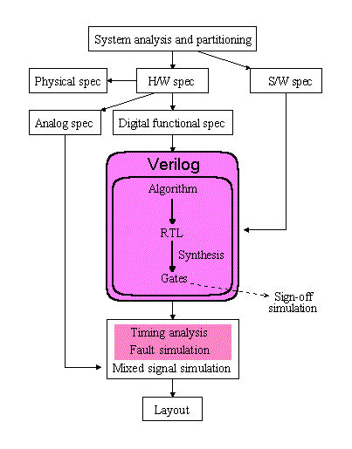
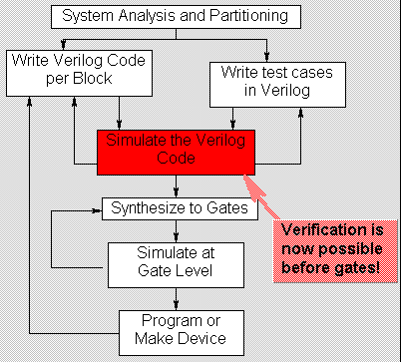
Verilog is suitable for use today in the digital hardware design process, from functional simulation, manual design and logic synthesis down to gate-level simulation. Verilog tools provide an integrated design environment in this area.
Verilog is also suited for specialized implementation-level design verification tools such as fault simulation, switch level simulation and worst case timing simulation. Verilog can be used to simulate gate level fanout loading effects through the import of SDF files.

A Simple Design

A design is described in Verilog using the concept of a module. A module can be conceptualised as consisting of two parts,
- the port declarations
- the module body
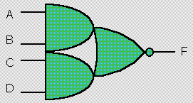
The port declarations represent the external interface to the module. The module body represents the internal description of the module - its behaviour, its structure, or a mixture of both. Let’s imagine we want to describe an and-or-invert (AOI) gate in Verilog.

Verilog: an AOI gate module
// Verilog code for AND-OR-INVERT gate

module AOI (A, B, C, D, F);
input A, B, C, D;
output F;

assign F = ~((A & B) | (C & D));

endmodule

// end of Verilog code

OK, that’s the code. Let’s dissect it line by line...

// Verilog code for AND-OR-INVERT gate
Similar to many programming languages, Verilog supports comments. There are two types of comment in Verilog, line comments and block comments; we will look at line comments for now. Comments are not part of the Verilog design, but allow the user to make notes referring to the Verilog code, usually as an aid to understanding it. Here the comment is a “header” that tells us that the Verilog describes an AOI gate. It is no more than an aide de memoire in this case. A Verilog compiler will ignore this line of Verilog. Two forward slashes mark the start of a line comment, which is ignored by the Verilog compiler. A line comment can be on a separate line or at the end of a line of Verilog code, but in any case stops at the end of the line.

module AOI (A, B, C, D, F);
The name of the module is just an arbitrary label invented by the user. It does not correspond to a name pre-defined in a Verilog component library. module is a Verilog keyword. This line defines the start of a new Verilog module definition. All of the input and output ports of the module must appear in parentheses after the module name. The ordering of ports is not important for the module definition per se, although it is conventional to specify input ports first.

input A, B, C, D;
output F;
The port declarations must repeat the names of the ports in the module header. A port may correspond to a pin on an IC, an edge connector on a board, or any logical channel of communication with a block of hardware. Each port declaration includes the name of one or more ports ( e.g., A, B ), and the direction that information is allowed to flow through the ports (input, output or inout).

Endmodule
The module definition is terminated by the Verilog keyword endmodule.

Well, that’s the interface to the module taken care of, but what about it’s functionality?

assign F = ~((A & B) | (C & D));
In this module body, there is but one statement, and all the names referenced in this statement are in fact the ports of the design. Because all of the names used in the module body are declared in the module header and port declarations, there are no further declarations for internal elements required in the module body. assign is a Verilog keyword. It denotes a concurrent continuous assignment, which describes the functionality of the module. The concurrent assignment executes whenever one of the four ports A, B, C or D change value. The ~, & and | symbols represent the bit-wise not, and and or operators respectively, which are built in to the Verilog language. That’s it! That’s all there is to describing the functionality of an AOI gate in Verilog.

// end of VHDL code
Another Verilog comment, and that’s the end of a Verilog description for an AOI gate.

Wires
The module shown on the “Modules” page, was simple enough to describe using a continuous assignment where the output was a function of the inputs. Usually, modules are more complex than this, and internal connections are required. To make a continuous assignment to an internal signal, the signal must first be declared as a wire.
A Verilog wire represents an electrical connection. A wire declaration looks like a port declaration, with a type (wire), an optional vector width and a name or list of names.
Ports default to being wires, so the definition of wire F in the Verilog code is optional.
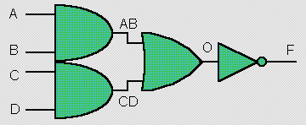
Verilog: Internal signals of an AOI gate module
// Verilog code for AND-OR-INVERT gate

module AOI (A, B, C, D, F);
input A, B, C, D;
output F;

wire F; // the default

wire AB, CD, O; // necessary

assign AB = A & B;
assign CD = C & D;
assign O = AB | CD;
assign F = ~O;

endmodule

// end of Verilog code
OK, that’s the code. Let’s examine it a little more closely...

wire AB, CD, O;
This is the syntax for a wire declaration. You can create separate wire declarations if you wish, for example:
wire AB, CD;
wire O;
is an alternative way of creating wire declarations.

assign AB = A & B;
assign CD = C & D;
assign O = AB | CD;
assign F = ~O;
In this module body, there are four continuous assignment statements. These statements are independent and executed concurrently. They are not necessarily executed in the order in which they are written. This does not affect the functionality of the design. Suppose B changes value. This causes assign AB = A & B; to be evaluated. If AB changes as a result then assign O = AB | CD; is evaluated. If O changes value then assign F = ~O; will be evaluated; possibly the output of the module will change due to a change on B.

A Design Hierarchy

Modules can reference other modules to form a hierarchy. Here we see a 2:1 multiplexer with an inverting data path consisting of an AOI gate and a pair of inverters.
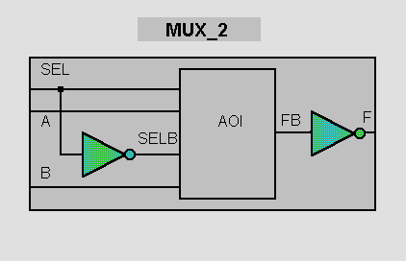

Module Instances
The MUX_2 module contains references to each of the lower level modules, and describes the interconnections between them. In Verilog jargon, a reference to a lower level module is called a module instance.
Each instance is an independent, concurrently active copy of a module. Each module instance consists of the name of the module being instanced (e.g. AOI or INV), an instance name (unique to that instance within the current module) and a port connection list.
The module port connections can be given in order (positional mapping), or the ports can be explicitly named as they are connected (named mapping). Named mapping is usually preferred for long connection lists as it makes errors less likely.

Verilog: 2-input multiplexer module
// Verilog code for 2-input multiplexer

module INV (A, F); // An inverter
input A;
output F;

assign F = ~A;
endmodule

module AOI (A, B, C, D, F);
input A, B, C, D;
output F;

assign F = ~((A & B) | (C & D));

endmodule

module MUX2 (SEL, A, B, F); // 2:1 multiplexer
input SEL, A, B;
output F;

// wires SELB and FB are implicit

// Module instances...

INV G1 (SEL, SELB);
AOI G2 (SELB, A, SEL, B, FB);
INV G3 (.A(FB), .F(F)); // Named mapping
endmodule

// end of Verilog code

Yes, it’s time to dissect the code line by line again, but we’ll concentrate on the new lines as the module interface has been covered before (see A Simple Design).

// wires SELB and FB are implicit
The wires used in continuous assignments MUST be declared. However, one-bit wires connecting component instances together do not need to be declared. Such wires are regarded as implicit wires. Note that implicit wires are only one bit wide, if a connection between two components is a bus, you must declare the bus as a wire.

AOI G2 (SELB, A, SEL, B, FB);
In a module instance, the ports defined in the module interface are connected to wires in the instantiating module through the use of port mapping. For thge instance of AOI, the first wire in the port list is SELB. In the module header for the AOI hgate, A is the first port in the port list, so SELB is connected to A. The second port in the module header is B, the second wire in the port list is A, thus the wire A in MUX2 is connecyted to the port B of the AOI gate instance.

INV G3 (.A(FB), .F(F));
The second INV instance, G3, uses named mapping rather than positiuonal mapping. In the port list for the G£ instance, the wire FB is connected to the input port, A, of the INV instance. The period character is followed by the name of the module header port; in brackets following the formal port, the name of the wire is entered.

Test Benches
Test benches prove that a design is correct. How do you create a simple testbench in Verilog?
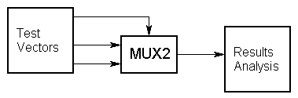
Let’s take the exisiting MUX_2 example module and create a testbench for it. We can create a template for the testbench code simply by refering to the diagram above.
module MUX2TEST; // No ports!
...
initial
// Stimulus

... MUX2 M (SEL, A, B, F);

initial
// Analysis
...
endmodule

In this code fragment, the stimulus and response capture are going to be coded using a pair of initial blocks. An initial block can contain sequential statements that can be used to describe the behavior of signals in a test bench.

In the Stimulus initial block, we need to generate waveform on the A, B and SEL inputs. Thus:
initial // Stimulus
begin
SEL = 0; A = 0; B = 0;
#10 A = 1;
#10 SEL = 1;
#10 B = 1;
end

Once again, let’s look at each line in turn.

initial // Stimulus
begin
// statements
end

SEL = 0; A = 0; B = 0;
This line contains three sequential statements. First of all, SEL is set to 0, then A, then B. All three are set to 0 at simulation time 0.

#10 A = 1;
In terms of simulation, the simulator now advances by 10 time units and then assigns 1 to A. Note that we are at simulation time = 10 time units, not 10 ns or 10 ps! Unless we direct the Verilog simulator otherwise, a Verilog simulation works in dimensionless time units.

#10 SEL = 1;
#10 B = 1;
These two lines are similar to the one above. 10 time units after A is set to 1, SEL is set to 1. Another 10 time units later (so we are now at simulation time = 30 time units), B is set to 1. The diagram below shows how the initial block has created a waveform sequence for the three signals.
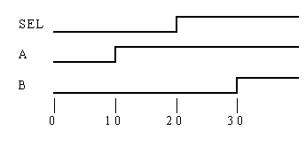
We shall look at the use of the initial block to capture the MUX_2’s response in the next tutorial.

Response Capture

Now, let's look at how to capture the response of our device under test.
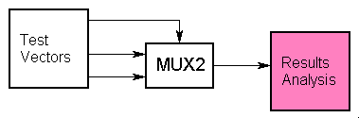
Remember from the module template that we are using initial blocks to code up the Stimulus and Response blocks.
module MUX2TEST; // No ports!
...
initial
// Stimulus

... MUX2 M (SEL, A, B, F);

initial
// Analysis
...
endmodule

The Response initial block can be described very easily in Verilog as we can benefit from a built-in Verilog system task. Thus:

initial // Response
$monitor($time, , SEL, A, B, F);

Once again, let’s look at each item in turn.

$monitor();
$monitor is a system task that is part of the Verilog language. Its mission in life is to print values to the screen. The values it prints are those corresponding to the arguments that you pass to the task when it is executed. The $monitor task is executed whenever any one of its arguments changes, with one or two notable exceptions.

$time
$time is a system function (as opposed to a system task). It returns the current simulation time. In the above example, $time is an argument to $monitor. However, $time changing does not cause $monitor to execute — $monitor is clever enough to know that you wouldn’t really want to print to the screen the values of all of the arguments every time the simulation time changed.
, ,
The space at position 2 in the argument list ensures that a space is printed to the screen after the value of $time each time $monitor is executed. This is a simple method of formatting the screen output.

SEL, A, B, F
Finally we come to the signal arguments themselves. Each time one of these signals changes value, $monitor will execute. When $monitor executes it will print all of the argument values to the screen, including $time. This is the output created by $monitor in our MUX2 testbench:
0 0000
10 0101
20 1100
30 1111
This is simply a tabular listing of the waveforms that would be generated during simulation (if we had a waveform viewer, that is!).

It’s amazing what you can learn from two lines of code, isn’t it? We’ll look at more elaborate output formatting soon.

