WattsLog
4/4/2020
Ultrasonic detector is using A4, A5 for I/O and those are dedicated pins on an Arduino Uno for SDA/SCL. Move the Ultrasonic detector to A2, A3 and verify that I2C using A4, A5 works correctly while the Ultrasonic detector still works.

- Verify that SmartCar_Core20191227.ino runs the robot correctly including operation of the Ultrasonic with no changes.
Loaded up the software, had to install Arduino_IRremote library. Not sure why that was not required before, possibly because I haven't compiled and uploaded the main program before. Verified successfully by using the IR remote to trigger progrem 2, obstacle-avoidance mode, and it was using ultrasonic detector to find obstacles, stop,change direction, detect whether it was clear ahead, and then continuing. By holding the SmartCar in my hand I could simulate the same behavior with my hand in front of the detector.
- Modify SmartCar_Core20191227.ino for Ultrasonic detector to use A2, A3.
Version 1.0.1, changes defines for ECHO_PIN and TRIG_PIN
Hardware: spliced wires for the two control pins so they could reach the A2, A3 solder points on the daughter board.
- Verify that the robot still runs correctly including operation of the Ultrasonic detectors.
Verified in the same way as in step 1.
- Verify that I2C works with the INA219.
- Calibrate all four of the INA219 modules.
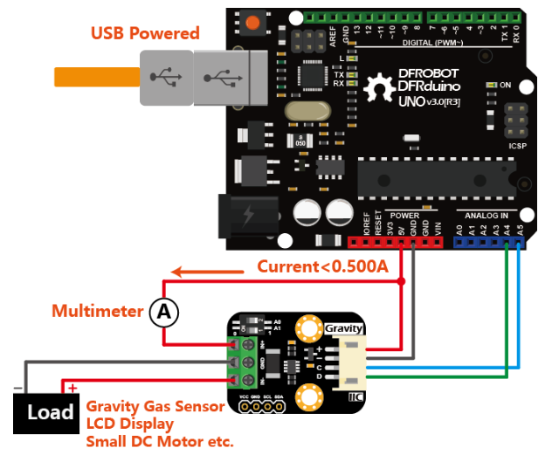
  - Calibration test circuit.
  - Code: ina219_calibrate.ino
  - INA219_I2C_ADDRESS4 0x45 A0 = 1 A1 = 1.
ina219Reading_mA = 1000
extMeterReading_mA = 1020
  - INA219_I2C_ADDRESS3 0x44 A0 = 0 A1 = 1
ina219Reading_mA = 1000
extMeterReading_mA = 1000
  - INA219_I2C_ADDRESS2 0x41 A0 = 1 A1 = 0
ina219Reading_mA = 1000
extMeterReading_mA = 1000
  - INA219_I2C_ADDRESS1 0x40 A0 = 0 A1 = 0
ina219Reading_mA = 1000
extMeterReading_mA = 1010
- Wire up the four INA219 modules.
  - Create schematic drawing.
  - Create wiring diagram and connection table
  - Prepare cable for all interconnections
  - Drill INA219 mounting holes
  - Pre-assemble INA219 hardware, test fit
  - Disassemble INA219 from mounting
  - Desolder wireless coil from power PCB
  - Glue wireless charging coil to underside of chassis
  - Re-solder wireless coil to power PCB
  - Attach power PCB to top of lower chassis
  - Drill RpiZero mounting holes
  - Assemble RpiZero to top chassis platform
This step resulted in tearing the AIY connector ribbon cable off the board. RpiZero still operates and the GPIO ports are now available.
  - Install battery charging cable and wiring management
  - Wire INA219-1 through INA219-4
  - Wire battery, wireless charger, Uno and RpiZero
  - Install wiring harness and wiring management
  - Re-install INA219 modules to mountings
  - Install final connection to I2C
- Add the getVoltageCurrentPower code integrated into the SmartCarCore
  - Modified getVoltageCurrentPower to get4VoltageCurrentPower
  - Power up, smelled smoke, unplugged all, found voltage on Rpi was out of spec. Battery is putting out 7.7v when being charged and USB voltage must be from 4.75v to 5.25v. Rpi worked OK with no issues when charger was not plugged in.
  - Program works fine without Rpi plugged in. Uno is OK with higher voltage.
  - Battery pack automatically turns ON when charger is plugged in. I was expecting that with the battery charging I could have it ON or OFF, controlled by the switch.
  - With charger plugged in and charging:
    - Uno: E=7.79v I=80mA P=620mW
    - Rpi: E=7.81v I=0mA P=0mW
    - Motors: E=7.82 I=10mA P=60mW
    - Chg: E=4.31v I=420mA P=1800mW
  - With charger plugged in and NOT charging:
    - Uno: E=7.68v I=80mA P=620mW
    - Rpi: E=7.69v I=0mA P=0mW
    - Motors: E=7.70 I=10mA P=60mW
    - Chg: E=.04v I=-1mA P=0mW
  - With charger unplugged and battery pack OFF:
    - Uno: E=0.71v I=0mA P=0mW
    - Rpi: E=.72v I=0mA P=0mW
    - Motors: E=.73 I=0mA P=0mW
    - Chg: E=.04v I=-1mA P=0mW
    - Uno was still powered from the USB cable at 4.9v. Unplugging the USB cable (for programming) turned off the power to the Uno and it stopped. Without the USB cable from Uno to workstation the serial monitor was no longer available to report EIP data, so testing with MQTT will be required to see that it still works – no reason to think it would not.

4/30/2020
Received and installed replacement RpiZero.
Used power picked off of Uno board for 5v source.
Connected power, keyboard+mouse+hdmi to test JeVois camera software.
Needed a new SD image so that there was a GUI to show imaging from JeVois camera
New SD images built with balenaEtcher were failing.
The boot process would get interrupted and then restart, never succeeded in restarting
Tried multiple images but with same result.
Tried on an Rpi 3 B+ and it seemed to do the same thing.
Powered from a mains wall wart and a Noobs Raspian image booted successfully.
Received a new 10K MaH battery small enough for the trunk
Next steps:
- Revisit the power schematic so wiring doesn't get picked off of Uno and validate that there is no boot cycling problem with on board battery power.
Testing completed successfully.
- Test with Uno and RpiZero both running on the new battery pack.
Testing completed successfully with both.
- Test the charging capability from wireless charger.
- Install the JeVois camera on the RpiZero.
  - Plugged into the RpiZero USB mini port. No luck getting the RpiZero to recognize the camera. 5/6/20
  - Try to use it with Rpi 3 B+ or Rpi 4 or Jetson. Failed on Rpi 3 B+. 5/8/20
- Connect JeVois camera to USB inputs of the RpiZero. There are no more USB ports so need to use VNC to access the RpiZero and operate the controller remotely to test with JeVois camera.
Test failed, but did get VNC working with RpiZero. It's quite slow. Same SD card in Rpi 3 B+ was much faster of course. VNC and desktop are quite fast on Rpi3 and will probably be much faster on Rpi4 – need to purchase one or find one in my stash of Rpi's.
- JeVois camera has so far failed to connect with all hosts I've tried, RpiZero, Rpi3 and Mac. I have all the USB connectors/adapters to make each of these work, including OTB versions of them. The camera is failing to be recognized by any host.
  - Opened support request in the JeVois community. 5/9/20
- Validate multiple JeVois functions from the RpiZero to verify this is a workable platform using the serial port to make setting changes and to receive target location data for driving the pan-tilt platform.
- Design and build the pan-tilt platform for the JeVois camera.
- Design and code the pan-tilt servo driver modules.

5/11/20
Continue with the list of tasks above, but also pursue the original design of Watts without the JeVois camera. I know that RpiZero works with a standard RpiCamera module, and that it was used with the AI module software provided by Google, so I can build TinyML software that will start to reach the goals of Watts.
- Consider using an instance of some kind of bug tracking software like Jira, Airbrake, Backlog. Backlog, Bugzilla, Mantis Bug Tracker, Redmine and Zoho Bug Tracker are open source. Many commercial products have free versions for individuals. I want to be able to track a set of backlogs for each of the sub projects within Watts.
- Get serial communication working with Watts
  - software serial library on Arduino platform
  - WiringSserial library on Rpi platform
  - PubSubClient.h
    - sudo pip3 install paho.mqtt
    - import paho.mqtt.client
    - python libraries for collecting serial data and pushing messages to mqtt
- i2c servo drivers for pan-tilt platform for the camera, whether using the RpiCamera or JeVois camera.
- Research JetBot ROS (robot operating system) as a platform for the hardware and software for Watts. Information on Sparkfun site.
  - Power requirements
  - Jetson module as a platform for Watts
  - AWS Robomaker
  - 2 camera ports
  - ML libraries that run here
- Researching Julia programming language – faster, compiled language

