Deploying CEPH CSI (RBD & CephFS) onto Kubernetes

(25 Nov2025)

Overview

Deploying, specifically both the RBD and CephFS stacks onto an Kubernetes cluster into separate namespace.

Well firstly, what is CEPH, you may ask.

Ceph is an open-source, software-defined storage platform that provides unified object, block, and file storage within a single, scalable cluster. It links multiple storage servers into a single distributed system, making it fault-tolerant and highly available without a single point of failure. Ceph is known for its flexibility, ability to run on commodity hardware, and compatibility with other open-source projects like OpenStack and Kubernetes.

See Ceph: An Overview

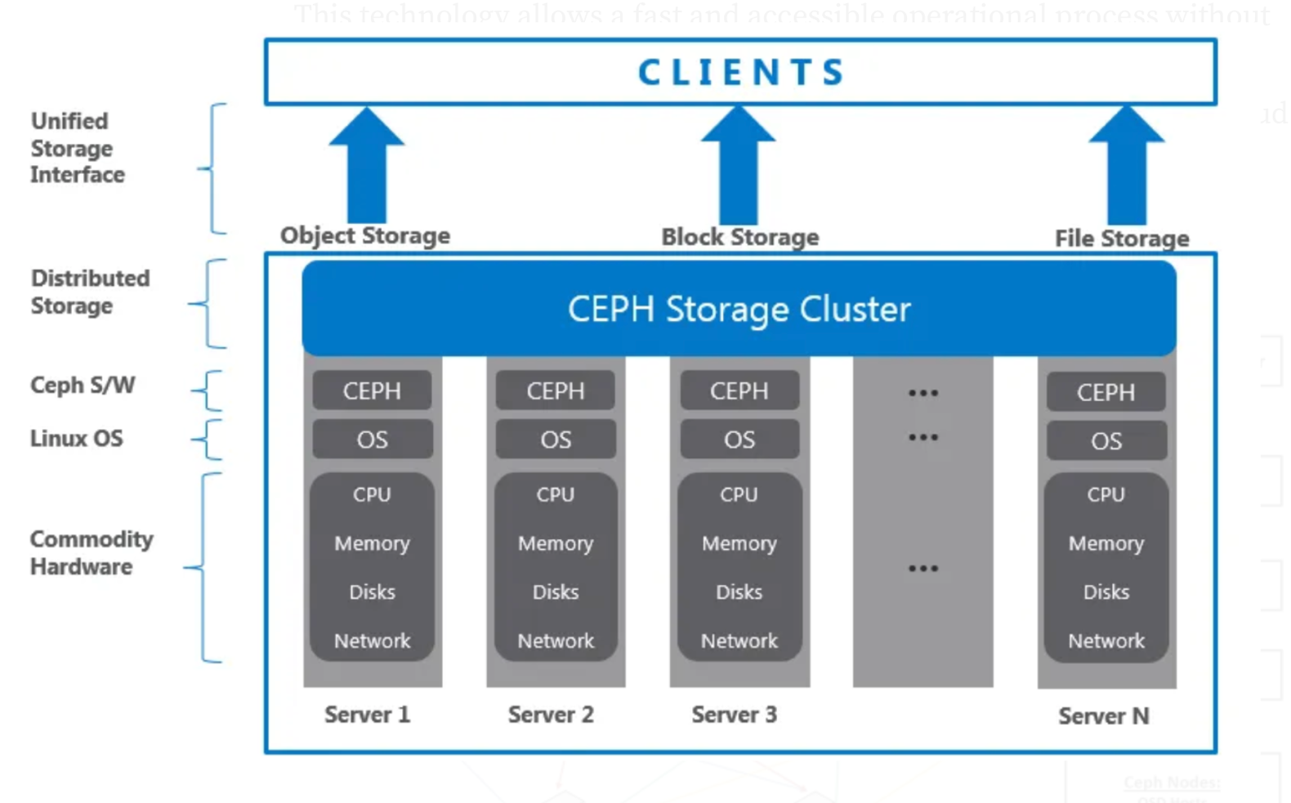

This all started with my desire to deploy various containers onto my Kubespray cluster.

- PostgreSQL
- MinIO
- Neo4J
- Apache Kafka using the Confluent deployment stack
- Apache Flink
- Apache Fluss (Incubating)
- Apache Iceberg
- Apache Paimon

For which some require a S3 based object storage, some requiring File system-based PVC storage and some just happy with a blob of PVC.

For the above I basically required what’s called a CSI driver/stack, CSI meaning Container Storage Interface allowing my Kubernetes cluster to use external persistent storage.

As my environment is all hosted as VM's on a Proxmox cluster and it itself includes CEPH... well that then lead to the below.

About my Environment

Below is a little overview of my lab.

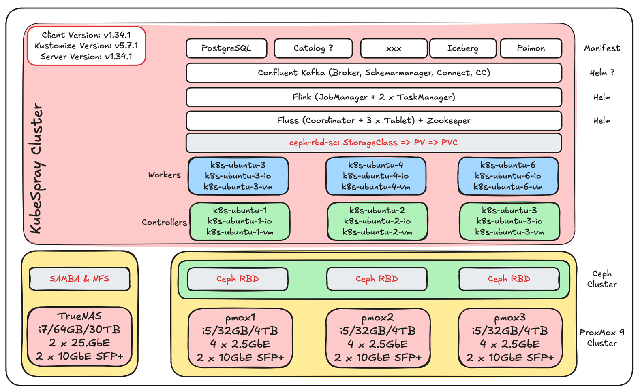

3 x minicomputers

- i5-1335U [12 x 13th Gen Intel(R) Core(TM) i5-1335U (1 Socket)]
- 32GB RAM,
- 4 TB NVMe card, partitioned into 60GB for Proxmox and balance, as per below

- pmox1
- 172.16.10.51 (bridge0, 2 x 2.5GbE)
- 172.16.40.51 (bridge1, 2 x 10GbE SFP+)
- pmox2
- 172.16.10.52
- 172.16.40.51
- pmox3
- 172.16.10.53
- 172.16.40.53

The base Hypervisor is Proxmox 9.0.11 configured into a HA Cluster.

I then configured a CEPH cluster using the Proxmox included CEPH capability. The CEPH cluster is configured with OSD's (think disks) using the remaining space from the NVME SSD's.

On this CEPH storage I then provisioned pools, (imgpool was created via the Proxmox CEPH GUI interface, the others via the below *_deploy.md documented steps).

- imgpool is used as the storage pool hosting the below 6 VM's images.
- k8s_pool for RBD - see rmd_deploy.md
- k8s_data - see cephfs_deploy.md
- k8s_metadata - see cephfs_deploy.md

To deploy me entire environment (and I rediscovered, due to my own fault, I by accident deleted my pool that host my VM images, using a master clone and Ansible is advantages).

Script as much as you can using Ansible, make notes in README.md 's files located your code directories, you will thank me later.

I build up a master image (Ubuntu 24.10), this is hosted/presented via an NFS mounted volume which is hosted on my TrueNAS

The master image was pre-configured with some users (ansible) and included the `ssh's key's` from my MBP, before a template was created.

This template image was then cloned into the following 6 VM's.

- 301 k8s-ubuntu-1 pmox1 master/control plane
- 172.16.10.71 (net0, Public Access, over bridge0)
- 172.16.30.71 (net1, K8S inter node comm, over bridge1)
- 172.16.40.71 (net2, IO comms, traffic between nodes and between nodes and the TrueNAS, over bridge1)

- 302 k8s-ubuntu-2 pmox2 master /control plane
- 172.16.10.72
- 172.16.30.72
- 172.16.40.72

- 303 k8s-ubuntu-3 pmox3 master /control plane
- 172.16.10.73
- 172.16.30.73
- 172.16.40.73

- 304 k8s-ubuntu-4 pmox1 worker
- 172.16.10.74
- 172.16.30.74
- 172.16.40.74

- 305 k8s-ubuntu-5 pmox2 worker
- 172.16.10.75
- 172.16.30.75
- 172.16.40.75

- 306 k8s-ubuntu-6 pmox3 worker
- 172.16.10.76
- 172.16.30.76
- 172.16.40.76

NOTE: for the Kubernetes and Ceph and MetalLB stack to work the above VM's need to be configured with processor as x86-63-v2

Each VM is configured with:

- 2 vCPU
- 4 GB RAM
- 20 GB disk

Once the 6 x VM's were up and running I then used Kubespray to deploy my Kubernetes cluster.

See: Setting up a Kubernetes cluster with Kubespray

At this point, we are now ready to deploy our Ceph CSI stack onto our Kubernetes cluster that will act as "client interface" allowing us use storage as available from the Proxmox hosted Ceph cluster. Allot of the "other" examples out on the interwebs want to show you how to deploy a CEPH cluster onto your Kubernetes cluster. I opted to rather "plug" into the one I already had.

Once you clone my project GIT repo, you will find 2 folders. You will see their names match up to the CEPH CSI GIT repo structure... read on you will see why.

So, between the 2 folders we have everything required to deploy the Ceph RBD and Ceph FS CSI drivers.

I've gone with a dedicated namespace for each. Quickly figured it out was not simple, deploying just one CSI stack, is easy, but as soon as you try both the RBD and Cephfs, you run into some fun, in the end I think the management would be simpler though.

The biggest thing, ye accurate copy/past'ing is important, hehehe and then the 2 directories each contain a values.yaml file, as included in the Ceph git repo for the Helm deployment. The biggest change in these files is the modification of the `container` and `service` ports numbers.

The trick in the end was to modify the container and service ports for the RBD CSI install onto ports 8082 and for Cephfs CSI install onto 8081.

I've decided to stick with the "suggested" namespaces, storage class and secret names:

Namespaces:

- ceph-csi-cephfs
- ceph-csi-rbd

Storageclass:

- csi-cephfs-sc
- csi-rbd-sc

Secrets:

The secrets I did decide to relocate into the dedicate respective namespace though, the base script normally deploys the secrets into the default namespace.

- csi-cephfs-secret
- csi-rbd-secret

### Deploying.

To deploy the stack, copy the contents of ceph-csi-cephfs into the ceph-csi/charts/ceph-csi-cephfs directory as located in the project GIT repo cloned and similarly copy the contents of ceph-csi-rbd into the ceph-csi/ceph-csi/rbd directory.

Now follow the rbd-deploy.md to deploy the RBD CSI stack and the cephfs-deploy.md to deploy the Cephfs CSI stack.

Once You done the above you will end with something that should look like this.

```
kubectl get sc
NAME PROVISIONER RECLAIMPOLICY VOLUMEBINDINGMODE ALLOWVOLUMEEXPANSION AGE
csi-cephfs-sc cephfs.csi.ceph.com Delete Immediate true 16h
csi-rbd-sc (default) rbd.csi.ceph.com Delete Immediate true 83s
kubectl get storageclass csi-rbd-sc -n ceph-csi-rbd
NAME PROVISIONER RECLAIMPOLICY VOLUMEBINDINGMODE ALLOWVOLUMEEXPANSION AGE
csi-rbd-sc (default) rbd.csi.ceph.com Delete Immediate true 3m40s

kubectl get pv
NAME CAPACITY ACCESS MODES RECLAIM POLICY STATUS CLAIM STORAGECLASS VOLUMEATTRIBUTESCLASS REASON AGE
pvc-724518f3-3207-435c-93ed-dd4a0a9c74ac 1Gi RWO Delete Bound ceph-csi-rbd/rbd-pvc csi-rbd-sc <unset> 3m35s
pvc-b08b5aaf-8b51-4f49-99d1-41f0ab9bc812 1Gi RWX Delete Bound ceph-csi-cephfs/cephfs-pvc csi-cephfs-sc <unset> 16h
```

Credits

While trying to figure out how to get the above done, and allot of searching, I could not find "exactly/perfectly" what I wanted.

But then I got lucky and found Ceph Storage Integration with Kubernetes using Ceph CSI by Satish Patel.

This got me going with the RBD CSI stack. Using this pattern and allot of trying, googling, trying again, claude'ing etc. I got the Cephfs figured out.

Summary

Hope I got it all accurately documented and copied, Hope it’s of benefit for someone.

Thanks for following. Till next time.



About Me

I’m a techie, a technologist, always curious, love data, have for as long as I can remember always worked with data in one form or the other, Database admin, Database product lead, data platforms architect, infrastructure architect hosting databases, backing it up, optimizing performance, accessing it. Data data data… it makes the world go round.

In recent years, pivoted into a more generic Technology Architect role, capable of full stack architecture.

George Leonard
georgelza@gmail.com
https://medium.com/@georgelza

