# From Kafka via Flink CDC Action framework, persisted into Apache Paimon on S3. – Part 3

IoT Data packaged in JSON format, serialized as Avro byte stream, pushed into Kafka Topic, extracted using Flink CDC, using Flink action framework & Stored into Apache Paimon.

(10 April 2025)

See [Part 2](https://medium.com/@georgelza/from-kafka-via-flink-cdc-action-framework-persisted-into-apache-paimon-on-s3-part-3-700a9ea71c6d) and [Part 1](https://medium.com/@georgelza/from-kafka-via-flink-cdc-action-framework-persisted-into-apache-paimon-on-s3-0da16bbaf378) for previous blog.

**Overview**

In a previous previous [blog](https://medium.com/@georgelza/from-mongodb-via-flink-cd-action-framework-persisted-into-apache-paimon-on-s3-008976cdbfff) we were inserting our JSON packaged IoT generated data into a MongoDB Collection and then using [Apache Flink’s flink_paimon_action](https://paimon.apache.org/docs/master/cdc-ingestion/overview/) framework to CDC source the data and sink (insert) it into a [Apache Paimon](https://paimon.apache.org/) database..

Last time we publish the same data onto a Confluent Kafka Topic and then utilize the [Apache Flink’s flink_paimon_action](https://paimon.apache.org/docs/master/cdc-ingestion/overview/) framework again to [CDC](https://en.wikipedia.org/wiki/Change_data_capture) source the payload directly out of our Topic and store it directly into [Apache Parquet](https://parquet.apache.org/) files stored in our [Apache Paimon](https://paimon.apache.org/) based table, written onto S3 Object storage provided via a [MinIO](https://min.io/) server. Only issue here was it was a simple JSON byte steam.

This all is very real-world type of IoT flow that you will run across. But we always want to make it better/faster/more optimized so…

So… This time we take the previous payload and “polish” it a bit. We will serialize it first using Avro. To do this we need to registry an Avro based schema and key on our Confluent Schema Registry.

Our data is again generated via a Python IoT program (located in *app_iot1/* and now containerized) created in the previous blog.

* The first *app_iot1* creates our simplest IoT JSON payload.
  + This is accomplished by setting *TSHUMAN, STRUCMOD & DEVICETYPE* = 0
* In *app_iot2* we extend the payload to include *TSHUMAN*=1 and *STRUCMOD*=1.
  + This adds a human readable date field and the location object to the metadata tag section.
* In *app_iot3* we go one step further and add *DEVICETYPE=1* to the payload.
  + This adds a text string defining the device type.

Showing the versatility of JSON for IoT data and the ability along our entire path from source to data store to accommodate the dynamic data structure.

For catalog services we will be using the [Apache Hive](https://hive.apache.org/)’s and their [Metastore](https://cwiki.apache.org/confluence/display/hive/design#Design-Metastore) functionality as created in a previous blogs (but with a little version update applied recently).

For those that have been following my previous blogs, you will notice I’ve upgraded my [Confluent](https://www.confluent.io/) Kafka Cluster (now 7.7.1) and the [Apache Flink](https://flink.apache.org/) environment (now 1.19.1). The [Apache Paimon](https://paimon.apache.org/) stack has also been upgraded to 0.9.0

As always, all the code can be found in the [GIT repository](https://github.com/georgelza/DataPipeline-KakfaPaimon-avro.git), and yes, we’re still using a substantial amount of Makefiles, Docker-compose.yml and Dockerfile’s.

I’ve decided not to digress as usual and do allot of other “things” like aggregation. We’ve demonstrated that a couple of times now.

Ok, back to why we’re here.

We will use our Python application to create a IoT data stream as if we’re reading sensors in factories fitted to machinery. These “[JSON](https://www.json.org/)” documents will be pushed onto our Kafka Topic called *factory_iot*. The topic “*key”* is set to the *siteId* of the various factories.

I grouped the factories into 3 sets, North, South and East. (simulating a sort of regional distribution).

We will then use the [Kafka CDC capability via the action frame](https://paimon.apache.org/docs/0.9/flink/cdc-ingestion/kafka-cdc/) to replicate this directly into an Apache Paimon Table.

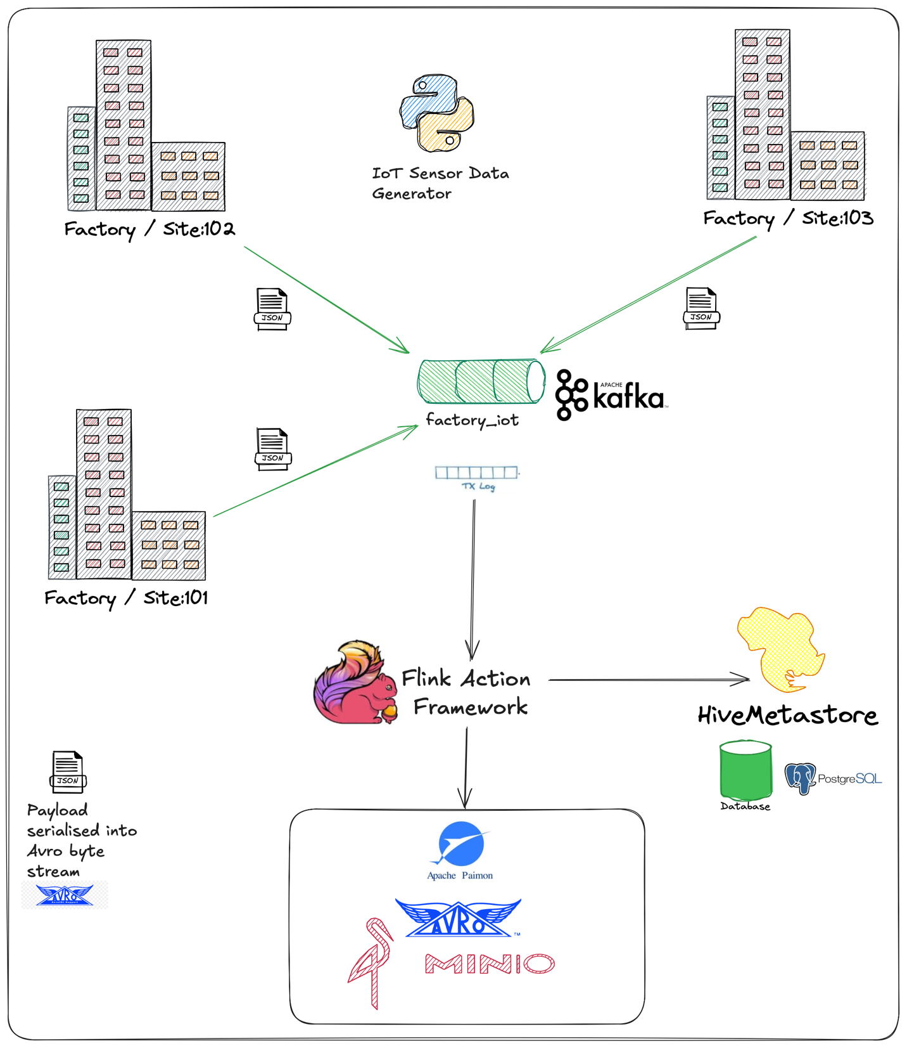

Once the scaffolding is build, this is it, and this is all of it. Not to running the stack, this is accomplished by executing the below in the following order.

* cd devlab
* make run leave it 30seconds - 1 min before executing the next command.
* make deploy
* cd creTopics
* ./creTopics.sh
* ./reg_key.sh
* ./reg_value.sh

Next:

First start by running *app_iot.* This can be done by running the containerized version (from with devlab by executing make rp1 ) or by executing ./run1.sh located in <root>/app_iot1/

This will start publishing our very simply payload as below onto our *factory_iot* topic.

(if you execute the app by running the bash script method you can run *app_iot2* & *app_iot3* similarly by running *run2.bsh* & *run3.bsh* from within *app_iot1* directory), otherwise you can run *app_iot2* and *app_iot3* by executing *make* *rp2* and *make* *rp3.* You can stop the apps using make *sp# #* being *1, 2* or *3.*

{

"ts" : 123421452622,

"siteId" : 1009,

"metadata" : {

"deviceId" : 1042,

"sensorId" : 10180,

"unit" : "Psi",

"ts_human" : "2024-10-02T00:00:00.869Z"

},

"measurement" : 1013.3997

}

This results in the below payload on our Kafka Topic.

Now let’s just have a look at that payload a bit first.

You will notice some differences from previous blog. We were required to modify how the original payload looked into what you see above and then how it is further packaged in our Python code.

This is all required to accommodate CDC fields required as part of the introduction of Avro Serialization of our payload and schema in combination with the utilization of the schema registry.

One of these being the requirement to move *siteId* to the root level as it is specified as the payload key and the addition of the “op” tag and defaulted to “c” implying create this record, all wrapped into a “before” and “after” blocks. As said… this is all to do with the introduction of the schema registry and Avro serialization… This “little” piece took me by far the longest to figure out (final bit was thanks to ChatGPT, hehehe we have to use what we have available) … in combination with the modified below /*opt/flink/bin/flink* command.

See *simulate.py lines 93 -> 120*

The next Note… and I’m not a Java guy, at all… by any stretch. Do take note of the additional jar files required to get all of this working vs the previous blog. This can be seen in *<root>/devlab/getlibs.sh*

Here I got to Thank :

[Giannis Polyzos](https://www.linkedin.com/in/polyzos/) - Staff Streaming Architect | [Fluss](https://www.ververica.com/blog/introducing-fluss) Lead @ [Ververica](https://www.ververica.com/) | Apache Flink &

[Jark Wu](https://www.linkedin.com/in/jarkwu/) - Head of [Fluss](https://www.ververica.com/blog/introducing-fluss) and Flink SQL at [Alibaba Cloud](https://www.alibabacloud.com/) ([Ververica](https://www.ververica.com/))

For the final <you missing this, you missing that….>

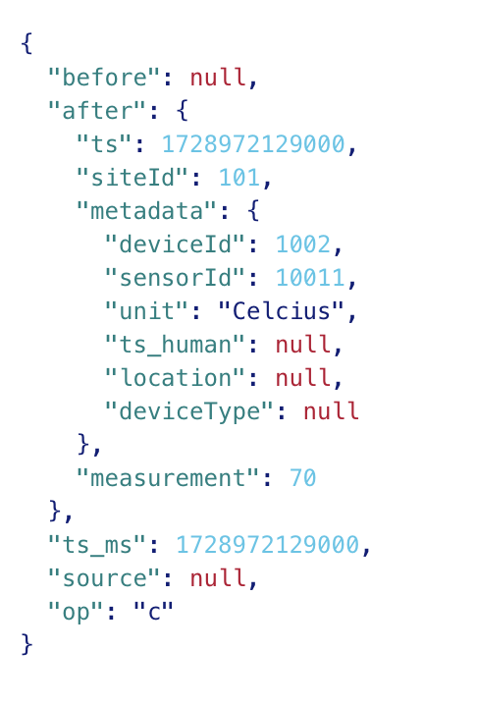

Once it is running then execute the below by executing *make jm* from within the *devlab* directory which will open up the Flink job manager and put you at the command line.

You can simply copy/paste the below and hit enter.

This will start our “subscribing” process on our source topic (*factory_iot)* and pushing the data into our target Apache Paimon database/table.

NOTE: Make sure to first start the data generator as per above so that when the below command is executed there is some shape of a payload with a structure to infer a schema from. If we don’t do it this way then we would first have had to create the table structure manually beforehand.

/opt/flink/bin/flink run \

/opt/flink/lib/paimon/paimon-flink-action-0.9.0.jar \

kafka_sync_table \

-Dexecution.checkpointing.interval=10s \

-Dexecution.checkpointing.num-retained=5 \

-Dstate.checkpoints.num-retained=10 \

-Dpipeline.name='sync-kafka-topic-to-paimon-s3' \

--kafka_conf properties.bootstrap.servers=broker:29092 \

--kafka_conf topic=factory_iot \

--kafka_conf value.format=debezium-avro \

--kafka_conf key.format=debezium-avro \

--kafka_conf key.field=siteId \

--kafka_conf properties.group.id=123456 \

--kafka_conf schema.registry.url=http://schema-registry:9081 \

--kafka_conf scan.startup.mode=earliest-offset \

--catalog_conf metastore=hive \

--catalog_conf uri=thrift://metastore:9083 \

--warehouse s3a://warehouse/paimon/ \

--database iot \

--table factory_iot \

--table_conf changelog-producer=input \

--table_conf write-mode=append-only \

--table_conf sink.parallelism=4

*NOTE:* even though the documentation does not call for *scan.startup.mode=earliest-offset* please do include it, even whensourcing a new topic.

Those that read the previous blogs will notice quite a couple of additional values required to get this working. This was all part of the introduction of using Avro Serialization and Schema Registry for our payload onto the Kafka Topic.

Ok, so this is funky. And simple. Let’s test schema evolution.

Execute the *app_iot2*. This as you would have seen above adds the *TSHUMAN* and *LOCATION* object to the payload.

{

"ts" : 123421452622,

"siteId" : 1009,

"metadata" : {

"deviceId" : 1042,

"sensorId" : 10180,

"unit" : "Psi",

"ts_human" : "2024-10-02T00:00:00.869Z",

"location": {

"latitude": -26.195246,

"longitude": 28.034088

}

},

"measurement" : 1013.3997

}

This results in the following payload on Topic.

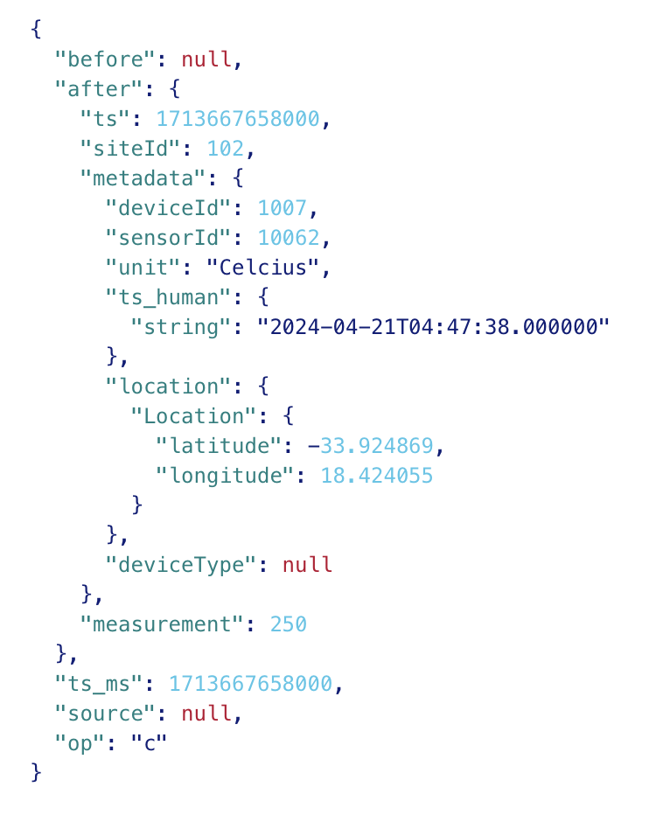

And lastly as we’re feeling very lucky, run *app_iot3* which will add the *DEVICETYPE* field to the metadata tag.

{

"timestamp" : "2024-10-02T00:00:00.869Z",

"siteId" : 1009,

"metadata" : {

"deviceId" : 1042,

"sensorId" : 10180,

"unit" : "Psi",

"ts_human" : "2024-10-02T00:00:00.869Z",

"location": {

"latitude": -26.195246,

"longitude": 28.034088

},

"deviceType" : "Oil Pump",

},

"measurement" : 1013.3997

}

Resulting in:

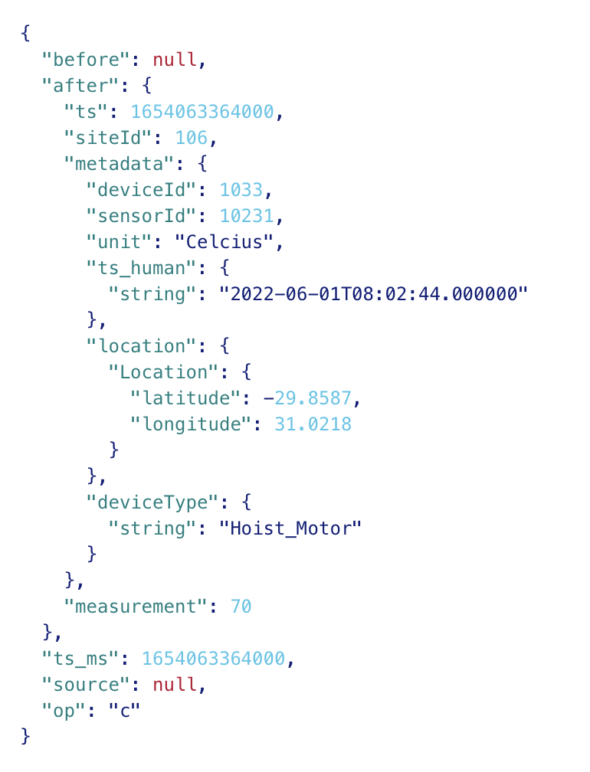

And that’s it… a very short blog compared to previous ;).

So, in summary, we build a data pipeline from Kafka Topic, that can handle schema evolution, have that data flow into our Apache Paimon data store stored as Apache Parquet files.

I think this is pretty neat… Hope you enjoyed the exploration.

Good luck, this is all fraught with rabbit holes, as always, so many and you can disappear so easily… but then that’s ½ the fun.



*Note: to execute this blog start with README.md located in the root folder and work from there, it will tell you exactly what to execute in which order to download all the dependencies and build everything.*

**About Me**

I’m a techie, a technologist, always curious, love data, have for as long as I can remember always worked with data in one form or the other, Database admin, Database product lead, data platforms architect, infrastructure architect hosting databases, backing it up, optimizing performance, accessing it. Data data data… it makes the world go round.

In recent years, pivoted into a more generic Technology Architect role, capable of full stack architecture.

[George Leonard](https://www.linkedin.com/in/george-leonard-945b502/)

[georgelza@gmail.com](mailto:georgelza@gmail.com)

<https://www.linkedin.com/in/george-leonard-945b502/>

<https://medium.com/@georgelza>