Deploying MinIO as Single Instance, Distributed using HELM or YAML onto Kubernetes

(18 Dec2025)

Overview

Ok, writing this one now, but it’s a weird one.

I did this work… as part of my lab, as a deployment component…but this was all done before MinIO
decided to put the project into maintenance mode. Still can’t believe it.

This is not going to be a long blog…

We have two deployment patterns:

- HELM based and
- YAML/Manifest based.

For both we have:

- single instance deployment &
- multi node, distributed deployment to provide a HA (High availability, resilient, fault tolerant)

This all started with my desire to deploy various containers onto my Kubespray cluster.

- MinIsO
- Ceph
- Apache Flink
- Apache Iceberg
- Apache Paimon
- Apache Fluss (incubating)
- Prometheus
- Grafana
- PostgreSQL
- Neo4J Graph Datastore
- MongoDB
- CockroachDB

I also have a MetalLB stack deployed to assist with routing inbound traffic.

Deploying:

Start by reading <Project root>/README.md

GIT REPO

Re my Lab Environment

Below is a little (he he) overview of my lab.

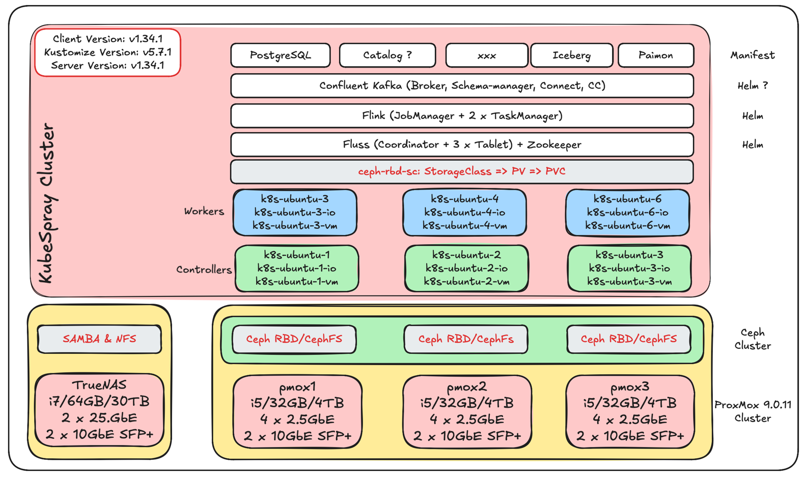

3 x minicomputers Topton, Soon to be x5

- i5-1335U [12 x 13th Gen Intel(R) Core (TM) i5-1335U (1 Socket)]
- 32GB RAM,
- 4 TB NVMe card, partitioned into 60GB for Proxmox and balance, as per below

pmox1
- 172.16.10.51 (bridge0, 2 x 2.5GbE)
- 172.16.40.51 (bridge1, 2 x 10GbE SFP+)

pmox2
- 172.16.10.52
- 172.16.40.51

pmox3
- 172.16.10.53
- 172.16.40.53

The base Hypervisor is Proxmox 9.0.11 configured into a HA Cluster.

I then configured a CEPH cluster using the Proxmox included CEPH capability. The CEPH cluster is configured with OSD's (think disks) using the remaining space from the NVME SSD's.

On this CEPH storage I then provisioned pools, (imgpool was created via the Proxmox CEPH GUI interface, the others via the below *_deploy.md documented steps).

- imgpool is used as the storage pool hosting the below 6 VM's images.
- k8s_pool for RBD - see rbd_deploy.md
- k8s_data - see cephfs_deploy.md
- k8s_metadata - see cephfs_deploy.md

To deploy me entire environment (and I rediscovered, due to my own fault, I by accident deleted my pool that host my VM images, using a master clone and Ansible is advantages).

Script as much as you can using Ansible, make notes in README.md 's files located your code directories, you will thank me later.

I build up a master image (Ubuntu 24.10), this is hosted/presented via an NFS mounted volume which is hosted on my TrueNAS

The master image was pre-configured with some users (ansible) and included the `ssh's key's` from my MBP, before a template was created.

This template image was then cloned into the following 9 VM's.

3 x Master
6 x Worker, was originally 3, but as I needed 4 workers for MinIO distributed deployment I ended extending the cluster with additional VM’s, pretty easy once you have the Ansible scripts.

301 k8s-ubuntu-1 hosted on pmox1 as a master
- 172.16.10.71 (net0, Public Access, over bridge0)
- 172.16.30.71 (net1, K8S inter node comm, over bridge1)
- 172.16.40.71 (net2, IO comms, traffic between nodes and between nodes and the TrueNAS, over bridge1)

302 k8s-ubuntu-2 hosted on pmox2 as a master
- 172.16.10.72
- 172.16.30.72
- 172.16.40.72

303 k8s-ubuntu-3 hosted on pmox3 as a master
- 172.16.10.73
- 172.16.30.73
- 172.16.40.73

304 k8s-ubuntu-4 hosted on pmox1 as a worker
- 172.16.10.74
- 172.16.30.74
- 172.16.40.74

305 k8s-ubuntu-5 hosted on pmox2 as a worker
- 172.16.10.75
- 172.16.30.75
- 172.16.40.75

306 k8s-ubuntu-6 hosted on pmox3 as a worker
- 172.16.10.76
- 172.16.30.76
- 172.16.40.76

307 k8s-ubuntu-7 hosted on pmox1 as a worker
- 172.16.10.77
- 172.16.30.77
- 172.16.40.77

308 k8s-ubuntu-8 hosted on pmox2 as a worker
- 172.16.10.78
- 172.16.30.78
- 172.16.40.78

309 k8s-ubuntu-9 hosted on pmox3 as a worker
- 172.16.10.79
- 172.16.30.79
- 172.16.40.79

/etc/hosts

172.16.10.51 pmox1.<domain>.com pmox1
172.16.30.51 pmox1-vm.<domain>.com pmox1-vm
172.16.40.51 pmox1-io.<domain>.com pmox1-io

172.16.10.52 pmox2.<domain>.com pmox2
172.16.30.52 pmox2-vm.<domain>.com pmox2-vm
172.16.40.52 pmox2-io.<domain>.com pmox2-io

172.16.10.53 pmox3.<domain>.com pmox3
172.16.30.53 pmox3-vm.<domain>.com pmox3-vm
172.16.40.53 pmox3-io.<domain>.com pmox3-io

172.16.10.24 vaultx.<domain>.com vaultx
172.16.40.24 vaultx-io.<domain>.com vaultx-io

# Kubespray Prd Cluster
172.16.10.61 ubuntu-1.<domain>.com ubuntu-1
172.16.30.61 ubuntu-1-vm.<domain>.com ubuntu-1-vm
172.16.40.61 ubuntu-1-io.<domain>.com ubuntu-1-io

172.16.10.62 ubuntu-2.<domain>.com ubuntu-2
172.16.30.62 ubuntu-2-vm.<domain>.com ubuntu-2-vm
172.16.40.62 ubuntu-2-io.<domain>.com ubuntu-2-io

172.16.10.71 k8s-ubuntu-1.<domain>.com k8s-ubuntu-1
172.16.30.71 k8s-ubuntu-1-vm.<domain>.com k8s-ubuntu-1-vm
172.16.40.71 k8s-ubuntu-1-io.<domain>.com k8s-ubuntu-1-io

172.16.10.72 k8s-ubuntu-2.<domain>.com k8s-ubuntu-2
172.16.30.72 k8s-ubuntu-2-vm.<domain>.com k8s-ubuntu-2-vm
172.16.40.72 k8s-ubuntu-2-io.<domain>.com k8s-ubuntu-2-io

172.16.10.73 k8s-ubuntu-3.<domain>.com k8s-ubuntu-3
172.16.30.73 k8s-ubuntu-3-vm.<domain>.com k8s-ubuntu-3-vm
172.16.40.73 k8s-ubuntu-3-io.<domain>.com k8s-ubuntu-3-io

172.16.10.74 k8s-ubuntu-4.<domain>.com k8s-ubuntu-4
172.16.30.74 k8s-ubuntu-4-vm.<domain>.com k8s-ubuntu-4-vm
172.16.40.74 k8s-ubuntu-4-io.<domain>.com k8s-ubuntu-4-io

172.16.10.75 k8s-ubuntu-5.<domain>.com k8s-ubuntu-5
172.16.30.75 k8s-ubuntu-5-vm.<domain>.com k8s-ubuntu-5-vm
172.16.40.75 k8s-ubuntu-5-io.<domain>.com k8s-ubuntu-5-io

172.16.10.76 k8s-ubuntu-6.<domain>.com k8s-ubuntu-6
172.16.30.76 k8s-ubuntu-6-vm.<domain>.com k8s-ubuntu-6-vm
172.16.40.76 k8s-ubuntu-6-io.<domain>.com k8s-ubuntu-6-io

172.16.10.77 k8s-ubuntu-7.<domain>.com k8s-ubuntu-7
172.16.30.77 k8s-ubuntu-7-vm.<domain>.com k8s-ubuntu-7-vm
172.16.40.77 k8s-ubuntu-7-io.<domain>.com k8s-ubuntu-7-io

172.16.10.78 k8s-ubuntu-8.<domain>.com k8s-ubuntu-8
172.16.30.78 k8s-ubuntu-8-vm.<domain>.com k8s-ubuntu-8-vm
172.16.40.78 k8s-ubuntu-8-io.<domain>.com k8s-ubuntu-8-io

172.16.10.79 k8s-ubuntu-9.<domain>.com k8s-ubuntu-9
172.16.30.79 k8s-ubuntu-9-vm.<domain>.com k8s-ubuntu-9-vm
172.16.40.79 k8s-ubuntu-9-io.<domain>.com k8s-ubuntu-9-io

NOTE: for the Kubernetes, Ceph and MetalLB stack to work the above VM's need to be configured with processor as x86-63-v2

Each Master node VM is configured with:

- 2 vCPU
- 4 GB RAM
- 20 GB disk

Each Worker node VM is configured with:

- 4 vCPU
- 16 GB RAM
- 20 GB disk

Once the 9 x VM's were up and running I then used Kubespray to deploy my Kubernetes cluster.

See: Setting up a Kubernetes cluster with Kubespray

Summary

Well, hope I got it all accurately documented and copied, Hope it’s of benefit for someone.

Thanks for following. Till next time.



And like that we're done with our little trip down another Rabbit Hole.



Credits

While trying to figure out how to get the above done, and allot of searching, I could not find "exactly/perfectly" what I wanted.

But then I got lucky and found Ceph Storage Integration with Kubernetes using Ceph CSI by Satish Patel.

This got me going with the RBD CSI stack. Using this pattern and allot of trying, googling, trying again, claude'ing etc. I got the Cephfs figured out.

About Me

I’m a techie, a technologist, always curious, love data, have for as long as I can remember always worked with data in one form or the other, Database admin, Database product lead, data platforms architect, infrastructure architect hosting databases, backing it up, optimizing performance, accessing it. Data data data… it makes the world go round.

In recent years, pivoted into a more generic Technology Architect role, capable of full stack architecture.

George Leonard
georgelza@gmail.com
https://medium.com/@georgelza



