Apache Iceberg and Apache Paimon utilizing JDBC based Catalog with PostgreSQL for Persistence.

(217Dec2025)

Overview

Just decided, want to see what’s involved to configure a Unified Catalog for an Apache Flink environment.

Allowing me to create catalogs for Apache Iceberg and Apache Paimon tables using Apache Flink’s JDBC catalog ('catalog-impl' = 'org.apache.iceberg.jdbc.JdbcCatalog') capability.

What follows is the result, after well, a fair amount of figuring out what’s required and what’s not. What to be configured and where.

This is all part of a bigger trip down the rabbit hole, which ended sidetracking me into this little exploration of Apache Flink Catalogs and how to configure them based on our Open Table Format selected.

As per a Google Search:

Open table formats (OTFs) like Delta Lake, Apache Iceberg, and Apache Hudi are metadata layers that bring database-like structure, reliability (ACID transactions, schema enforcement, time travel) to data lakes, sitting on top of data files (like Parquet/ORC) in object storage, enabling efficient management, faster queries, and multi-engine access for big data analytics. They manage file organization, schema evolution, and data history, effectively turning raw files into queryable tables.

As always the code can be found at: GIT REPO

Regarding our environment.

Below are 2 diagrams, showing our Shadowtraffic -> PostgreSQL -> Apache Flink -> ending in either Apache Iceberg or Apache Paimon tables store on an MinIO Object store…

Apache Iceberg

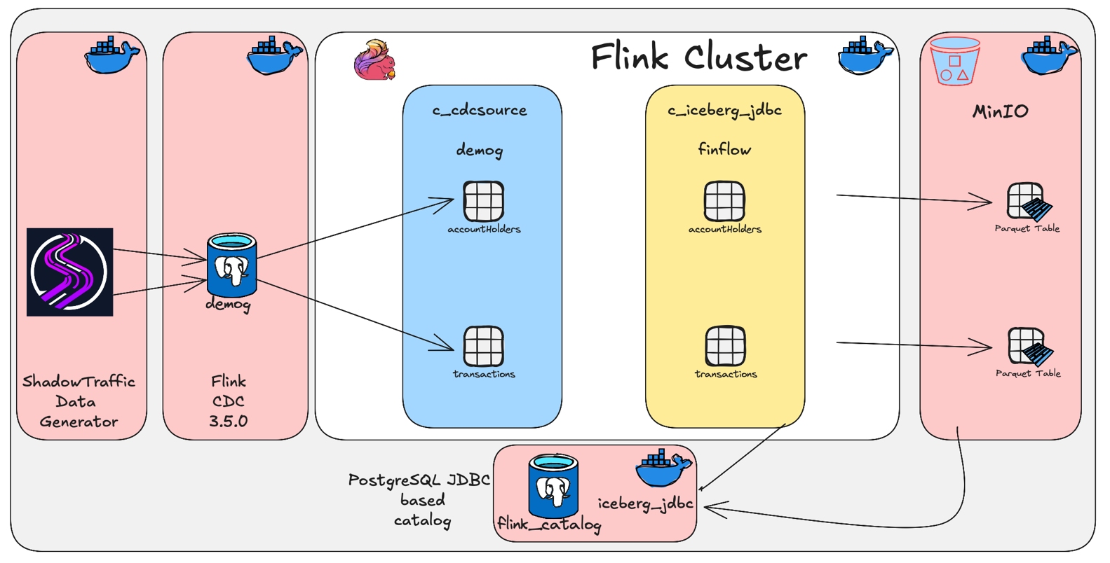

Apache Paimon

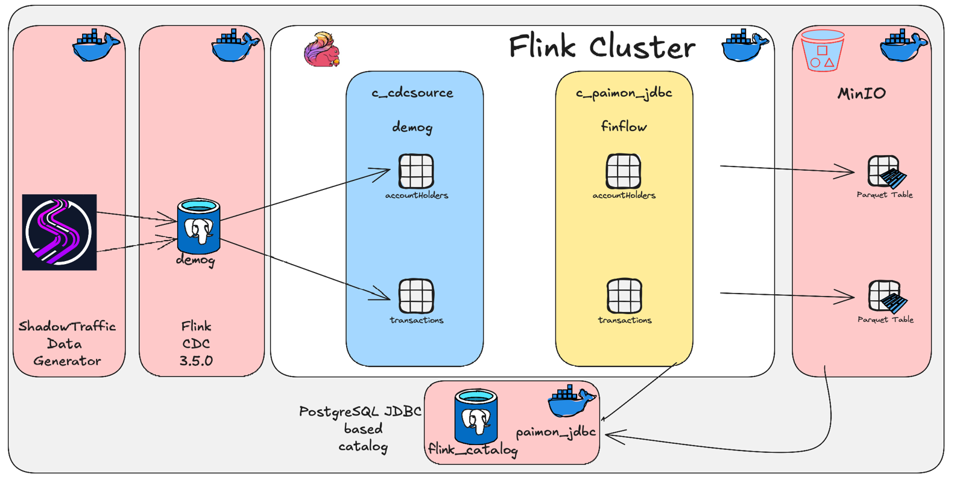

As you will notice, they are pretty much identical. The primary difference being the catalog name and the backing PostgreSQL scheme names.

We will be creating an inbound data stream utilizing Shadowtraffic. These records will be inserted into a PostgreSQL backed database (demog) into 2 tables:

- AccountHolders
- Transactions

For the Shadowtraffic generator see: <Project Root/shadowtraffic/conf/config.json>.

We will then use Apache Flink CDC consume (or it can be thought of made visible) these records.

For the above two PostgreSQL tables, we will create Flink CDC sourced copies in a Apache Flink Generic_inmemory catalog called c_cdcsource, containing a database called demog.

We will have two set of tables, one to be used by our Iceberg pipeline and one for the Paimon pipeline:
- accountHolders_iceberg
- transations_iceberg
and
- accountHolders_paimon
- transations_paimon

Next up we will create 2 catalogs.

One for our Apache Iceberg environment (c_iceberg_jdbc), configured to store the data on an MinIO based object store (warehouse/iceberg_jdbc) and one for our Apache Paimon environment (c_paimon_jdbc), configured to store the data on the same MinIO based object store (warehouse/paimon_jdbc).

- Apache Iceberg catalog (c_iceberg_jdbc)
- Apache Paimon catalog (c_paimon_jdbc)

Ok, that’s what we want to do…

How do we do this, well first, we need to build our Apache Flink container used to run the Jobmanager and Taskmanager with the correct JAR modules.

And this is where the Jar Jar tango happens… in between reading allot of blogs.. (The best being by Robbin Moffat, see: <Project root/README.md, Appendix>) and a fair amount of Claud AI questions, and when I ran out of tokens there I used Gemini, but eventually we worked through the errors and got the perfect combination of JAR files specified, the Goldie lox combination.

The next part of this was also providing the Apache Flink stack with the correct “credentials” where required. This all was primarily around the S3 credentials and configuration values.

This requirement ended being:

- /opt/flink/conf/core-site.xml with the relevant MinIO / S3 credentials

- <Project root/devlab/>/Docker-compose.yaml with the S3 credentials in the Jobmanager and Taskmanager service, correctly specified using the s3a.* syntax, and also telling Jobmanager and taskmanager to use the above core-site.xml

- And then lastly providing the credentials again, in the correct format when we created the catalog’s (see: <Project root>/devlab/creFlinkFlows/1.1creCat.sql).

Apache Iceberg Catalog create and finflow database create.

-- Apache Iceberg based catalog stored inside PostgreSQL database using JDBC interface
-------------------------------------------------------------------------------------------------------------------------
-- server: postgrescat
-- db: flink_catalog
-- schema: iceberg_jdbc

CREATE CATALOG c_iceberg_jdbc WITH (
'type' = 'iceberg'
,'catalog-impl' = 'org.apache.iceberg.jdbc.JdbcCatalog'

-- PostgreSQL connection details
,'uri' = 'jdbc:postgresql://postgrescat:5432/flink_catalog?currentSchema=iceberg_jdbc'
,'jdbc.user' = 'dbadmin'
,'jdbc.password' = 'dbpassword'
,'jdbc.driver' = 'org.postgresql.Driver'

-- Data warehouse location (can be S3, HDFS, or local)
,'warehouse' = 's3a://warehouse/iceberg_jdbc'

-- S3 connection details / For Iceberg we need to use s3a.* in combination with specific jar files. Ask Robin Moffat re Jar files ;(
,'s3a.endpoint' = 'http://minio:9000'
,'s3a.access-key-id' = 'mnadmin'
,'s3a.secret-access-key' = 'mnpassword'
,'s3a.path-style-access' = 'true'

,'table-default.file.format' = 'parquet'
);

USE CATALOG c_iceberg_jdbc;
CREATE DATABASE IF NOT EXISTS c_iceberg_jdbc.finflow;

Apache Paimon Catalog create and finflow database create.

-- Apache Paimon based catalog stored inside PostgreSQL database using JDBC interface
-------------------------------------------------------------------------------------------------------------------------
-- server: postgrescat
-- db: flink_catalog
-- schema: paimon_jdbc
CREATE CATALOG c_paimon_jdbc WITH (
'type' = 'paimon'
,'metastore' = 'jdbc' -- JDBC Based Catalog

-- PostgreSQL connection details
,'catalog-key' = 'jdbc'
,'uri' = 'jdbc:postgresql://postgrescat:5432/flink_catalog?currentSchema=paimon_jdbc'
,'jdbc.user' = 'dbadmin'
,'jdbc.password' = 'dbpassword'
,'jdbc.driver' = 'org.postgresql.Driver'

-- Data warehouse location (can be S3, HDFS, or local)
,'warehouse' = 's3://warehouse/paimon_jdbc' -- bucket / datastore

-- S3 connection details
,'s3.endpoint' = 'http://minio:900'
,'s3.access-key-id' = 'mnadmin'
,'s3.secret-access-key' = 'mnpassword'
,'s3.path-style-access' =' true'

,'table-default.file.format' = 'parquet'
);

USE CATALOG c_paimon_jdbc;
CREATE DATABASE IF NOT EXISTS c_paimon_jdbc.finflow;

In each of these two catalogs we will then create a finflow database in which we will then create 2 tables (See: <Project root>/devlab/creFlinkFlows/2.1creCDC.sql).

- AccountHolders
- Transactions

The tables will be created using CTAS syntax (Create Table as Select), and as such this will also create our Apache Flink jobs that will move all new inbound data from our c_cdcsource/demog/* tables into the c_<iceberg or paimon>_jdbc/finflow/ based tables. (See: <Project Root/devlab/creFlinkFlows/3.2.creTarget.sql)

To run all of this. Start by reading <Project root/README.md>

Things to take note of:

- <Project root>/infrastructure/README.md
- <Project root>/infrastructure/flink/README.md

You will notice we are using two PostgreSQL databases, one as the data target/data store, referred to as postgrecdc in our <Project root/devlab/docker-compose.yaml file and the 2nd being our datastore (db: flink_catalog) in which we create the two schema’s for our two catalogs. See: docker-compose.yaml service => postgrecat

For each of these two databases see the <Project root>/devlab/sql/<dbname>/postgresql-init.sql scripts which is executed as part of the bootstrap process when the container service is started. We use this process to create our users and assign the required permissions.

Also pay attention to the fs.s3a.* values at the end of <Project root>/devlab/conf/config.yaml.

# The s3a is specifically required by Iceberg, Paimon is happy to wrk with s3
fs:
s3a:
access.key: mnadmin
secret.key: mnpassword
endpoint: http://minio:9000
path:
style:
access: true
connection:
ssl:
enabled: false
impl: org.apache.hadoop.fs.s3a.S3AFileSystem
aws:
credentials:
provider: org.apache.hadoop.fs.s3a.SimpleAWSCredentialsProvider

Summary

Well, hope I got it all accurately documented and copied, Hope it’s of benefit for someone.

Thanks for following. Till next time.



And like that we're done with our little trip down another Rabbit Hole.



About Me

I’m a techie, a technologist, always curious, love data, have for as long as I can remember always worked with data in one form or the other, Database admin, Database product lead, data platforms architect, infrastructure architect hosting databases, backing it up, optimizing performance, accessing it. Data data data… it makes the world go round.

In recent years, pivoted into a more generic Technology Architect role, capable of full stack architecture.

George Leonard
georgelza@gmail.com
https://medium.com/@georgelza



