Apache Iceberg with Apache Polaris as Catalog with PostgreSQL for Persistence & MinIO Object store.

(18 Dec2025)

Overview

The following is a little explore of Apache Polaris (incubating) as a Catalog store for Lakehouse environments, primarily an Apache Iceberg catalog store.

First: What is Apache Polaris and what’s does it do for us

Apache Polaris is a catalog for data lakes. It provides new levels of choice, flexibility and control over data, with full enterprise security and Apache Iceberg interoperability across a multitude of engines and infrastructure. Apache Polaris builds on standards such as those created by Apache Iceberg, providing the following benefits for the ecosystem:

- Multi-engine interoperability over a single copy of data, eliminating the need for moving and copying data across different engines and catalogs.
- An interoperable security model providing a unified authorization layer independent from the engines processing analytical tables.
- For multi-catalog scenarios, a unified catalog level view of data across multiple catalogs via catalog notification integrations.
- The ability to host Polaris Catalog on the infrastructure of your choice.

Above abstract as from: PolarisProposal

Now back to our scheduled programming: ;)

The requirement originally started with me creating an application which created two data products using ShadowTraffic.

- accountholders
- transactions

These data products are inserted into our PostgreSQL database called demog, which is hosted by our postgrescdc docker-compose based service.

The plan is then to consume this data stream from PostgreSQL into Apache Flink using the Apache Flink CDC framework This is accomplished by defining 2 tables inside Apache Flink, referencing our Postgres database/tables.

From here we can then work with this data. This would normally be via either Java based jobs, Python based jobs via PyFlink framework or using Apache Flink SQL.

The output of these processing steps are records insert into a Lakehouse tables, referred to as an Open Table Formats, the most popular being:

- Apache Iceberg
- Apache Paimon
- Apache Hudi
- Delta Lake

Now, a phone book, ye I'm old enough to know what they looked like was useless without the index at the back. That index was a sort of catalog of the records contained in the book.

The index in the back was our "reference" of what tables/records are in our book and where to find them.

And that’s what a catalog does for us, it keeps track of our tables, their structures, storage location, access rules, other words, metadata etc.

All this allows one user to create tables inside a database in one session and makes this available to another user in a different session to access that table and the contents, using the processing engine of choice.

In the past, I always used Hive Metastore (HMS), see Central Metastore Catalog. But let’s see, I like Rabbit holes so decided to mix things up a bit, or was that I wanted to simplify the stack (HMS is tech heavy), and here we are, lets introduce Apache Polaris (incubating) and it's REST interface as Catalog service for our Apache Iceberg based Lakehouse.

What is a Lakehouse

A data lakehouse is a modern data architecture blending the flexibility and low-cost storage of a data lake with the structure, performance, and management features of a data warehouse, creating a unified platform for diverse data types and workloads like BI, SQL, data science, and machine learning, all from one central repository.

It achieves this by using open formats (like Delta Lake, Apache Iceberg, Apache Hudi) on top of object storage, adding database-like capabilities (transactions, schema enforcement) for reliability and quality.

Key Components & Features:

- Unified Storage: Stores structured, semi-structured, and unstructured data together, eliminating silos.
- Data Lake Benefits: Low-cost, scalable storage (e.g., cloud object storage) and flexibility for raw data.
- Data Warehouse Benefits: ACID (atomicity, consistency, isolation, durability) transactions, schema enforcement, data quality, and performance for BI.
- Open Formats: Uses open standards (Apache Iceberg, Delta Lake, Apache Hudi) for interoperability and avoiding vendor lock-in.
- Decoupled Compute & Storage: Allows independent scaling of processing power and storage.
- Diverse Workloads: Supports SQL analytics, BI, data science, and machine learning on the same data.

Benefits:

- Simplified Architecture: Replaces complex multi-tiered systems with a single source of truth.
- Reduced Costs: Lowers ETL, data duplication, and storage expenses.
- Improved Governance: Easier to manage security and data quality centrally.
- Faster Insights: Enables real-time streaming and quicker access to refined data.

About Apache Polaris (incubating)

Some background on Apache Polaris (incubating) first, Polaris is an open-source project donated to the community by Snowflake.

Apache Polaris (incubating) was initially created by engineers at Snowflake who open-sourced the technology in June 2024 and contributed it to the Apache Software Foundation for incubation. Dremio was an original co-creator and has been a leading contributor to the project since its inception.

The project is now a community-driven open-source initiative under the Apache Software Foundation, with contributions from a diverse group of companies including AWS, Google Cloud, Azure, Stripe, IBM, and others.

Key individuals involved in writing and authoring guides on Apache Polaris (incubating) include:

- Alex Merced (Head of Developer Relations at Dremio a primary author of the O'Reilly book Apache Polaris: The Definitive Guide.
- Andrew Madson and Tomer Shiran (Founder and Chief Product Officer of Dremio) are also listed as co-authors of the definitive guide.

As per previous, Apache Polaris (incubating) is primarily an Apache Iceberg table format catalog, but does offer `Generic Table` functionality, enabling it to store metadata for tables other than Apache Iceberg (see: What is a Generic Table?).

Also critical is catalog persistence. Apache Polaris (incubating) just happens to natively include every to interface with PostgreSQL.

BLOG: []()

GIT REPO: Polaris_Pg_Flink

NOTE: this project is built on the back of Open Table Formats (Apache Iceberg and Apache Paimon) with JDBC based Catalog backed by PostgreSQL for Persistence where we figured out what Jar file combination we need for Apache Flink/Apache Iceberg/MinIO to work together.

About our Stack:

Overview

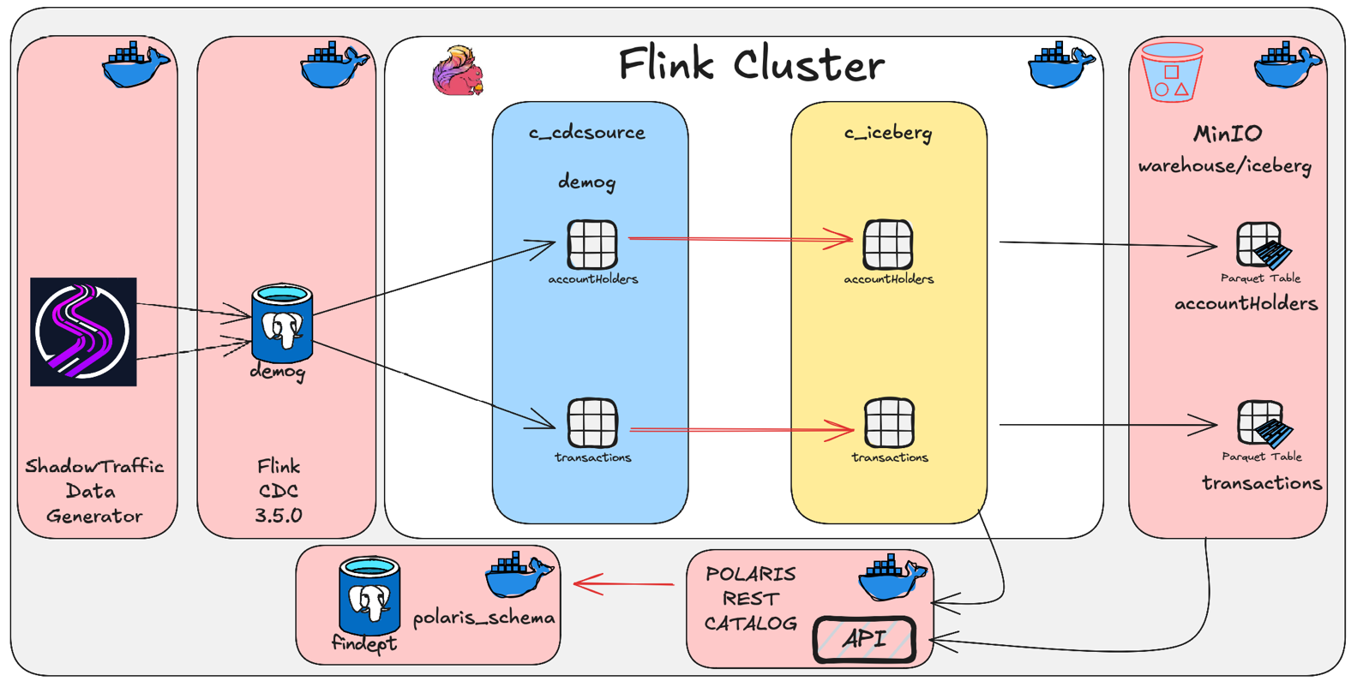

The stack goes through 3 phases, if we can call it that:

- Build the minimum environment to get our Apache Polaris (incubating) catalog up, with the PostgreSQL backend datastore and MinIO configured/integrated.
- Add to this minimal stack our Apache Flink 1.20.1 cluster, enabling us to define our catalog, create a Flink database and create tables inside our database homed inside our catalog.
- Run our data generation utilizing Shadowtraffic, providing us with a data stream into a PostgreSQL datastore, which we will CDC source and move around.

NOTES

Take note of the s3a:// usage when referring to our MinIO Object store locations. This is defined in our:

- Docker-compose.yaml file for the Jobmanager and Taskmanager service configuration.
- Docker-compose.yaml file for the polaris-setup service configuration.
- In the Apache Flink configuration file as part of the fs.s3a.* parameters, (see: <Project root>/devlab/conf/config.yaml)
- Part of our Apache Flink Container build, (see: <Project root>/infrastructure/flink/Dockerfile), we create FLINK_HOME/conf/core-site.xml where we specify our s3 configuration and credentials.
- Our Apache Flink catalog create, where we specify, we will be using a REST based catalog (see: <Project root>/devlab/creFlinkFlows/1.1.creCat.sql)

Building and running the environment

You're reading this file, under this directory is our devlab, infrastructure and shadowtraffic sub directories.

- <Project root>/devlab contains all our code to run the project.
- <Project>/infrastructure is where our Dockerfile’s are located to build the environment, in addition to Makefiles that can be used to docker pull our base containers and wget additional jar modules.
- <Project root>/shadowtraffic contains our data generator/config file.

You will also find a configuration file used to provide various environment variables as used by our <Project root>/devlab/Docker-compose.yaml projects in <Project root>/devlab/.env

Our environment can be built and brough online using <Project root>/devlab/Makefile

The first time you start the project, we need to pull and build the required containers, this can be done by:

1. via devlab ...

- cd ../devlab
- make build

or

2. via infrastructure ...

- cd infrastructure
- make pull_base
- make pull
- make build

At this point we can start up the minimum environment to make sure our Polaris/Postgres and MinIO is working, or the full stack which adds the Apache Flink cluster.

Run the Stack

1. Minimal Environment (Polaris, Postgres & MinIO)

This will use <Project Root>/devlab/docker-compose-basic.yml Docker Compose file.

- make run_base
- ... look around
- make down

2. Full Environment (Polaris, Flink, Postgres and MinIO),

This will use <Project Root>/devlab/docker-compose-flink.yml Docker Compose file.

- make run
- run ShadowTraffic data generator,
(see <Project root>/shadowtraffic/run_pg.sh)
- Create our c_iceberg Apache Polaris REST based catalog,
(see: <Project root>/devlab/creFlinkFlows/1.1creCat.sql)
- Create our two Apache Flink CDC sourced tables: accountHolders and transactions, to be located in c_cdcsource catalog which is an Apache Flink Generic in memory catalog, demog database),
(see: <Project root>/devlab/creFlinkFlows/1.1creCDC.sql)
- Execute Flink SQL to move the data from the CDC source tables into our Apache Iceberg tables (to be located in the c_iceberg catalog in the finflow database), configured with persistent storage on our MinIO object storage service, aka S3 service.
This is accomplished using the Apache Flink SQL using the CTAS (Create Table as Select) pattern,
(see: <Project root>/devlab/creFlinkFlows/1.1creTarget.sql).
- … look around
- make down

Notes

During the startup cycle of our PostgreSQL datastore's, they will go through their standard bootstrap process which happens to include creating a database.

If you want to create some personal bits, modify this process then you are able to place your desired SQL inside postgresql-init.sql which is mapped/mounted into the PostgreSQL container and run at startup.

For our datastore as used by Shadowtraffic, I've placed table create SQL in the above script (postgresql-init.sql) which creates the below two tables, they will be used as target tables for ShadowTraffic and also be our source tables for Apache Flink CDC (note, I could have opted not to have ShadowTraffic create these tables itself, but I like to do things more in line with how things happen in a production realm), as such we create them using the above postgresql-init.sql script.

For now, these tables are located in a database called demog inside the public schema in our postgrecdc docker compose service.

- accountholders
- transactions

To create our c_iceberg REST based Apache Polaris catalog, see the below:

-- Apache Iceberg based REST Catalog stored inside PostgreSQL database using Polaris as catalog store
-------------------------------------------------------------------------------------------------------------------------
-- server: postgrescat
-- db: findept
-- schema: polaris_schema
CREATE CATALOG c_iceberg WITH (
'type' = 'iceberg'
,'catalog-type' = 'rest'
,'uri' = 'http://polaris:8181/api/catalog'
,'warehouse' = 'icebergcat'
,'oauth2-server-uri' = 'http://polaris:8181/api/catalog/v1/oauth/tokens'
,'credential' = 'root:s3cr3t'
,'scope' = 'PRINCIPAL_ROLE:ALL'
,'s3a.endpoint' = 'http://minio:9000'
,'s3a.access-key-id' = 'mnadmin'
,'s3a.secret-access-key' = 'mnpassword'
,'s3a.path-style-access' = 'true'
,'table-default.file.format' = 'parquet'
);

USE CATALOG c_iceberg;
CREATE DATABASE IF NOT EXISTS c_iceberg.finflow;

Take NOTE:

See the <polaris-setup> service as defined in the <Project root>/devlab/docker-compose.yaml file. The service defines the bootstrap properties pushed into the below scripts.

This service itself calls <<Project root>/devlab/conf/polaris/

- createcatalog.sh
- obtain-token.sh

Part of this process includes creating basic Apache Polaris roles, users and assigning basic permissions.

Management interfaces

- Polaris: http://localhost:8181 (Client API)
- Polaris: http://localhost:8181 (Management API)
- Flink UI: http://localhost:8084 (Console)
- MinIO API: http://localhost:9000 (Client API)
- MinIO UI: http://localhost:9001 (Console, mnadmin/mnpassword)

Software/package versions

The following stack is deployed using one of the provided <Project Root>/devlab/docker-compose-<basic or flink>.yaml files as per above.

- Apache Polaris 1.2.0 (incubating)
- Apache Flink 1.20.1
- Apache Flink CDC 3.5.0
- Apache Iceberg 1.9.1
- PostgreSQL 12
- MinIO - Project has gone into Maintenance mode...
- Shadowtraffic

Summary

Well, hope I got it all accurately documented and copied, Hope it’s of benefit for someone.

Thanks for following. Till next time.



And like that we're done with our little trip down another Rabbit Hole.



About Me

I’m a techie, a technologist, always curious, love data, have for as long as I can remember always worked with data in one form or the other, Database admin, Database product lead, data platforms architect, infrastructure architect hosting databases, backing it up, optimizing performance, accessing it. Data data data… it makes the world go round.

In recent years, pivoted into a more generic Technology Architect role, capable of full stack architecture.

George Leonard
georgelza@gmail.com
https://medium.com/@georgelza



