An Practical “How to” build a PostgresSQL -> Apache Fluss with Apache Iceberg based Lakehouse streaming solution.

(9 Feb 2026)

Overview

Welcome to another trip down the Rabbit Hole.

We’re still on continue mode.

So, we’ve now done PostgreSQL (using CDC) -> Apache Flink-> Apache Paimon with JDBC & Rest based Apache Polaris (Incubating) Catalog.
So, we’ve now done PostgreSQL (using CDC) -> Apache Flink-> Apache Iceberg with JDBC and Rest based Apache Polaris (Incubating) Catalog.

For both above the catalogs had persistence configured using a PostgreSQL Datastore.

Then we changed the data stream to PostgreSQL -> Apache Flink-> Apache Fluss (Incubating) -> Lakehouse tier.

For Lakehouse tier we’ve shown Apache Paimon and Apache Iceberg with an JDBC (hosted inside PostgreSQL) based catalog.

This time round, we’re switching JDBC catalog out for an Apache Polaris (Incubating).

Again, all with fully workable demo with all the required docker-compose code, Dockerfiles listing all required Jar's and Apache Flink SQL showing how to create data.

Al storage is on MinIO/S3 Object store.

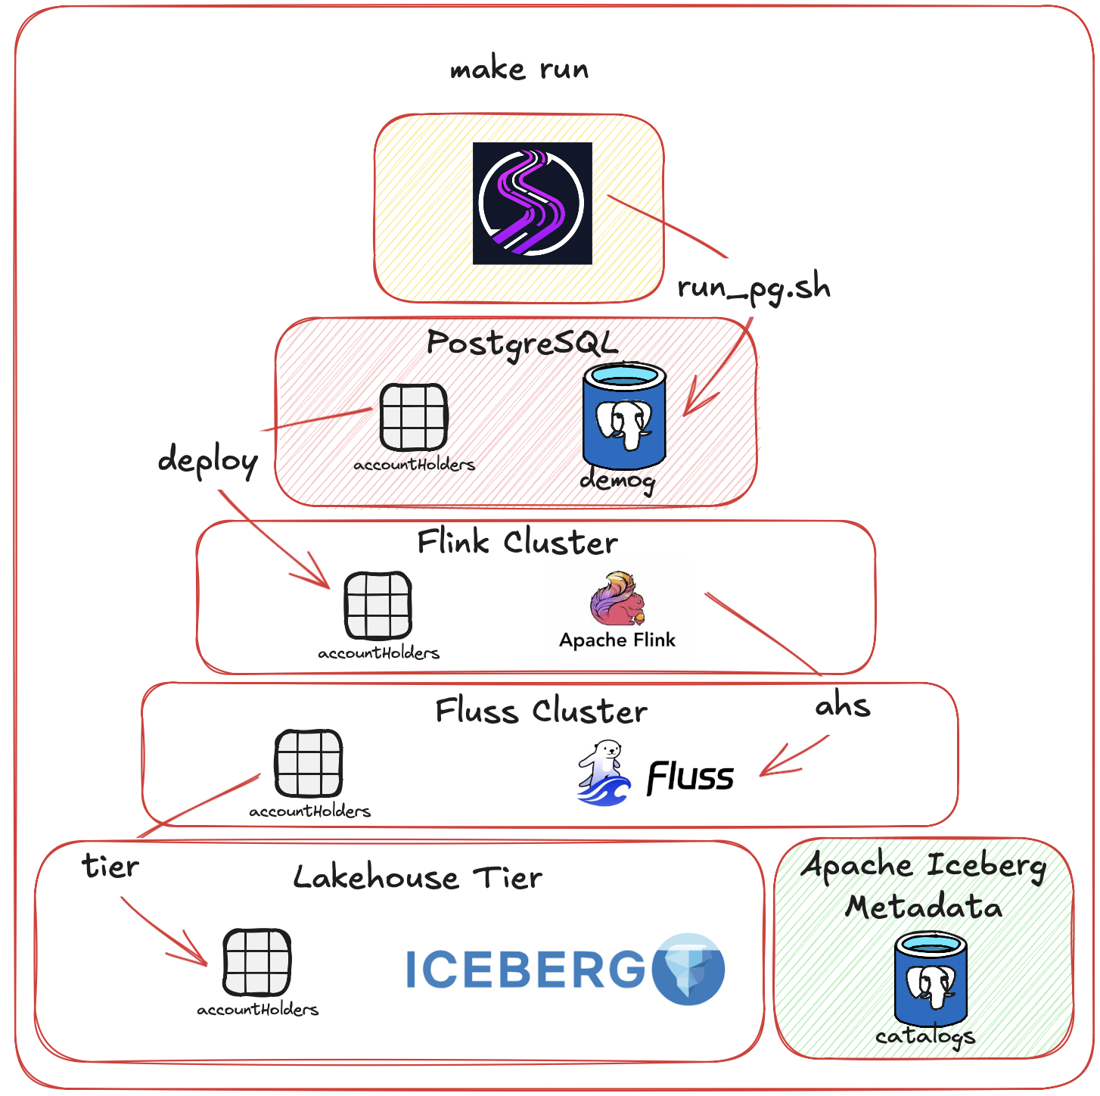

The first being Lakehouse storage on local file system, the second onto MinIO/S3 based object store.

- Configure Apache Fluss (Incubating) tiering into Apache Iceberg based table as our Lakehouse tier, configured onto MinIO/S3 Object store with an Apache Polaris (Incubating) based metadata catalog for our Apache Iceberg tables.

Source to S3 Object store based:

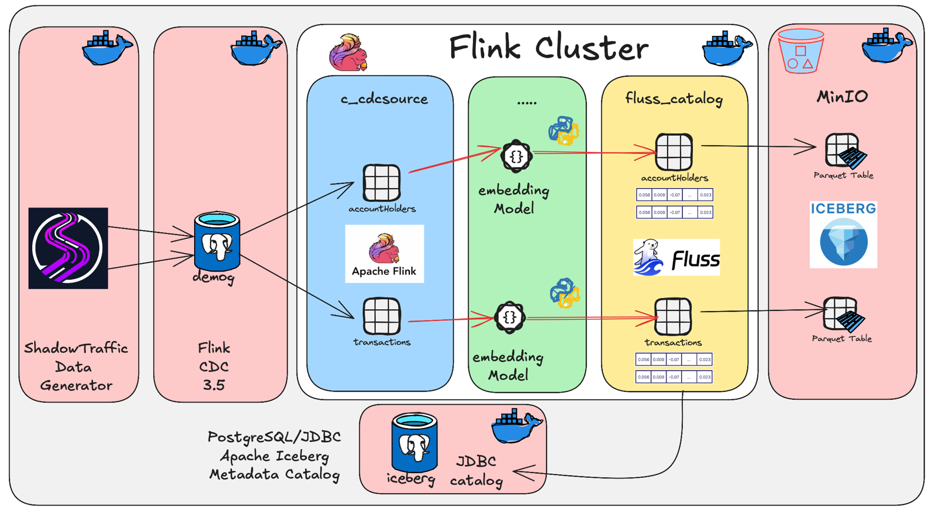

GIT REPO: PyFlink-Embedding-fluss-iceberg-Polaris

Building:

Below is the Dockerfile's for our main two container images, namely the Apache Flink and Apache Fluss (incubating).

These two containers can be built by changing into <Project root>/infrastructure and executing make build or by

- cd infrastructure/flink_base
- make pull
- make build

- cd infrastructure/flink
- make pull
- make build

- cd infrastructure/fluss
- make pull
- make build

Apache Fluss (Incubating) Dockerfile - JAR's

FROM apache/fluss:0.8.0-incubating
SHELL ["/bin/bash", "-c"]

ENV FLUSS_HOME=/opt/fluss
ENV HADOOP_CONF_DIR=/opt/fluss/conf

# Required for Iceberg / JDBC catalog
# See Option 2, https://fluss.apache.org/docs/next/streaming-lakehouse/integrate-data-lakes/iceberg/#2-custom-catalog-implementations
# Required for Iceberg: https://fluss.apache.org/docs/next/streaming-lakehouse/integrate-data-lakes/iceberg/#configure-iceberg-in-cluster-configurations

# 1. Iceberg / JDBC catalog
RUN mkdir -p /opt/fluss/plugins/iceberg

COPY stage/hadoop-apache-3.3.5-2.jar ${FLUSS_HOME}/plugins/iceberg
COPY stage/iceberg-core-1.9.1.jar ${FLUSS_HOME}/plugins/iceberg

# Added during DEBUG!
COPY stage/iceberg-aws-bundle-1.9.1.jar ${FLUSS_HOME}/plugins/iceberg
COPY stage/iceberg-aws-1.9.1.jar ${FLUSS_HOME}/plugins/iceberg

# 1a. Add Iceberg AWS S3 FileIO support - CRITICAL FOR S3FileIO
# Updated aws-java-sdk-bundle-1.12.770.jar to later version
COPY stage/aws-java-sdk-bundle-1.12.770.jar ${FLUSS_HOME}/plugins/iceberg
COPY stage/hadoop-shaded-guava-1.1.1.jar ${FLUSS_HOME}/plugins/iceberg

# 2. Fluss -> S3 Lakehouse tiering
RUN mv ${FLUSS_HOME}/plugins/s3/fluss-fs-s3-0.8.0-incubating.jar ${FLUSS_HOME}/lib
RUN rm -rf ${FLUSS_HOME}/plugins/s3

# 4. Lets make sure with our copying of JARs that all is owned by the right user/group.
RUN chown -R fluss:fluss ${FLUSS_HOME}

Apache Flink Dockerfile - JAR's

Something to take notice of.

I build my final Apache Flink container in two steps, first we build the flink_base (see: <Project root>/infrastructure/flink_base) container where I add generic OS utilities and settings in addition to installing Python stack part of our PyFlink UDF demo’s.

In the second phase we then add/copy all the JAVA libraries as require for the Open Table Format, the desired Lakehouse storage layer and our catalog configurations.

The below is our second phase Dockerfile:
(see: <Project root>/infrastructure/flink)

There is of course multi-phase Docker image pattern I could rather have used, but that’s for another day.

FROM georgelza/apacheflink-base-1.20.2-scala_2.12-java17:1.0.0
SHELL ["/bin/bash", "-c"]

# 2. Environment Variables
ENV PYTHON_HOME=/usr/bin/python3.10
ENV PATH=$PATH:$PYTHON_HOME
ENV JAVA_HOME=/usr/lib/jvm/java-17-openjdk-arm64
ENV FLINK_HOME=/opt/flink
ENV HIVE_HOME=${FLINK_HOME}/conf/
ENV HADOOP_CONF_DIR=${FLINK_HOME}/conf/
ENV FLINK_VERSION_SHORT=1.20
ENV FLINK_VERSION_FULL=1.20.2
ENV ICEBERG_VERSION=1.9.1
ENV POSTGRESQL_CONNECTOR=42.7.6
ENV FLINK_CDC=3.5.0
ENV FLUSS=0.8.0
ENV HADOOP_VERSION=3.3.4

# 5. Directory Structure
RUN mkdir -p /opt/flink/conf/ && \
mkdir -p /opt/flink/checkpoints && \
mkdir -p /opt/flink/rocksdb && \
mkdir -p /opt/flink/lib

# 6.
RUN echo "-> Install JARs: S3 Plugin (Internal Flink System)" && \
mkdir -p ./plugins/s3-fs-hadoop && \
mv /opt/flink/opt/flink-s3-fs-hadoop-${FLINK_VERSION_FULL}.jar ./plugins/s3-fs-hadoop/

# 7. Install JARs: Connectors & Hadoop
RUN echo "-> Install JARs: Postgres Driver and Flink CDC Postgres connector"
COPY stage/flink-sql-connector-postgres-cdc-${FLINK_CDC}.jar ${FLINK_HOME}/lib/
COPY stage/postgresql-${POSTGRESQL_CONNECTOR}.jar ${FLINK_HOME}/lib/

# 8.
RUN echo "-> Install JARs: Generic Flink"
COPY stage/flink-sql-parquet-${FLINK_VERSION_FULL}.jar ${FLINK_HOME}/lib/
COPY stage/flink-python-${FLINK_VERSION_FULL}.jar ${FLINK_HOME}/lib/

# Jars that make the world go round, if you exclude them then most things Flink, Flink CDC, PyFlink etc simply does not work.
# 9.
RUN echo "-> Install JARs: Generic Hadoop"
COPY stage/commons-configuration2-2.1.1.jar ${FLINK_HOME}/lib/
COPY stage/commons-logging-1.1.3.jar ${FLINK_HOME}/lib/
COPY stage/hadoop-shaded-guava-1.1.1.jar ${FLINK_HOME}/lib/
COPY stage/stax2-api-4.2.1.jar ${FLINK_HOME}/lib/
COPY stage/woodstox-core-5.3.0.jar ${FLINK_HOME}/lib/
COPY stage/aws-java-sdk-bundle-1.12.262.jar ${FLINK_HOME}/lib/
COPY stage/hadoop-apache-3.3.5.jar ${FLINK_HOME}/lib/

# 10.
RUN echo "-> Install JARs: Dependencies for Fluss"
COPY stage/fluss-flink-${FLINK_VERSION_SHORT}-${FLUSS}-incubating.jar ${FLINK_HOME}/lib/
COPY stage/fluss-flink-tiering-${FLUSS}-incubating.jar ${FLINK_HOME}/lib/
COPY stage/fluss-fs-s3-${FLUSS}-incubating.jar ${FLINK_HOME}/lib/
# Lakehouse options Libraries
COPY stage/fluss-lake-iceberg-${FLUSS}-incubating.jar ${FLINK_HOME}/lib/

# 11. S3 FileIO
# https://fluss.apache.org/docs/streaming-lakehouse/integrate-data-lakes/iceberg/#5-iceberg-fileio-dependencies
RUN echo "-> Install JARs: Dependencies for Iceberg FileIO"
COPY stage/iceberg-aws-1.9.1.jar ${FLINK_HOME}/lib/
COPY stage/iceberg-aws-bundle-1.9.1.jar ${FLINK_HOME}/lib/
COPY stage/failsafe-3.3.2.jar ${FLINK_HOME}/lib/

RUN echo "--> Set Ownerships of /opt/flink" && \
chown -R flink:flink $FLINK_HOME

USER flink:flink
CMD ./bin/start-cluster.sh && sleep infinity

Running the Lab

Once we have these two containers build, we can run the lab.

The biggest difference now being the coordinator and tablet-server configurations as per the docker-compose.yaml and the configuration of our Apache Flink tiering job. (see: devlab1/Makefile) for these, at the end of the file... ;)

Everything for the lab can be found in <Project root>/devlab1

- make run

- make deploy

- make ahs or make txns

- Run the ShadowTraffic load generator, <Project root>/shadowtraffic/run_pg#.sh

- make tier

Note: you can also run the ShadowTraffic after the deploy command.

Key Findings:

The biggest part of this how to blog can be found in the Apache Polaris (Incubating) and Apache Fluss (Incubating) Docker-Compose service definition. Peeking behind the curtain… well the surprise was values required, was not as expected, and the “sharing” of values between the Apache Polaris (Incubating) and Apache Fluss (Incubating) docker-compose services.

- Pay careful attention to each service “depends_on” block. It’s surprising how important the correct order is.

- For both the Apache Flink and Apache Fluss (Incubating) service we use a configs import to “import” the Hadoop configuration file into /opt/<Software>/conf/core-site.xml

The source file can be found in <Project root>/devlab1/conf.
This file contains the following S3 settings.

fs.s3a.endpoint
fs.s3a.access.key
fs.s3a.secret.key
fs.s3a.path.style.access
fs.s3a.connection.ssl.enabled
fs.s3a.impl
fs.s3a.aws.credentials.provider

Apache Fluss (Incubating)

(<Project root>/devlab1/docker-compose.yaml)

-> coordinator-server & tablet-server-# services

For the below code snippet, see the values for:
- datalake.iceberg.warehouse and
- datalake.iceberg.catlog.name.

Both configured as “icebergcat”. Make note of this… ;)

environment:
- |
FLUSS_PROPERTIES=
bind.listeners : INTERNAL://coordinator-server:9124, CLIENT://coordinator-server:9123
advertised.listeners : INTERNAL://coordinator-server:9124, CLIENT://coordinator-server:9123
zookeeper.address : zookeeper:2181
internal.listener.name : INTERNAL

data.dir : /tmp/local-data
remote.data.dir : /tmp/remote-data

# Lakehouse store on S3 and catalog in Polaris
datalake.enabled : true
datalake.format : iceberg
datalake.iceberg.warehouse : icebergcat # NOTE: this aligns with our polaris catalog, also matches below catalog.name value.
datalake.iceberg.table-default.file.format : parquet

# Polaris Catalog
datalake.iceberg.catalog.name : icebergcat
datalake.iceberg.type : rest
datalake.iceberg.uri : http://polaris:8181/api/catalog # Correct - client adds /v1/icebergcat automatically
datalake.iceberg.oauth2-server-uri : http://polaris:8181/api/catalog/v1/oauth/tokens
datalake.iceberg.credential: ${ROOT_CLIENT_ID} :${ROOT_CLIENT_SECRET}
datalake.iceberg.scope : PRINCIPAL_ROLE:ALL

Apache Polaris Configuration

(<Project root>/devlab1/docker-compose.yaml)
-> polaris-setup service

And we’re back, now the next bit, and this is where things get tied together, note the very last line, where we tell polaris-setup to create our catalog using our helper script (create-catalog.sh, which can be found in conf/polaris), well the last parameter, catalog-name.

Well, this comes from our .env file, and without “copying” the contents here, the value specified is “icebergcat”, as also used/specified above in our coordinator-server (and the not shown tablet-server-# service configurations).

What we also define for the catalog create is where the data will go, as in our S3 location, which now maps to s3a://warehouse/iceberg which is again a value specified in .env as S3_BUCKET and well iceberg is iceberg ;).

If you read the previous blogs, note the $$<Params> parameters are now wrapped in ‘ ” & “’ quotes, just something that’s required as the values are passed around from the docker-compose into the helper scripts.

command:
- "-c"
- >-
chmod +x /polaris/create-catalog.sh;
chmod +x /polaris/obtain-token.sh;
source /polaris/obtain-token.sh "$$POLARIS_HOST" "$$POLARIS_REALM" "$$CLIENT_ID" "$$CLIENT_SECRET";
export PROPERTIES='{
"default-base-location": "s3a://'$$S3_BUCKET'/iceberg",
"s3a.endpoint": "'$$S3_ENDPOINT'",
"s3a.path-style-access": true,
"s3a.access-key-id": "'$$AWS_ACCESS_KEY_ID'",
"s3a.secret-access-key": "'$$AWS_SECRET_ACCESS_KEY'",
"s3a.region": "'$$AWS_REGION'"
}';
export STORAGE_CONFIG_INFO='{
"storageType": "S3",
"endpoint": "'$$S3_ENDPOINT'",
"endpointInternal": "'$$S3_ENDPOINT'",
"region": "'$$AWS_REGION'",
"pathStyleAccess": true,
"allowedLocations": ["s3a://'$$S3_BUCKET'/iceberg/*"],
"accessKeyId": "'$$AWS_ACCESS_KEY_ID'",
"secretAccessKey": "'$$AWS_SECRET_ACCESS_KEY'"
}';
export STORAGE_LOCATION="s3a://$$S3_BUCKET/iceberg";
source /polaris/create-catalog.sh "$$POLARIS_HOST" "$$POLARIS_REALM" "$$CATALOG_NAME";

Tiering Job - Makefile
(<Project root>/devlab1/Makefile)

Again, the reader will notice we don’t specify where to tier to, we reference (re-use the values for datalake.iceberg.* from our various Apache Fluss (Incubating) services), the warehouse and catalog.name which then drives that configuration as a sort of feedback loop.

tier:
@echo "-- Submitting Iceberg Tiering Job... Polaris Catalog"
docker compose exec --interactive --tty jobmanager \
/opt/flink/bin/flink run \
-Dpipeline.name="My Fluss Tiering Service, output to Iceberg, Polaris Catalog" \
-Dparallelism.default=2 \
/opt/flink/lib/fluss-flink-tiering-0.8.0-incubating.jar \
--fluss.bootstrap.servers coordinator-server:9123 \
--datalake.format iceberg \
--datalake.iceberg.warehouse icebergcat \
--datalake.iceberg.catalog.name icebergcat \
--datalake.iceberg.type rest \
--datalake.iceberg.uri http://polaris:8181/api/catalog \
--datalake.iceberg.oauth2-server-uri http://polaris:8181/api/catalog/v1/oauth/tokens \
--datalake.iceberg.credential ${ROOT_CLIENT_ID}:${ROOT_CLIENT_SECRET} \
--datalake.iceberg.scope PRINCIPAL_ROLE:ALL

Regarding our Stack

The various labs are deployed using a combination of the provided <Project root>/devlab1/docker-compose.yaml files, which deploys the below containers or variants of them.

- Apache Flink 1.20.2
- Apache Flink CDC 3.5.0
- Apache Iceberg 1.9.1
- Apache Polaris (Incubating) – we used latest
- PostgreSQL 15
- MinIO - Project has gone into Maintenance mode...
- ShadowTraffic

Summary

So, we now have a working example whereby we insert two data products into PostgreSQL tables. We then utilise Apache Flink CDC to source those records into transient Apache Flink Tables. From there we push the data steam into Apache Fluss (Incubating) configured with Apache Iceberg as lakehouse tier, hosted on a S3/MinIO Object store, all with Apache Polaris (Incubating) as metadata store for our Iceberg table.

Nifty, I think.

As previous, these are not complete solutions, but rather blocks that can be used to build a larger stack. I have one

Last blog in this series, but that’s waiting for Apache Fluss (Incubating) 0.9.0, which is imminent.



And like that we're done with our little trip down another Rabbit Hole.



About Me

I’m a techie, a technologist, always curious, love data, have for as long as I can remember always worked with data in one form or the other, Database admin, Database product lead, data platforms architect, infrastructure architect hosting databases, backing it up, optimizing performance, accessing it. Data data data… it makes the world go round.

In recent years, pivoted into a more generic Technology Architect role, capable of full stack architecture.

George Leonard
georgelza@gmail.com
https://medium.com/@georgelza



