Using PyFlink UDF to calculate embedding vectors on inbound tables via Flink.

(26 Dec2025)

Overview

So, the original idea, generate data, do embedding using Pyflink, store into a lakehouse, simple.

Well mission accomplished, even if we did change some of the original outputs, will see if I can circle back on the next demo/blog... ye, there is another one already drawn out, started.

Our little project, create accountHolder records (that defines a person, family at an address) and then financial transactions (well who can life without spending money) modeled as an outbound and inbound event, very real world.

These are all inserted into a PostgreSQL database/table.

We then utilize Apache Flink CDC to consume these into transient tables inside Apache Flink (we're using Generic in memory catalog). Apache Flink CDC is built on top of a common Change Data Capture technology/capability available on most databases these days, see the CDC and Change Data Capture links.

Next up, we need to do the embedding calculation, this is done using two Pyflink User Defined Functions (UDF), (See: `<Project root/devlab/pyflink/udfs/`).

These are called as per below, as inline function calls, returning the embedding vector that is inserted into our lakehouse, based on Apache Paimon.

Insert into c_paimon.finflow.<target table>
select (
fields
, ...
, ...
,generate_<function>_embedding(
fields
, ...
, ...
) AS embedding_vector
,384 AS embedding_dimensions
,CURRENT_TIMESTAMP AS embedding_timestamp
,created_at
)
from c_cdcsource.demog.<source table>;

BLOG: Using Pyflink UDF to calculate embedding vectors on inbound tables via Flink CDC

GIT REPO: PyFlink_Embedder

Overview

The stack allows for the Lakehouse tables to either be created on S3 Object storage hosted on MinIO container or on the local file system <Project root/devlab/data/flink/paimon/

S3/ MinIO

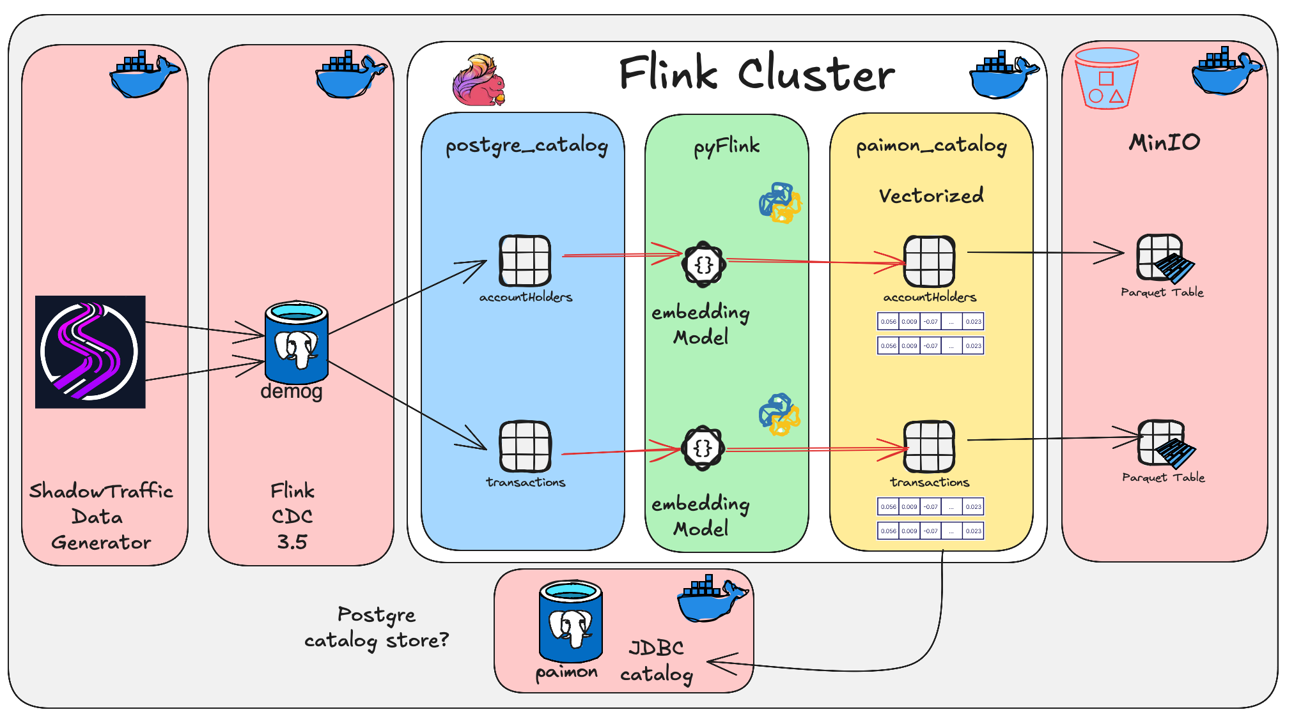

Filesystem

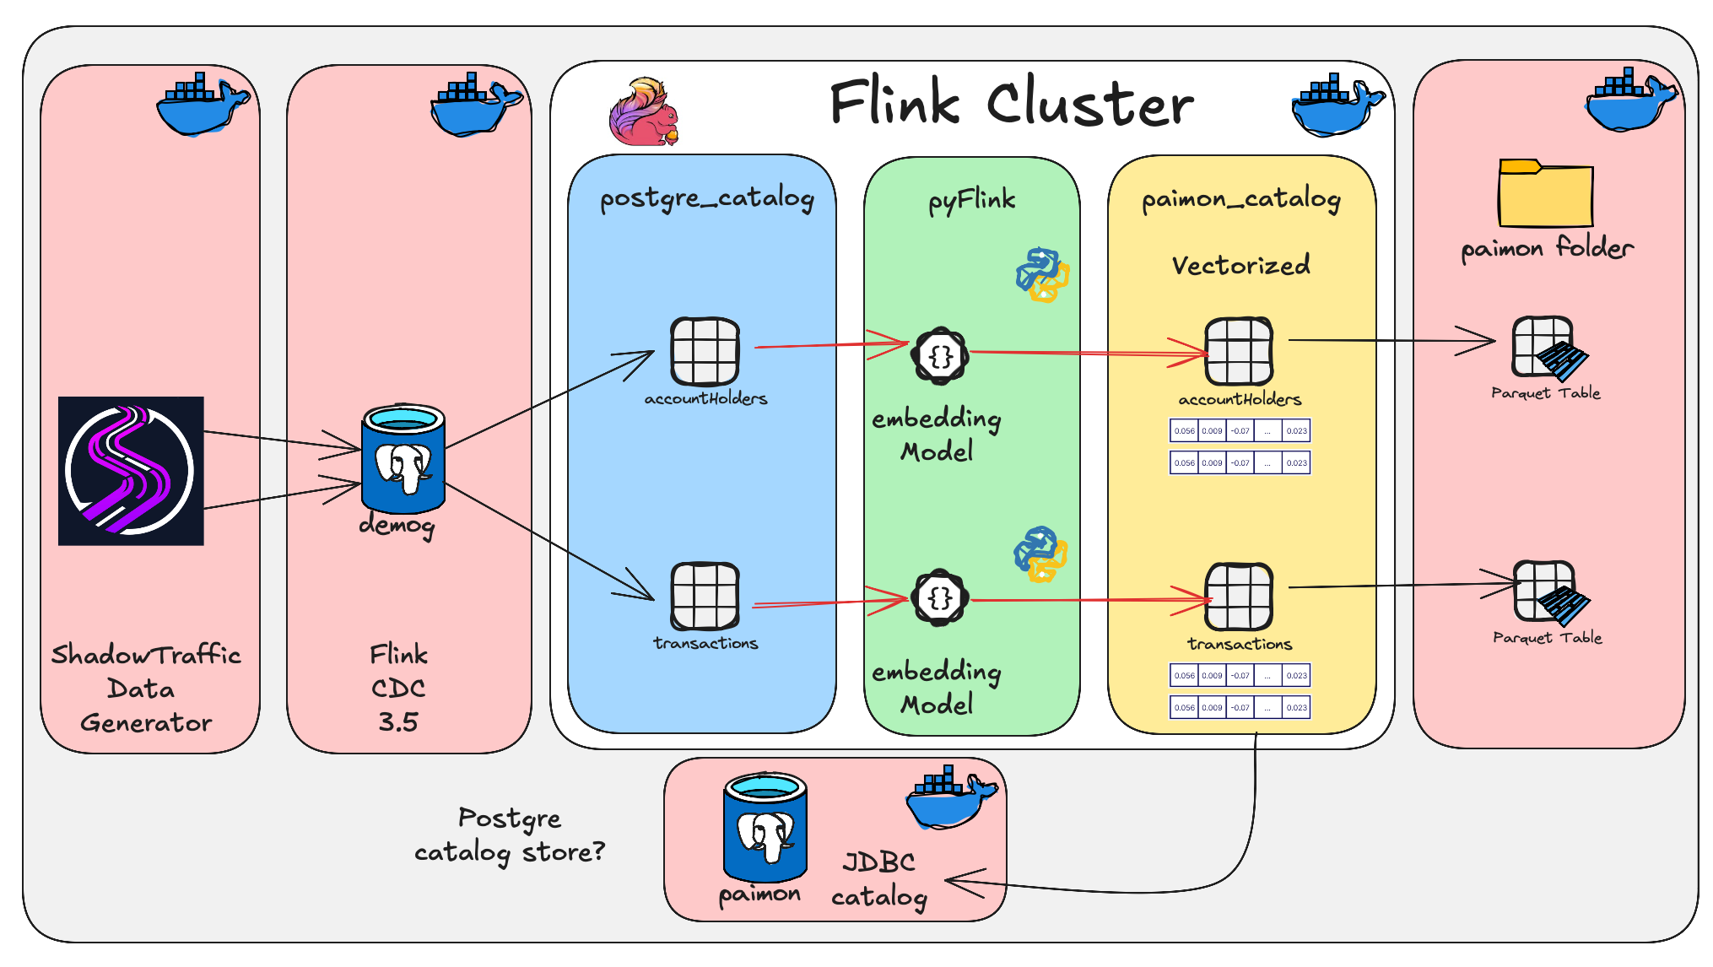

Summary

Ok, the code was not that difficult or is not really that complicated. What did come out is the tweaking of the settings on a docker-compose based lab, to balance the memory etc. for Apache Flink. Some of this is due to us using UDF's and pretty sure this will also come up in real life, in production.

Also, the various deployment options, how to be able to tear things down, make a tweak and then redeploy. Time spends doing this adds up.

Did figure along the way to be open to making changes, from original plans. Hey, we're in IT, accept change, invite change, adopt change.

Deployment

Bring our stack up based on <Project Root>/devlab/docker-compose.yml or <Project Root>/devlab/docker-compose-fs.yml, by executing either of the following 2 (both will use .env environment file with some variables, also notice the .pwd for some "secrets").

- Deploy stack make run -> Run MinIO/S3 based version.
- Deploy stack make run-fs -> Run Filesystem based version.

Next, we need to build our catalogs and tables,

- Deploy catalog and tables make deploy -> Run MinIO/S3 based version.
- Deploy catalog and tables make deploy-fs -> Run Filesystem based version.

NOTE: For the above deploy I ran into an interesting situation. As you will notice the PostgreSQL source table is created in the c_cdcsource catalog. Now that catalog is of type generic in memory as per Apache Flink. So whats so special about that, well, it’s session scoped, ONLY. This means whatever you create in the catalog is only available/visible for that session, during that session.
Ok. Now this means when we create the catalog, the source PostgreSQL reference, the UDF referencing the source table, well, they all have to be done in one session. So… how did we get around this, why is this a issue. Well we still want to compartmentalise our code, as in keep the catalog create in the catalog script, the CDC source table creates in their script and then the UDF separate as well as its registration. Code duplication is also note a great idea, we want to re-use these bits.
So at this point, I’m going to say, look at our Makefile, at the deploy: and deploy-fs: sections, and how they call master: or master-fs:, and how we use the “>” operator to build a master.sql or master-fs.sql script, which we then execute in deploy or deploy-fs. There is still room for improvement here, but for now this worked.
MinIO/S3 based deployment
# S3/Minio based => Default
master:
@echo "-- Generated MinIO/S3 master.sql" > ./creFlinkFlows/master.sql
@cat ./creFlinkFlows/scripts/1.1.creCat.sql >> ./creFlinkFlows/master.sql
@cat ./creFlinkFlows/scripts/3.1.creTargetFinflow.sql >> ./creFlinkFlows/master.sql
@cat ./creFlinkFlows/scripts/3.2.creTargetCmplx.sql >> ./creFlinkFlows/master.sql
@echo "✅ master.sql for MinIO/S3 generated"

deploy: master
@echo "Deploying Paimon based Catalog with MinIO/S3 Storage..."
docker compose exec --interactive --tty jobmanager /opt/flink/bin/sql-client.sh -f /creFlinkFlows/master.sql
File System based deployment
# File System based
master-fs:
@echo "-- Generated fs master.sql" > ./creFlinkFlows/master-fs.sql
@cat ./creFlinkFlows/scripts/1.1.creCat-fs.sql >> ./creFlinkFlows/master-fs.sql
@cat ./creFlinkFlows/scripts/3.1.creTargetFinflow.sql >> ./creFlinkFlows/master-fs.sql
@cat ./creFlinkFlows/scripts/3.2.creTargetCmplx.sql >> ./creFlinkFlows/master-fs.sql

deploy-fs: master-fs
@echo "Deploying Paimon based Catalog with Filesystem..."
docker compose exec --interactive --tty jobmanager /opt/flink/bin/sql-client.sh -f /creFlinkFlows/master-fs.sql

Let’s continue…

Deploy our PyFlink UDF:

- make ahs -> Deploy our accountHolder embedding flow as an Apache Flink job
- make txns -> Deploy our transaction embedding flow as an Apache Flink job

Generate data, by executing our Shadowtraffic based data generator to create our two data products:

- AccountHolders
- Transactions

The process will output create records in two PostgreSQL tables provided by our postgrescdc docker-compose based service.

The data generation is run by executing <Project Root>/shadowtraffic/run_pg1.sh.

If you want to increase the data generate rate execute <Project Root>/shadowtraffic/run_pg2.sh.

PS: make sure to update the <Project Root>/shadowtraffic/conf/license.env file. You can get a trial/demo license from the project GIT repo. See the shadowtraffic-examples/ directory for the free-trial-license.env

Regarding our Stack

The following stack is deployed using one of the provided <Project Root>/devlab/docker-compose-*.yaml files as per above.

- Apache Flink 1.20.2
- Apache Flink CDC 3.5.0
- Apache Paimon 1.3.1
- PostgreSQL 12
- MinIO - Project has gone into Maintenance mode...
- ShadowTraffic

Data Products

Below is an overview of the data products we will create using Shadowtraffic, these will be inserted into our PostgreSQL CDC datastore.

From where they will be Change Data Capture (CDC) source into our Apache Flink environment into Flink tables that will be "consumed" using PyFlink jobs, first flattened and then as a second job calculate vector embeddings (using different local HuggingFace LLM models).

1. AccountHolders

_id => Sequentially incrementing value
nationalid => Random 16 Digits unique Number, excluded from embedding calc
firstname
lastname
dob => YY/MM/DD Min = current - 16yrs
gender
children
address => Can we drive addresses chosen based on country via .env value
{
Street Address
Suburb
Town
Province
Country
Postal Code
}
accounts [
# (1-5) => .env driven
Bank Account/s
tenantId => .env driven (PickList / or from PostgreSql Table of possible values)
=> this becomes the tenantId, fromId, toId
memberName => .env driven (PickList / or from PostgreSql Table of possible values)
bicFi => .env driven (PickList / or from PostgreSql Table of possible values)
=> this becomes the fromId or toId, possible same as tenantId
brancId => .env driven (PickList / or from PostgreSql Table of possible values)
=> this become the fromBranchId or toFIBranchId
accountId => concat bicfi-<random-unique-16>
=> this is either the accountId or counterPartyAccountId
accountType => .env driven (PickList / or from PostgreSql Table of possible values)
accountOpenDate
Credit Card/s
issuingBank (tenantId) => .env driven (PickList / or from PostgreSql Table of possible values)
bicFi => .env driven (PickList / or from PostgreSql Table of possible values)
cardNumber => CC Structure, can we maybe pick first 4 chars from .env pick list (known as bin numbers)
cardType (VISA/MasterCard/Amex/DinerClub) => .env driven (PickList / or from PostgreSql Table of possible values)
expDate => Current mm/year - <.env driven # months>
]
emailaddress
mobilephonenumber
embedding_vector => To be Calculated, Account Holder profile model
embedding_dimensions
embedding_timestamp
created_at

2. Financial Transactions

- Outbound Txn: From Payer to Payee

_id => Sequentially incrementing value
eventId => UUIDv7 Unique, excluded from embedding calc
transactionid => UUIDv7 Shared with Inbound, excluded from embedding calc
eventtime => "2023-07-31T12:59:02"
direction: outbound
eventtype
creationdate
accountholdernationalid
accountholderaccount => row
counterpartynationalid
counterpartyaccount => row
tenantid
fromid
accountagentid
fromfibranchid
accountnumber
toid
accountidcode
counterpartyagentid
tofibranchid
counterpartynumber
counterpartyidcode
verificationresult => .end driven (pick List)
amount { => row
basecurrency => .env driven (pick List)
basevalue
roe => .env driven
currency => .env driven (pick List)
value
}
msgType => .end driven (pick List)
settlementclearingsystemcode
paymentclearingsystemreference
requestexecutiondate
settlementdate
destinationcountry
localinstrument
msgstatus
paymentmethod
settlementmethod
transactiontype
verificationresult
numberoftransactions
schemaversion
usercode
embeddingVector => To be Calculated, transaction profile model
embedding_dimensions
embedding_timestamp
created_at

- Inbound Txn: To Payee from Payer

(separate insert as a second record into Transaction table)

_id => Sequentially incrementing value
eventId => UUIDv7 Unique, excluded from embedding calc
transactionid => UUIDv7 Shared with Inbound, excluded from embedding calc
eventtime => "2023-07-31T12:59:02"
direction: inbound
eventtype
creationdate
accountholdernationalid
accountholderaccount => row
counterpartynationalid
counterpartyaccount => row
tenantid
fromid
accountagentid
fromfibranchid
accountnumber
toid
accountidcode
counterpartyagentid
tofibranchid
counterpartynumber
counterpartyidcode
verificationresult => .end driven (pick List)
amount { => row
basecurrency => .env driven (pick List)
basevalue
roe => .env driven
currency => .env driven (pick List)
value
}
msgType => .end driven (pick List)
settlementclearingsystemcode
paymentclearingsystemreference
requestexecutiondate
settlementdate
destinationcountry
localinstrument
msgstatus
paymentmethod
settlementmethod
transactiontype
verificationresult
numberoftransactions
schemaversion
usercode
embeddingVector => To be Calculated, transaction profile model
embedding_dimensions
embedding_timestamp
created_at

Example Embedding
[0.01445724256336689, 0.09701855480670929, -0.07058391720056534, 0.011932402849197388, -0.042993444949388504, -0.006094191689044237, -0.0036664914805442095, -0.0439387708902359, 0.03239914029836655, 0.006903071887791157, -0.023519961163401604, -0.11289187520742416, -0.05749013274908066, -0.005956214852631092, -0.0031315817032009363, 0.02947763167321682, -0.09478286653757095, -0.03548044711351395, -0.022092759609222412, -0.01592298597097397, -0.024021180346608162, 0.05686800926923752, 0.033077921718358994, -0.07411571592092514, 0.013140725903213024, 0.016234660521149635, -0.016816841438412666, -0.0013654181966558099, -0.05573897063732147, 0.027418503537774086, 0.10348410904407501, 0.01615741290152073, 0.06825506687164307, 0.003716151462867856, 0.07578625530004501, -0.01984473317861557, -0.010832651518285275, 0.0130238626152277, 0.07774016261100769, 0.0055547053925693035, 0.024760769680142403, 0.025823557749390602, 0.008250007405877113, -0.08509925752878189, 0.03672507777810097, -0.01744483970105648, -0.04598455876111984, 0.06477422267198563, 0.016414327546954155, 0.04829961434006691, -0.08511459082365036, -0.02875206619501114, -0.06640172004699707, -0.03677041456103325, -0.030314570292830467, 0.05330394580960274, -0.0378086157143116, 0.0022430499084293842, -0.02948828600347042, -0.14869192242622375, 0.13566133379936218, -0.0892162099480629, 0.01586977392435074, -0.006163639482110739, -0.04763994738459587, -0.02110172249376774, -0.0036623189225792885, 0.06345203518867493, 0.009852107614278793, 0.00469460804015398, 0.08407268673181534, 0.017484942451119423, -0.1351720243692398, -0.03657697141170502, -0.011379201896488667, 0.0577419176697731, -0.015083692967891693, -0.04733581840991974, 0.028635118156671524, 0.038763877004384995, -0.06364966183900833, -0.09279768168926239, -0.015070167370140553, 0.02993790991604328, -0.05375237390398979, -0.02416551671922207, 0.022553078830242157, -0.0547633022069931, -0.05643220618367195, -0.09647511690855026, 0.01238572783768177, 0.02875027060508728, 0.06269342452287674, -0.02251129038631916, 0.021183989942073822, -0.0330234058201313, -0.047148216515779495, 0.01044992171227932, -0.03328917175531387, 0.03771573677659035, 0.03077775426208973, 0.007826277054846287, 0.012478535063564777, 0.025886887684464455, 0.010915850289165974, -0.03679786995053291, 0.06901649385690689, 0.004846378229558468, -0.055046938359737396, -0.018712222576141357, -0.05879242718219757, 0.10408871620893478, -0.040405843406915665, -0.009299897588789463, -0.05575906112790108, 0.05365501344203949, -0.0333436094224453, -0.015246537514030933, 0.038751475512981415, 0.11423555016517639, 0.06783945858478546, 0.0528503879904747, -0.08985263109207153, -0.00028901954647153616, -0.07461360841989517, -0.00822678953409195, 0.032966382801532745, 6.606865998796667e-33, 0.025819335132837296, -0.010162467136979103, 0.08787351101636887, -0.038631368428468704, 0.044968556612730026, -0.009287834167480469, -0.0005302869831211865, -0.010876474902033806, -0.06729944050312042, 0.030863067135214806, -0.03825314715504646, 0.015166128985583782, 0.016902541741728783, -0.06364969909191132, -0.08595366030931473, -0.013054024428129196, -0.020344212651252747, 0.04360846057534218, -0.01838183030486107, 0.061172887682914734, 0.04793967679142952, -0.028150314465165138, 0.013457799330353737, 0.01103556714951992, 0.007126997224986553, -0.03483690321445465, -0.01723560132086277, -0.007620658725500107, 0.007113696075975895, -0.003081327537074685, 0.006095733027905226, -0.019369831308722496, -0.059379320591688156, 0.01068485714495182, 0.01734069362282753, 0.016113778576254845, 0.0041007185354828835, -0.02769881673157215, -0.02647516131401062, -0.006150154396891594, 0.042373452335596085, 0.013931894674897194, -0.021867617964744568, 0.012468893080949783, -0.050995443016290665, 0.04285035282373428, 0.054363325238227844, -0.011801832355558872, 0.038123372942209244, 0.1104031652212143, -0.09524010866880417, -0.021757908165454865, -0.08757801353931427, 0.021562477573752403, -0.009538906626403332, -0.06980178505182266, 0.007426466327160597, 0.04249999672174454, -0.019606882706284523, -0.08598697185516357, -0.03359426558017731, -0.03045780211687088, -0.029933691024780273, -0.02879221923649311, -0.0030573599506169558, -0.011444106698036194, 0.036980707198381424, 0.050892654806375504, -0.05759561061859131, -0.0233415849506855, 0.06399598717689514, 0.06564252823591232, 0.07692365348339081, 0.004598638042807579, -0.012292577885091305, -0.024257011711597443, 0.026312880218029022, 0.023623552173376083, -0.08025413751602173, 0.017048273235559464, -0.010633602738380432, -0.03539843484759331, -0.10656623542308807, 0.019425952807068825, -0.056103963404893875, 0.08255546540021896, 0.030456192791461945, -0.010039657354354858, -0.003980475477874279, -0.014931751415133476, -0.05647285655140877, 0.01591447927057743, 0.008003110066056252, -0.09286193549633026, 0.03468788042664528, -6.579490939417924e-33, -0.015427743084728718, -0.10830073803663254, 0.010604418814182281, -0.07818305492401123, 0.035146333277225494, -0.034272611141204834, 0.09510688483715057, 0.060013748705387115, 0.060294587165117264, 0.05410393327474594, -0.0021154098212718964, -0.007788327522575855, 0.00662427581846714, 0.0010634184582158923, -0.0026219200808554888, -0.002514033578336239, 0.026383155956864357, -0.01032191701233387, 0.05528317391872406, -0.060554467141628265, -0.009761083871126175, 0.12140814960002899, 0.005253996700048447, 0.11738768219947815, -0.04252001643180847, 0.00769762322306633, -0.04652160033583641, -0.006731592118740082, -0.05374257639050484, -0.04287009313702583, 0.00661688344553113, -0.004920736886560917, -0.06401774287223816, 0.16328631341457367, -0.03284180536866188, -0.05886811390519142, 0.049893319606781006, 0.14305256307125092, 0.008835623040795326, 0.025986146181821823, -0.05728818476200104, 0.05838644504547119, -0.06155768781900406, -0.01672307774424553, 0.11300477385520935, -0.07410354912281036, 0.07022126019001007, 0.0807722955942154, 0.023974521085619926, 0.015869883820414543, -0.02912481129169464, 0.028636422008275986, 0.020273413509130478, 0.07854845374822617, -0.021635757759213448, 0.02133004367351532, 0.08900494873523712, -0.12539200484752655, 0.02572852000594139, -0.04642574116587639, -0.047795504331588745, 0.008509854786098003, -0.013882540166378021, 0.0620017871260643, 0.10516469180583954, -0.07167930901050568, -0.12429015338420868, -0.04375037923455238, 0.01157595869153738, -0.05809766799211502, -0.05273028090596199, -0.03299769014120102, 0.041604697704315186, 0.011798587627708912, 0.06994105130434036, 0.03875454142689705, -0.007789905183017254, -0.02146754413843155, 0.016096383333206177, -0.0029915357008576393, -0.04314110055565834, 0.011563235893845558, 0.06989781558513641, 0.10614857077598572, -0.005375722888857126, -0.06222904473543167, 0.05068686977028847, -0.02163858525454998, -0.0519559420645237, 0.022771429270505905, -0.04744955152273178, -0.06968621164560318, 0.005243504885584116, -0.01680915616452694, -0.03360667824745178, -4.885920290575996e-08, -0.094224713742733, 0.012783687561750412, -0.05097033083438873, 0.0700933113694191, 0.040955428034067154, -0.0026087972801178694, 0.060624152421951294, 0.005253113340586424, 0.02429630607366562, -0.03725544363260269, 0.014338591136038303, 0.03452818840742111, -0.05485669896006584, -0.036376576870679855, -0.01968587562441826, -0.07906590402126312, -0.027743682265281677, -0.041793905198574066, -0.011850448325276375, 0.07265486568212509, 0.05993847921490669, 0.0025851561222225428, 0.04004496708512306, -0.04679706692695618, 0.041704751551151276, 0.030657365918159485, 0.06578417867422104, 0.013316458091139793, 0.02521015889942646, -0.00249406136572361, -0.08444495499134064, -0.004125269129872322, 0.09345779567956924, -0.012830285355448723, -0.025352561846375465, -0.0365150161087513, 0.08301182091236115, 0.06995091587305069, -0.08128015697002411, 0.021049831062555313, -0.009434772655367851, 0.002971216570585966, -0.05356437340378761, -0.006063755601644516, 0.01138035673648119, -0.001472060801461339, 0.00046972950804047287, 0.04840453714132309, 0.14277133345603943, -0.04243571311235428, -0.031986601650714874, 0.02233492024242878, 0.08535728603601456, 0.021260948851704597, -0.06663625687360764, -0.01146132405847311, -0.03511764481663704, 0.0060256775468587875, 0.020984845235943794, 0.04760892689228058, 0.16756628453731537, -0.021030085161328316, 0.005351607222110033, 0.015160152688622475]

Summary
Now… At this point we have allot of options, for the purpose of the blog I wrote the outbound data stream into Apache Paimon. I could however just as easily have pushed this onto:
- Apache Kafka Topic, processed it and then use their Connect framework to sink it into a target of choosing,
- Mongo DB Collection
- Into a Real time streaming storage platform like Apache Fluss (incubating), and from there utilised their Lakehouse tiering into Apache Paimon, Apache Iceberg or LanceDB.
There are so many options that can be brought together.

Well, hope I got it all accurately documented and copied, Hope it’s of benefit for someone.

Thanks for following. Till next time.



And like that we're done with our little trip down another Rabbit Hole.



About Me

I’m a techie, a technologist, always curious, love data, have for as long as I can remember always worked with data in one form or the other, Database admin, Database product lead, data platforms architect, infrastructure architect hosting databases, backing it up, optimizing performance, accessing it. Data data data… it makes the world go round.

In recent years, pivoted into a more generic Technology Architect role, capable of full stack architecture.

George Leonard
georgelza@gmail.com
https://medium.com/@georgelza



