AI / ML / Embedding, Vectors, VectorDB’s, an Primer of sort – (part X of …).

(X Nov 2025)

Overview

This is part X of a series… not yet sure how many parts there will be. I say X as it’s not yet Part 4, but it needs to be discussed before I do part 4.
- In part 1 we explored how to push data into a GraphDB platform (build using Neo4J) as a graph based data model using the cypher language.

- In part 2 we took the transaction data and added a lineage component to it, also called temporarily, all just fancy words for we link the previous transaction to the next to show the transactions for an account.

- In part 3 we took our above model and configured streaming job which consumed our data from our Kafka topics, creating nodes and edges in our Neo4J Graph datastore in real time using the Kafka Connect Sink Framework.
BUT, before we do part 4, I want to discuss the below concept/terms as related to this new mind bobbling monster called the AI and some of the concepts/terms.
Understand, this is all how I unpack the technology for my own understanding, and my thinking is always, if this helps me I’m sure it might help someone else, so here we go.

What I want to do is list some basic concepts/terms and discuss what they actually mean.
As a start… We have:
- Source Data
- Embedding Data and models.
- Datastore Stores
- Vector Indexes
- Retrieving Data

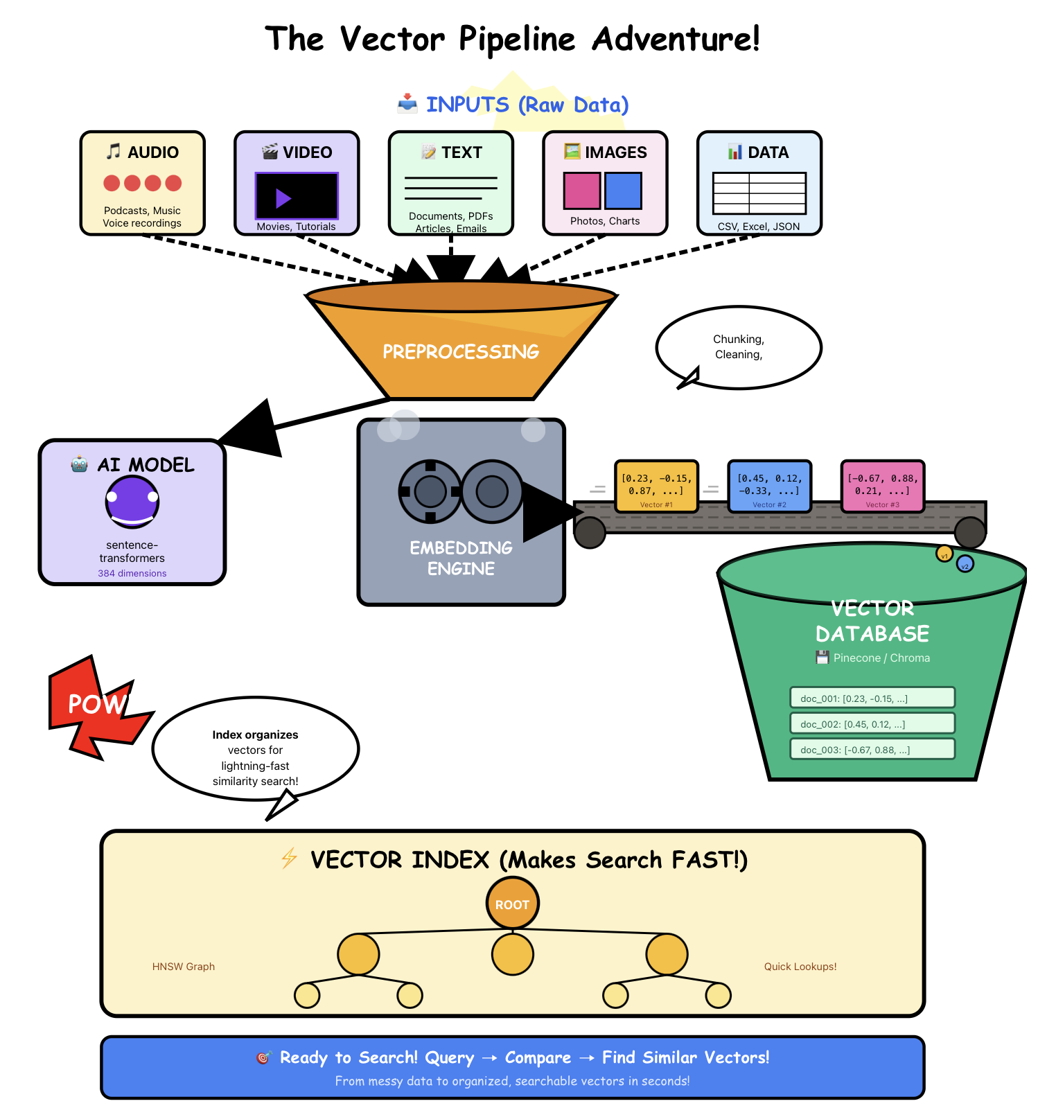

If we now look at each of these in a little more detail.

Source Data:

Well Lets first set the scene, nothing in IT happens without some of data. So, what’s our various formats.

  - MS Word well this is just text in the end.
  - Adobe Pdf again, different wrapper, but also just text,
  - Txt and again, text.

All three above is what most commonly known/think off, which they’ve used with AI when online AI sites like ChatGPT, Claude.ai, Gemini & Grok etc.

  - Sound well, this is not text, this is very different, it’s sound, can be voice/conversations, it can be the sound produced by a machine, or a natural sound produced by our environment.
  - Video again, a digital, viewable stream of images.
  - Picture single image

Again, allot of people would have exposure to the above, we’ve all heard/seen deep fakes, we’ve been called by automated bots. We’ve seen pictures/photos produced by an AI trying to proof some narrative, true or not.

  - Data / records Interesting enough, this is probably where the biggest use case in my mind sit, taking information, we have in data stores, collected over years, and extracting value out of it. Looking for patterns that can be used to improve something, protect someone against i.e. fraud or discover anomalies of some form.

Embedding, Vectorizing Data:
Hey, what’s embeddings you ask, also sometimes referred to as Vectorizing. Well, this is the process of taking the various data formats as per above and create embeddings on it, think of it as a universal translator for meaning: i.e.
- Inputs: Any text in human language
- Output: A "fingerprint" of numbers that represents what it means
- Similar meanings → similar fingerprints
- You can then measure, compare, and search these fingerprints mathematically
Embedding model or called an AI model.

Think of an AI model as a really sophisticated pattern-matching machine that learns from examples. It is what takes our input and converts it to the fingerprint that represents the input using numbers.

The Basic Idea:
Imagine teaching a child to recognize dogs. You show them hundreds of pictures: "This is a dog, this is a dog, this is NOT a dog (it's a cat)." Eventually, the child learns what features make something a dog - four legs, fur, certain face shapes, etc. They can then recognize dogs they've never seen before. The different versions of a dog and it features then result in an similar number.
Different models are simply trained on different types of data. So one model might represent a dog using one fingerprint and another a different set of numbers/fingerprint… And this is a very important concept to understand/realise, more on this later.
An AI model works similarly, but with math instead of a brain.

What It Actually Is:
An AI model is basically a mathematical recipe - a huge collection of numbers and calculations that:
- Takes in information (like an image, text, or data)
- Processes it through layers of mathematical operations
- Produces an output (like "this is a dog" or "here's a response to your question")

The Learning Process
When we "train" a model:
- We feed it thousands or millions of examples
- Initially, it makes terrible guesses
- Each time it's wrong, we adjust those internal numbers slightly, like helping the child with how to say yes that is a dog, and that is not and why it is not…
- After seeing enough examples, those numbers settle into a pattern that works pretty well
It's like adjusting the knobs on a radio until you get a clear signal - except there might be billions of "knobs" (called parameters), common models at moment contain in the excess of 70 billion parameters. The more parameters it has, the larger the AI engine needs to be.

Why "Model" you ask?
We call it a "model" because it's creating a simplified model of reality - just like a model airplane represents a real airplane. It captures the patterns and rules it observed in the training data, then applies them to new situations.

The Key Limitation:
The model doesn't truly "understand" anything - it's recognizing statistical patterns. It's incredibly good at this, but it's still just very sophisticated pattern matching, not genuine comprehension, it’s not conscious.

Embedding Dimensions, What Are?
Embedding dimensions refer to how many numbers you use to represent something in AI.

The Basic Concept
In AI, we can't work directly with words, images, or other data - we need to convert them into numbers. An "embedding" is a way to represent something as a list of numbers, and the "dimensions" are how long that list is.
Think of it like describing a person:
- 1 dimension: Just their height (5'8")
- 2 dimensions: Height + weight (5'8", 160 lbs)
- 3 dimensions: Height + weight + age (5'8", 160 lbs, 32 years)
- More dimensions: Add personality traits, interests, income, etc.
More dimensions = more detailed description. But this also mean larger numbers, more space required to represent the “dog”.

In Practice
When AI converts a word like "king" into an embedding, it might become something like:
- 50 dimensions: [0.2, -0.5, 0.8, 0.1, ..., 0.3] (50 numbers)
- 300 dimensions: [0.2, -0.5, 0.8, ..., 0.3] (300 numbers)
- 1536 dimensions: Modern models like OpenAI's use this many
Each number captures some aspect of the word's meaning in a way the AI can work with mathematically, some models will create a fingerprint of the single word, some models will create fingerprints of multiple words, to understand / define a sequence of words as they have specific context based on the order and how they are used together.

Why It Matters
Higher dimensions:
- ✅ Capture more nuanced relationships and meaning
- ✅ Better at distinguishing subtle differences
- ❌ Require more storage and computation
- ❌ Can be overkill for simple tasks
Lower dimensions:
- ✅ Faster and more efficient
- ✅ Easier to visualize and work with
- ❌ May lose important details
- ❌ Can't capture complex relationships as well

Real-World Analogy
Imagine describing locations:
- 1D: Just the street number (incomplete)
- 2D: Latitude + longitude (works for a map)
- 3D: Add altitude (better for flying)
- 4D+: Add time, weather, traffic patterns (even richer)
Similarly, embedding dimensions determine how richly you can represent and distinguish between different pieces of data in AI systems.
A Question: If I provide a input search string, which is then converted (vectorized) to a embedding-vector, does it need to be encoded using the same number of dimensions, as used for the data we want to compare/search against.
Answer: Absolutely YES.
Side note: The embedding model used for the input data/vectors in the datastore needs to match the embedding model used to embed/vectorize the question, search criteria.
In Summary
Embedding Dimensions… Well, what’s the right choice, you might ask, and well we’re in IT, so how long is the string or YMMV (Your Milage May Vary) is the answer. Ye I also don’t like it.
Using higher dimension is not always better. What’s needed here is to vectorize your data, then run queries, measure their run time, the underlying resources used and the accuracy of the answer. Now even if you think that’s perfect, try more, see which others provide what results. Some might improve one data point, i.e. reduced resource usage, but at the same time the accuracy might decrease. Simply put, no one size fits all.
A Practical consideration:
All vectors in a column (same table) with a vector index must have the same dimension count.
This is a fundamental requirement because:
- Mathematical operations require consistent dimensions - Vector similarity calculations (cosine similarity, euclidean distance, etc.) only work between vectors of the same dimensionality. You can't compare a 768-dimensional vector with a 1536-dimensional one.
- Index structure depends on fixed dimensions - Vector indexes (like HNSW, IVFFlat, etc.) build their data structures based on a specific dimension size. The index needs to know the exact size upfront to organize and traverse the vector space efficiently.
- Storage optimization - Databases allocate fixed storage per vector based on the declared dimensions for performance reasons.

Practical implications:
- Choose one embedding model and stick with it for a given column (e.g., OpenAI's text-embedding-3-small produces 1536 dimensions)
- If you need to switch models, you'll typically need to:
  - Create a new column with the new dimension count
  - Re-embed all your data
  - Build a new index
- If you have multiple data types requiring different embeddings, create separate columns (e.g., text_embedding, image_embedding)
Most vector databases will even enforce this constraint at the schema level - you declare the dimension count when creating the column/collection, and inserts with mismatched dimensions will fail.

Datastores

So, with everything in IT, we need to store what we have learned, as humans we also do it, we remember it, so that we can retrieve it later when asked,

  - Purpose-Built Vector Databases (Top 10)

Here we have some specialized purpose design data stores, that themselves are amazing doing this one thing, but will all-purpose build solutions there are always tradeoffs.

- LanceDB - Embedded/serverless, columnar format, open source
- Qdrant - Rust-based, payload filtering, open source
- Vespa - Yahoo's platform, combines vector + structured search
- Pinecone - Fully managed, serverless, focus on ease of use
- Weaviate - Open source, GraphQL API, hybrid search
- Milvus - Open source, highly scalable, CNCF project
- Chroma - Embedded, developer-friendly, open source
- Zilliz - Managed Milvus service, enterprise features
- Vald - Distributed, cloud-native, built on NGT algorithm
- txtai - Python-first, semantic search focus

Note: Not directly related to the AI subject but will become evident why the following is interesting.
In the streaming world Apache Flink is the de facto batch and streaming engine.
Apache Flink originates out of Germany, originally a research paper, Project Statosphere. The company that is the primary custodian is called Ververica out of Germany.

Ververica together with Alibaba, their parent company (now) have spun off 2 products recently.

    - Apache Paimon &
    - Apache Fluss (Incubating)

Now Apache Fluss (Incubating) is busy extending their native data format capabilities storing complex data types. Nothing special there so far but also being added is native VectorDB capabilities by incorporating LanceDB into it.

A further interesting point, Allloootttt of AI tooling/research etc is build using Python. Well Python can directly be executed on the stream of data being processed by the Apache Flink cluster using an internal capability called Pyflink.

Apache Fluss (Incubating) and Apache Paimon is referred to as Lakehouse Storage Open Table Formats.

  - Generic Data Stores with Vector Capabilities

And then we have more generic solutions, but the world is never perfect, where you win some, you always loose some. These might be able to store your vector data, and other data/documents etc, but again, there are always compromises.

- Relational Databases:

- PostgreSQL (pgvector extension)
- Oracle (AI Vector Search - 23ai+)
- MySQL (vector support in 9.0+)
- SingleStore (native vector functions)
- AlloyDB (Google's PostgreSQL-compatible)
- Azure SQL Database (vector support preview)

- Document/NoSQL Databases:

- MongoDB (Atlas Vector Search)
- Elasticsearch (dense_vector field type)
- OpenSearch (k-NN plugin)
- Couchbase (vector search)
- ArangoDB (multi-model with vector search)

- Key-Value/Cache Stores:

- Redis (RediSearch with vector similarity)
- Aerospike (vector search capability)

- Graph Databases:

- Neo4j (vector index + graph traversal)

- Cloud-Native/Distributed:

- Cassandra/DataStax Astra (vector search)
- ClickHouse (vector similarity functions)
- Apache Solr (dense vector search)
- Rockset (real-time vector indexing)

- Object Storage with Vector:

- MinIO (with vector search plugins)
- Apache Iceberg (with vector extensions)

Note: Apache Iceberg is another Lakehouse format, Open Table format, as per Apache Paimon and Apache Fluss (Incubating) mentioned above.

Now allot of databases can store vector data by defining a column of an appropriate primitive type, such as an array of floats/doubles or a binary type, but it does not have native built-in support for vector data types or specialized vector search indexing (like HNSW or IVFFlat for nearest neighbor search).

The key distinction: purpose-built vector DBs optimize everything for vectors (indexing, query planning, storage), while generic stores add vector capabilities to existing infrastructure - which can be advantageous if you already use them and need both vector and traditional queries.

Which brings us onto relationship types and concepts.

When we use vector indexes we want to determine some form of relationship between our stored data, based on their embedding values, vectors, as stored in our VectorDB, as indexed using a vector specific index and our input data or another piece of data, i.e. find similar records etc.

Below I list the various relationship maps, depending on what we want to find.

Social Network Analysis (SNA)
This refers to analysing relationships and connections between entities (people, organizations, documents, etc.) in a network structure. In AI/ML contexts, it involves:
- Mapping connections as nodes (entities) and edges (relationships)
- Identifying influential nodes, communities, or clusters
- Analysing information flow and patterns of interaction
- Common in recommendation systems, fraud detection, and understanding user behaviour
For example, analysing Twitter followers, LinkedIn connections, or citation networks between research papers.

K-Nearest Neighbours (KNN)
I think you meant "k-nearest neighbours" rather than "closest known neighbour" - this is a fundamental machine learning algorithm that:
- Classifies or predicts values based on the k most similar data points
- Uses distance metrics (like Euclidean distance) to find "neighbours"
- Is simple, interpretable, but can be computationally expensive for large datasets
- Works for both classification (voting among neighbours) and regression (averaging neighbour values)
For instance, predicting whether a customer will buy a product based on the behaviour of similar customers.

Similarity Server
This refers to a system or service designed to find similar items efficiently at scale. It:
- Indexes large datasets to enable fast similarity searches
- Often uses techniques like vector embeddings, hashing, or approximate nearest neighbour algorithms
- Powers features like "customers who bought this also bought..." or "similar images"
- Examples include vector databases (Pinecone, Weaviate) or search engines with similarity functions
These are commonly used in recommendation engines, semantic search, and content discovery systems.
All three above concepts revolve around measuring and utilizing similarity or relationships in data, but they serve different purposes and operate at different scales.
Now it would be easy if everything ended there, but our use cases require allot more, so, on we go:

Hierarchical Relationships
- Parent-child structures (organizational charts, taxonomies)
- Tree structures (file systems, product categories)
- Inheritance relationships (class hierarchies in ontologies)
- Example: A company's reporting structure or biological classification systems

Temporal Relationships
- Sequential dependencies (event A happens before event B)
- Time-series correlations (stock prices moving together)
- Causal chains (cause-effect relationships over time)
- Example: Customer journey analysis or process mining

Spatial Relationships
- Geographic proximity (nearby locations)
- Containment (point within a region)
- Adjacency (neighbouring areas)
- Example: Location-based services, geospatial analysis

Semantic Relationships
- Synonymy (words with similar meanings)
- Hypernymy/hyponymy (is-a relationships: "dog" is-a "animal")
- Part-whole relationships (meronymy: "wheel" is part of "car")
- Example: Knowledge graphs, natural language processing

Co-occurrence Relationships
- Items appearing together (market basket analysis)
- Words appearing in same context (topic modelling)
- Users interacting with same content
- Example: "People who bought X also bought Y"

Collaborative Relationships
- Co-authorship networks
- Joint project participation
- Shared group memberships
- Example: Research collaboration networks, GitHub contributors

Dependency Relationships
- Functional dependencies (one variable determines another)
- Resource dependencies (task A requires output from task B)
- Feature correlations (statistical dependencies between variables)
- Example: Project management, data pipeline orchestration

Adversarial Relationships
- Competitive interactions
- Opposing positions or preferences
- Conflict patterns
- Example: Game theory applications, fraud vs. detection systems

Bipartite Relationships
- Two distinct types of nodes with connections only between types
- User-item interactions (ratings, purchases)
- Author-document relationships
- Example: Recommendation systems, collaborative filtering

Weighted/Scored Relationships
- Relationships with strength or confidence scores
- Probabilistic connections
- Ranked associations
- Example: Confidence in product recommendations, relationship strength in social networks
Each relationship type requires different analysis techniques and can reveal different insights about your data. Many real-world systems combine multiple relationship types - for instance, a social network might have friendship connections (social), geographic proximity (spatial), and shared interests (semantic).
Vector Indexes

Vector indexes come in several fundamentally different types with different data structures and algorithms. The indexes themselves vary significantly, and then yes, you layer on different use cases and query patterns on top of them, each with their own pro’s and con’s.

Core Index Types

1. Flat/Brute Force (FLAT)

- Exhaustive search through all vectors
- 100% accurate but slow at scale
- Good baseline for small datasets (<10K vectors)

2. Inverted File Index (IVF)

- Partitions space into clusters using k-means
- Searches only relevant clusters
- Trade-off: speed vs accuracy through nprobe parameter
- Examples: IVF_FLAT, IVF_PQ

3. Hierarchical Navigable Small World (HNSW)

- Graph-based approach with multiple layers
- Fast queries, high recall
- Higher memory usage
- Popular in production (used by Pinecone, Weaviate)

4. Product Quantization (PQ)

- Compresses vectors into smaller codes
- Dramatically reduces memory footprint
- Slight accuracy loss
- Often combined with IVF (IVF_PQ)

5. Locality-Sensitive Hashing (LSH)

- Hash functions that preserve similarity
- Good for extremely high dimensions
- Probabilistic guarantees

6. Tree-Based (Annoy, KD-Trees)

- Binary trees splitting space recursively
- Annoy: Random projection trees
- Good read performance, slower writes

7. Disk-Based (DiskANN, SPANN)

- Designed for datasets larger than RAM
- Graph-based with SSD optimization
- Microsoft's DiskANN is notable here

Then You Have Usage Patterns

Once you've chosen an index, you apply different query patterns:

- Similarity search: Find k-nearest neighbors
- Range queries: All vectors within distance threshold
- Filtered search: Similarity + metadata filters
- Hybrid search: Vector + keyword/BM25 combination
- Multi-vector: Compare multiple query vectors
- Graph traversal: Navigate relationships (can integrate with graph DBs)
- Clustering/anomaly detection: Analyze vector distributions

The index type affects what's the most efficient way to “index” our vector. This efficient is multi-dimensional, in that we want to consider the storage space required and the read performance.

For example, HNSW excels at top-k similarity but struggles with large-scale filtering. IVF can be optimized for filtered queries.

Graph analysis might use HNSW's underlying graph structure or overlay social network algorithms on the results.

Vector Search:

Simple enough, this is the process of taking a question, vectorizing it, using the same embedding model (that’s funny enough something that’s commonly mentioned, but at the same time very important) and the passing this into our VectorDB/data store to be executed, where it then utilizes the vector indexes to extract data based on various forms of relationships.

Ok, so we’ve discussed the basic concepts:

Below is a sort of, “simple” diagram depicting our basic flow.

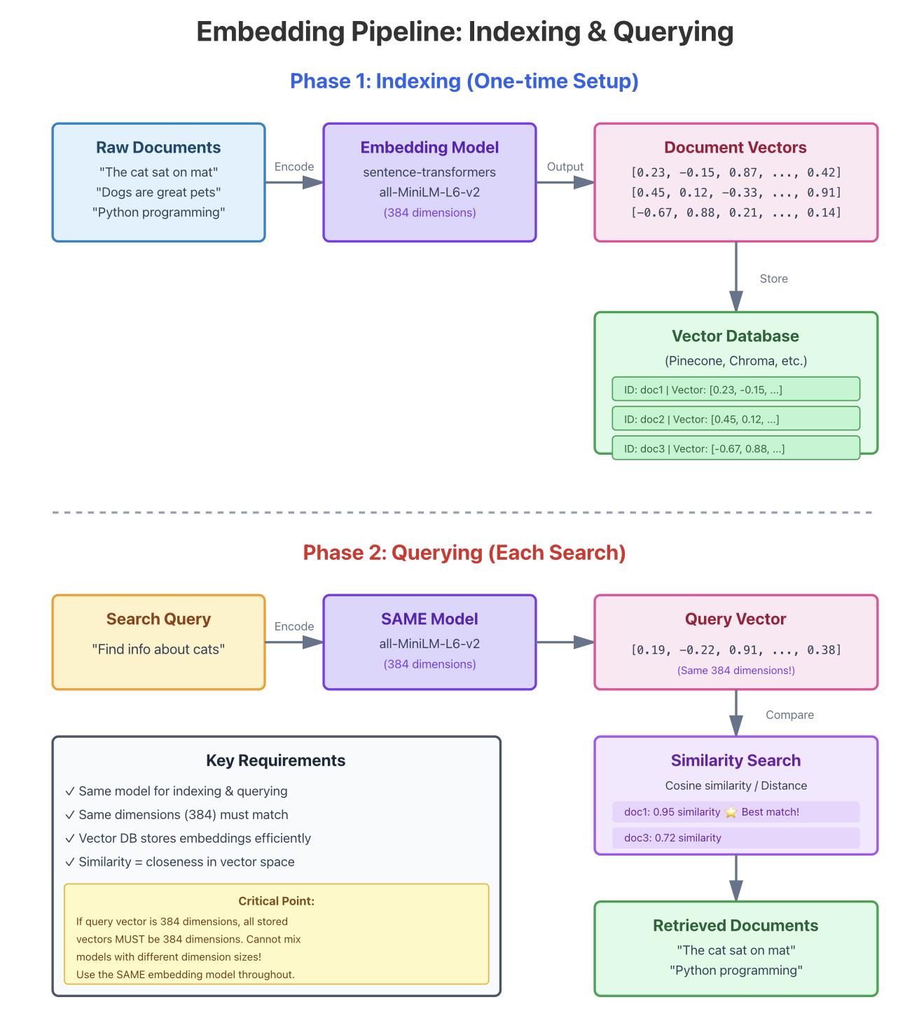

Regarding the dimension used during source data embedding and dimensions used on our query/filter… They need to match.
# This works ✅
search_query_vector = [0.2, 0.5, 0.8] # 3 dimensions
document_vector = [0.3, 0.4, 0.7] # 3 dimensions
similarity = compare(search_query_vector, document_vector) # ✅

# This FAILS ❌
search_query_vector = [0.2, 0.5, 0.8] # 3 dimensions
document_vector = [0.3, 0.4, 0.7, 0.1] # 4 dimensions
similarity = compare(search_query_vector, document_vector) # ❌ ERROR!

So how do we implement all of this.

Well, it all starts with, how do we “encode” our data. We start by calling an embedding model.
Models are normally executed/available either locally or via an online (public internet) as an API.

Easy enough, so far, or so we think. ;)

When calling an embedding model via a local function or an online API, a document or word is passed in as a parameter, that defines the data for which we want a vector value returned, now a word here does necessarily mean a single word, what we refer to here is a token, the string for which we want a vector value. Most times we will store the original text passed into the API and the returned value/vector in our datastore of choice.

Ok, sounds simple enough so far, but what’s this token we’re talking about.
Think of a token as a chunk of text that the AI processes as a single unit.
When you send text to an embedding model, it doesn't read it letter-by-letter or even word-by-word. Instead, it breaks your text into tokens first.
Examples:
- The word "cat" = 1 token
- The word "basketball" might be 2 tokens ("basket" + "ball")
- A space and short word like " is" = 1 token
- Punctuation often counts as its own token
Why it matters for embedding models:
Embedding models have a token limit - like a maximum capacity. If your text is 1,000 tokens and the model's limit is 512 tokens, you'll need to either:
- Split your text into smaller chunks, or
- Truncate it (cut it off)
The cost angle can never be ignored either, because nothing is ever for free, really… ;) :
You typically pay for AI services based on how many tokens you use. So a 100-token text costs less to process than a 1,000-token text.
Rule of thumb: In English, 1 token ≈ 4 characters or about 3/4 of a word on average. So roughly 100 tokens ≈ 75 words, and well, as you can imagine, this can add up quickly.
The embedding model of choice converts these tokens into a mathematical representation (the "embedding") that captures the meaning of your text - but it all starts with breaking your text into these tokens first.
At the same time.
As mentioned a token can be less than a word, exactly one word, OR multiple words, a phrase - though multiple words in a single token is less common.
Examples:
One token = multiple words:
- Common phrases like "New York" might be one token
- Contractions like "don't" = 1 token (it's treated as a single unit)
- Some frequent word combinations in certain languages
One word = multiple tokens:
- "unfortunately" might be split into 2-3 tokens like "un" + "fortun" + "ately"
- Technical terms: "cryptocurrency" could be "crypto" + "currency"
- Rare or complex words get broken into smaller pieces
The key insight:
Tokenizers (the tools that split text into tokens) are trained on massive amounts of text. They learn to create tokens based on what appears frequently:
- Common words/phrases → become single tokens (efficient!)
- Rare words → get broken into smaller sub-word pieces
- New/unusual words → might be split into many tokens
Why this matters:
If you're using an embedding model with a 512-token limit, you might fit:
- ~400 words of common English text, OR
- Only ~250 words if your text has lots of technical jargon, rare words, or non-English characters
The tokenizer tries to be smart enough by creating the most efficient chunks for the AI to process!
Most, or well all online models charge you for usage, primarily, this is normally done as we mentioned based on the number of tokens. Some might allow a small number of calls, aka some small number of tokens.

Ok, time for us to introduce sentence-transformers. Well, it’s a Python package at the simplest level, so why do you want to know about it?

Before we continue, why are we showing a Python package, well it’s simply, it’s the most common programming language utilised in the AI space and also in data analytics. Is it the only, NO, but it is def the most common…

Sentence-transformers as mentioned is a Python library that converts text (sentences, paragraphs or entire documents) into embeddings - those lists of numbers we discussed earlier. It's specifically designed to capture the meaning of text in a way that similar sentences get similar numbers.
Ok, but still how do we calculate embedding-vectors, easy answer, this is done by using the sentence-transformers Python package.

Now, as hinted above, a convenient feature of sentence-transformers is the fact that we can pass it and entire document to sentence transformers, it will figure out itself how to break it into words, and then return a single embedding-vector representing the meaning of the document. Ok, that’s sounds great, but also realize, sometimes you don’t want a single embedding vector for an entire document. There might be situations where you on purpose want to split the document into smaller chunks.

Sentence-transformers itself is basically a wrapper API, that can be configured to use any number for models, locally. Models that themselves can be downloaded, from i.e. Hugging Face and then used to compute vector values for our input data.

Before we continue, lets quickly discuss Hugging Face as it occupies a pretty importance space.

Hugging Face is firstly best known as a hub for downloading and hosting open-source machine learning models, datasets, and tools (via its Model Hub and libraries like Transformers). However, it also provides direct API interfaces for running inference on those models without needing to download or host them yourself. This allows you to make HTTP calls (or use SDKs) to execute tasks like text generation, embeddings, classification, and more on thousands of models hosted on their infrastructure.
For a non-local use case, below are some online examples. To use these, you would create an online account with the provider, this would normally include a billing section, after which they will then provide you with an API key, to be used when calling the API.

Depending on the provider, some of the functionality might be free, some NOT. Most will allow a small number of calls at no cost, after which you will be charged based on token count utilized.

- openai by OpenAI import openai
- genai by Google import genai
- cohere by Cohere import cohere

Let’s get back to Sentence transformers for a second, so exactly why is it's useful
Unlike simple word embeddings, sentence-transformers understands entire sentences as a unit. This means:
- "The cat sat on the mat" and "A feline rested on the rug" will have similar embeddings (similar meaning)
- You can compare, search, and cluster text based on actual meaning, not just keywords

Some Common Use Cases
1. Semantic Search
# Find documents similar to a query based on meaning
query = "How do I reset my password?"
# Matches "I forgot my login credentials" better than keyword search would
2. Duplicate Detection
# Find similar customer support tickets
# "My internet is down" ≈ "I can't connect to WiFi"
3. Clustering & Classification
- Group similar documents together
- Classify text into categories
4. Question-Answering Systems
- Match questions to relevant answers in a database

Basic Usage

from sentence_transformers import SentenceTransformer
# Load a pre-trained model
model = SentenceTransformer('all-MiniLM-L6-v2')

# Convert sentences to embeddings
sentences = [
"I love pizza",
"Pizza is my favorite food",
"I enjoy playing tennis"
]
embeddings = model.encode(sentences)
print(embeddings)
# Returns arrays like: [[0.2, -0.5, ...], [0.3, -0.4, ...], ...]

# Compare similarity
from sentence_transformers.util import cos_sim
similarity = cos_sim(embeddings[0], embeddings[1])
# High similarity between first two, lower with third

In our above Python examples, we used the 'all-MiniLM-L6-v2' model, below I list some more models supported by sentence-transformers and their proposed usage based on the documentation.

As per the documentation, Sentence-transformers supports a wide variety of pre-trained models. Over 10,000-15,000 pre-trained models in fact are available on Hugging Face SentenceTransformersPyPI, including models from the Massive Text Embeddings Benchmark (MTEB) leaderboard.
Here is the simplest example of a Python embedding encoder/vectorizer…
from sentence_transformers import SentenceTransformer
# Load the model (downloads on first run)
model = SentenceTransformer('all-MiniLM-L6-v2')
# Read your text file
with open('document.txt', 'r', encoding='utf-8') as f:
text = f.read()
# Create embedding
embedding = model.encode(text)
# Print results
print(f"Text length: {len(text)} characters")
print(f"Vector dimensions: {len(embedding)}")
print(f"First 10 values: {embedding[:10]}")
print(f"\nFull vector:\n{embedding}")

Accompanying this blog is a Git REPO with a Python application that’s capable of vectorizing a pdf and/or txt document/s. The application/example is currently capable to storing the computed vector values in either MongoDB and/or RedisDB, it’s simply what I had handy.

Below is a very incomplete, but short listing (even if this does not look like a short list) of the main categories and popular models:

General Purpose Models (all- series)*

These were trained on over 1 billion training pairs Sentence Transformers:
- all-mpnet-base-v2 Best quality general-purpose model
- all-MiniLM-L6-v2 Fast (5x faster than mpnet) with good quality, ideal for general embeddings
- all-MiniLM-L12-v2 Balance between speed and quality

Semantic Search Models

For question-answering and information retrieval:
- multi-qa-mpnet-base-cos-v1/dot-v1 - Trained on 215M Q&A pairs from diverse sources
- multi-qa-MiniLM-L6-cos-v1/dot-v1 - Faster, smaller version
- msmarco-distilbert-dot-v5 - Trained on Bing search queries
- msmarco-MiniLM-L6-cos-v5 - Good for search applications

Multilingual Models

Support 50+ languages:
- paraphrase-multilingual-mpnet-base-v2 - Best multilingual semantic similarity
- paraphrase-multilingual-MiniLM-L12-v2 - Faster multilingual option
- distiluse-base-multilingual-cased-v1 - 15 languages
- LaBSE - 109 languages, best for translation pair detection

Multimodal (Image + Text)

- clip-ViT-B-32 - Joint image-text embeddings
- clip-ViT-B-16 - Higher quality version
- clip-ViT-B-32-multilingual-v1 - Multilingual text with images

Specialized Models

- INSTRUCTOR models (hkunlp/instructor-large) Use task-specific instructions/prompts
- SPECTER Scientific paper similarity
- Sparse models (naver/splade-cocondenser-ensembledistil) For efficient retrieval

Choosing a model: Use all-MiniLM-L6-v2 for general tasks where speed matters, all-mpnet-base-v2 for best quality, multi-qa models for search/QA, and multilingual models when working across languages.

A more practical look, considering our blog series:

If we look out previous blog’s, we had 2 main data sources (topics, Adults and Children) that we convert to our below 5 data products as per below.

I’ve included the examples message (as JSON files) in the examples folder for reference.

- People profiles
  - 1. Adults
  - 2. Children
- 3. Addresses
- Bank Account Profiles
  - 4. Bank Accounts
  - 5. Credit Cards

Some considerations for embedding our data products.

1. People Profiles (Adults and Children)

Best: all-mpnet-base-v2 or all-MiniLM-L6-v2

- People profiles likely contain mixed textual data (names, descriptions, attributes)
- General-purpose models excel at capturing semantic meaning from varied text
- Use all-mpnet-base-v2 for highest accuracy
- Use all-MiniLM-L6-v2 if you need faster processing with large volumes

2. Address Profiles

Best: all-MiniLM-L6-v2 or paraphrase-MiniLM-L6-v2
- Addresses benefit from models that understand paraphrasing (same location, different formats)
- Consider paraphrase-multilingual-mpnet-base-v2 if dealing with international addresses
- Speed is often important for address matching at scale

Consider Multi-qa Models If…

- If your use case involves querying profiles (e.g., "find people in similar neighborhoods with young families"), then multi-qa-mpnet-base-cos-v1 might be better since it's optimized for question-answering retrieval.

Final Recommendation:

- Stick with all-mpnet-base-v2 for best quality or all-MiniLM-L6-v2 for speed. The expanded data makes embeddings more useful, not less, as the models can capture richer semantic relationships across all these dimensions.

3. Bank Account Profiles (Bank accounts and Credit Cards)

Best: all-mpnet-base-v2 or multi-qa-mpnet-base-cos-v1

- If accounts have descriptive text: use general-purpose models
- If you need to retrieve similar accounts based on queries: multi-qa-mpnet-base-cos-v1
- For structured data (account numbers, types), consider if embeddings are even needed vs. traditional matching

4. Bank Transaction Profiles - Fraud Detection

Well this one is not shown, but pretty relevant.

Best: Consider fine-tuning or specialized approach

- Challenge: Transaction patterns are often numerical/categorical, not natural language
- If you have transaction descriptions (text): Start with all-mpnet-base-v2
- However: For fraud detection, standard sentence transformers may not be optimal

For fraud detection specifically:

- Transaction data (amounts, times, locations, merchant categories) is typically better handled by:
- Custom embeddings trained on labeled fraud data
- Specialized fraud detection models
- Graph neural networks for transaction networks
- You could use sentence transformers for the textual descriptions of transactions, then combine with numeric features

Overall recommendation: Start with all-mpnet-base-v2 for profiles 1-3 (best quality), or all-MiniLM-L6-v2 if you need speed. For fraud detection, you'll likely need a more specialized ML approach beyond just text embeddings.

Regarding financial transactions, well they always follow an industry standard pattern.

You will always find an outbound transaction and an inbound transaction.

- The outbound transaction is always from an outbound bank, basically the payer’s account and then you have the inbound transaction, which is the receiving account, the payee account.

- Now, for the outbound transaction, which we can refer to as an event on the outbound account, the outbound account (payer) is called the accountHolder and the inbound account is called the counterPartyAccountHolder.

- The outbound bank for this view is referred to as the tenant and the inbound bank is called the counterPartyTenant.

- If we change our viewpoint to the inbound account, as an event, the Payee’s view in other words, they are now referred to as the accountHolder and the payer account is referred to as the counterPartyAccountHolder.

- In this second scenario the inbound bank is referred to the tenant and the outbound bank is now referred to as the counterPartyTenant.

A key challenge with Financial Transaction Data is, well, it is Not Natural Language.

Standard sentence-transformers are designed for semantic text similarity, but transaction data is very different, its primarily based on:

- Numerical: amounts, timestamps, frequencies
- Categorical: transaction types, merchant categories
- Relational: account-to-account flows, network patterns
- Temporal: time-series patterns, velocity changes

This leaves us with the following possible embedding options:

Option 1: Hybrid Text + Numeric Embeddings (Recommended Starting Point)

For text fields (if you have them):

- Merchant names/descriptions
- Transaction notes/memos
- Account descriptions

Use all-MiniLM-L6-v2 to embed these, then combine with:
For numeric/behavioral features, create manual feature vectors:

# Example feature vector per transaction
[
amount_normalized,
hour_of_day,
day_of_week,
time_since_last_transaction,
amount_deviation_from_mean,
transaction_velocity_7d,
counterparty_frequency,
# ... etc
]

Combine both:

combined_embedding = concatenate([
text_embedding, # 384-dim from MiniLM
behavioral_features # your custom features
])

Option 2: Graph-Based Embeddings (Better for Mule Detection)

For identifying mule accounts and transaction pipelines, you need to understand the network structure:

Consider:

- Node2Vec or DeepWalk: Create embeddings that capture account relationships in the transaction graph
- Graph Neural Networks (GNNs): Learn patterns like rapid in-out flows typical of mule behavior
- Libraries: PyTorch Geometric, Stellargraph, DGL

This is superior for detecting:

- Layering patterns (money moving through multiple accounts)
- Hub accounts (receiving from many, sending to few)
- Unusual connectivity patterns

Option 3: Specialized Transaction Embeddings

Train your own model on labeled fraud data:

- Use Sentence-BERT architecture but train on transaction sequences
- Input: Transaction history sequences
- Output: Embeddings where similar fraud patterns cluster together
- Requires: Labeled fraud/non-fraud examples

Option 4: Autoencoders for Anomaly Detection

For detecting "payments that don't fit normal behavior":

# Per account holder, train an autoencoder on their normal transactions
# High reconstruction error = anomalous transaction

This captures per-account baselines better than global embeddings.

Specific Recommendations for a Financial Use Cases:

Similar Payments by Account Holder

Approach: Concatenate transaction features into text, then embed

transaction_text = f"""
Account: {account_id}
Amount: {amount} {currency}
Counterparty: {counterparty_type}
Time: {time_features}
Frequency: {recent_frequency}
"""
embedding = model.encode(transaction_text)
```
**Model:** all-MiniLM-L6-v2 or all-mpnet-base-v2

### ** Anomalous Payments (Breaking Normal Behavior)**
**Better approach:**
- Build per-account behavioral profiles (mean/std of amounts, typical counterparties, time patterns)
- Use **Isolation Forest**, **Local Outlier Factor**, or **Autoencoders**
- Embeddings alone won't capture "deviation from personal norm" well

### ** Mule Account Detection**
**Best approach:** Graph-based methods
- Model accounts as nodes, transactions as edges
- Features: in-degree, out-degree, clustering coefficient, betweenness centrality
- **Graph embeddings** (Node2Vec) or **GNN** to learn structural patterns
- Look for: high transaction velocity, low balance retention, many unique counterparties

## **Practical Hybrid Architecture:**
```
Transaction Data
↓
┌─────────────────────────────────────┐
│ Feature Engineering │
├─────────────────────────────────────┤
│ • Text: Embed with sentence-transformers │
│ • Numeric: Normalize & engineer │
│ • Graph: Compute network features │
└─────────────────────────────────────┘
↓
Combined Feature Vector
↓
┌─────────────────────────────────────┐
│ Detection Models │
├─────────────────────────────────────┤
│ • Clustering: Find similar patterns │
│ • Anomaly Detection: Flag outliers │
│ • Classification: Use fraud scores │
│ • Graph Analysis: Identify mules │
└─────────────────────────────────────┘

Final Recommendations:

- Start simple: Use all-MiniLM-L6-v2 for any textual transaction descriptions + manual feature engineering for numerical data
- For anomaly detection: Per-account behavioral modeling (statistical or autoencoder-based) will outperform generic embeddings
- For mule detection: Invest in graph-based approaches - this is where the real signal is for pipeline detection
- Don't rely solely on sentence-transformers - they're designed for semantic text similarity, not fraud pattern detection
- Consider: Building a custom model fine-tuned on your labeled fraud data using the sentence-transformer framework as a starting point

For AI and machine learning applications that require vector search capabilities, the data is typically handled as follows:
- Storage: Embedding vectors can be stored within Paimon tables as a column using standard data types (e.g., ARRAY<FLOAT>). Various datastores have a proposed PIP-XXX to introduce a Blob store for multimodal data (images, audio, and their embedding vectors), which suggests a path for handling such data efficiently.
- Processing and Analysis: For performing actual vector similarity search or k-nearest neighbors (kNN) search, Various DB stores integrate with external systems or processing engines:
- Flink ML: Datastores that have Apache Flink integration capability can used with Flink ML to improve vector search and build AI-driven applications, where the vector processing logic is handled by the Flink engine.
- OLAP Systems: Datastores that can integrate with analytical engines like StarRocks and Apache Doris, which might offer their own capabilities for vector indexing and search on the data stored in XXX.
- External Vector Databases: A common pattern is to use a separate dedicated vector database (like pgvector or a specialized vector DB) for high-performance similarity search, with XXX serving as the unified lake storage for the raw data and potentially the source for continuously updating the vector database with real-time embeddings.
In summary, XXX (insert your lakehouse/vector datastore of choice) acts as a highly efficient, real-time data lake storage layer for all data types (structured and potentially semi-structured/unstructured via the Blob feature), but the specialized function of vector search is generally handled by the integrated processing or analytical tools built around it.

Hope this all got your curiosity tickled, and well, hope it was clear and well understandable… and not confusing…
Well this def did not exactly fit into the 5 minute read I originally envisaged.
Now that we’ve discussed this, as you can see AI and the related technologies themselves are a serious RABBIT Hole.
Fair warning, we haven’t even scratched the surface yet, there are concepts like RAG, Agentic IA, MCP etc.

And with that we shall shortly return to the normal scheduled program… ;)

Thanks for following. Till next time.



About Me

I’m a techie, a technologist, always curious, love data, have for as long as I can remember always worked with data in one form or the other, Database admin, Database product lead, data platforms architect, infrastructure architect hosting databases, backing it up, optimizing performance, accessing it. Data data data… it makes the world go round.

In recent years, pivoted into a more generic Technology Architect role, capable of full stack architecture.

George Leonard
georgelza@gmail.com
https://medium.com/@georgelza

