# Apache Flink SNMP Source Connector.

(7 July 2025)

# Overview

This all started with an accompanying blog, to be released shortly. The idea here is to take a new look at Datacenter monitoring using an old (or is that very mature) technology, namely SNMP, but integrate it with modern data streaming concepts i.e.: Apache Flink / Apache Fluss.

Firstly, what is SNMP (Simple Network Management Protocol).

As per Wikipedia

[**Simple Network Management Protocol**](https://en.wikipedia.org/wiki/Simple_Network_Management_Protocol)(**SNMP**) is an [Internet Standard](https://en.wikipedia.org/wiki/Internet_Standard)protocol for collecting and organizing information about managed devices on [IP](https://en.wikipedia.org/wiki/Internet_Protocol" \o "Internet Protocol)networks and for modifying that information to change device behavior. Devices that typically support SNMP include [cable modems](https://en.wikipedia.org/wiki/Cable_modem), [routers](https://en.wikipedia.org/wiki/Router_(computing)), [network switches](https://en.wikipedia.org/wiki/Network_switch), servers, workstations, printers, and more

As per [DPSelete](https://www.dpstele.com/snmp/what-does-oid-network-elements.php) reference:

SNMP Definition: Simple Network Management Protocol is an application-layer protocol that allows for the exchange of monitoring and managing information between network devices.

At the simplest level it’s a protocol allowing Datacenter devices, called Agents to send key/value sets of data to what’s called a Network Management Service, aka our Manager.

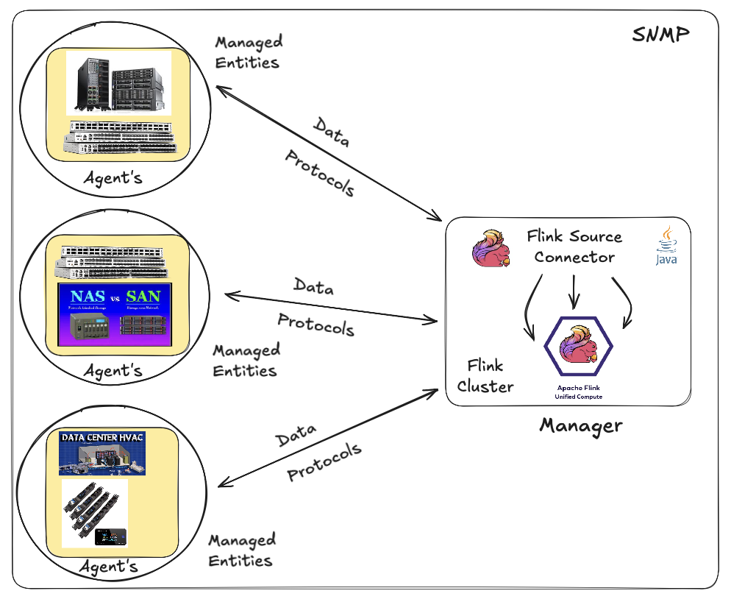

Now what is considered a agents… well, it’s really an open-ended question… It’s probably one of the most underappreciated standards available but underutilized in data centers still today. One I think needs more attention especially based on the rate that data centers are growing, at an amazing rate.

Back to agents, pretty much everything electronic today (bar mobile phones) is enabled as a snmp agent, even your home printer.

Below are 2 examples executed in my home network.

*snmpget -v1 -c abfr24 172.16.10.24 .1.3.6.1.2.1.1.5.0*

*SNMPv2-MIB::sysName.0 = STRING: vaultx*

*snmpwalk -v1 -c abfr24 172.16.10.3 1.3.6.1.2.1.1.2*

*SNMPv2-MIB::sysDescr.0 = STRING: Linux USWAggregation 3.18.24 #0 Thu Aug 30 12:10:54 2018 mips*

*SNMPv2-MIB::sysObjectID.0 = OID: NET-SNMP-MIB::netSnmpAgentOIDs.10*

*DISMAN-EVENT-MIB::sysUpTimeInstance = Timeticks: (1980275900) 229 days, 4:45:59.00*

*SNMPv2-MIB::sysContact.0 = STRING: Default*

*SNMPv2-MIB::sysName.0 = STRING: USWAggregation*

*SNMPv2-MIB::sysLocation.0 = STRING: Stud*

This project simply plugs into this standard and instead of being polled by a standard NMS (Network Management Service), we going to use An Apache Flink Cluster enabled with a SNMP Source Connector to poll our agents and retrieve our Data.

The source connector has been written in such a way to allow the user to utilize [Apache Flink](https://flink.apache.org/) SQL to define a “agent” or “agents”, referred to in the below example as “targets”.

The user can then define one or more OIDs (Object Identifier) to retrieve data from.

If the “snmp.poll_mode” is “GET” then multiple OIDs can be specified, if it is specified as a “WALK” then a single root will be configured, which will result in all the data of that and the child OID’s to be retrieved.

The rest of the variables are all in support of the above. The below link will redirect you to the GIT repo which will explain in more detail how to configure and build the project itself.

The accompanying (to follow) BLOG will then go into more of a use case, and deployment examples.

This Project: [GIT REPO](https://github.com/georgelza/DataPipeline-SNMP_Flink_Fluss.git)

CREATE TABLE hive.snmp.snmp_poll_data2 (

device_id VARCHAR(255) NOT NULL

,metric_oid VARCHAR(255) NOT NULL

,metric_value VARCHAR(1000) NOT NULL

,data_type VARCHAR(50) NOT NULL

,instance_identifier VARCHAR(255) NULL

,ts TIMESTAMP(3) NOT NULL

,WATERMARK FOR ts AS ts - INTERVAL '5' SECONDS

,PROC_TIME AS PROCTIME()

) WITH (

'connector' = 'snmp'

,'target' = '172.16.10.2:161,'172.16.10.3:161'

,'snmp.version' = 'SNMPv1'

,'snmp.community-string' = 'abfr24'

,'snmp.poll_mode' = 'GET'

,'oids' = '.1.3.6.1.2.1.1.5.0'

,'snmp.interval_seconds' = '10'

,'snmp.timeout_seconds' = '5'

,'snmp.retries' = '2'

);

use hive.snmp;

select * from hive.snmp.snmp_data_poll2;

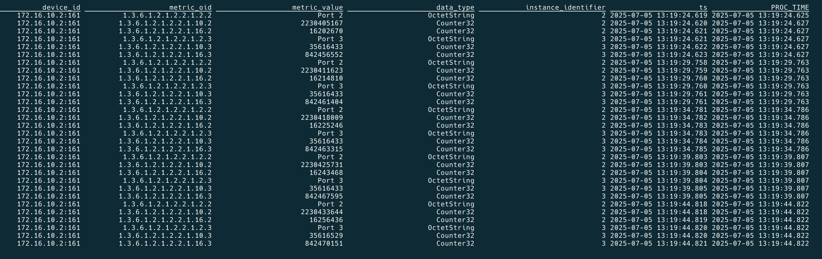

At this point, you have an active data stream source/Apache Flink table which can queried.



# And In Summary.

It looks simple. You might ask but why do we want to do this, well we now have the ability to define SNMP agents as targets (a table that we can query) using Flink SQL. What’s possible at this point is actually not fully realised, or appreciated yet I would say.

You can pull metrics directly from all data centre devices, via a real time data stream, enrich it and analyse that using simply analytics or AI/ML/RAG/MCP…

As always, I’m predictable, but I really do think this is pretty amazing… Hope you enjoyed the exploration, the journey up to now.

The next idea is brewing already ;)

Good luck, this is all fraught with rabbit holes, as always, so many and you can disappear so easily… but then that’s ½ the fun.



*Note: to execute this blog start with README.md located in the root folder and work from there, it will tell you exactly what to execute in which order to download all the dependencies and build everything. If you have any problems, welcome to reach out to me via one of the below profiles.*

**About Me**

I’m a techie, a technologist, always curious, love data, have for as long as I can remember always worked with data in one form or the other, Database admin, Database product lead, data platforms architect, infrastructure architect hosting databases, backing it up, optimizing performance, accessing it. Data data data… it makes the world go round.

In recent years, pivoted into a more generic Technology Architect role, capable of full stack architecture.

[George Leonard](https://www.linkedin.com/in/george-leonard-945b502/)

[georgelza@gmail.com](mailto:georgelza@gmail.com)

<https://www.linkedin.com/in/george-leonard-945b502/>

<https://medium.com/@georgelza>