COMP2221 Systems Programming Summative Coursework Report
[001138180]
xxxx-xxxx/0x/$xx.00 © 200x IEEE Published by the IEEE Computer Society
—————————— ——————————

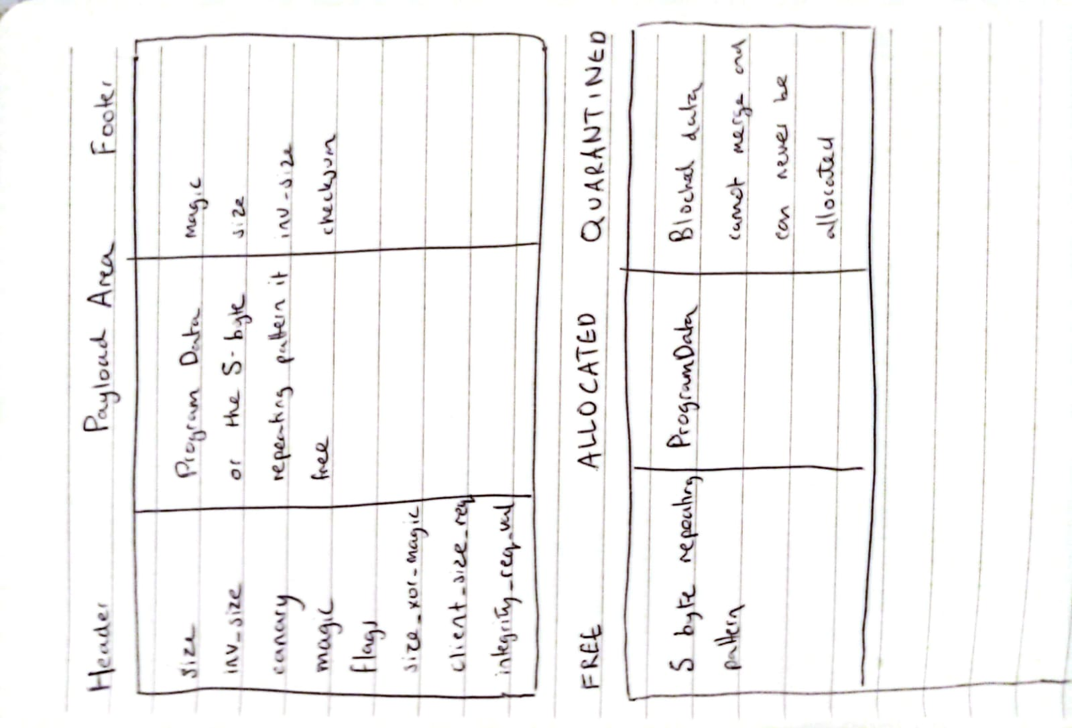
1 Summary of Approach & Solution Design
The memory management system is implemented as a robust, fault-tolerant allocator that operates solely within a single coniguous memory block provided by the rover's operating system. The design places a strong emphasis on integrity, data validation, and safe-failure behavior - ensuring resilience to bit-flips and partial writes - rather than prioritising raw run-time performance.

The solution uses an implicit free list, where all metadata is stored in redundant Header and Footer structures within the Heap itself, avoiding the use of any standard C library allocation functions.
All returned payload pointers are strictly 40-byte aligned (MM_ALIGNMENT 40u). This is enforced in mm_init by calculating the first 40-byte aligned address for g_heap and adjusting g_heap_size accordingly and is verified in mm_malloc and validate_payload_ptr relative to g_heap_base.

Each memory block uses a 40-byte BlockHeader and a 16-byte BlockFooter. The header includees redundant size fields (size and inv_size), integrity check key (canary), a full metadata checksum, and a unique resilience field, size_xor_magic (size ^ BLOCK_MAGIC).
Fig 1. Structure showing Header, Payload and Footer

Faults are handled by isolation. If validate_block detects corruption, the alloctor does not follow corrupted pointers but instead quarintenes the damaged block using quarantine_block (setting FLAG_QUARINTINED) permanently removing it from the allocation pool.

The allocator uses a Best-Fit allocation strategy, implemented via a linera scan of the entire implicit free list. This approach minimises external fragmentation and safely skips quarantined or corrupted blocks.

Fig 2. Heap layout showing 3 blocks labelled FREE, ALLOCATED and QUARANTINED.

The BlockHeader structure includes a specific field, size_xor_magic. This field is calculated and set in write_header using size ^ BLOCK_MAGIC and is explicitly checked during block validation in validate_block, proving an extra layer of corruption detection beyond the mirrored size fields and standard checksums.
A robust canary-value is calculated using bitwise operations combining offset, size, and BLOCK_MAGIC in compute_integrity_key, which is stored in the header. This canary is validated not only when reading the block but also during deallocation to prevent merging with a corrupted adjacent previous block.
Atomicity is enforced by calculating and writing the checksum as the last step in write_header. Furthermore, mm_write checks the payload hash before writing, then calculates and updates the hash after writing the data, ensuring any partial write due to a brownout will result in a hash mismatch on the next mm_read_operation, leading to quarantine.
mm_init calls detect_unused_pattern to identify the 5-byte repeating pattern, which is then used by paint_free_payload to clear freed memory, satisfying the requirement to clearly identify unused bytes.

2 Analysis of Solution
The time complexity incurred for mm_malloc is O(n) because the allocator must scan the entire implicit free list to find the block that minimises wasted space. This is slower than First-Fit but improves memory utilisation.
mm_read and mm_write operation high overhead due to the mandatory payload hash verification, resulting in O(p) complexity where p is paylaod size.
The recover_header_from_footer function, triggered by validation failure, implements a slow, byte-by-byte search (foff += 1) for a valid footer. This guarantees maximum resilience against misaligned corruption but significantly increases recovery time.

Each block consumes 56 bytes of fixed overhead regardless of payload size. This high ratio is necessary to store redundant checks (e.g. size, inv_size, checksum, canary, and the custom size_xor_magic)
All payload sizes are aligned up to the 40-byte requirement (MM_ALIGNMENT 40u). This can waste up to 39 bytes per allocation but was essential to meet the strict alignment constraint for the payload pointer.
The core resilience mechanism of quarantining damaged blocks (FLAG_QUARANTINED) permanently removes them from the usable heap. This results in irreversible external fragmentation but prevents corruption from spreading or causing fatal crashes, ensuring minimal survival.

3 USES of Generative AI, Tools, or other Resources
ChatGPT was used primarily for assisting with the implementation of complex boilerplate C functions and standard optimisation techniques. It was also used to help formulate standard utility functions (like align_up and align_down) and to refine the implementation of complex integrity functions such as polynomial hashes used in calculate_data_fingerprint and verify_metadata_hash.
VS Code Copilot was also used for code formatting, whitespace removal and code completion.
AI was deliberately excluded from core algorithmic decisions. The logic for the Best-Fit allocation strategy and the introduction of the novel resilience mechanisms were designed independently.

Another resource I used was IEEE Access' "Bits to Qubits: A Comparative Study of Memory Management in Classical and Quantum Systems " [1]. I used this for Triple Metadata Redundancy, advanced quarantine and containment and best-fit algorithm for fragmentation control.
The concepts outlined in this article informed several design decisions in my allocator. The articles discussion of metadata redundancy influenced my use of mirrored fieldsm checksums, and canary values to enable early detection of corruption. Its treatment of quarantine-based fault containment guided my approach to isolating damaged regions and preventing corrupted blocks from being merged during deallocation. Additionally, the articles analysis of allocation strategies reinforced my decision to adopt a Best-Fit search to limit external fragmentation, particularly importat when quarantined blocks reduce usable memory. Overall, the techniques presented in the source provided a solid foundation for developing a fault tolerant allocator capable of maintaining safe operation under memory corruption conditions.

4 Additional FUNCTIONALITIES
The allocator uses Best-Fit instead of First-Fit for mm_malloc. This O(n) search strategy minimises fragmentation by finding the smallest block that fits the needed size, thereby leaving larger blocks intact for future allocations.

The BlockHeader includes an extra custom integrity field: size_xor_magic. This field is set in write_header using size ^ BLOCK_MAGIC and is verified alongside other metadata checks in validate_blocks. This provides an enhanced defense against random bit-flips that might otherwise corrupt a single field.

The function coalesce_with_neighbours includes a special integrity check before merging with the previous block. It berifies the previous blocks canary against computer key (ph->canary != compute_integriy_key (prev_off, psize)). If the canary mismatches, the prebious block is immediatlet quarantined and merging is aborted preventing corruption from spreading backward through the heap.

The optional functions mm_heap_stats and mm_heap_dump are implemented. These tools provide detailed, structured output regarding memory usage (free, allocated, quarantined bytes), block counts, and alignment status, which is vital forr post-failure analysis.

References
- J.S. Bridle, Probabilistic Interpretation of Feedforward Classification Network Outputs, with Relationships to Statistical Pattern Recognition, Neurocomputing—Algorithms, Architectures and Applications, F. Fogelman-Soulie and J. Herault, eds., NATO ASI Series F68, Berlin: Springer-Verlag, pp. 227-236, 1989. (Book style with paper title and editor)
- W.-K. Chen, Linear Networks and Systems, Belmont, Calif.: Wadsworth, pp. 123-135, 1993. (Book style)
- H. Poor, A Hypertext History of Multiuser Dimensions, MUD History, http://www.ccs.neu.edu/home/pb/mud-history.html. 1986. (URL link *include year)
- K. Elissa, An Overview of Decision Theory, unpublished. (Unpublished manuscript)

Formatting Instructions for Word (DELETE)
TABLE 1
Units for Magnetic Properties
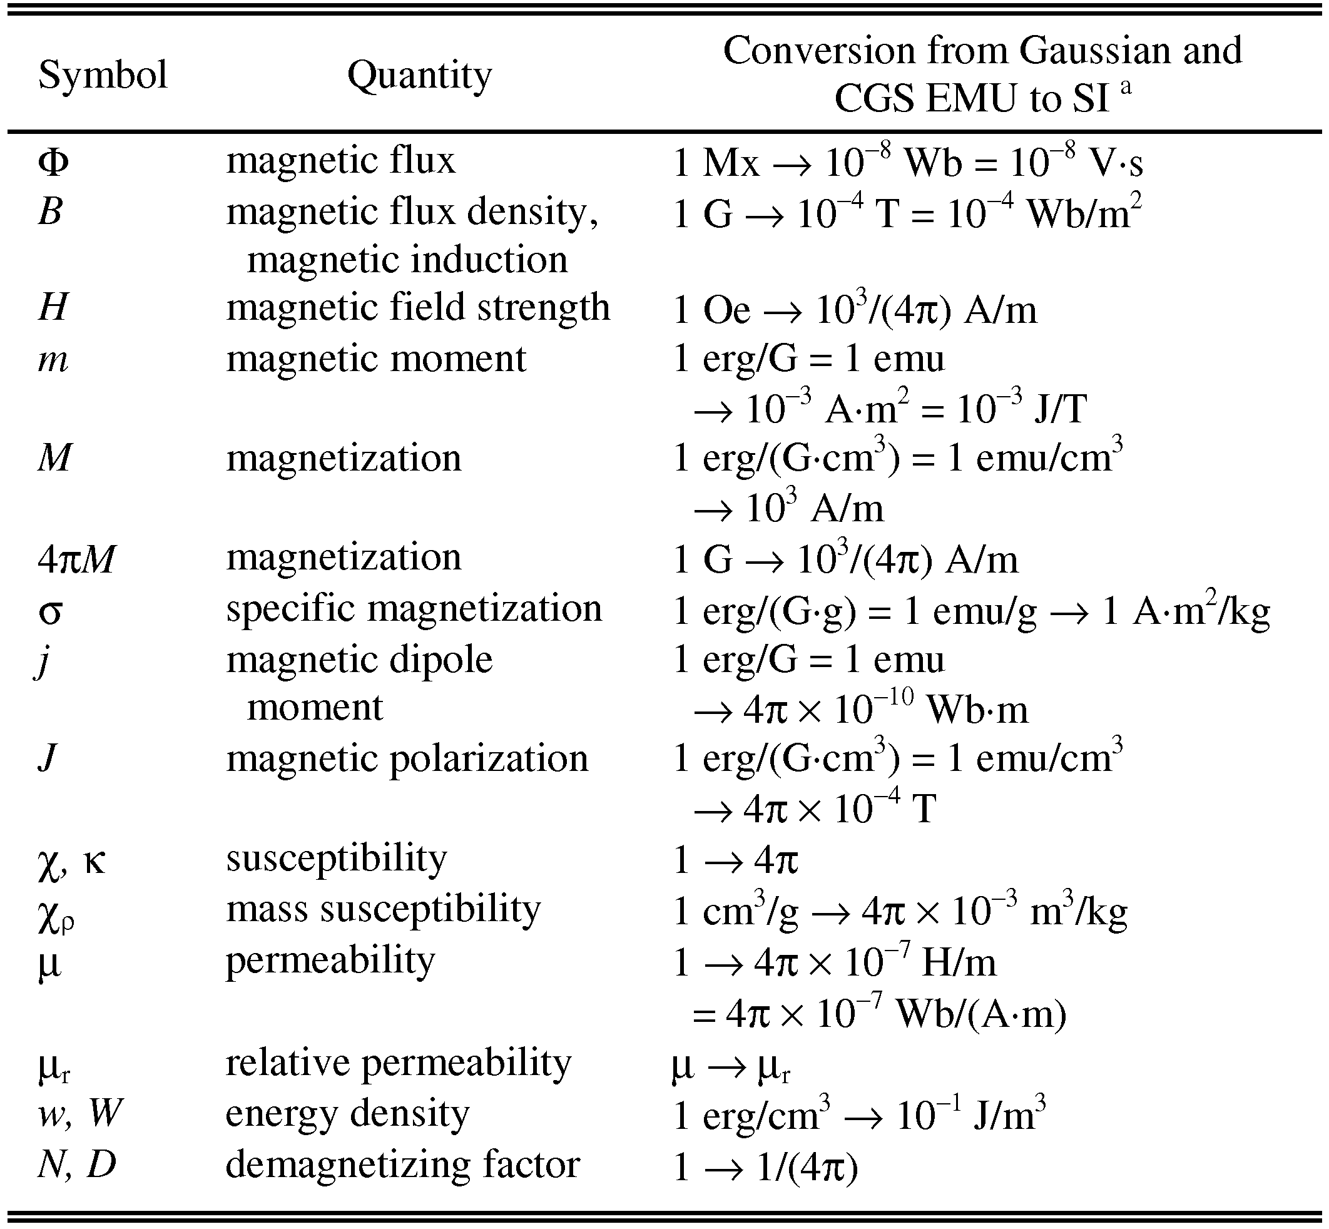
Statements that serve as captions for the entire table do not need footnote letters. E.g. Mx = maxwell, G = gauss, Oe = oersted; Wb = weber, V = volt, s = second, T = tesla, m = meter, A = ampere, J = joule, kg = kilogram, H = henry.

References
The list of cited references should appear at the end of the report, listed by order of appearance in the paper. The required style is to note citations in individual brackets, followed by a comma, e.g. “[1], [5]” (as opposed to the more common “[1, 5]” form.) Citation ranges should be formatted as follows: [1], [2], [3], [4] (as opposed to [1]-[4]). When citing a section in a book, please give the relevant page numbers [2]. In sentences, refer simply to the reference number, as in [3]. Do not use “Ref. [3]” or “reference [3]” At the beginning of a sentence use the author names instead of “Reference [3],” e.g., “Smith and Smith [3] show ... .”.

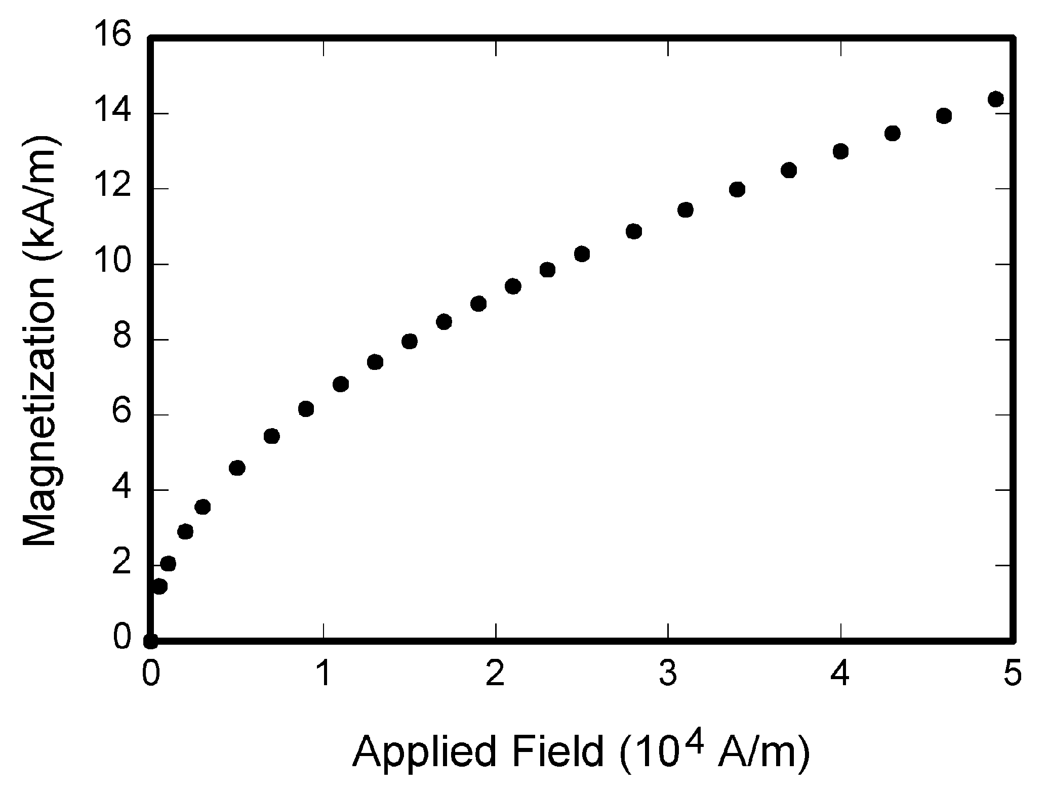
Fig 1. Magnetization as a function of applied field. There is a period after the figure number, followed by two spaces. It is good practice to explain the significance of the figure in the caption

