**Argument**

Ever since I was a teenager, I’ve caught myself daydreaming about the future — wondering what life might look like, what crazy inventions might catch on, and which ones we will laugh about later. Out of everything, artificial intelligence has probably been the one thing I kept coming back to. It is not just something out of sci-fi anymore, it is in our phones, our homes, and even quietly influencing decisions we do not even realize we are making.

I believe my interest in AI began after I read an article about self-driving cars. The idea that a machine could make split-second decisions on the road without a human behind the wheel honestly blew my mind because of how shocking this whole concept is. After that, I started noticing AI everywhere — in phones’ recommendations, in ads that weirdly seemed to know exactly what we are thinking about. That is when it hit me: AI is not just about robots or futuristic tech. It’s already woven into our daily lives.

One of the reasons I picked this topic for my project is that I genuinely think AI is going to keep changing the way we live, in ways we are only starting to notice. Some of changes can be seen already — certain jobs in the market start to be redefined because specific tasks can now be automated. Even the music we listen to and the games we all play are shaped by algorithms that somehow know what we like before we even do. What really fascinates me, though, is not just the tech itself, it’s how people respond to it. Some people are all in for it, while others are more hesitant or even skeptical.

With this project, I want to explore how AI is affecting everyday life — not just the big headlines, but the small stuff too. From the content we see in our feeds to the way we approach work and relationships, AI is already part of the picture. I’m hoping to capture both the excitement and the weirdness that comes with it. Because, like every major shift in technology, how we deal with AI now is going to shape our future in ways we probably can’t fully comprehend yet.

**Chapter 1. Introduction**

The rapid development of artificial intelligence began in the mid-20th century, when computer scientists first explored the idea that machines could be programmed to simulate human reasoning. Early experiments in the 1950s and 1960s produced only limited results, but they laid the foundation for what AI would later become. Progress slowed for several decades due to technical limitations, a period often referred to as the “AI winter.” However, advances in computing power, the growth of the internet, and the availability of vast amounts of data in the late 20th and early 21st century allowed artificial intelligence to evolve at a much faster pace.

By the early 2000s, AI was already present in daily life in subtle ways, such as spam filters in email, predictive text, and simple online recommendation systems. The real breakthrough came with the development of machine learning and deep learning, which enabled computers to process and analyse information in ways that were far more advanced than before. This progress opened the door to technologies such as voice recognition, facial recognition, and self-driving cars.

Today, artificial intelligence has expanded beyond specialised research and is increasingly integrated into ordinary routines. Smartphones, navigation apps, and social media platforms rely heavily on AI to adapt to user behaviour. At the same time, industries such as healthcare, education, and finance are reshaped by automated systems that can perform tasks once reserved for humans. The influence of AI is not limited to technology itself, but extends to the way people work, communicate, and even organise their personal lives.

As with all major technological revolutions, the spread of AI brings both opportunities and challenges. It promises efficiency, safety, and convenience, but it also raises important questions about privacy, employment, and the balance between human control and machine autonomy. These concerns make AI one of the most debated and influential subjects of the present time, and its role in shaping everyday life will only continue to grow in the years to come.

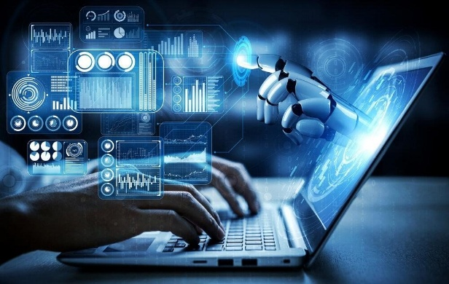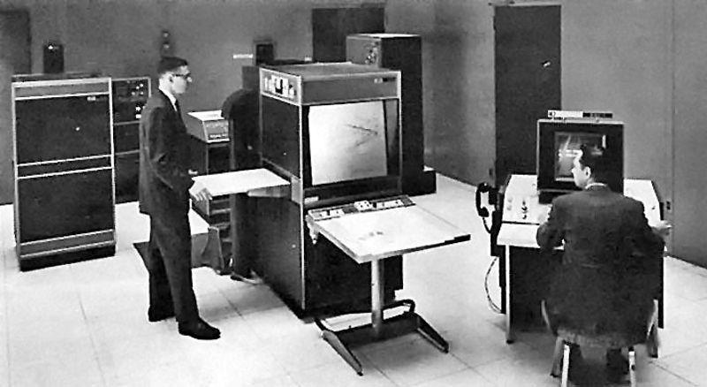

**Chapter 2. Benefits**

**2.1 Transforming Work Life**

Artificial intelligence has already begun to reshape the world of work, and its influence will only increase in the years to come. One of the most visible benefits is the automation of repetitive and time-consuming tasks. Simple office duties, such as sorting emails, scheduling meetings, or analysing basic data, can now be carried out by AI-powered systems. This allows employees to focus on more creative, strategic, and meaningful aspects of their jobs. In many industries, from finance to manufacturing, this shift increases productivity while reducing human error.

Another major advantage is the flexibility AI offers to workers. With the development of intelligent digital assistants, online collaboration platforms, and smart scheduling systems, remote work has become much more efficient. During the recent global health crisis, AI tools proved their value by allowing businesses to adapt quickly to remote working conditions. In the future, smart cities will support this trend even further, by providing reliable internet infrastructure and AI-driven logistics systems that help companies operate smoothly no matter where their employees are located.

**2.2 Enhancing Personal Life**

AI is not limited to the professional sphere. It is also present in our private lives in ways that bring convenience, comfort, and even health benefits. Smart homes, for example, are becoming increasingly common. They use AI to regulate heating, cooling, and lighting in order to save energy and reduce costs. AI-powered security systems can recognise unusual activity and alert homeowners in real time. Even grocery shopping is being transformed, as online platforms learn individual preferences and suggest products accordingly.

Health and wellbeing are also improved through AI applications. Wearable devices such as smartwatches now monitor heart rate, sleep patterns, and exercise routines, providing personalised advice for healthier living. In medicine, AI systems help doctors detect illnesses earlier and choose treatments more suited to each patient’s needs. These developments not only increase life expectancy but also improve quality of life by offering people more control over their health.

Entertainment and communication are further examples of AI’s impact on daily life. Streaming platforms recommend films and music based on personal taste, while translation apps allow people to communicate across language barriers. All of these technologies bring a sense of personalisation and accessibility that was unthinkable just a few decades ago.

**2.3 Smart Cities and Urban Living**

Perhaps one of the most ambitious and fascinating applications of artificial intelligence is the development of smart cities. These cities use AI and digital technologies to manage resources more efficiently and to create safer, cleaner, and more liveable urban environments.

Transportation is one of the areas where smart cities can offer the greatest benefits. AI-powered traffic systems are able to analyse real-time data and adjust traffic lights to reduce congestion. Self-driving buses and taxis are already being tested in several cities, offering safer and more efficient ways of moving people. These changes could lead to shorter commutes, less stress, and reduced pollution.

Energy and environmental management are also central to the concept of smart cities. With the help of AI, electricity grids can predict demand and avoid blackouts, while smart meters in households encourage residents to reduce unnecessary consumption. Waste management is being improved by AI systems that predict collection needs and optimise recycling processes. All of this contributes to more sustainable cities and a healthier environment.

Public safety is another benefit. AI-supported surveillance and emergency systems can detect unusual patterns and alert authorities more quickly than human observers could. Although this raises ethical debates, the advantage is clear when it comes to preventing accidents, responding to natural disasters, or detecting crimes.

Cities like London and New York are already experimenting with AI solutions to improve transport and reduce pollution, while Singapore has become a global example of how AI can make urban life more efficient and comfortable. In these cases, AI is not just a technological tool but a force that changes the very way citizens interact with their environment.

**2.4 Benefits for Society as a Whole**

Beyond individual advantages, AI also offers important benefits to society. In education, intelligent tutoring systems adapt to each student’s learning pace, making knowledge more accessible and effective. For people with disabilities, AI-powered tools such as voice recognition, text-to-speech software, and navigation aids provide greater independence and inclusion.

AI also strengthens global communication and cultural exchange. Real-time translation and personalised learning tools make it easier for people from different countries to understand each other, helping to reduce barriers between cultures.

In English-speaking countries, these benefits are closely tied to cultural values. In the United States, the emphasis often lies on innovation, speed, and convenience, which is reflected in the rapid adoption of AI for business and lifestyle. In the United Kingdom, the focus tends to be on sustainability and public welfare, so AI is often seen as a tool to improve healthcare, reduce pollution, and strengthen community life. These cultural differences show that AI is not only a technical development, but also a reflection of the priorities of the societies that adopt it.

**2.5 Looking Ahead**

The benefits of artificial intelligence are vast and diverse, and they are already transforming the way we live. From workplaces that are becoming more efficient, to homes that are smarter, to cities that are cleaner and safer, AI is a driving force of change. It offers the promise of a future where daily life is easier, healthier, and more connected.

Of course, this is only one side of the story. Just as AI brings opportunities, it also raises new risks and challenges. These will be discussed in the following chapter, but it is clear that the positive effects of AI are already visible, and they will continue to expand as the technology develops further.