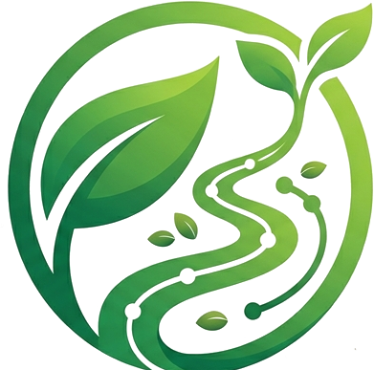 GREENTRACK
Nutrition List
Garden to Table Tracker
CROP NUTRITIONAL REFERENCE MATRIX

Crop Nutritional Reference Matrix
This matrix is the reference GreenTrack pulls from whenever a batch is scanned. Values are shown per 100 grams of raw, edible portion, calculated from GreenTrack's per-gram sensor baseline, so they can be compared directly against a typical serving size.
Crop | Calories | Carbs | Protein | Fiber | Key Highlight
🍅 Cherry tomatoes | 18 kcal | 3.9 g | 0.9 g | 1.2 g | High in lycopene, a powerful heart-healthy antioxidant, and Vitamin C.
🌿 Basil | 23 kcal | 2.7 g | 3.2 g | 1.6 g | Exceptionally rich in Vitamin K, vital for blood clotting and bone health.
🥬 Lettuce | 15 kcal | 2.9 g | 1.4 g | 1.3 g | Extremely high hydration content (95% water) and rich in Vitamin A.
🥒 Cucumber | 15 kcal | 3.6 g | 0.7 g | 0.5 g | Contains silica, a micronutrient essential for healthy skin, hair, and muscles.
🫑 Bell pepper | 20 kcal | 4.6 g | 0.9 g | 1.7 g | One of the richest dietary sources of bioavailable Vitamin C.
🌽 Sweet corn | 86 kcal | 18.7 g | 3.2 g | 2.0 g | High in lutein and zeaxanthin, carotenoids that protect eye health.
🧅 Spring onion | 32 kcal | 7.3 g | 1.8 g | 2.6 g | Rich in folate and allyl sulfides, which support immune defense.
🥬 Kale | 49 kcal | 8.8 g | 4.3 g | 3.6 g | Superfood status — packed with calcium, iron, and Vitamins A, C, and K.
🍆 Eggplant | 25 kcal | 5.9 g | 1.0 g | 3.0 g | The skin contains nasunin, a powerful antioxidant that protects brain cells.
🥕 Carrot | 41 kcal | 9.6 g | 0.9 g | 2.8 g | Outstanding source of beta-carotene, which the body converts to Vitamin A.
🥬 Pechay (Pak choi) | 13 kcal | 2.2 g | 1.5 g | 1.0 g | High in structural calcium and glucosinolates, compounds linked to cellular protection.
🫘 String beans | 31 kcal | 7.0 g | 1.8 g | 3.4 g | Excellent source of manganese, which aids metabolism and bone health.
Note: figures are averaged, raw-weight nutritional estimates intended for general reference inside the GreenTrack app, and may vary slightly by variety, growing conditions, and ripeness at harvest.

