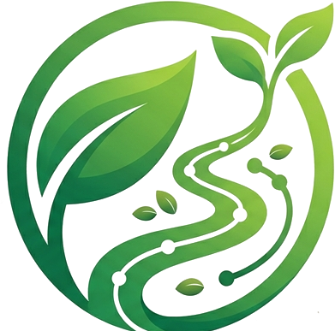 GREENTRACK
App Report
Cultivating Conscious Consumption
FARM-TO-TABLE TRACEABILITY PLATFORM

What GreenTrack Is
GreenTrack is a digital “Garden-to-Table” supply chain traceability app built to bring absolute transparency, safety, and climate resilience to the agricultural ecosystem.
The application functions as an end-to-end digital farm logbook and verification platform.
For farmers, it serves as a smart mobile diary that tracks crops throughout their entire lifecycle — mapping planting plots via GPS, tracking water usage, optimizing schedules against local weather, and enforcing safety countdowns for pest-control treatments. At harvest, the app aggregates this history to auto-generate a unique, tamper-proof QR code attached to the produce crates.
For commercial buyers (chefs) and consumers (diners), GreenTrack acts as a transparent window into their food. By simply scanning the QR code at a grocery shelf or restaurant table, users instantly unlock the exact origin, harvest timestamp, real-time farm weather history, organic verification, and a precise nutritional and caloric breakdown of their meal.

Defining the Exact Gap in the Market
While modern supply chains run on basic inventory software, the current agrifood market suffers from a critical “three-fold operational gap” that GreenTrack is built to solve:
GAP A

The “Anonymity Black Hole” for Small-Scale Farmers
Once a smallholder farmer harvests premium, sustainably grown, or 100% organic produce and sells it to bulk distributors, their identity is entirely erased. In traditional logistics, premium crops are mixed into generic crates with lower-grade produce.
The farmer has no way to prove the superior quality of their specific yield, preventing them from branding themselves or commanding premium market prices. Their hard work becomes invisible.
GAP B

The Lack of Verified “At-the-Source” Data
Most food-tracking systems are reactionary, entering the supply chain only after the food arrives at a packaging facility or warehouse.
There is a severe lack of verified data capturing what actually happens in the soil. Current systems cannot prove to a buyer whether a crop was watered with clean water, whether it survived a heavy climate storm, or whether a pesticide spray was given the mandatory days to safely break down before harvest.
GAP C

Consumer Skepticism and Nutritional Blindness
Today's consumers and diners are highly health-conscious and increasingly distrust generic “organic” or “fresh” marketing labels, which are easily falsified.
When looking at a plate of food or a supermarket shelf, the consumer is completely blind to its history. They have no fast, interactive way to verify actual freshness, trace its carbon footprint, or pull up an accurate, dynamic nutritional breakdown based on the food's real transit timeline.

Why GreenTrack Wins
The bottom line
GreenTrack fills these structural gaps by creating a two-sided, data-driven trust loop. It empowers the farmer with a digital voice and climate-smart warnings, while simultaneously giving the consumer unalterable proof of safety, nutrition, and origin — in under two seconds.

