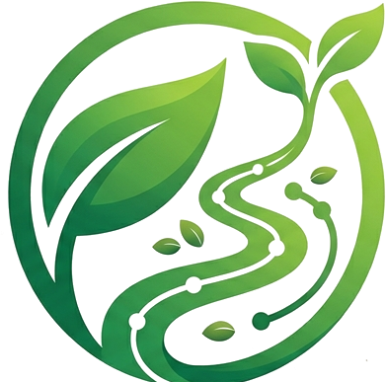 GREENTRACK
User Stories
One batch, four people
FARMER · SHOPPER · CHEF · DINER
A single crate of vegetables passes through four pairs of hands before it's eaten — here is what GreenTrack looks like from each one.
STOP 01
The Farmer
Mwangi — grower
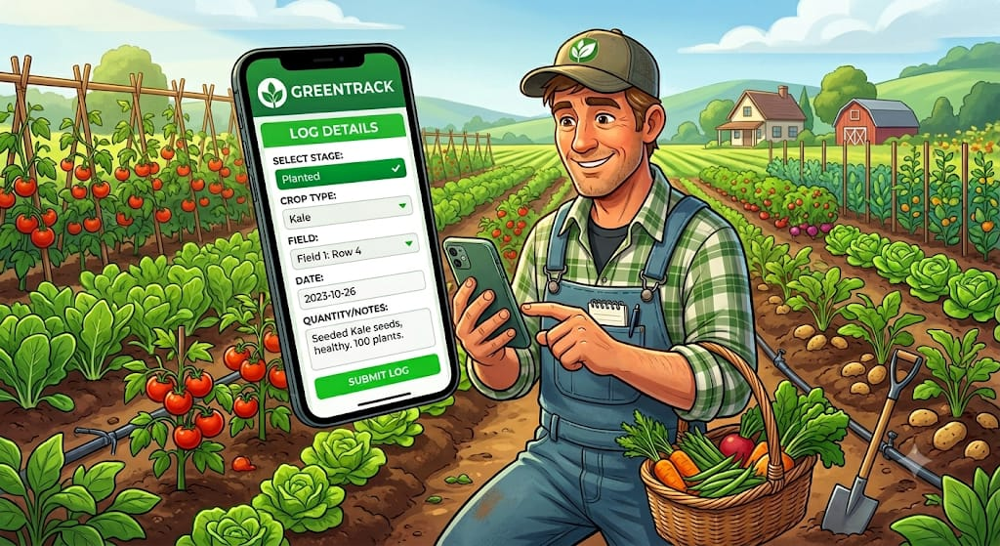
Mwangi logging a new crop batch on GreenTrack before sunrise.
Mwangi is a farmer who uses the GreenTrack app to track the progress of the crops in his garden.
Whenever he plants crops in his garden, he creates a new crop batch, inputs the crop name, selects his farming method, and uses his phone's GPS to pin-drop the exact location of his plot — all on the GreenTrack app.
To grow nutrient-rich vegetables, he manages a strict watering schedule. Using the app, he logs the irrigation with a single tap, recording the water source and the time he irrigated his crops. This way, he always knows the appropriate time for his next irrigation and the right amount of water for each crop, all scheduled automatically in the app.
Weather conditions are another key factor in the farming process. With GreenTrack, Mwangi no longer has to rely solely on traditional farming patterns passed down through generations. He can see the seasons for long and short rains, how much water his crops need under certain conditions, and the appropriate season to plant certain crops.
If he notices pests on his crops, instead of panicking he navigates to the Pest Diagnosis module on GreenTrack. He takes a photo of the affected leaves, and the app's integrated database matches the visual symptoms, confirms the type of pest, and recommends the appropriate pesticide and how to apply it.
When harvest time approaches, the app enforces a Pre-Harvest Interval (PHI) based on the pesticide used. It locks the harvest function for that crop batch, and Mwangi must wait out the countdown to guarantee that any spray residue has completely broken down, making the produce safe for consumption.
One to two days before harvest, Mwangi inspects his plot to check for maturity and estimate how many kilograms or crates will be yielded, then inputs that data into the app. This alerts partnered buyers that a fresh batch of a specific size is about to be available, preventing food waste from sitting around after being picked.
When harvesting, the farmer taps “Log Harvest” in the app, which automatically captures the exact date, time, and ambient weather conditions, and aggregates all historical data from planting onward.
After harvest, Mwangi inputs the final verified weight into the app, which instantly processes all the logs and auto-generates a unique QR code for that specific batch. Mwangi then prints the QR code and sticks it directly onto the delivery crates or packages.
Mwangi can now deliver his harvest to his buyers, and he begins planning to plant new crops, repeating the same cycle using the GreenTrack app.
STOP 02
The Grocery Shopper
Faith — buyer
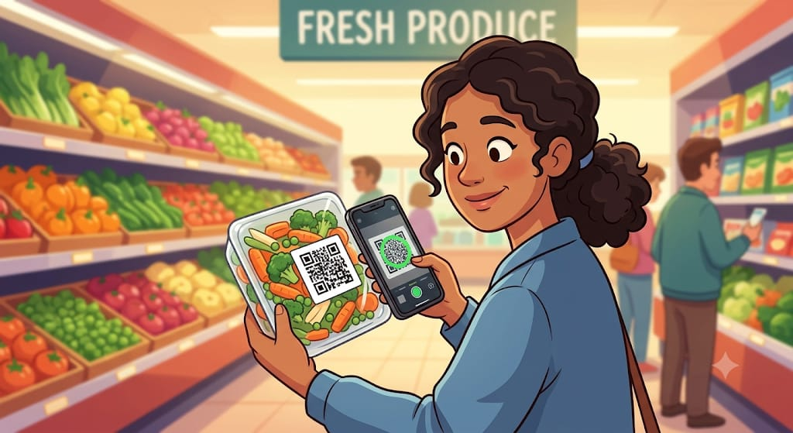
Faith scanning a batch tag before adding it to her cart.
Meet Faith, a busy shopper who cares deeply about organic, fresh food but is skeptical about supermarket labels and wants to know exactly where her vegetables are sourced.
Faith stands in the grocery aisle looking at a package of vegetables labelled “fresh,” but she has no way of verifying whether it was harvested yesterday locally or travelled for days on a truck.
She pulls out her phone, opens the GreenTrack app, and scans the QR code on the packaging. Instantly, she sees the exact farm where it was harvested and the journey the vegetables followed to reach the grocery store shelf.
She adds the vegetables to her shopping cart with confidence.
STOP 03
The Chef
Sarah — restaurant
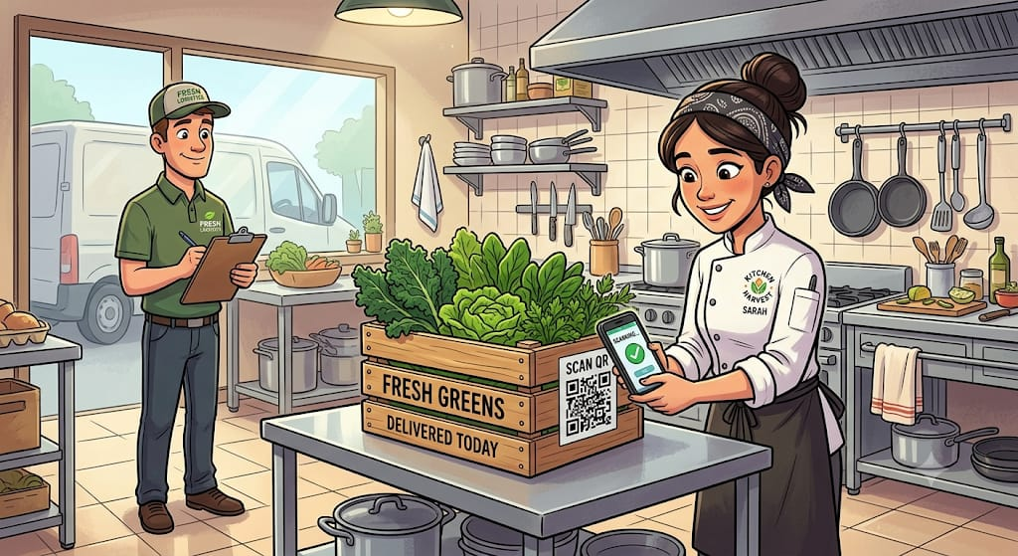
Sarah verifying a crate's freshness before the lunch rush.
Sarah is a chef at a restaurant well known for its “green bowl” (a vegetable dish). She has just received a crate of vegetables from a supplier and wants to ensure they are fresh and locally sourced.
Through GreenTrack, she doesn't have to trust the supplier's word for it and risk serving a dull, day-old produce that has lost its nutritional value the longer it sits in transit. Instead, she verifies the vegetables' freshness on the app.
She scans the QR code on the crate and instantly confirms the greens were harvested by Mwangi just hours ago, and that the batch carries organic certification. Confident in their freshness and maximum nutrient retention, she builds her signature green bowl for the lunch rush, proud to know exactly what is entering her kitchen.
STOP 04
The Diner
Mary — guest
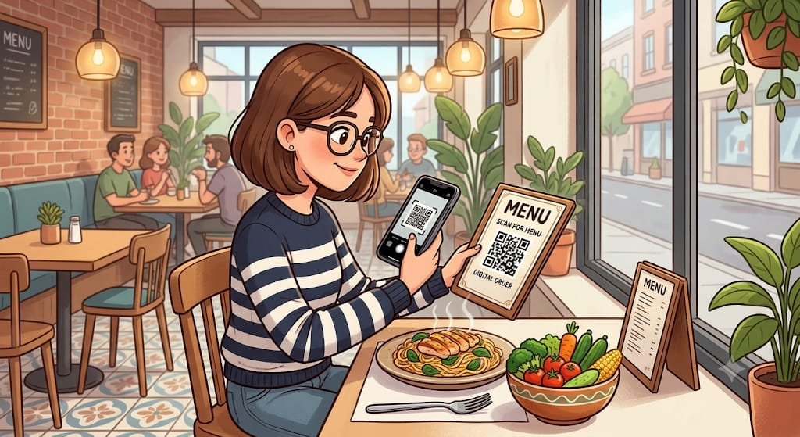
Mary scanning the code beside her menu before her meal arrives.
Mary, a fitness-conscious diner, sits at Chef Sarah's restaurant studying the menu. The description reads “Nutrient-rich organic green bowl,” but she's skeptical. Restaurant meals are notoriously hard to track accurately; she doesn't know the exact nutritional density, or whether the ingredients are truly fresh enough to have retained their vitamins.
When her meal arrives, she notices a small GreenTrack QR code printed next to the menu. She scans it with her phone, and instantly her screen populates with a clear breakdown of the exact vitamin and caloric content of the meal, verified by its fresh transit timeline.
She logs the exact nutrients into her fitness tracker with absolute peace of mind, and enjoys a meal she completely trusts.

