ML HW11 Report

物理三 潘阜承 B08202036

1. 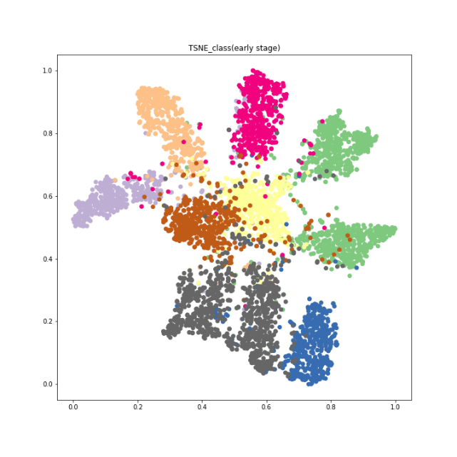Visualize distribution of features across different classes.

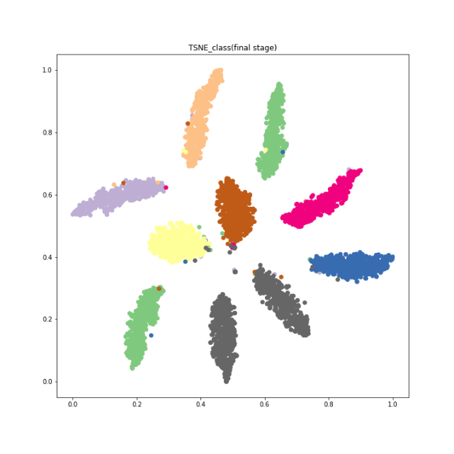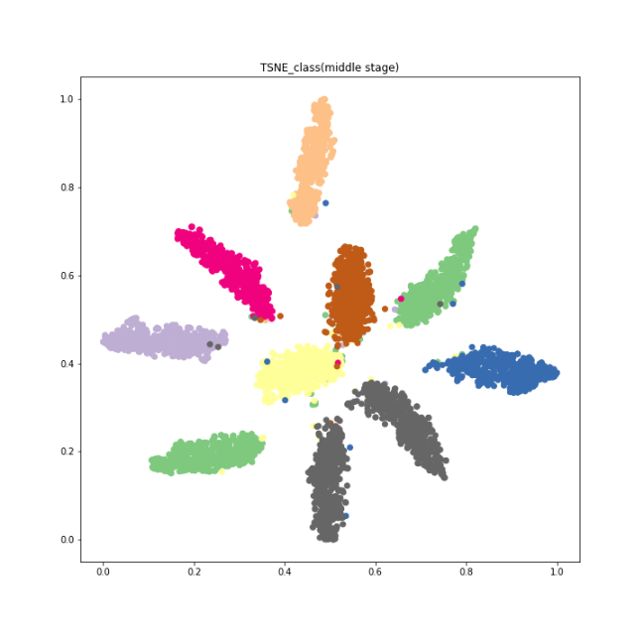

To be detailed, I trained the model for total 500 epochs. Therefore, early stage, middle stage and final stage refer to the model at 50 epoch, 250 epoch and the last epoch respectively. As we can see from the figures, I believe the feature extractor is a fairly good model for classification since we are able to see the separation of classes clearly in t-SNE from the middle stage. Also, we can also see that the performances of the model had gradually increased in terms of separating different classes. These results are quite reasonable since I followed the architecture of vgg model when creating feature extractor, and it is well-known that vgg performs well in terms of classification tasks.

1. 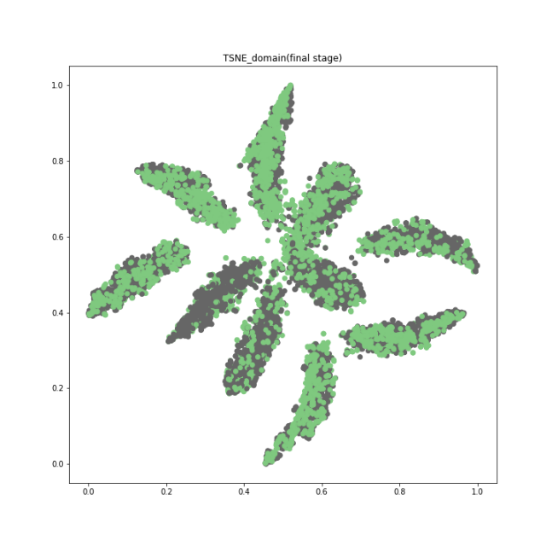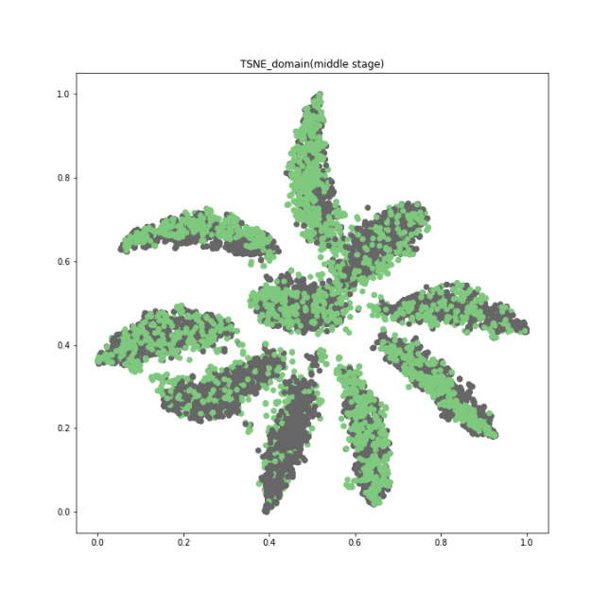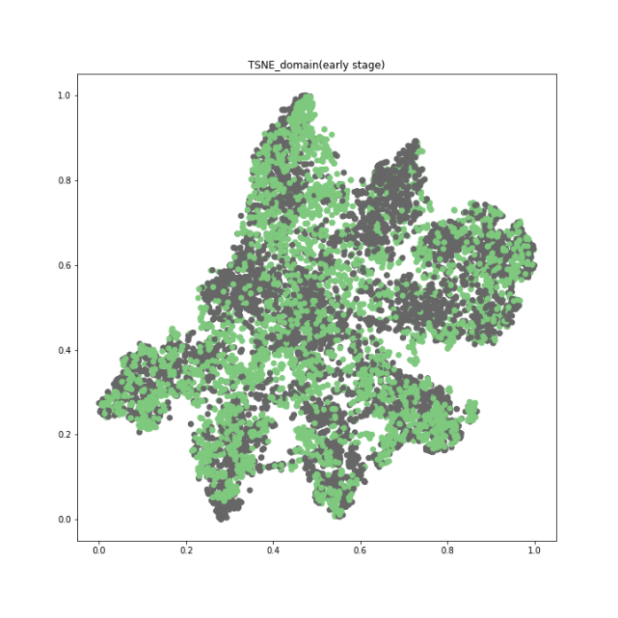Visualize distribution of features across different domains.

The settings of early, middle and final stages are the same as Q1. As we can see from the figures, source data and target data are well-merged even from the early stage and keep on improving until the final stage which has seemly the best performance. I believe this is a good feature extractor for domain adaptation (DA) tasks since we aimed to make distribution of different datasets look similar, and it is obvious from the figures that the features of two datasets look alike.