ML HW14 Report

B08202036 物理三 潘阜承

1. Plot the learning curve of the metric with every method.

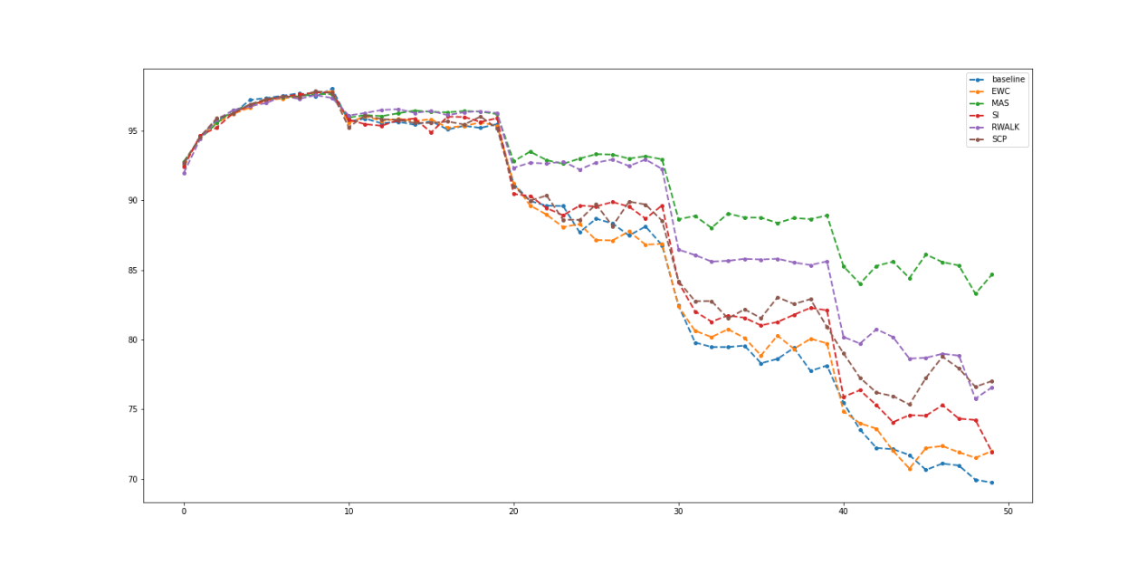

1. Describe the metric.

The metric we use in the homework in order to measure the performances of each method is simply counting the correct predictions produced by the model on the testing set. However, not only does it calculate the accuracy on the current task but also all the previous tasks. This way, we can check whether the model has forgotten the previous tasks.

1. Paste the code that you implement Omega Matrix for MAS.

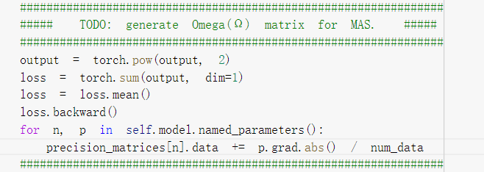

Reference:

1. https://arxiv.org/pdf/1711.09601.pdf