Lab Book Layout — Experiment 2: Gravitational Acceleration
George · how to set out pages 5–10, following the same layout as Ryan's lab book
How to read this guide
- Blue text = write this in your lab book by hand (headings, calculations, results).
- Grey boxes = the points to cover. Write these sentences in your own words.
- Orange dashed boxes = cut out that page of the print pack and glue it in there.

What to print
Print Lab_Book_Print_Pack_George.pdf (6 pages) and cut along the dashed boxes.
Print pack page | Item | Glue onto lab book
1 | Example of tracking the ball (Run 3) | Page 6
2 | Recorded data for Run 3 (full table) | Page 7
3 | Velocity vs time graph, Run 3 | Page 8
4 | Value of g for each run (or copy by hand) | Page 9
5 | All 9 runs combined graph (extra) | Page 10
6 | Air resistance check table (extra) | Page 10

Also save both Excel files (Experiment2_Gravity_George.xlsx and Experiment2_Data_Tables_George.xlsx) in your class computer folder for this lab — the lab book refers to them for the other 8 runs.

LAB BOOK — PAGE 5 Purpose · Apparatus · Procedure (group page, already written)

This page is already done. Make two corrections:
- Purpose, the equation: change h = v₀ + ½gt² to h = v₀t + ½gt²
- Procedure step 2: cross out "240 fps in slow-mo mode" and write 120 fps (normal video)

LAB BOOK — PAGE 6 Data Analysis

Data Analysis:
Write 2–3 sentences in your own words, including:
- The videos were filmed at 120 frames per second, so frames are 0.0083 s apart.
- The position of the ball was measured in every frame by tracking its centre with a video-tracking program (be honest that it was not Tracker).
- The scale came from the drop height: 82.5 cm from the bottom of the ball to the base, measured with a metre stick.
- Time t = 0 is the last frame before the ball starts to fall.

✂ GLUE IN: print pack page 1 — Example of tracking the ball (Run 3)
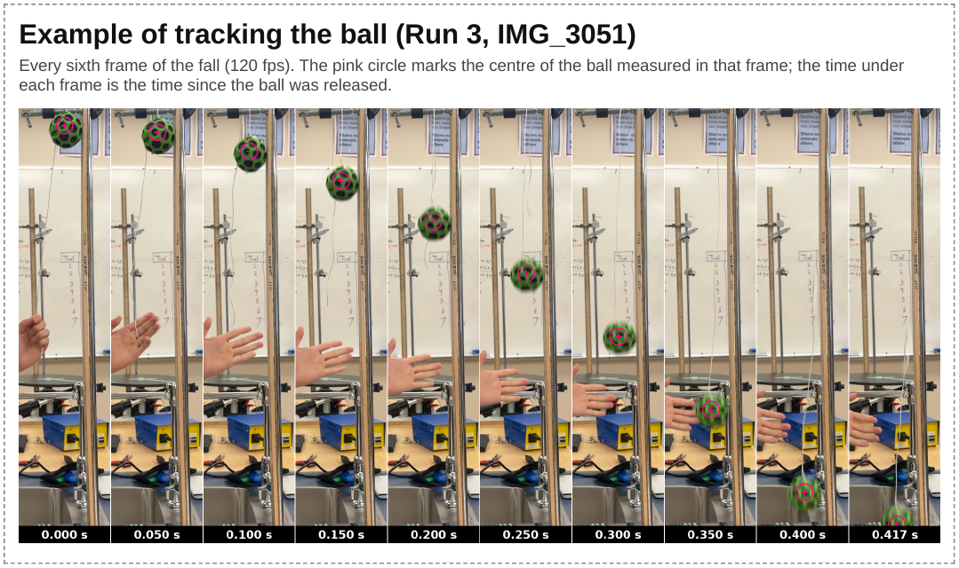
↑ label it: "Example of tracking (Run 3)"

LAB BOOK — PAGE 7 Recorded data + example calculations

 | Recorded Data for Run #3  Example of smoothed height for t₂  h_{s2} = (h₁ + h₂ + h₃) / 3  = (0.82496 + 0.82438 + 0.82257) / 3  No hₛ at t₁ or t₅₁ because h₀ and h₅₂ don't exist.  Example of average velocity at t₂  v₂ = (h_{s3} − h_{s2}) / (t₃ − t₂)  = (0.82267 − 0.82397) / (0.016667 − 0.008333)  ↑ extra decimal places from the spreadsheet; with the 3-decimal table values the rounding gives the wrong answer.  No velocity at t₁, t₅₀ or t₅₁ because hₛ is missing there.
  ✂ GLUE IN: print pack page 2 — Run 3 table
  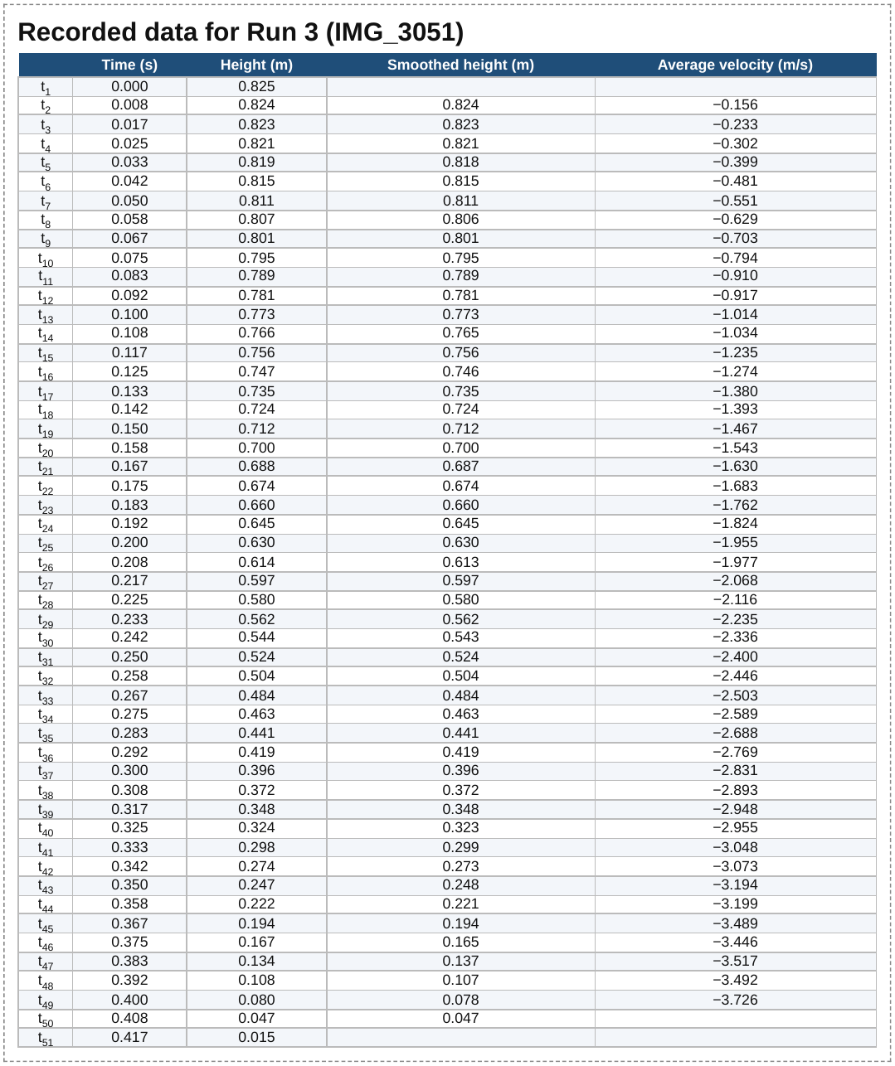
  h_{s2} = 0.82397 m
  v₂ = −0.156 m/s

LAB BOOK — PAGE 8 Graph + determining g

✂ GLUE IN: print pack page 3 — Velocity vs time graph, Run 3
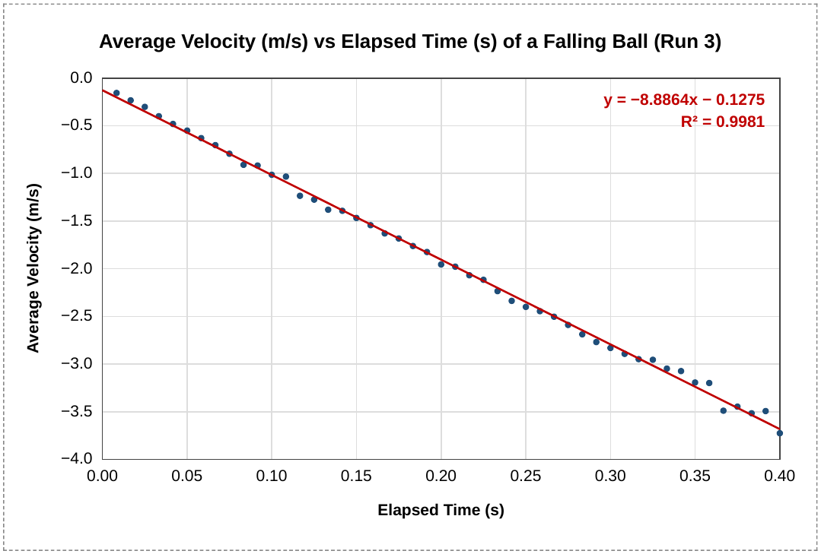

Data for the other 8 runs is in the Excel files (Experiment2_Gravity_George.xlsx) in the computer folder.

Determining constant g:
Within the velocity–time graph above, −g is given by the slope of the trendline.
y = −8.8864x − 0.1275
−g = −8.8864
∴ g = 8.8864 m/s²

LAB BOOK — PAGE 9 Results table · mean · uncertainty · conclusion

Copy this table by hand (or glue in print pack page 4):
Run # | Trendline Equation | R² value | Value of g (m/s²)
1 | y = −8.6225x − 0.2339 | 0.9901 | 8.6225
2 | y = −8.7772x − 0.1657 | 0.9980 | 8.7772
3 | y = −8.8864x − 0.1275 | 0.9981 | 8.8864
4 | y = −8.6806x − 0.1454 | 0.9971 | 8.6806
5 | y = −9.0588x − 0.1516 | 0.9985 | 9.0588
6 | y = −9.1246x − 0.0827 | 0.9982 | 9.1246
7 | y = −8.8489x − 0.2167 | 0.9982 | 8.8489
8 | y = −8.9518x − 0.1558 | 0.9975 | 8.9518
9 | y = −9.0938x − 0.2318 | 0.9983 | 9.0938

Mean Value of g
x̄ = Σxᵢ / n
= (8.6225 + 8.7772 + 8.8864 + 8.6806 + 9.0588 + 9.1246 + 8.8489 + 8.9518 + 9.0938) / 9
= 80.0446 / 9 = 8.8938
  g ≈ 8.89 m/s²
  Using TI-84 (1-Var Stats): Sx = 0.180 m/s²

Uncertainty: write in your own words, including:
- Air resistance is the main error, and you have evidence: g from the first half of each fall averaged 9.22 m/s² but the second half only 8.42 m/s² (light ball with holes).
- The ball was let go by hand, somewhere within one frame (8 ms) of t = 0.
- The drop height was measured with a metre stick (±0.5 cm of 82.5 cm, about 0.6%).
- One video (IMG_3041) was a duplicate of IMG_3055, so 9 runs were used, not 10.

Percent error = | Experimental − Theoretical | / Theoretical × 100
= | 8.89 − 9.81 | / 9.81 × 100 = 9.34 %

CONCLUSION
g = 8.89 m/s², Sx = ±0.18 m/s², percent error = 9.34 %
or rounded: 8.9 ± 0.2 m/s², 9 %

LAB BOOK — PAGE 10 (optional) Extension: all runs combined · air resistance · improvements

✂ GLUE IN: print pack page 5 — All 9 runs combined graph
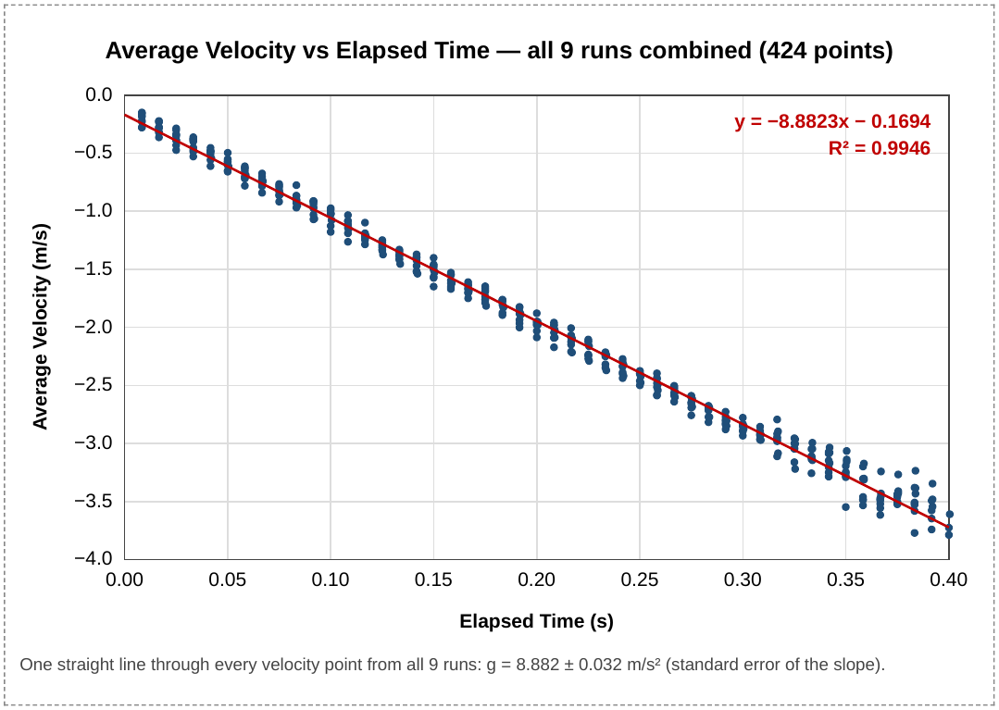
One trendline through all 424 points: g = 8.882 ± 0.032 m/s². Combining runs shrinks the random error, but not the error from air resistance.

  ✂ GLUE IN: print pack page 6 — Air resistance check
  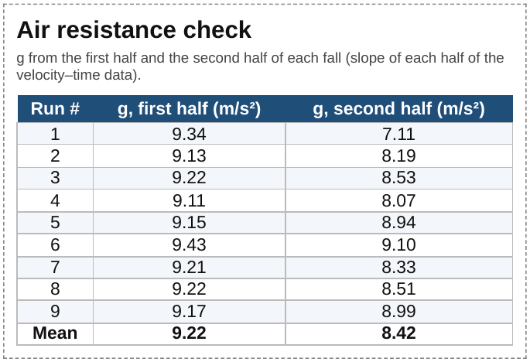
  Improvements: in your own words, e.g.
  - A heavier, solid ball (golf or steel) so air resistance matters less.
  - A cleaner release (cutting the string, or an electromagnet) so t = 0 is exact.
  - A higher frame rate (240 fps) for more points and better timing.
  - A metre stick turned to face the camera, as a second check on the scale.

