PRINT & CUT — Experiment 2 (George) · sheet 1 of 4 · Print at 100% (actual size, not "fit to page"). Cut along the dashed lines.
✂ LAB BOOK PAGE 6 · Example of tracking (Run 3)
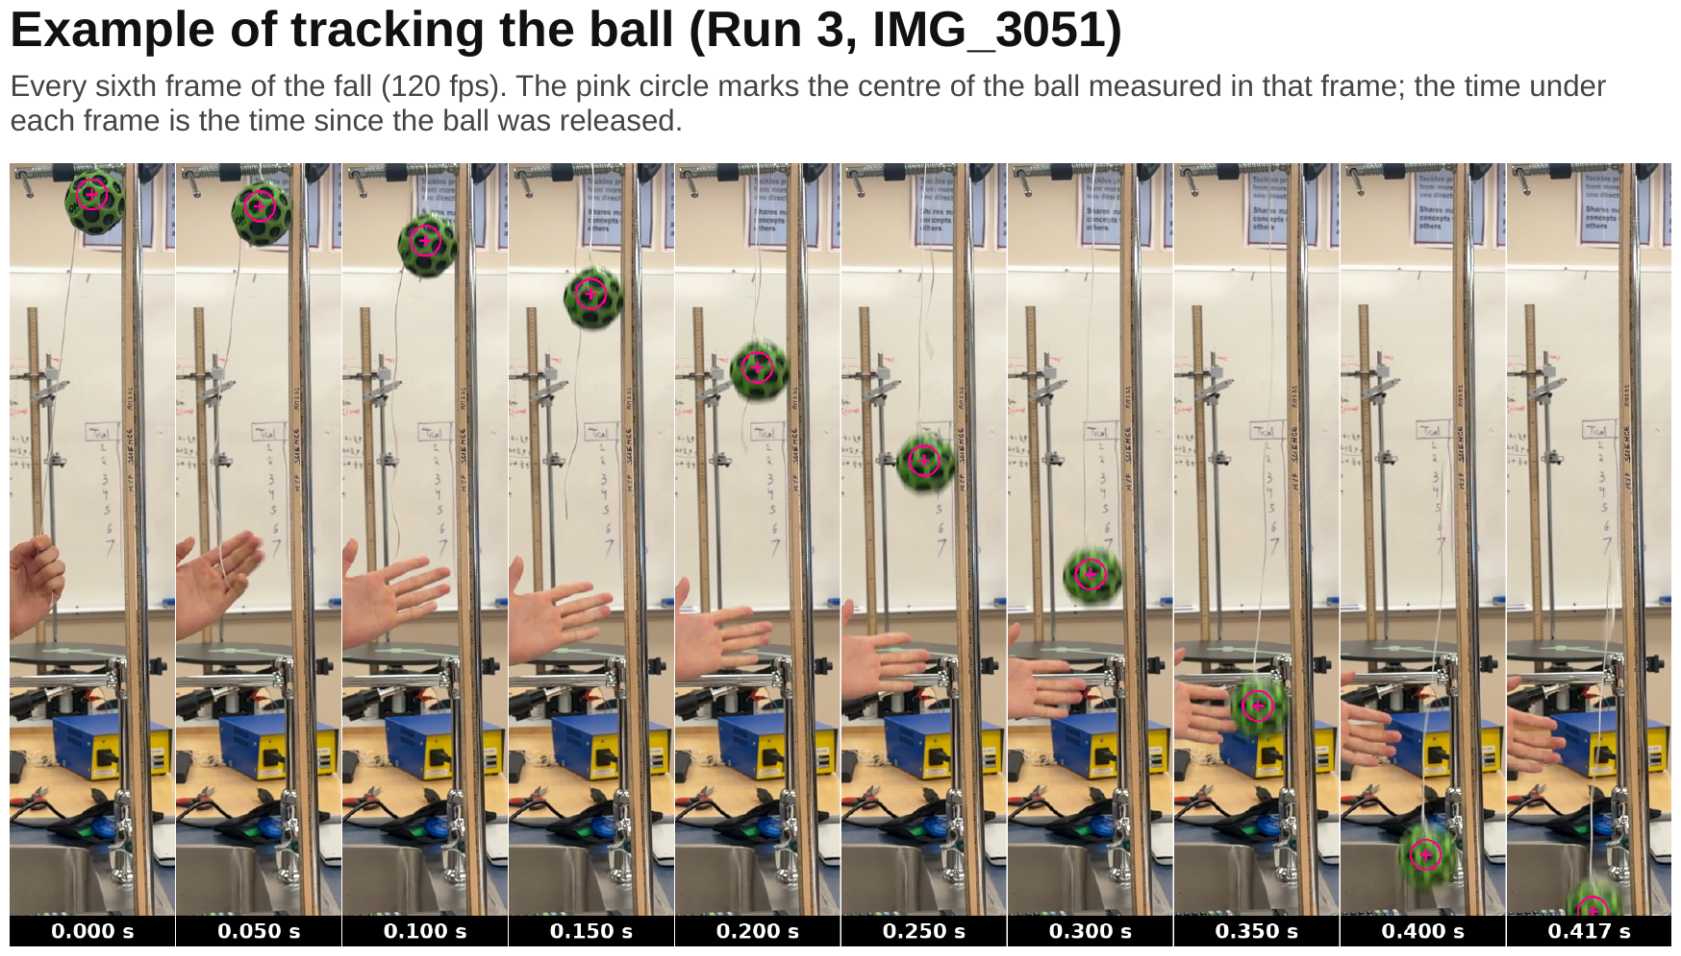

✂ LAB BOOK PAGE 8 · Velocity–time graph, Run 3
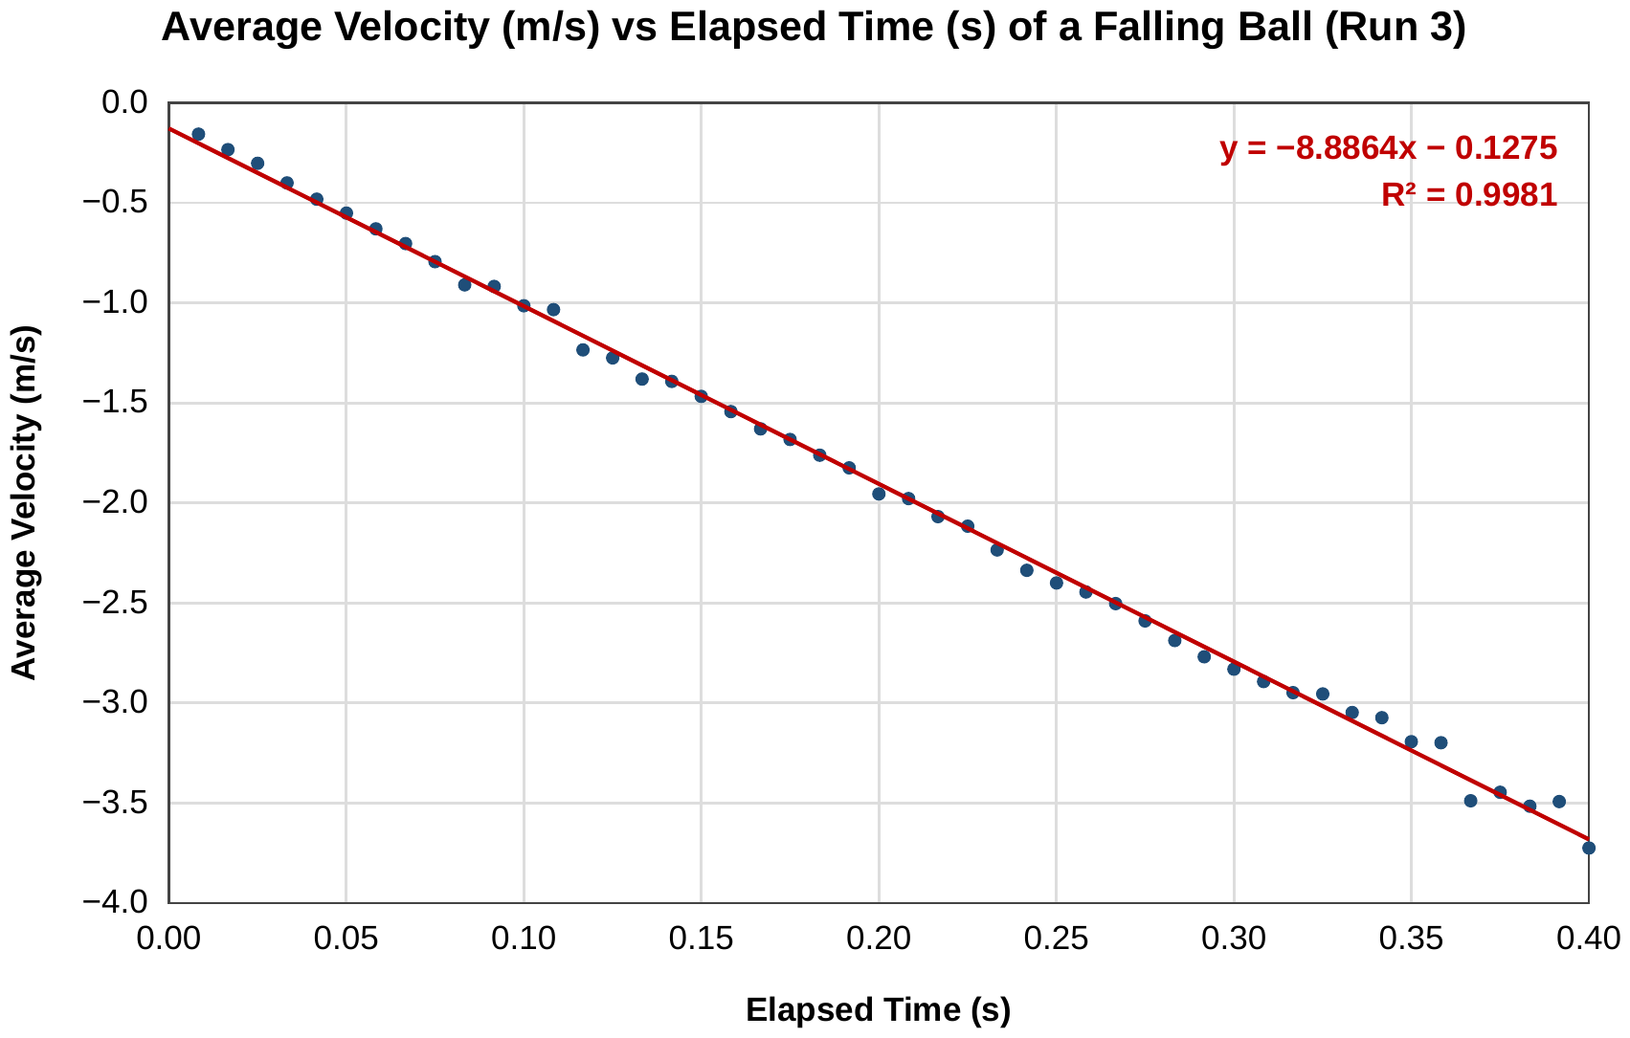

PRINT & CUT — Experiment 2 (George) · sheet 2 of 4
✂ LAB BOOK PAGE 7 · Recorded data for Run 3 · glue on the left half of the page
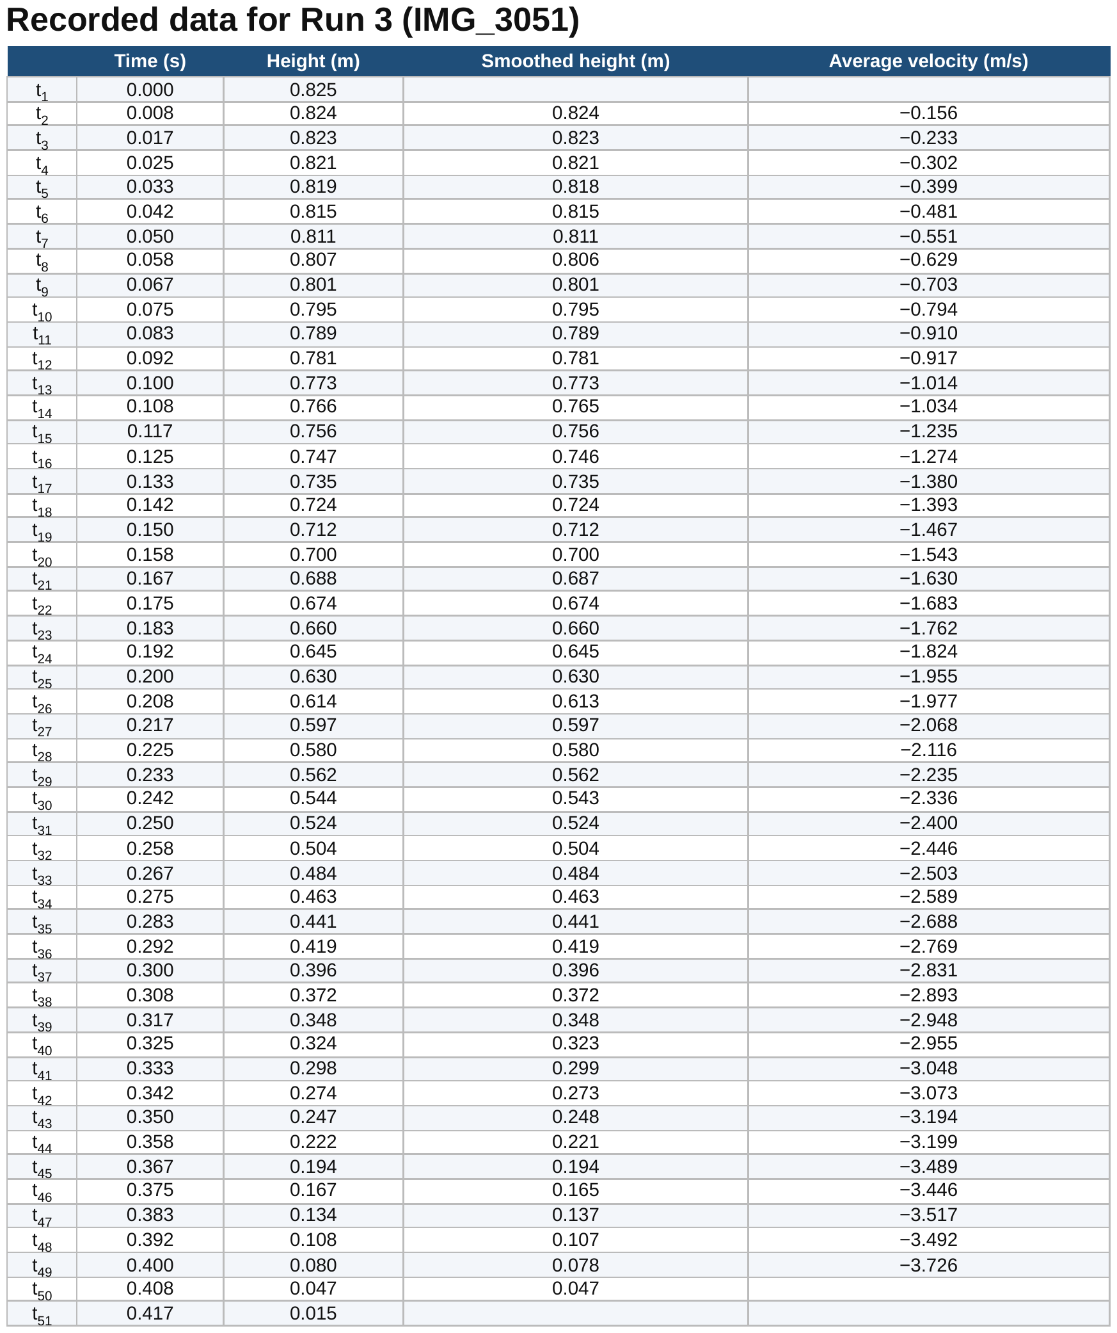

✂ LAB BOOK PAGE 10 · Air resistance check · optional extra
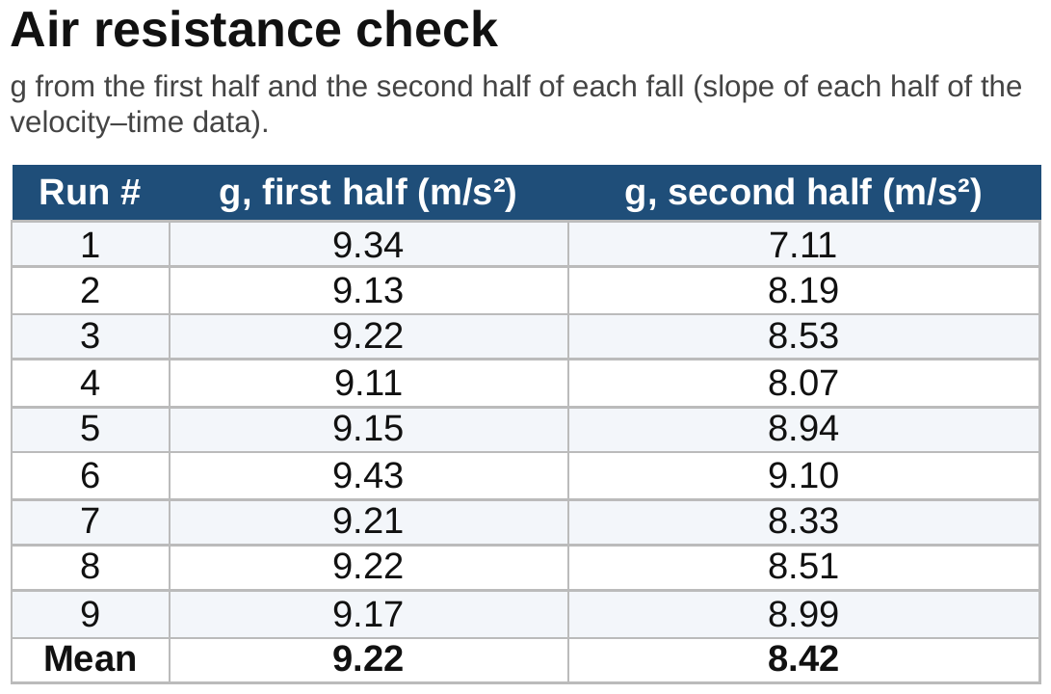

PRINT & CUT — Experiment 2 (George) · sheet 3 of 4
✂ LAB BOOK PAGE 9 · Value of g for each run · or copy it by hand
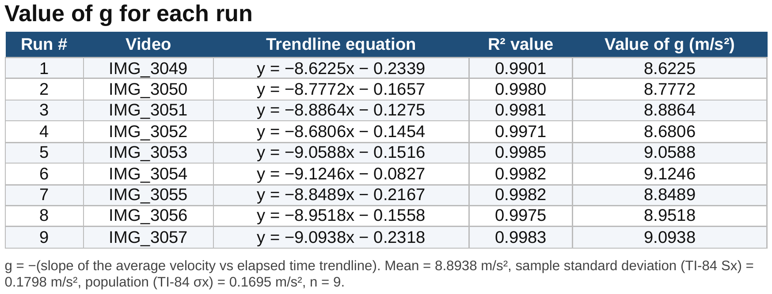

✂ LAB BOOK PAGE 10 · All 9 runs combined · optional extra
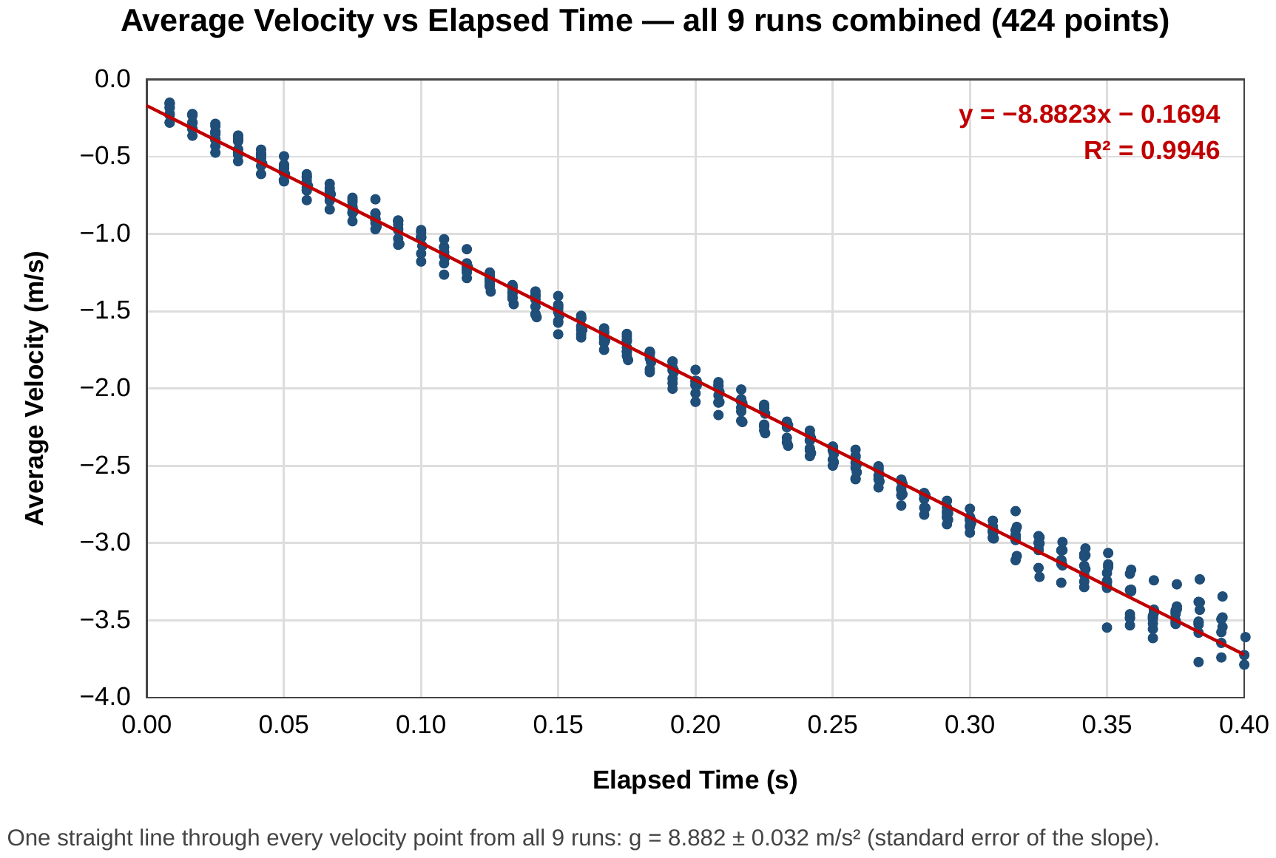

PRINT & CUT — Experiment 2 (George) · sheet 4 of 4 · OPTIONAL: only print this if your teacher allows a printed diagram; otherwise draw it by hand.
✂ LAB BOOK PAGE 5 · Apparatus diagram · optional
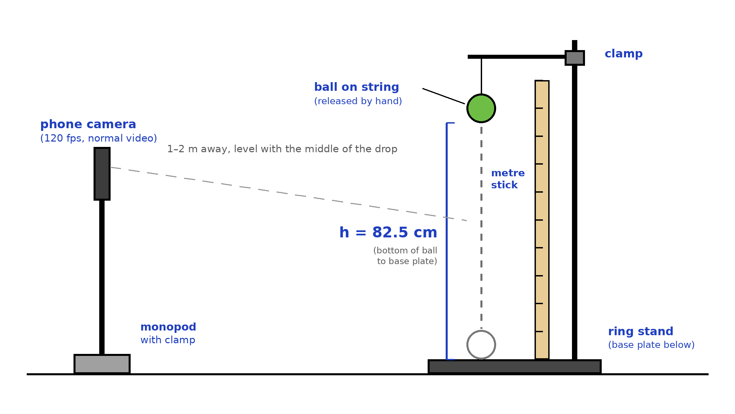

Checklist
☐ Lab book page 5: Apparatus diagram (sheet 4, optional; or draw by hand)
☐ Lab book page 6: Example of tracking (sheet 1)
☐ Lab book page 7: Recorded data for Run 3 (sheet 2)
☐ Lab book page 8: Velocity–time graph, Run 3 (sheet 1)
☐ Lab book page 9: Value of g for each run (sheet 3, or copy by hand)
☐ Lab book page 10: All runs combined + air resistance check (sheets 2–3, optional extras)

