Ass03
Vavoulis Giorgos 1040156
Brain and Mind Graduate Student

I implemented the codes asked in notebooks, where the visualization of the results are clear.
Question a is ass01.ipynb and question b is ass02.ipynb. I attach them both (no need to run them, I have already run them, just open them).

I just display here the image of the tensorboard of question a. results for the training of both the two last layers fc7, fc8 (only did 5 epochs instead of 30, due to limited resources. Didn’t try the 30 epochs since i notice that loss and accuracy have already started to converge to almost optimal values). The quickly achieved accuracy is impressing. Transfer learning significantly reduces the computation and data overhead of the training process and boosts the performance on the target task, compared to training from scratch. Generally tranfer learning lets us tackle problems like having little or almost no labeled data availability, gives the ability to transfer knowledge from one model to another based on different domains and tasks (i.e. here we used a pretrained model on ImageNet dataset, and fine-tuned it on another dataset, namely the wiki_art).
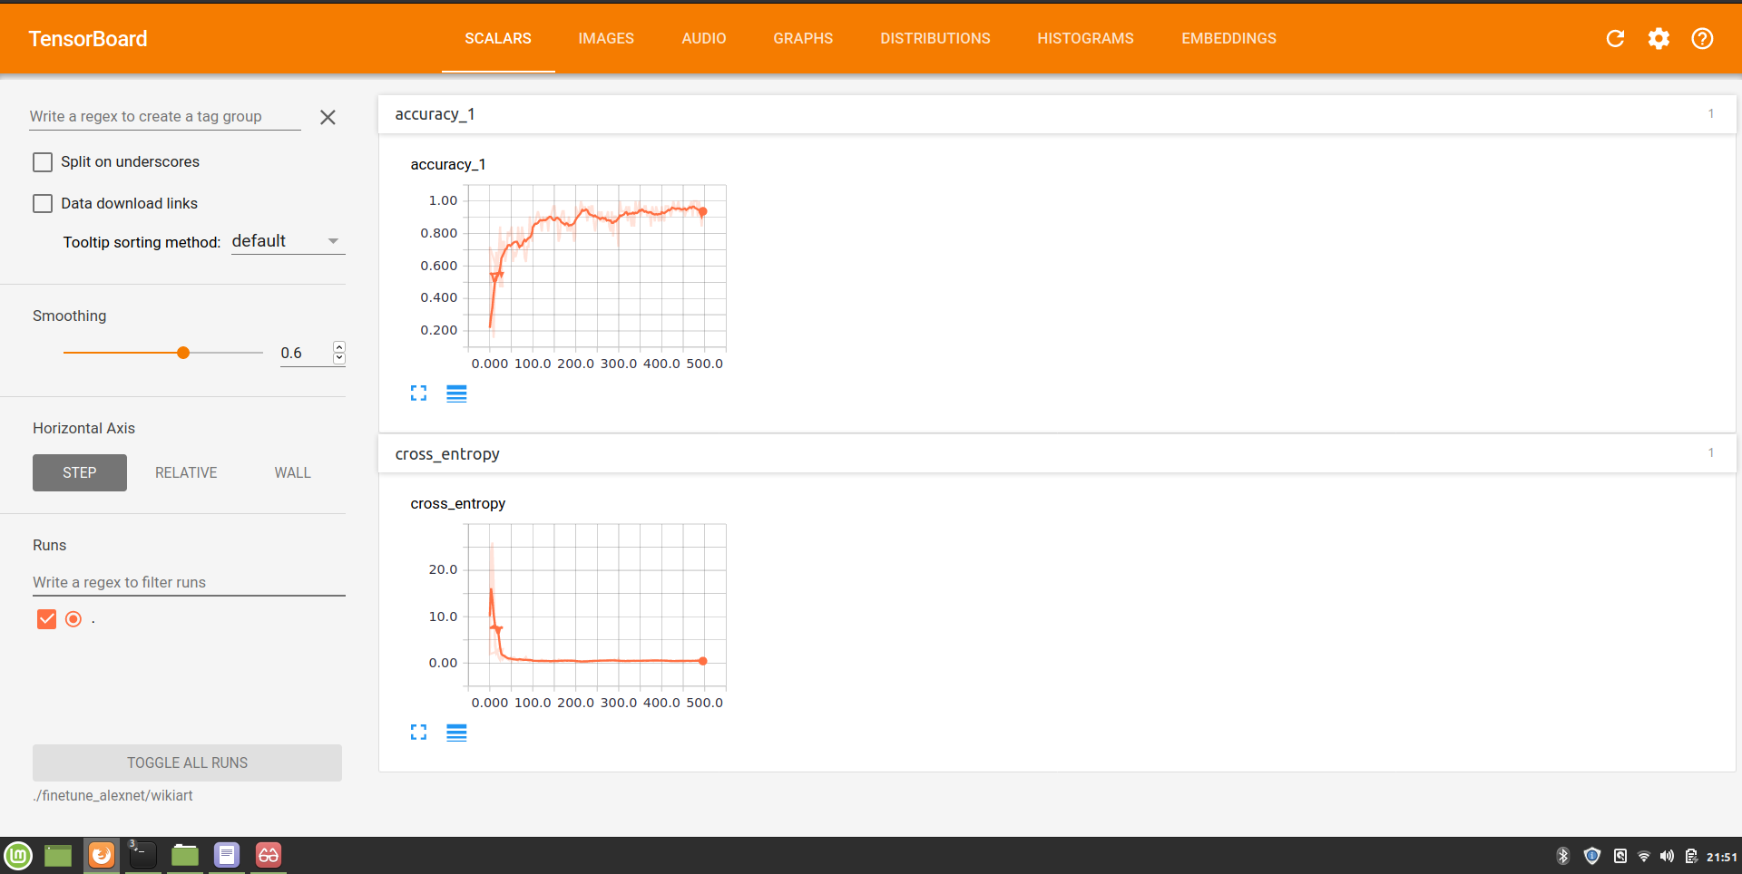

I attach the tensorboard eventfiles for both asked instances (train both fc7, fc8 /or only the last fc8 layer) for 5 epochs.

