Ass01
Vavoulis giorgos 1040156

The best classifier was trained on the 4th hyperparameter setting, with the following results:
training accuracy: 0.336306
validation accuracy: 0.354000

We wouldn’t expect anything much better from a linear classifier...

Resulting weights for each class, represent the filter that recognizes the respective class:

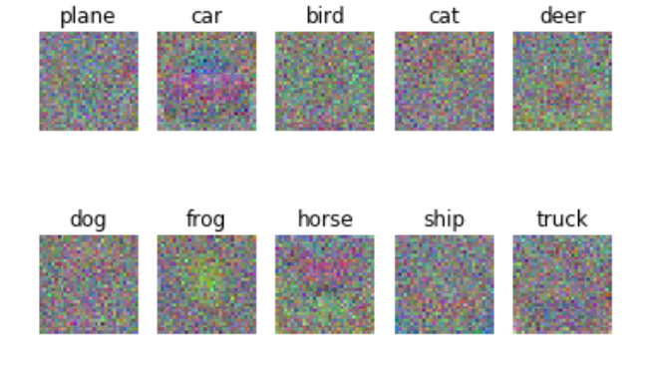

Observe that the car is something red, a ship is something blue on the bottom line of the image and so on. After all the classifier is just a linear classifier that takes the average of the images it has been trained on, to classify a new image.

