15/1/2017

George Robertson

CSY1018 -Web development – assignment 1

Contents

Initial investigations 2

Initial designs 2

Home page 2

2

2

Bio and CV page 3

Contact form 4

Features 4

Visual appeal 4

Navigation 5

Development timeline 5

Week 1 to week 7 5

Week 9 to present 6

Validations 6

# Initial investigations

One inspiration I’ve taken is related to my software engineering coursework with the website for Chester Zoo (<http://www.chesterzoo.org/>) This website has a large header image with sub boxes below where the contents is. I like how this looks as it looks professional and it keeps to a very simple layout.

In my website you can particularly see that I have stuck to the simple layout of things mainly due to the professionalism you can see from these kind of website. I also looked at this website (<https://www.themuse.com/advice/the-35-best-personal-websites-weve-ever-seen>). This website features some good examples of personal portfolios and allowed me to get some inspiration.

# Initial designs

## Home page

## 

# 

Image of me

Logo

Home | CV | Bio | Contact

This is the index page. At the top is the navbar with a large logo in the middle with my initials on it. At the bottom is the image of me that had to be included on the home page.

## Bio and CV page

Nav bar

Content box

Content box

Content box

Logo

This page is for both my cv and my bio page. At the top the same exists as in the home page both the nav bar and the logo. At the bottom, you can see the 3 content boxes that will hold all the content for my information. These boxes will adapt to flex. I also plan these to have a drop shadow with a background so it appears that they sit on the page.

## Contact form

Contact form

Nav bar

Logo

This once again holds the same content as my index page at the top but it has the additional contact form below. It features text boxes, line breaks to separate it all up and a radio button for the best contact time. It has a submit button to push it and save the inquirer.

# Features

## Visual appeal

I tried to make my website look appealing to the wider audience. I tried to use appealing colours to make it easy on the eye and use fonts that were easy to read. I tried to use words that were professional and sophisticated but also easy to comprehend. I tried not to use many graphics as it keeps it simple and less distracting.

## Navigation

I also tried to keep the navigation simple by just using text these are at the top of my page. I chose to do this as when I was looking at the initial websites, most of them had just text links as it makes it look minimalistic and makes it easier to navigate. https://georgerobbo.github.io/csy1018-assign1/

# Development timeline

## Week 1 to week 7

This was my initial design. The colours I chose were meant to stand out from each other. As a look back onto it, the buttons were a bit eccentric and made it look a bit unprofessional and more aimed at children.

## Week 9 to present

After a while I reviewed my website and realised I really wasn’t happy with the design that I was using. As it was very late in the project lifetime I had to work a lot to do to change this. I am much happier with the design I have now as I feel like I simplified it a lot and made it look a lot more professional. I made the design have 3 simple containers to hold my content that have a drop shadow so it stands out on the page.

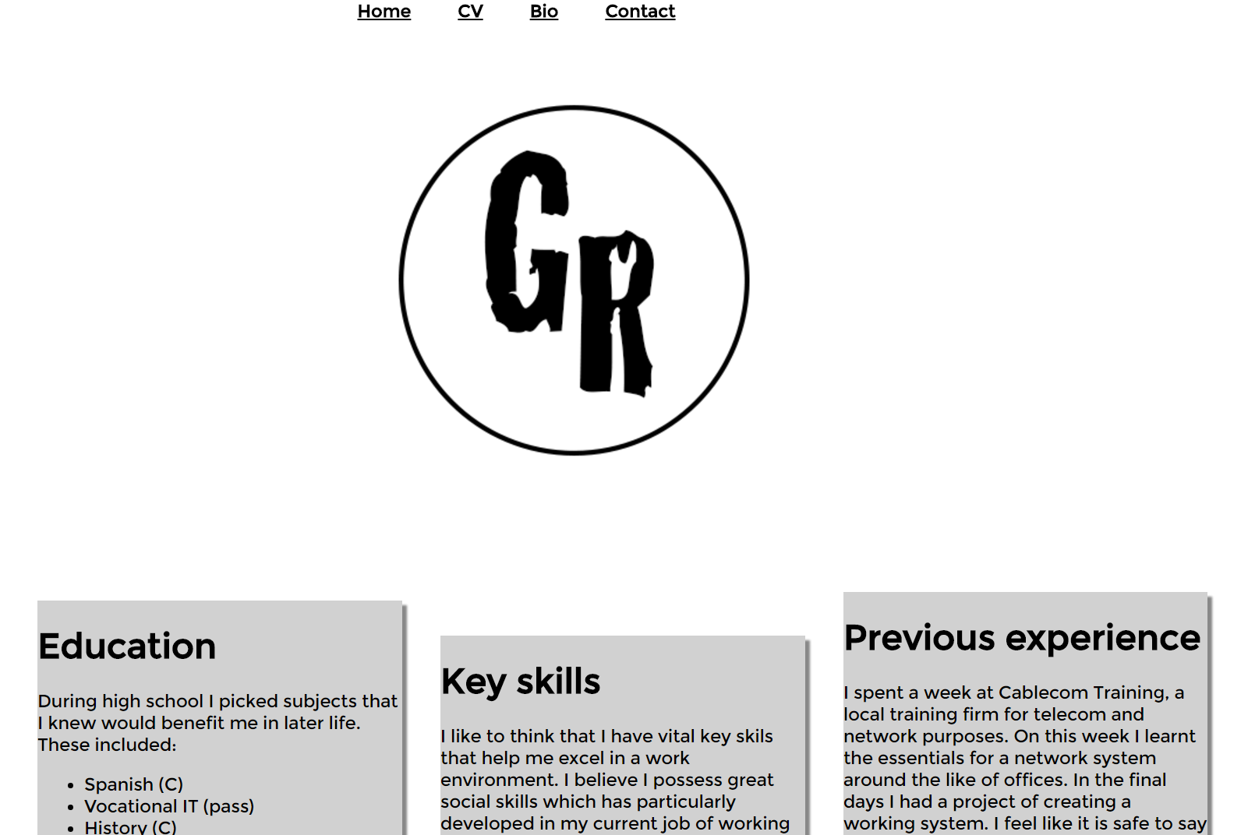

# Validations

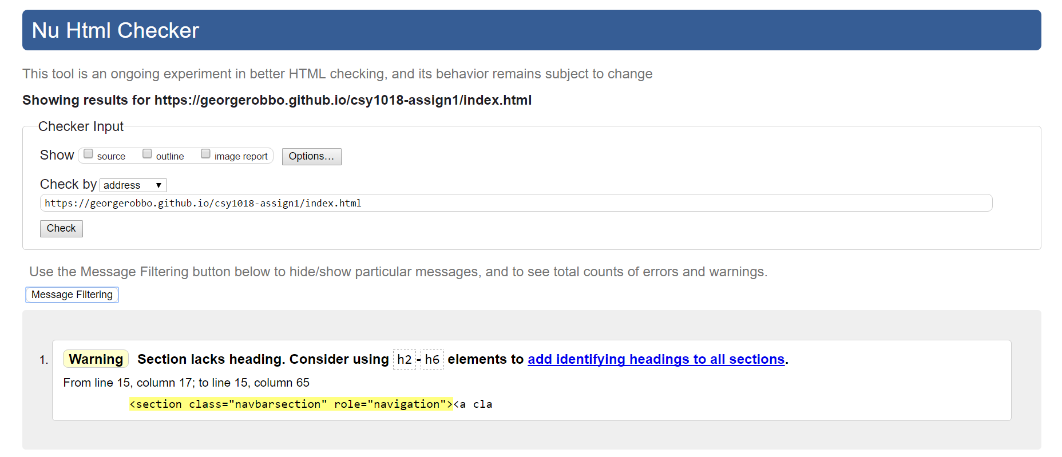

All my validations passed with only warnings. I had errors to start with but I changed these so I meet validation.

