Exercise 1.14
Tree drawing:
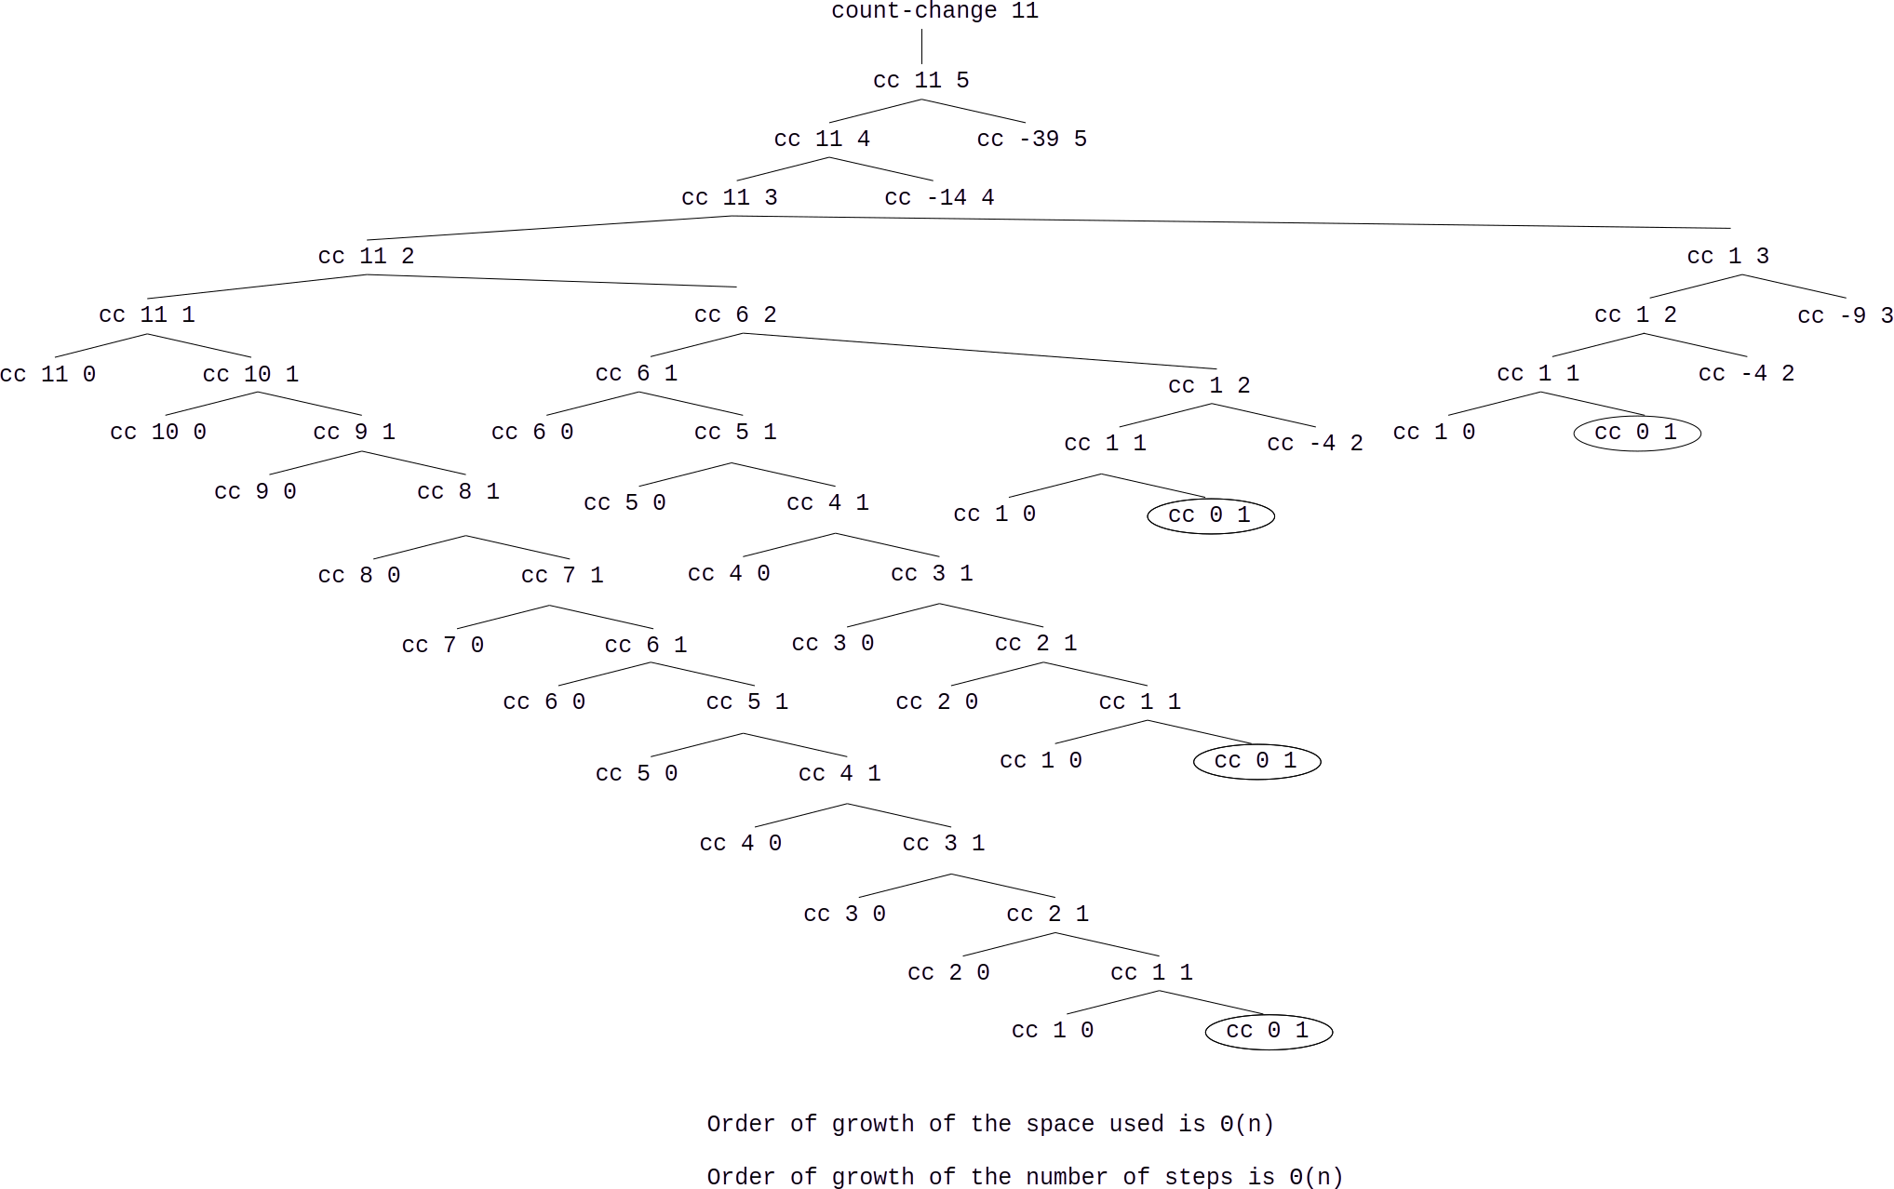
Orders of Growth

The order of growth of the space of the recursion tree will be proportional to the maximum depth of the tree which will be making n with n pennies. Though the procedure branches in two directions, this is limited in one direction by the number of kinds of coins (5). The tree will require a depth of n and grow with Θ(n).

The number of steps required is proportionate to the number of combinations. For very large numbers, the numbers can be divisible by all 5 kinds of coins, many times, which would mean many possible combinations, roughly n times as many combinations for every kind of coin. The number of steps would grow with Θ(n⁵) due to the 5 kinds of coins.

