George Suarez

David Cruz

CSE 460

**Lab 10 - Exploring XV6 File System**

1. Examining the header file *fs.h* and the program *fs.c* that implements the file system.

*fs.h*

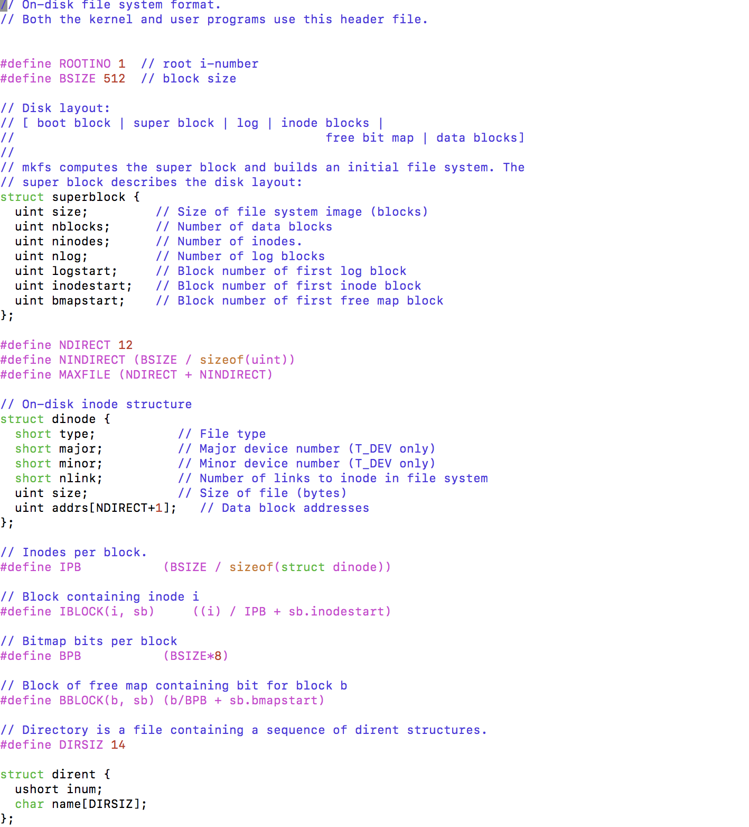

*fs.c*

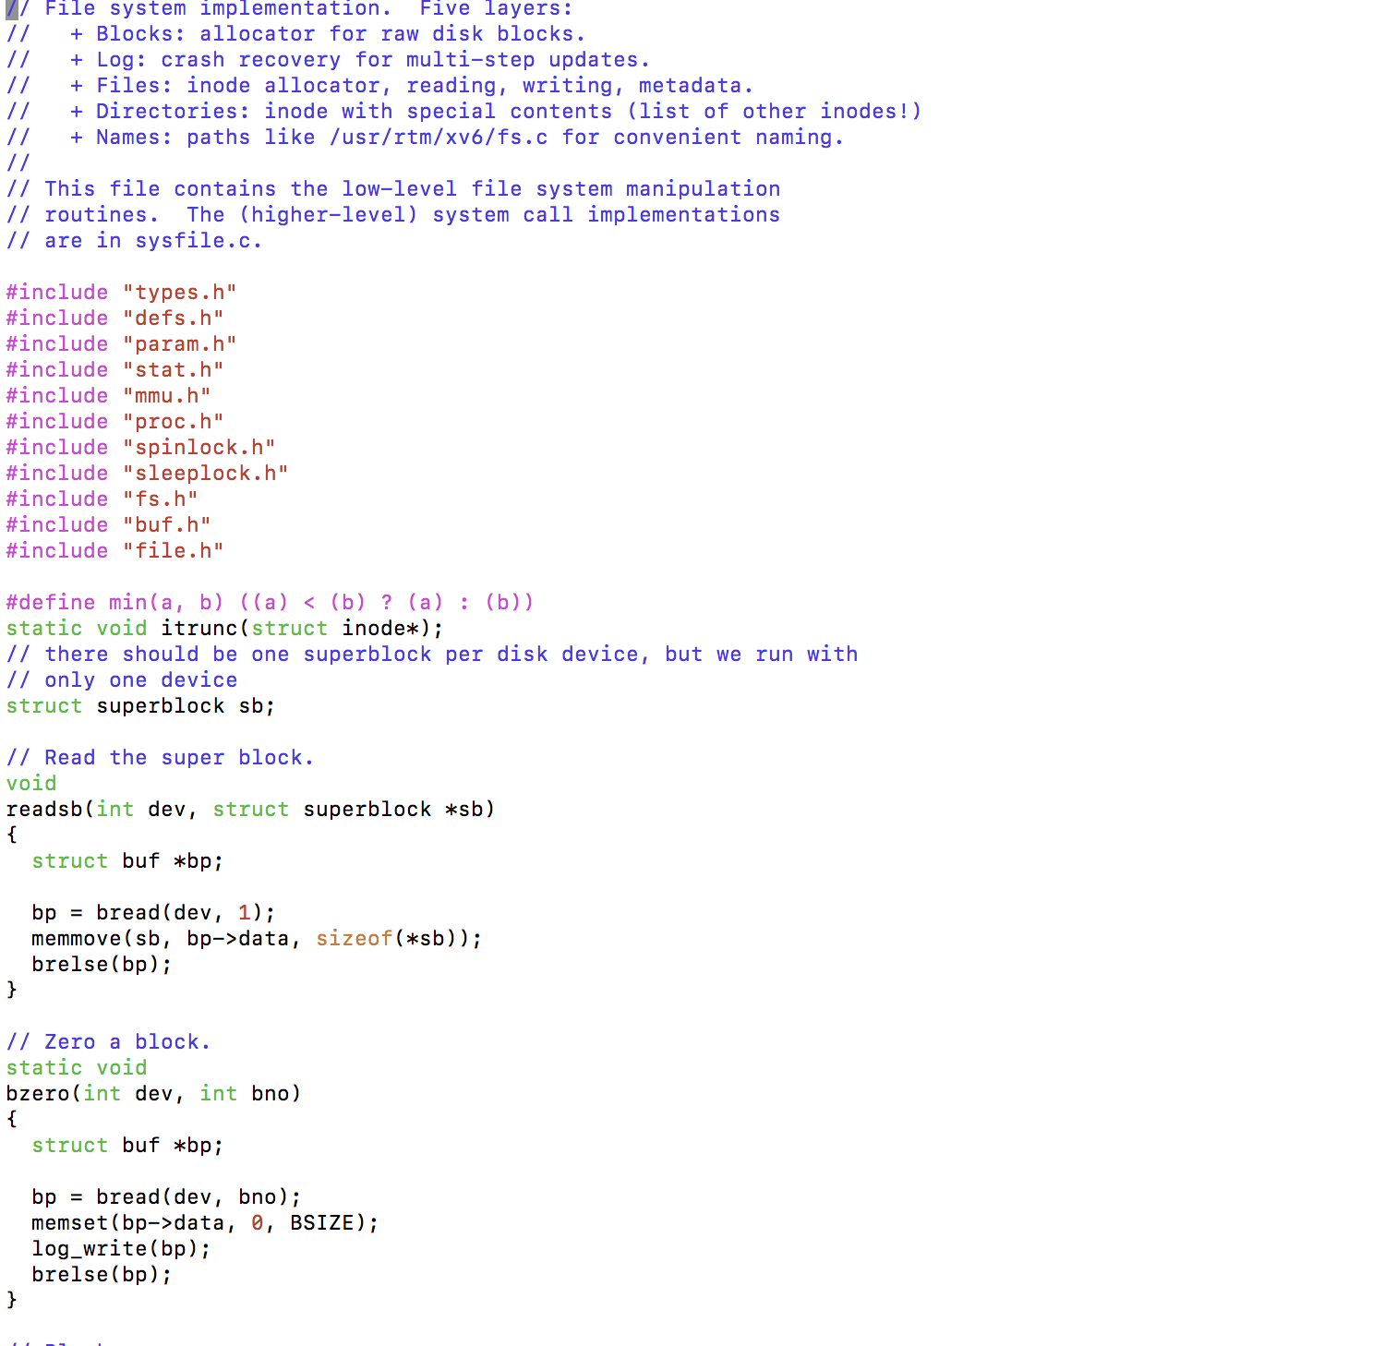

2. Add to a system call named pfs() in fs.c that prints out information of the file system

1. Adding the name to *syscall.h*

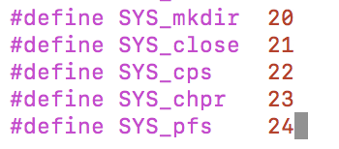

1. Adding the function prototype to *defs.h*

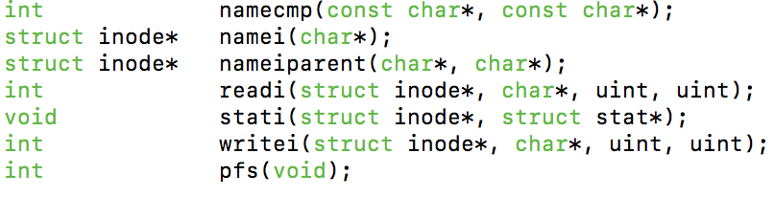

1. Added the function prototype to *users.h*

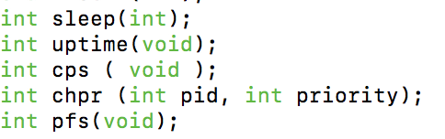

1. Added the function call to *syscall.c*

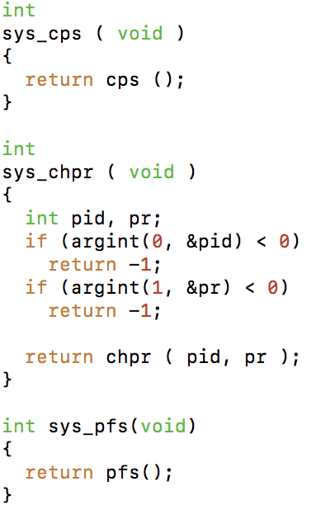

1. Added the call to *usys.S*

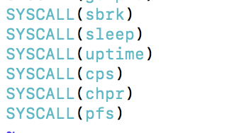

1. Added the call to *syscall.c*

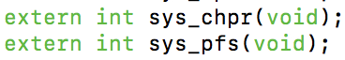

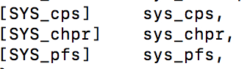

1. Add *pfs()* to *fs.c*

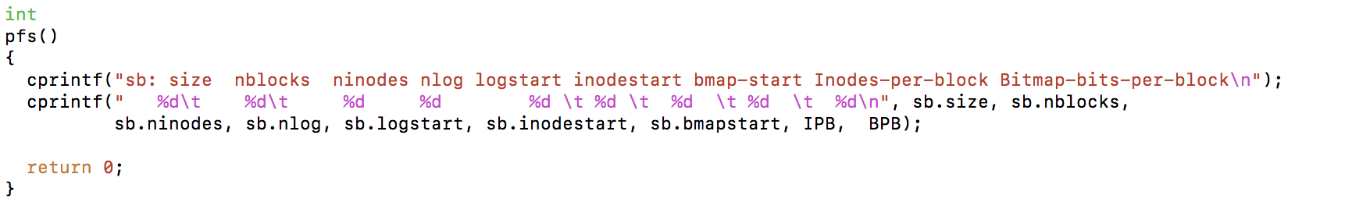

1. Write another program, say *printfs.c* and make other appropriate changes as you did in previous two labs to call **pfs**().
2. Implementing *printfs.c*

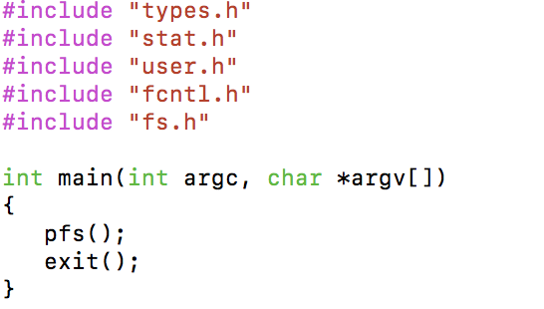

1. Adding *printfs.c* to the Makefile

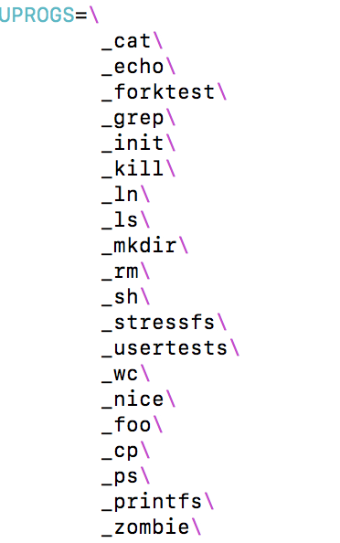

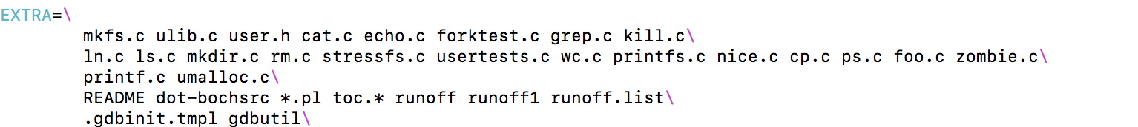

1. Output

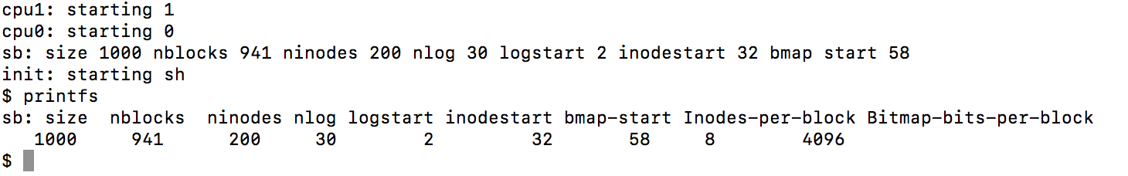

1. Add to your program and function call that prints out the free blocks and allocated blocks of the system as well as the number of free blocks and the number of allocated blocks in the system. The output of your program could look like the following:
2. Modified *pfs.c* function in *fs.c*

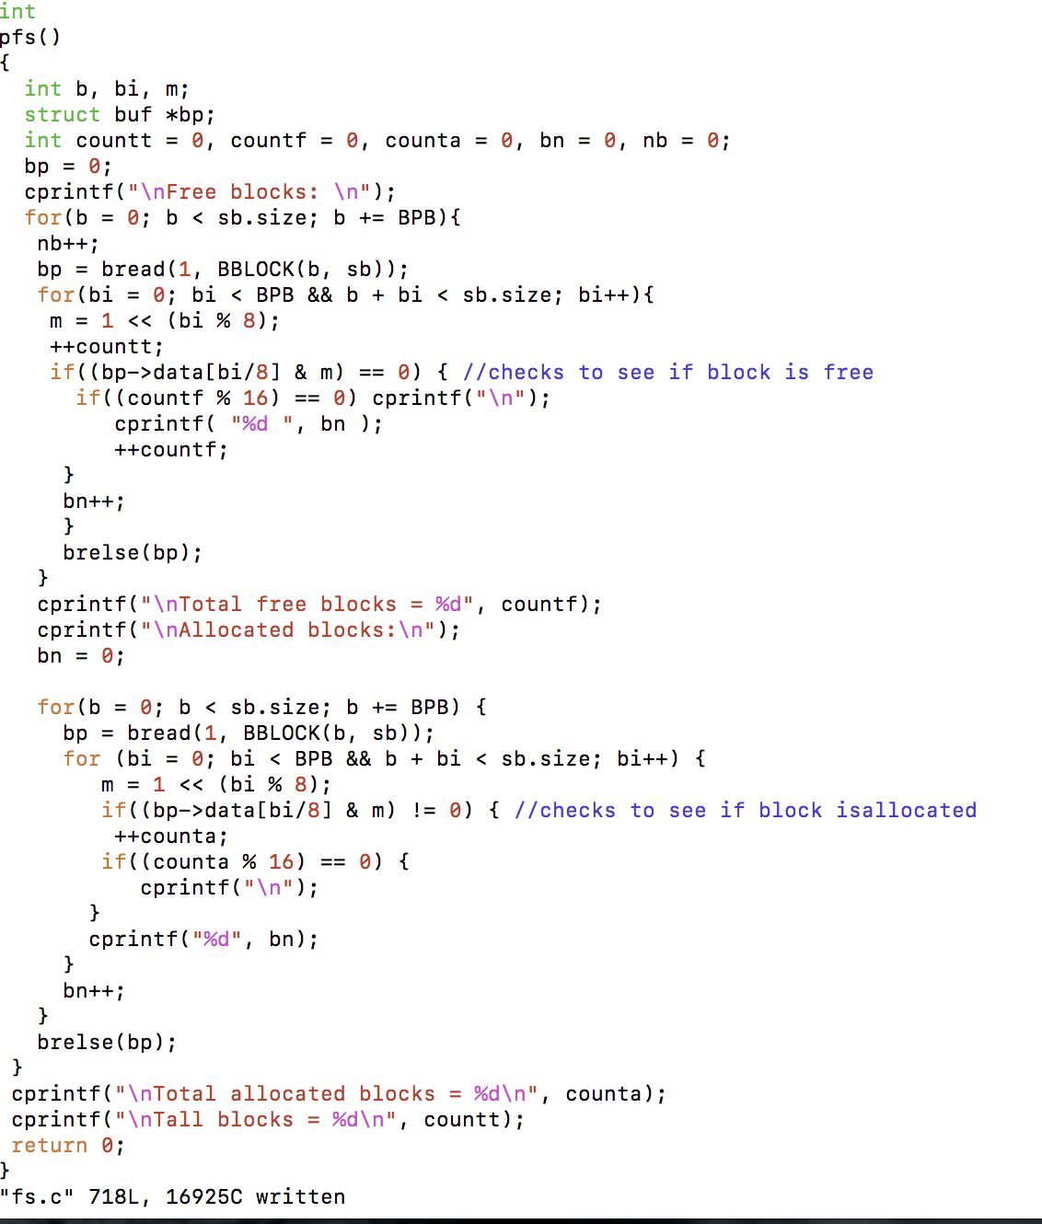

b. Output

