George Suarez

CSE 461

February 6, 2019

Homework 1

3. Consider a chain of processes $P_{1}, P_{2}, …, P_{n}$ implementing a multitiered client-server architecture. Process $P_{i}$ is client of process $P_{i+1}$, and $P_{i}$ will return a reply to $P_{i-1}$ only after receiving a reply from $P_{i+1}$. What are the main problems with this organization when taking a look at the request-reply performance at process $P_{i}?$

The main problem of using this organization is the time it takes for a process to get a reply from a previous process. For example, if $P_{2}$ is a client process of $P_{3}$, then $P_{2}$ will return a reply to $P_{1}$ once it receives a reply from $P_{3}$. If $P_{3}$ takes a really long time and more requests are still being made, then $P_{1}$ will have to wait for $P_{2},P_{3}, …, P_{n}$ processes to finish which the performance of the request-reply organization slow.

4. Show the B-trees of order four resulted from loading the following sets of keys (each letter is a key) in order:

1. C G J X
2. C G J X N S U O A E B H I
3. C G J X N S U O A E B H I F
4. C G J X N S U O A E B H I F K L Q R T V U W Z

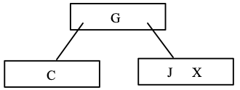

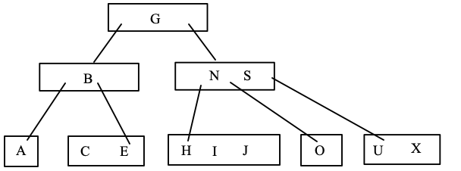

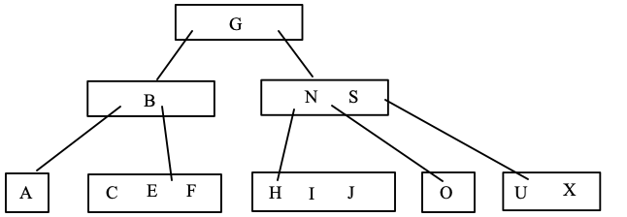

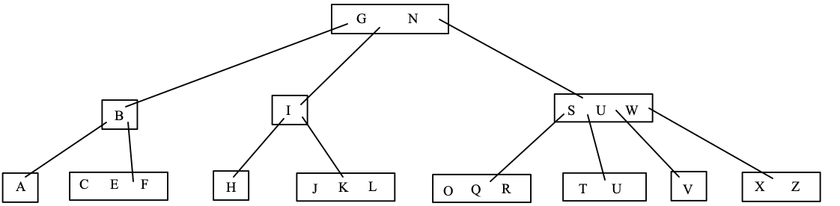

5. Given a B-tree of order 256,

1. What is the maximum number of children from a node?
2. Excluding the root and the leaves, what is the minimum number of children from a node?
3. What is the minimum number of children from the root?
4. What is the maximum depth of the tree if it contains 100,000 keys?
5. The maximum number of children from a node can have at most 256.
6. The minimum number of children from a node excluding root and the leaves is $⌈\frac{256}{2}⌉$ = 128 children.
7. The minimum number of children from the root is 2 children.
8. The maximum depth of the tree if it contains 100,000 keys is 2:

6. Construct a general resource graph for the following scenario and determine if the graph is completely reducible: R1, R2, and R3 are reusable resources with a total of two, two, and three units. Process P1 is allocated one unit each of R2 and R3 and is requesting one unit of R1. Process P2 is allocated one unit of R1 and is requesting two units of R3. Process P3 is allocated one unit each of R1 and R2 and is requesting one unit of R3.

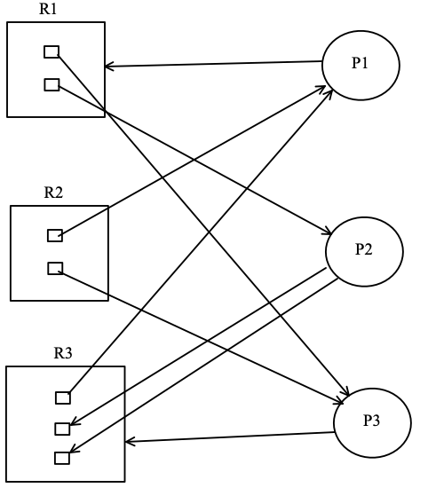 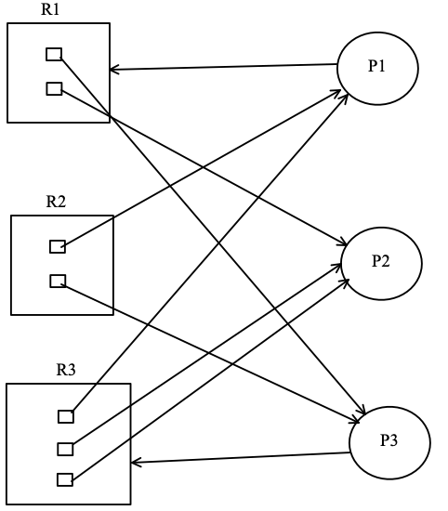

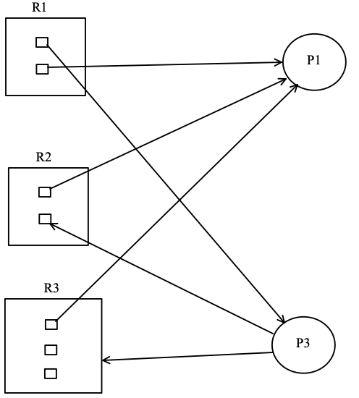 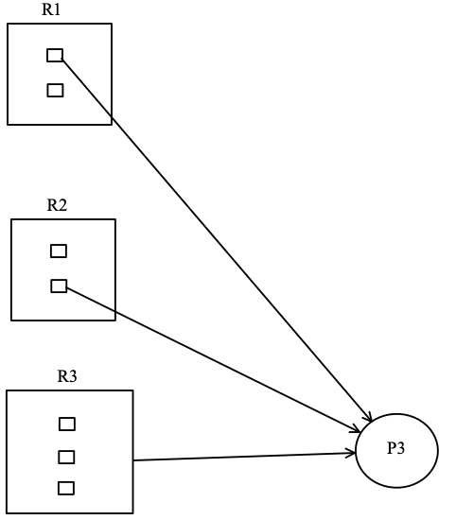

Can be reduced.