George Suarez

CSE 461

February 20, 2019

Homework 2

1. The following figure shows a resource graph for a system with consumable resources only. A resource is represented by a rectangle with thick lines and labeled as $R_{i}$. A process is represented by a circle, labeled $P_{i}$.
2. Is the graph a claim-limited graph? Why?
3. Is the graph reducible? Why?

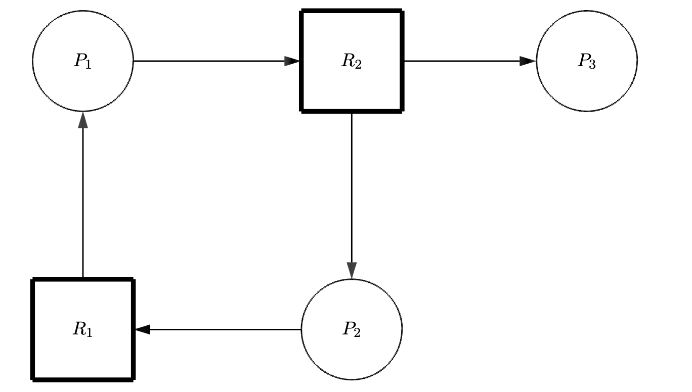

Solution:

1. The graph is a claim-limited graph because it represents a consumable resource system since each resource has 0 available units and each node has a request edge ( $P_{i}, R_{j})$ which $P_{i}$ is a consumer of $R_{j}$.
2. The graph is reducible since $P_{3}$ is a producer of $P_{2}$ and it is not blocked which means it can produce a unit for $R_{2}$ that reduces the edge $(P_{1},R_{2})$ and all other edges will be reduced as a result.
3. Assume a system has $P$ processes and $R$ identical units of a reusable resource. If each process can claim at most $N$ units of the resource, determine whether each of the following is true or false and prove your claim:
4. If the system is deadlock free, then $R≥P\left(N-1\right)+1$.
5. If $R≥P\left(N-1\right)+1$ then the system is deadlock free.

Solution:

1. **False** because if the system is already deadlock free, then the process does not need an additional resource.
2. **True** because if each process claims the same amount of $R$ identical units, then we are still left with 1 more available resource to use. Thus, the system is deadlock free if $R≥P\left(N-1\right)+1$.
3. The following figure shows a resource graph for a system with reusable resources only. A resource is represented by a rectangle, in which a small square indicates a unit of the resource.
4. Is the graph expedient? Why?
5. Is there any knot in the graph? Why?
6. Is there any deadlock in the system? Why?

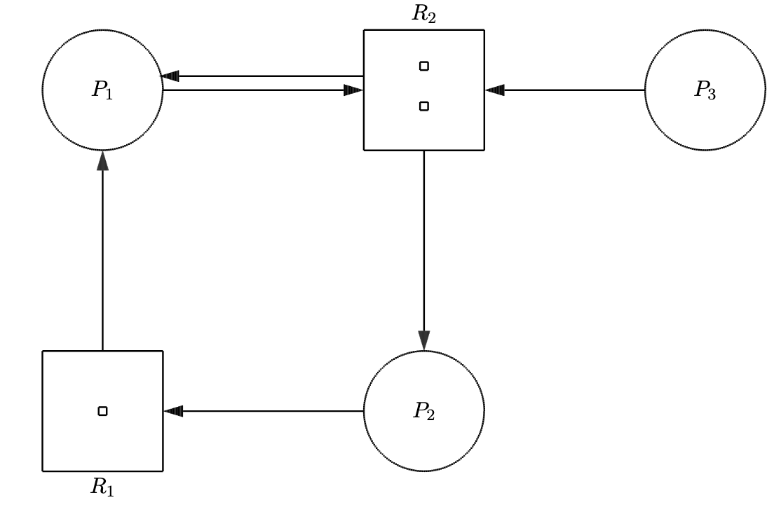

Solution:

1. The graph is expedient because processes $P_{1}, P_{2}, P_{3}$ have outstanding requests that are blocked.
2. The graph does have a knot because the subgraph G = $\left\{P_{1}, R_{2}, P_{2}, R_{1}\right\}$ are able to reach other, but process $P_{3}$ cannot be reached by any of the nodes the subgraph G.
3. The system is in a deadlock state because we have a knot in the graph which is a sufficient condition for a deadlock.
4. In this problem you are to compare reading a file using a single-threaded file server and a multithreaded server. It takes 15 milliseconds to get a request for work, dispatch it, and do the rest of the necessary processing, assuming that the data needed are in a cache in main memory. If a disk operation is needed, as is the case one-third of the time, an additional 75 milliseconds is required, during which time the thread sleeps. How many requests/sec can the server handle if it is single threaded? If it is multithreaded?

Solution:

For the single-threaded case, the total time it takes when reading a file is:

$$\frac{2}{3}× 15 msecs+\frac{1}{3}×90 msecs$$

$$=10 msecs+30 msecs$$

$$=40 msecs$$

Which the single-threaded file server can handle:

$$\frac{1 request}{40 msecs}×\frac{1000 msecs}{1 sec}=25\frac{requests}{sec}$$

For the multi-threaded case, the time we wait for the disk operation overlaps, so it only takes 15 milliseconds. Therefore, the multi-threaded file server takes:

$$\frac{1 request}{15 msecs}×\frac{1000 msecs}{1 sec}=66.67\frac{requests}{sec}$$

1. Consider the state of a system with processes $P_{1}, P_{2}, P_{3}$, defined by the following matrices:

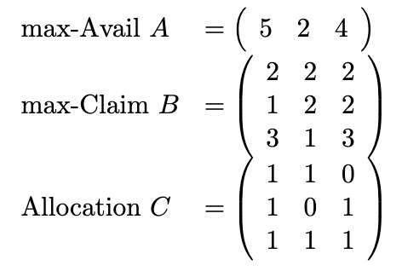

1. Find the available matrix $D$ and the need matrix $E$ in this state.
2. Suppose now process $P_{1}$ makes a request with

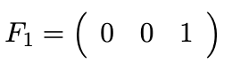

If the request were granted, what would be $D, C,$ and $E$ in the resulted state?

1. To ensure the system be safe, should the request be granted? Why? Give your reasons in detail.

Solution:

1. Available Matrix $D=$ Max-Avail Matrix $A$ $–$ Allocation Matrix $C$

$$\begin{matrix}D=(5 & 2 & 4)- \begin{matrix}(3 & 2 & 2)\end{matrix}\end{matrix}$$

$$D=\begin{matrix}(2 & 0 & 2\end{matrix})$$

Need Matrix $E$ = Max-Claim Matrix $B-$ Allocation Matrix $C$

$$E= \begin{matrix}1 & 1 & 2 \\ 0 & 2 & 1 \\ 2 & 0 & 2\end{matrix}$$

$D=D-F_{1}= \begin{matrix}(2 & 0 & 2\end{matrix})-\begin{matrix}(0 & 0 & 1\end{matrix})= \begin{matrix}(2 & 0 & 1\end{matrix})$

$$C_{i}=C_{i}+F_{i}$$

$$C= \begin{matrix}1 & 1 & 1 \\ 1 & 0 & 2 \\ 1 & 1 & 2\end{matrix}$$

$$E_{i}= E_{i}-F_{i}$$

$$E=\begin{matrix}1 & 1 & 1 \\ 0 & 2 & 0 \\ 2 & 0 & 1\end{matrix}$$

1. Using the safe-state check algorithm:

$P_{3}$: $D=$ $(\begin{matrix}2 & 0 & 1)+( \begin{matrix}1 & 1 & 2)\end{matrix}\end{matrix}=( \begin{matrix}3 & 1 & 3\end{matrix} )$*finished*

Since the processes $P_{1}$ and $P_{2}$ are not finished because $E_{1}$ and $E_{2}$ is not $≤D$. This means that the system is not safe, and the request is blocked. Thus, the system needs to be reset by doing the following operations:

$$D=D+F_{1}$$

$$C_{i}=C_{i}-F_{i}$$

$$E_{i}=E_{i}+F_{i}$$

Which now we get:

$$D=\left( \begin{matrix}2 & 0 & 2\end{matrix} \right)$$

$$C=\begin{matrix}1 & 1 & 0 \\ 1 & 0 & 1 \\ 1 & 1 & 1\end{matrix}$$

$$E= \begin{matrix}1 & 1 & 2 \\ 0 & 2 & 1 \\ 2 & 0 & 2\end{matrix}$$

And now process $P_{3}$ is now unfinished.