George Suarez

CSE 572 Database Systems

February 12, 2018

Lab 4

**SB_CSE572_Q1**

SELECT A.CRSE_ID, A.ACAD_GROUP, A.SUBJECT, A.CATALOG_NBR, A.ACAD_ORG

FROM PS_CRSE_OFFER A

WHERE ( A.ACAD_ORG = '189')

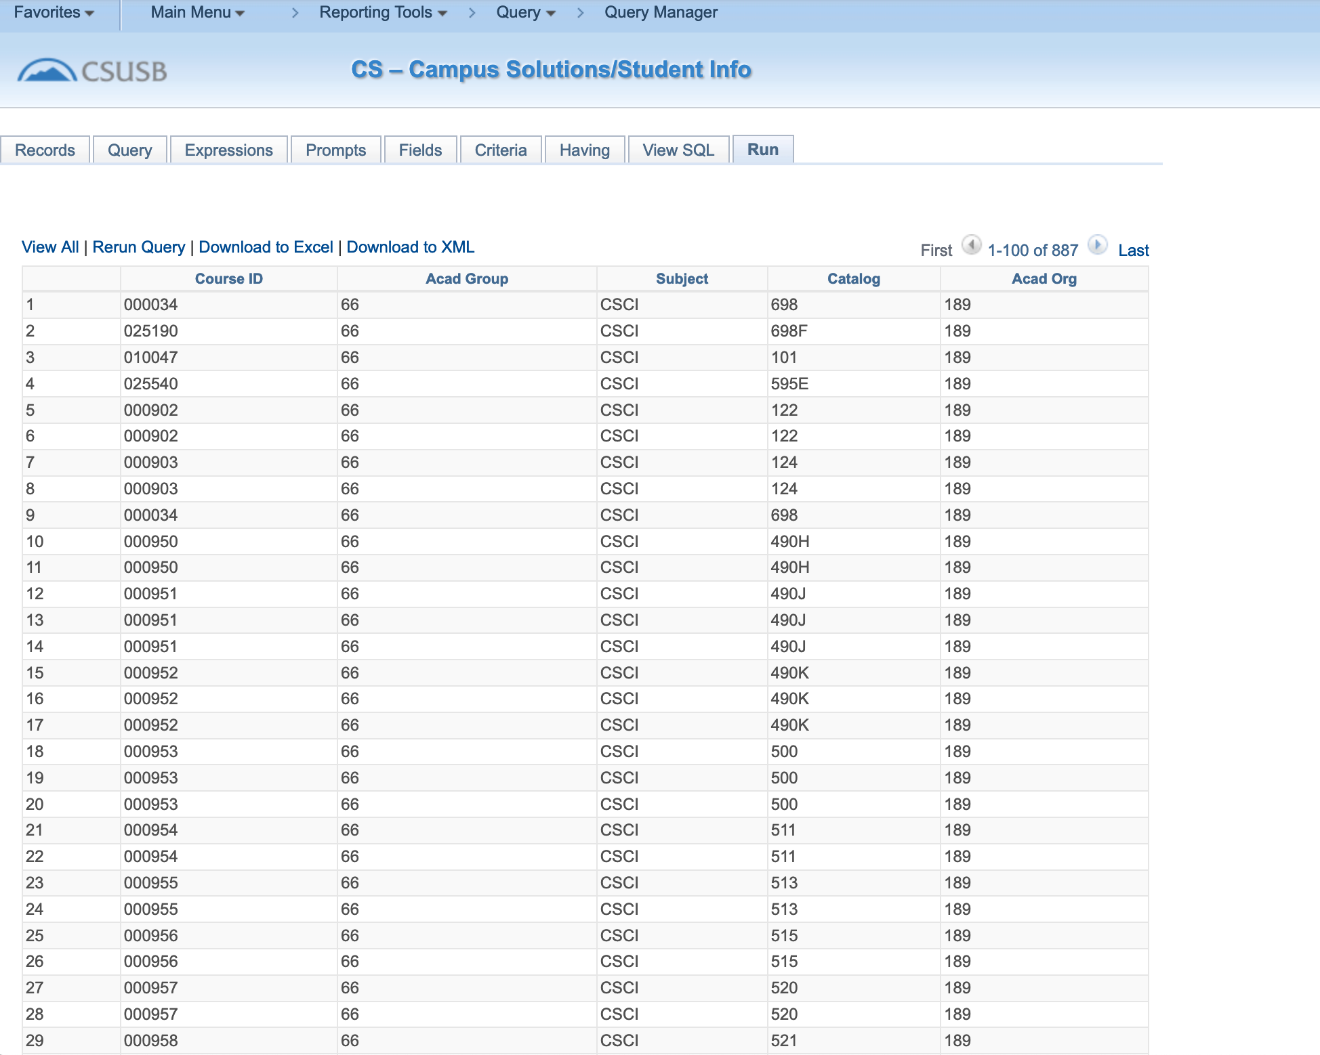

**SB_CSE572_Q2**

SELECT A.CRSE_ID, A.ACAD_GROUP, A.SUBJECT, A.CATALOG_NBR, A.ACAD_ORG, B.DESCR, C.ACAD_ORG, C.DESCR

FROM PS_CRSE_OFFER A, PS_ACAD_GROUP_TBL B, PS_ACAD_ORG_TBL C

WHERE ( B.ACAD_GROUP = A.ACAD_GROUP

AND B.INSTITUTION = A.INSTITUTION

AND ( A.EFFDT =

(SELECT MAX(A_ED.EFFDT) FROM PS_CRSE_OFFER A_ED

WHERE A.CRSE_ID = A_ED.CRSE_ID

AND A_ED.EFFDT <= SYSDATE)

AND B.EFFDT =

(SELECT MAX(B_ED.EFFDT) FROM PS_ACAD_GROUP_TBL B_ED

WHERE B.INSTITUTION = B_ED.INSTITUTION

AND B.ACAD_GROUP = B_ED.ACAD_GROUP

AND B_ED.EFFDT <= A.EFFDT)

AND A.ACAD_ORG = '189'

AND C.ACAD_ORG = A.ACAD_ORG

AND C.EFFDT =

(SELECT MAX(C_ED.EFFDT) FROM PS_ACAD_ORG_TBL C_ED

WHERE C.ACAD_ORG = C_ED.ACAD_ORG

AND C_ED.EFFDT <= SYSDATE) ))

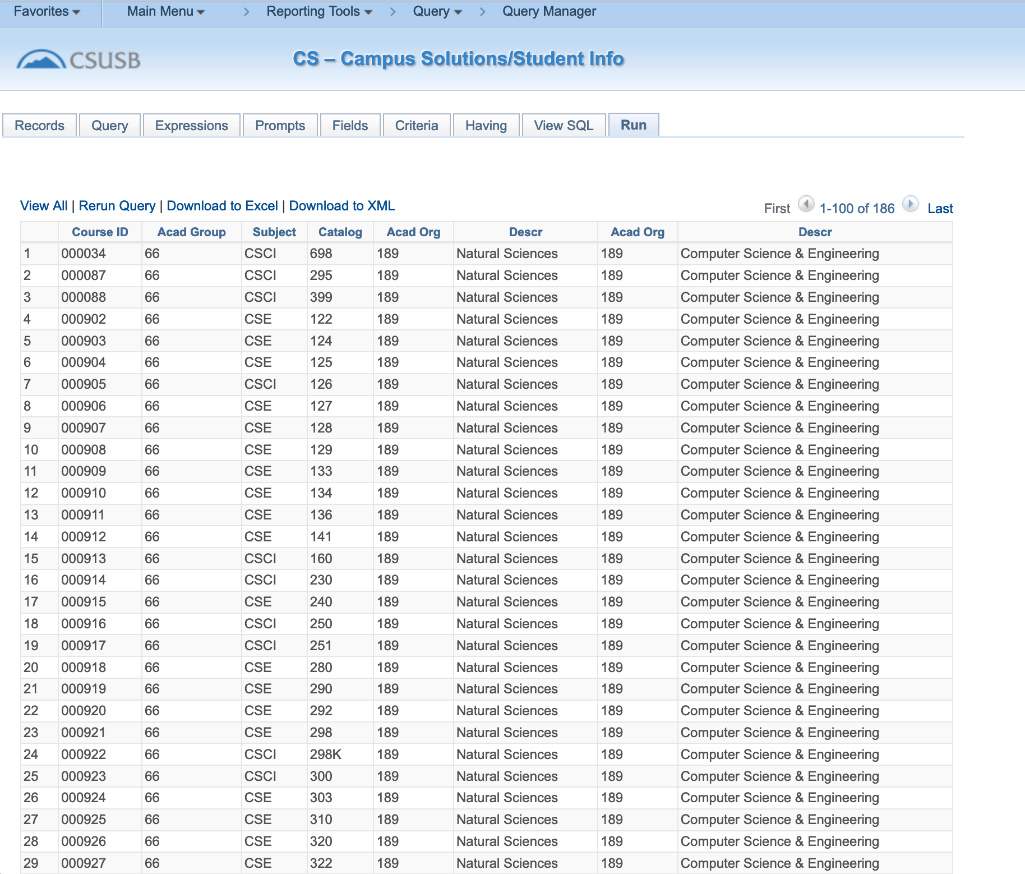

**SB_CSE572_Q3**

SELECT A.CRSE_ID, B.CRSE_ID, B.EFF_STATUS, B.COURSE_TITLE_LONG, B.DESCRLONG, A.ACAD_GROUP, A.SUBJECT, A.CATALOG_NBR, A.ACAD_ORG, C.DESCR, D.ACAD_ORG, D.DESCR

FROM PS_CRSE_OFFER A, PS_CRSE_CATALOG B, PS_ACAD_GROUP_TBL C, PS_ACAD_ORG_TBL D

WHERE ( B.CRSE_ID = A.CRSE_ID

AND C.ACAD_GROUP = A.ACAD_GROUP

AND C.INSTITUTION = A.INSTITUTION

AND ( A.EFFDT =

(SELECT MAX(A_ED.EFFDT) FROM PS_CRSE_OFFER A_ED

WHERE A.CRSE_ID = A_ED.CRSE_ID

AND A_ED.EFFDT <= SYSDATE)

AND B.EFFDT =

(SELECT MAX(B_ED.EFFDT) FROM PS_CRSE_CATALOG B_ED

WHERE B.CRSE_ID = B_ED.CRSE_ID

AND B_ED.EFFDT <= A.EFFDT)

AND A.ACAD_ORG = '189'

AND C.EFFDT =

(SELECT MAX(C_ED.EFFDT) FROM PS_ACAD_GROUP_TBL C_ED

WHERE C.INSTITUTION = C_ED.INSTITUTION

AND C.ACAD_GROUP = C_ED.ACAD_GROUP

AND C_ED.EFFDT <= A.EFFDT)

AND D.ACAD_ORG = A.ACAD_ORG

AND D.EFFDT =

(SELECT MAX(D_ED.EFFDT) FROM PS_ACAD_ORG_TBL D_ED

WHERE D.ACAD_ORG = D_ED.ACAD_ORG

AND D_ED.EFFDT <= SYSDATE) ))

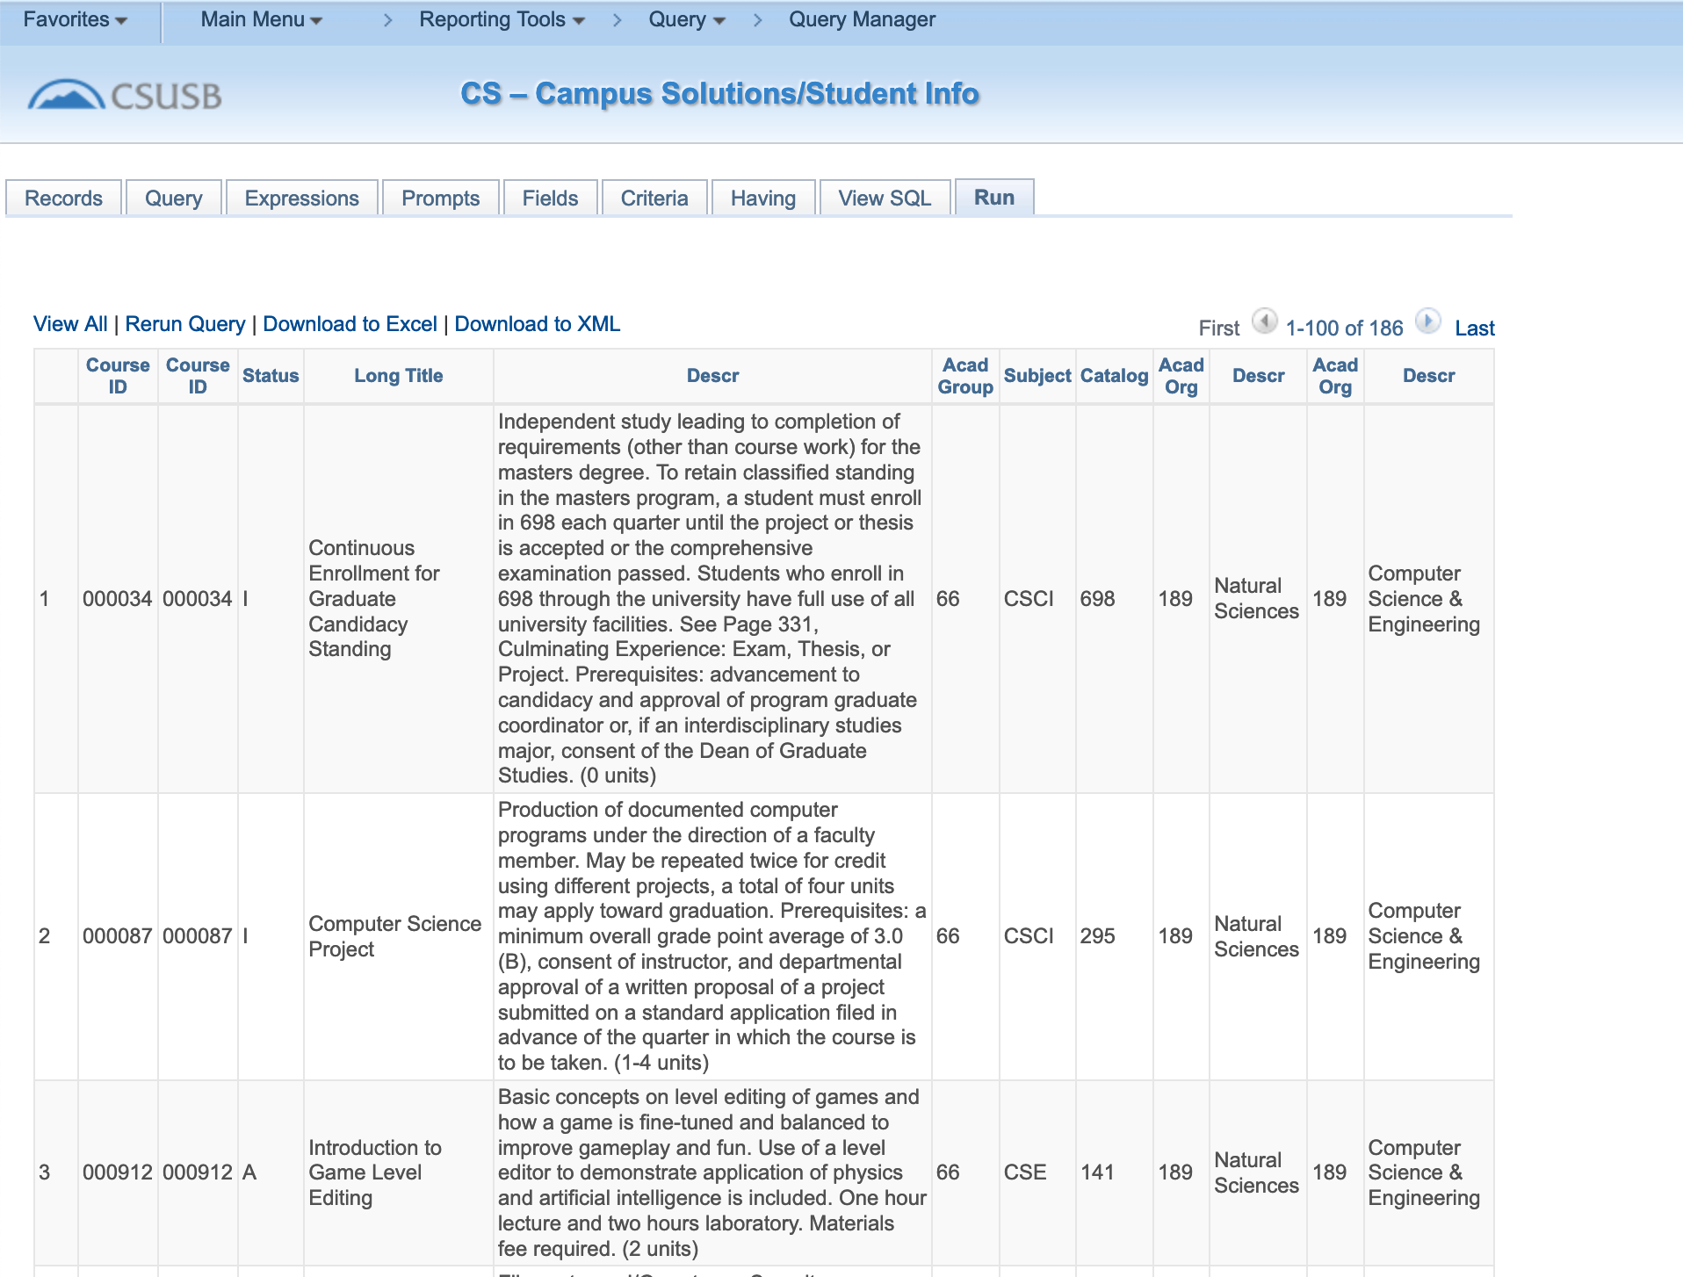

**SB_CSE572_Q4**

SELECT A.CRSE_ID, A.CRSE_OFFER_NBR, A.STRM, A.SESSION_CODE, A.CLASS_SECTION, B.NAME_TYPE, B.LAST_NAME, B.FIRST_NAME

FROM PS_CLASS_INSTR A, PS_NAMES_VW B

WHERE ( A.EMPLID = B.EMPLID

AND A.CRSE_ID = '010057'

AND A.CRSE_OFFER_NBR = 2

AND A.STRM = '2192'

AND A.SESSION_CODE = '1'

AND B.NAME_TYPE = 'PRF'

AND B.EFFDT =

(SELECT MAX(B_ED.EFFDT) FROM PS_NAMES_VW B_ED

WHERE B.EMPLID = B_ED.EMPLID

AND B.NAME_TYPE = B_ED.NAME_TYPE

AND B_ED.EFFDT <= SYSDATE))

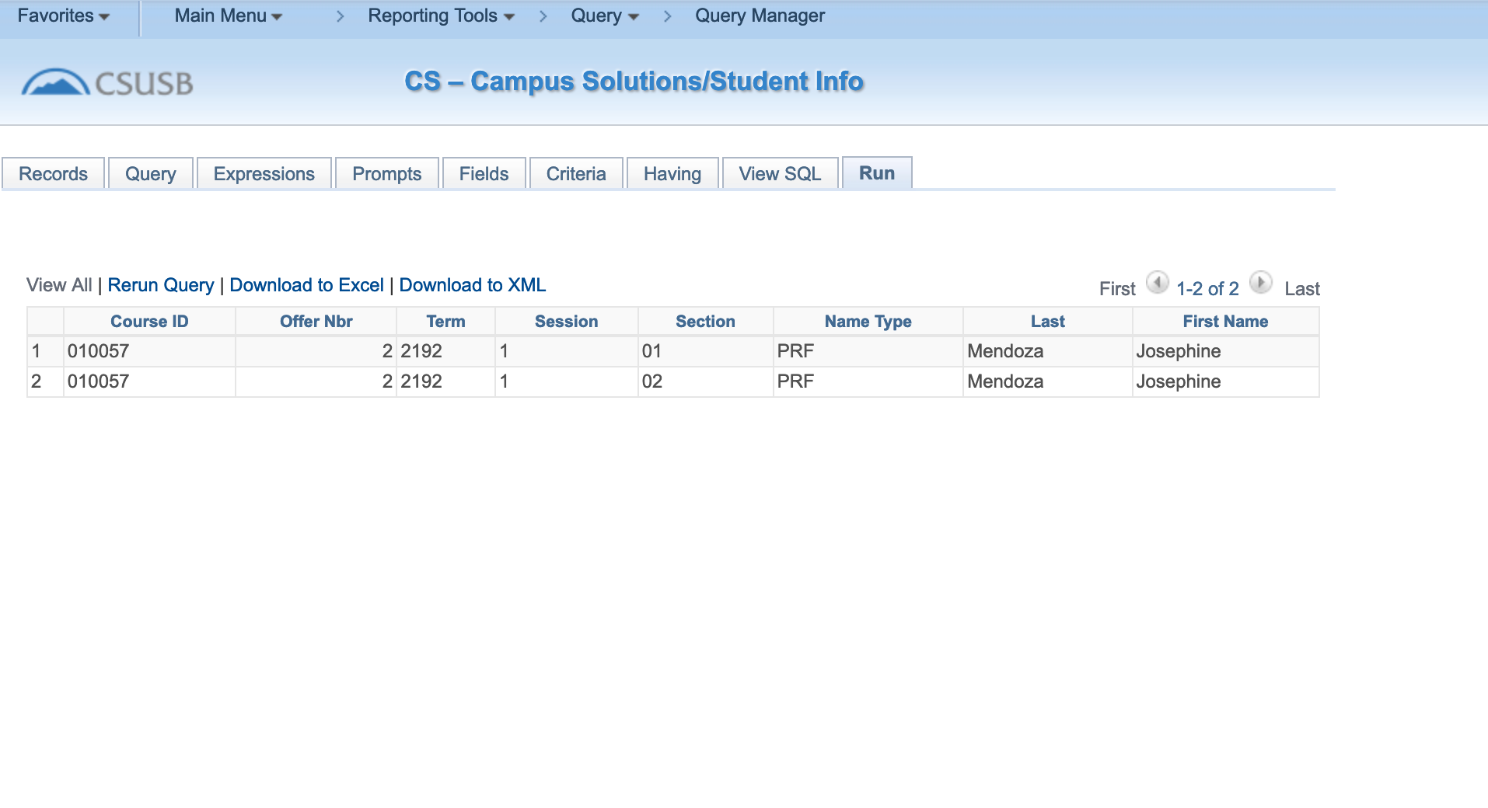

**SB_CSE572_Q5**

SELECT A.CRSE_ID, A.CRSE_OFFER_NBR, A.STRM, A.SESSION_CODE, A.DESCR, A.CLASS_NBR, B.STRM, B.DESCR, A.CLASS_SECTION, A.CATALOG_NBR, B.SESSION_CODE

FROM PS_CLASS_TBL A, PS_TERM_TBL B

WHERE ( A.STRM = :3

AND B.STRM = :3)

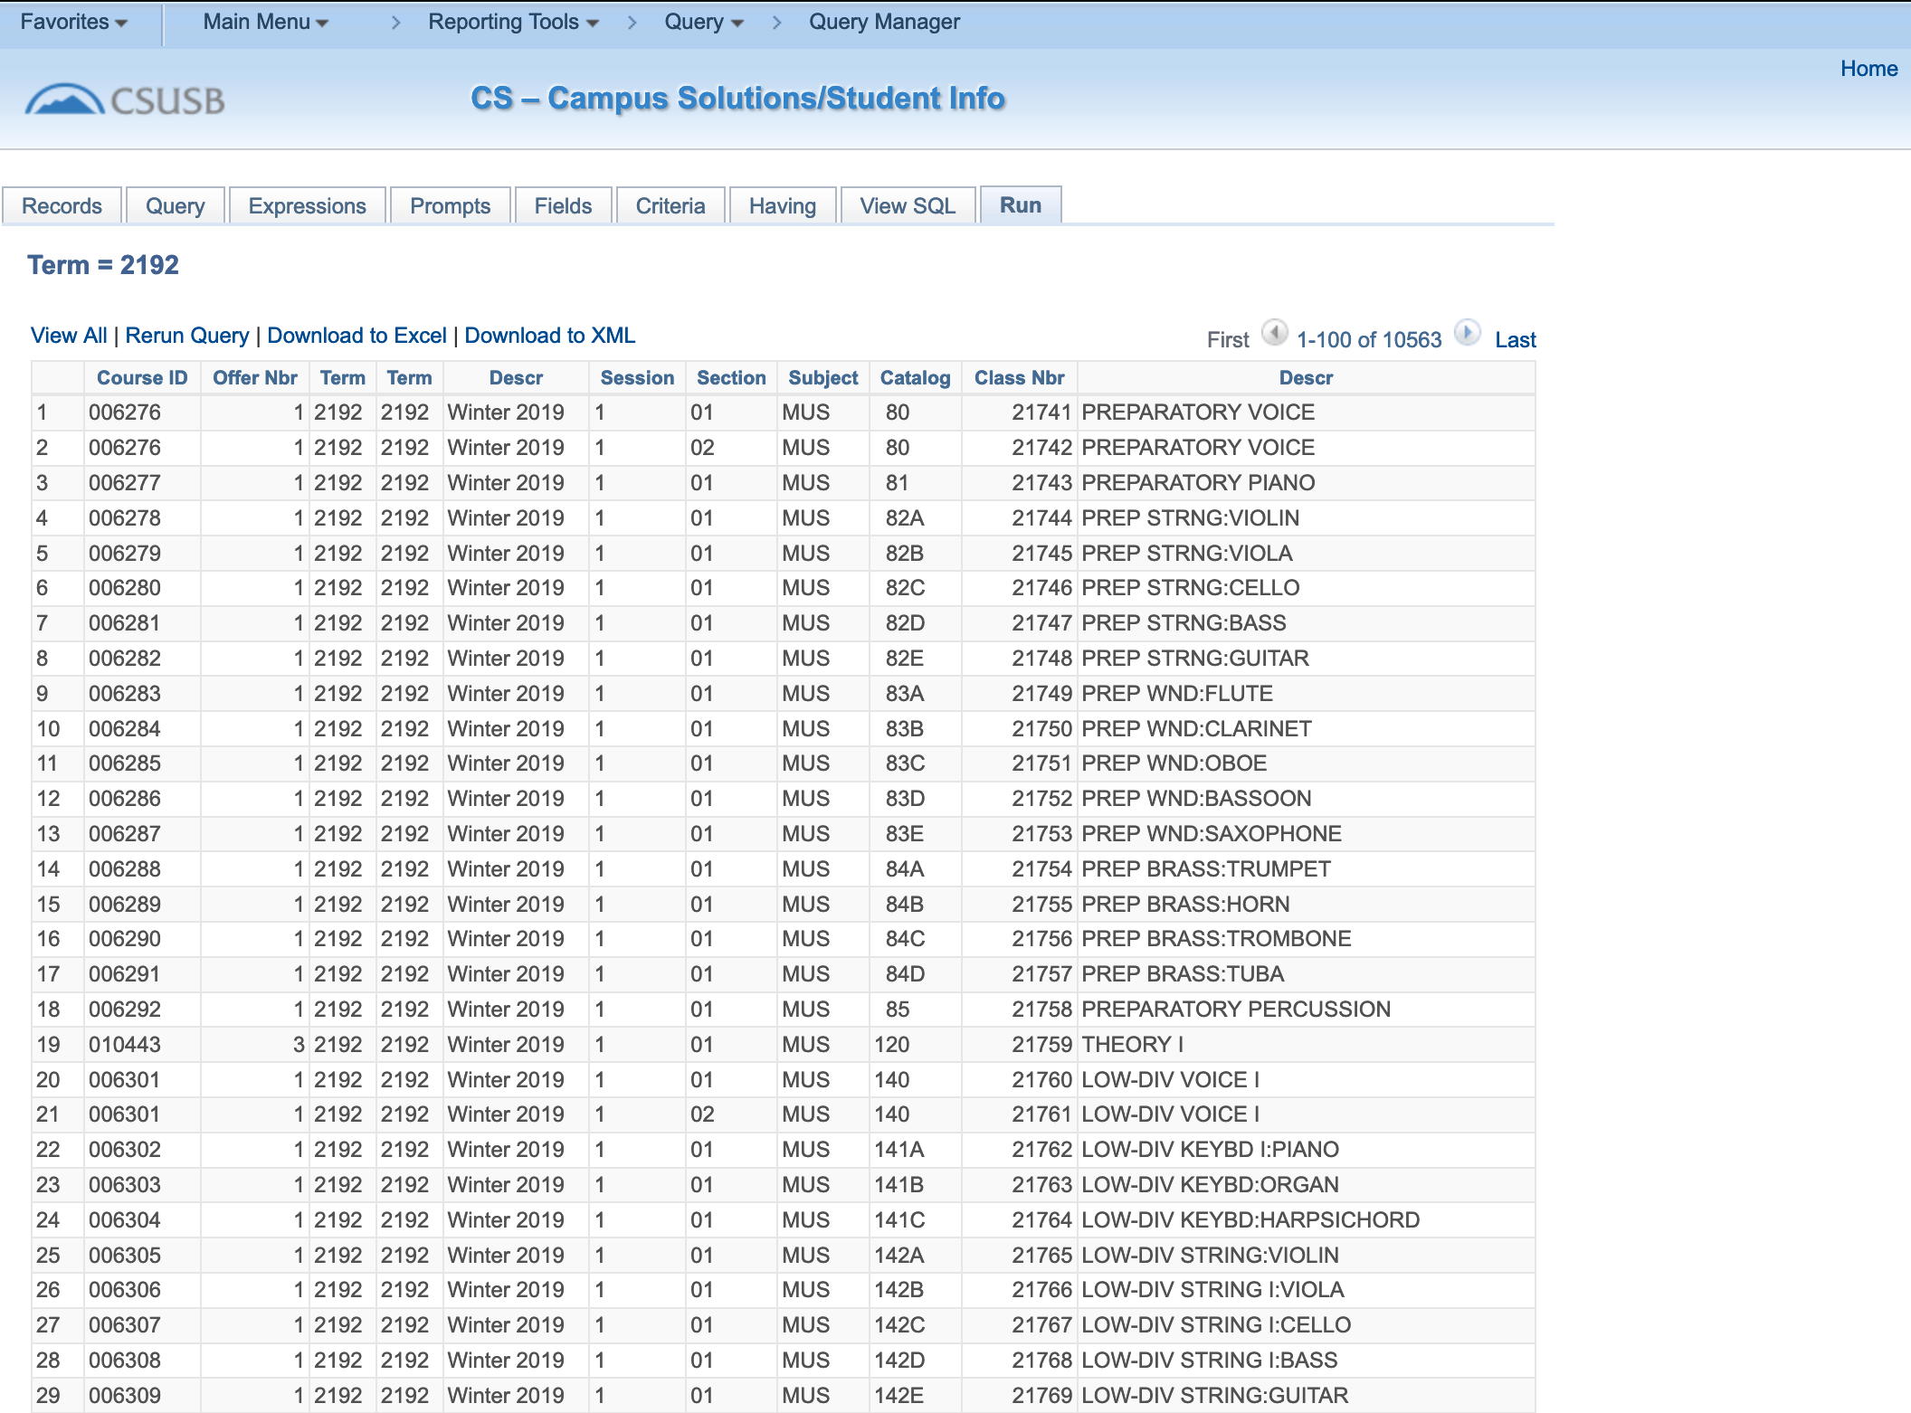

**SB_CSE572_Q6**

SELECT A.CRSE_ID, A.CRSE_OFFER_NBR, A.STRM, B.DESCR, A.SESSION_CODE, A.CLASS_SECTION, TO_CHAR(CAST((C.MEETING_TIME_START) AS TIMESTAMP),'HH24.MI.SS.FF'), TO_CHAR(CAST((C.MEETING_TIME_END) AS TIMESTAMP),'HH24.MI.SS.FF'), C.STND_MTG_PAT, D.BLDG_CD, D.ROOM

FROM PS_CLASS_TBL A, PS_TERM_TBL B, PS_CLASS_MTG_PAT C, PS_FACILITY_TBL D

WHERE ( D.FACILITY_ID = C.FACILITY_ID

AND ( A.STRM = B.STRM

AND A.SESSION_CODE = B.SESSION_CODE

AND B.INSTITUTION = A.INSTITUTION

AND B.ACAD_CAREER = A.ACAD_CAREER

AND A.CRSE_ID = C.CRSE_ID

AND A.CRSE_OFFER_NBR = C.CRSE_OFFER_NBR

AND A.STRM = C.STRM

AND A.SESSION_CODE = C.SESSION_CODE

AND A.CLASS_SECTION = C.CLASS_SECTION

AND D.EFFDT =

(SELECT MAX(D_ED.EFFDT) FROM PS_FACILITY_TBL D_ED

WHERE D.SETID = D_ED.SETID

AND D.FACILITY_ID = D_ED.FACILITY_ID

AND D_ED.EFFDT <= SYSDATE)

AND A.CRSE_ID = '010057'

AND A.CRSE_OFFER_NBR = 2

AND A.STRM = :1

AND A.SESSION_CODE = '1' ))

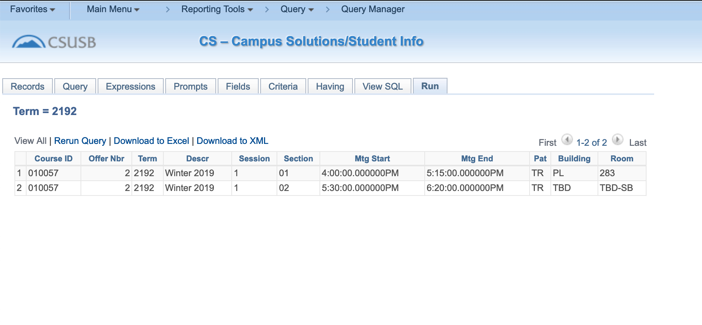

**SB_CSE572_Q7**

SELECT A.ACAD_PLAN_TYPE, A.ACAD_GROUP

FROM PS_SB_PLN_DPT_COL A

WHERE ( A.ACAD_PLAN_TYPE = 'MAJ'

AND A.ACAD_GROUP = '66')

