Game Information – Database Project

Group 8

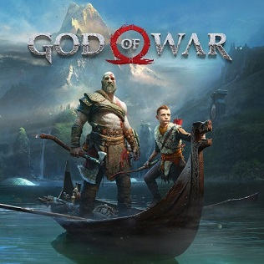

Image Courtesy: [https://en.wikipedia.org/wiki/God\_of\_War\_(2018\_video\_game)#/media/File:God\_of\_War\_4\_cover.jpg](https://en.wikipedia.org/wiki/God_of_War_(2018_video_game)" \l "/media/File:God_of_War_4_cover.jpg)

**[Section 1: Overview](https://en.wikipedia.org/wiki/God_of_War_(2018_video_game)" \l "/media/File:God_of_War_4_cover.jpg)**

[We have been tasked to create the back-end of a database; with it’s intended use as informational only. The database’s sole purpose is to provide the end user with as much information as possible that there is about the games available. Our vision was to create an expansive database which served the end user’s needs, for example: finding out when a game was created, the release date of future games, information about certain sound tracks, the names of developers/publishers/creators of games, where the idea originated, and overall rating. These are just few ideas of what the database could’ve been. Considering that this is the prototype, we were able to develop key points of the Game Database. In the future it could be turned into a subscription based database, or even free like Wikipedia, derived solely on the donations of it’s users. If the “paid subscription” is implemented, we could then create a front end website that allowed heavier loads of traffic and more expansive information to be created and stored.](https://en.wikipedia.org/wiki/God_of_War_(2018_video_game)" \l "/media/File:God_of_War_4_cover.jpg)

[Our functional specification for the utilities for such an application are as follows:](https://en.wikipedia.org/wiki/God_of_War_(2018_video_game)" \l "/media/File:God_of_War_4_cover.jpg)

* [We must store all key pieces of information about the game – Master Game Table.](https://en.wikipedia.org/wiki/God_of_War_(2018_video_game)" \l "/media/File:God_of_War_4_cover.jpg)
* [The Game must include child tables that allow for more descriptive information; if needed.](https://en.wikipedia.org/wiki/God_of_War_(2018_video_game)" \l "/media/File:God_of_War_4_cover.jpg)
* [The game must include a user rating system, that is solely based on the games available. If this is implemented, we must include critic reviews; To allow no-biased ratings](https://en.wikipedia.org/wiki/God_of_War_(2018_video_game)" \l "/media/File:God_of_War_4_cover.jpg)
* [The social aspect provided in the database is currently as registering your first and last name along with age and email (and credit card) in case you wanted to donate.](https://en.wikipedia.org/wiki/God_of_War_(2018_video_game)" \l "/media/File:God_of_War_4_cover.jpg)
* [We must keep COUNT of the available amount of games in our database that have been collected; Considering the database is still in BETA, we did not include a customer rental, and a table to record the amount of copies that have been rented out. But this can be implemented in the future.](https://en.wikipedia.org/wiki/God_of_War_(2018_video_game)" \l "/media/File:God_of_War_4_cover.jpg)
* [A user can currently query the database if they wanted to find out certain information about games. They can look at anything from the title of the game to the developer/publisher and soon to be tracks developed for the game.](https://en.wikipedia.org/wiki/God_of_War_(2018_video_game)" \l "/media/File:God_of_War_4_cover.jpg)

[Overal](https://en.wikipedia.org/wiki/God_of_War_(2018_video_game)" \l "/media/File:God_of_War_4_cover.jpg)