LAB 3 WORKSHEET
Lab: Lab 3 – Flutter Environment Audit and MySQL Database Design
Exercise A – Flutter Environment Audit and First Widget
Screenshot 1: flutter doctor -v
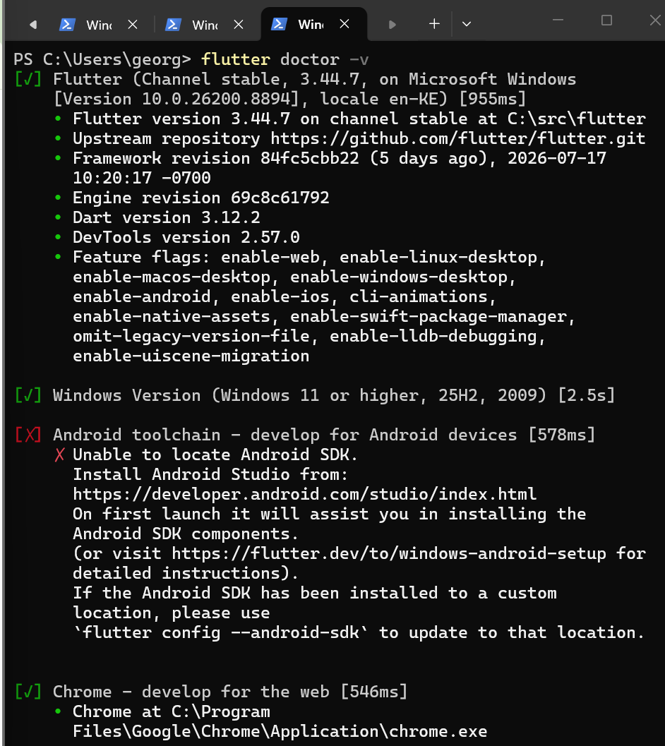
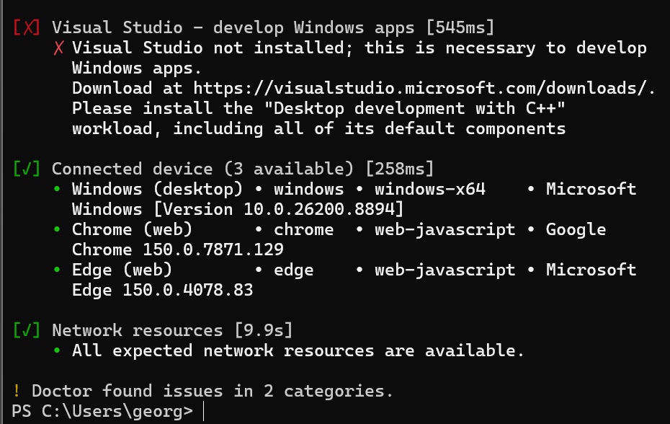

Screenshot 2: Running Flutter Application
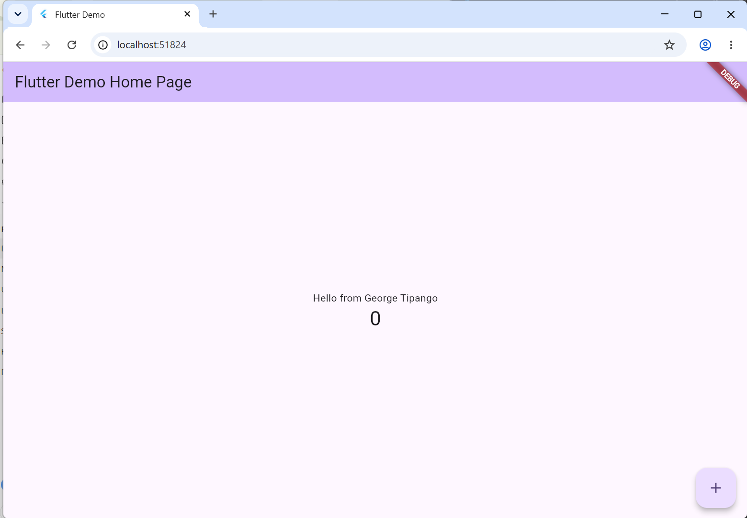

Explanation:
The lib/main.dart file is the main entry point of the Flutter application. It contains the application's code, including the user interface and the program logic. The main() function starts the application by calling runApp().
The MyApp class is the root widget of the application. It configures the overall application by defining the theme, application title, and the home page displayed when the app starts.
The MyHomePage class is a stateful widget that manages the application's interactive content. It stores the counter value and rebuilds the user interface whenever the state changes.
The FloatingActionButton is connected to the _incrementCounter() method. Each time the button is pressed, the setState() method updates the counter value and refreshes the user interface immediately without restarting the application.
Exercise B – MySQL Database Design and Querying

Screenshot 3: CREATE TABLE products
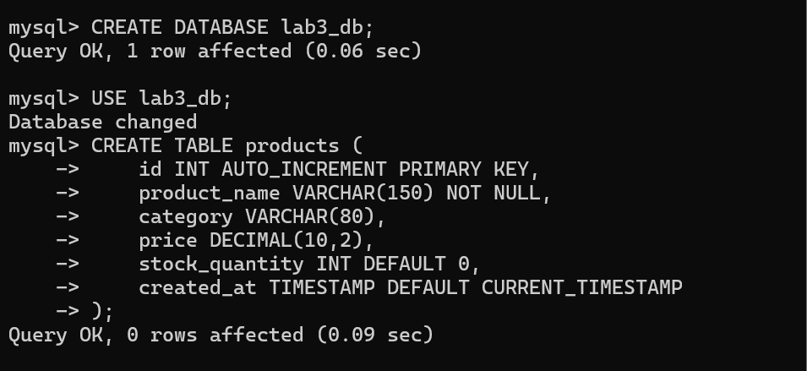

Screenshot 4: SELECT * FROM products
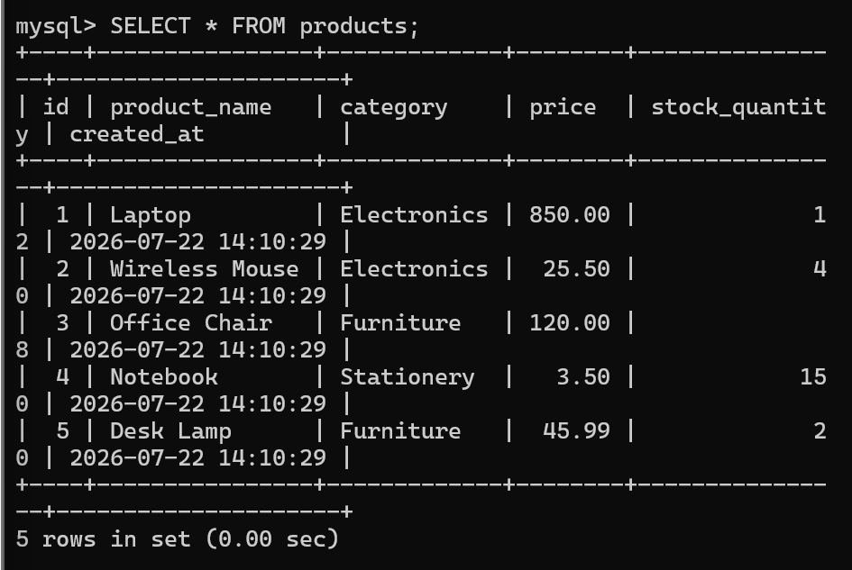

SELECT * FROM products
WHERE category = 'Electronics';
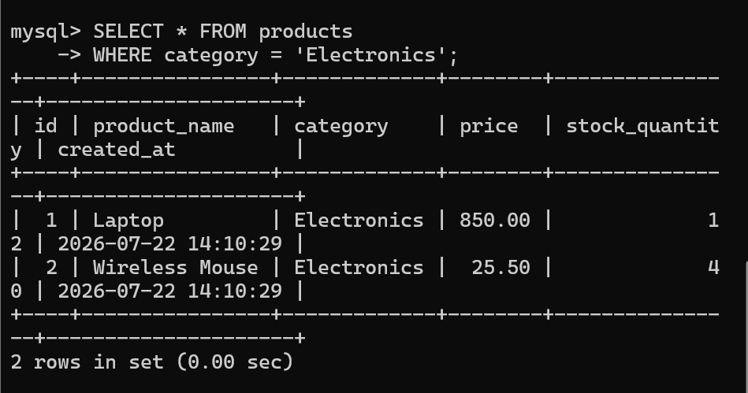

SELECT * FROM products
ORDER BY price ASC;
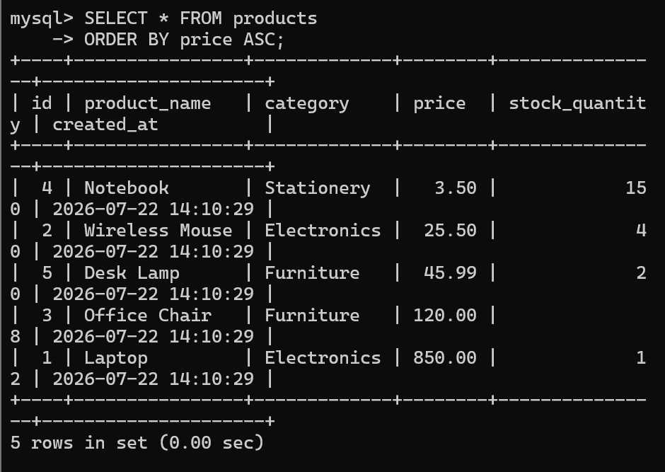
Explanation:
The DECIMAL(10,2) data type is used to store numbers with up to 10 digits, including 2 digits after the decimal point. It is preferred over FLOAT for storing currency because it stores exact decimal values and avoids rounding errors that can occur with floating-point numbers. This ensures financial calculations remain accurate.
The NOT NULL constraint ensures that a column must always contain a value. It prevents records from being inserted without required information, helping maintain the accuracy and integrity of the database.

