# Task

Create an application which finds feasible placement of wires inside wire bundle (or cable) so the bundle’s outside diameter is minimal. Assume that wires and bundle are having circular cross-section, the thickness of insulation do not take into account.

Data input is a text file with radii of wires, one per line. The output shall be diameter of wire bundle (cable) and organization of wires inside bundle. Found solution visualize in application (e.g. using GDI or WPF).

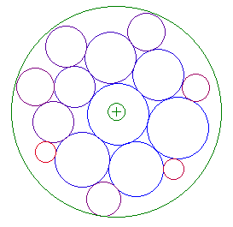

Image 1 Example of visualization

## Input file

Input file is ASCII encoded text file where radii are in millimeters, with dot as decimal separator. Lines beginning with # should be considered as comments.

## Environment

Use your favorite environment and language, preferably C#, C++ or java.

You can download Microsoft Visual Studio at <https://www.visualstudio.com/downloads/>