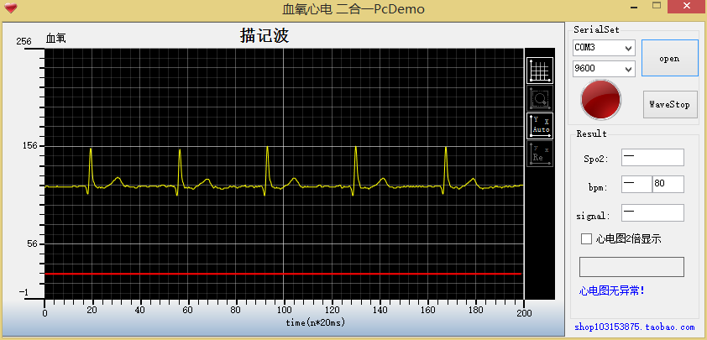

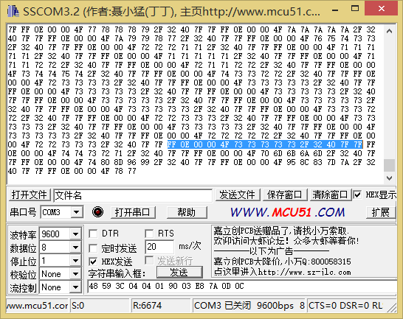

FF 0E 00 00 4F 73 73 73 73 73 2F 32 40 7F 7F

FF 帧头

OE LEN

1. 异常位：

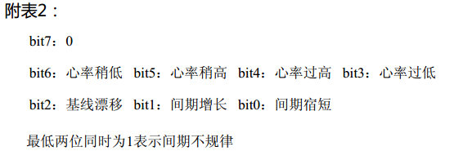

00 4F 心率=00\*100+4F=79

73 73 73 73 73 五个点的ECG

2F 32 40 7F 7F 血氧值

FF 0E 00 00 50 74 74 74 74 74 2F 32 40 7F 7F FF 0E 00 00 50 73 73 73 73 73 2F 32 40 7F 7F FF 0E 00 00 50 73 73 73 73 73 2F 32 40 7F 7F FF 0E 00 00 50 73 74 74 74 73 2F 32 40 7F 7F FF 0E 00 00 50 73 73 72 73 73 2F 32 40 7F 7F FF 0E 00 00 50 72 71 70 6E 6B 2F 32 40 7F 7F FF 0E 00 00 50 6A 6B 71 7C 89 2F 32 40 7F 7F FF 0E 00 00 50 94 9A 98 90 87 2F 32 40 7F 7F FF 0E 00 00 50 7F 7A 78 78 76 2F 32 40 7F 7F FF 0E 00 00 50 74 73 72 72 72 2F 32 40 7F 7F FF 0E 00 00 50 72 72 71 71 72 2F 32 40 7F 7F FF 0E 00 00 50 72 72 72 72 72 2F 32 40 7F 7F FF 0E 00 00 50 73 73 72 71 71 2F 32 40 7F 7F FF 0E 00 00 50 71 71 72 73 73 2F 32 40 7F 7F FF 0E 00 00 50 73 73 73 74 74 2F 32 40 7F 7F FF 0E 00 00 50 74 75 75 75 76 2F 32 40 7F 7F FF 0E 00 00 50 76 76 76 77 77 2F 32 40 7F 7F FF 0E 00 00 50 78 78 79 79 7A 2F 32 40 7F 7F FF 0E 00 00 50 7B 7B 7B 7C 7B 2F 32 40 7F 7F FF 0E 00 00 50 7B 7B 7A 79 78 2F 32 40 7F 7F FF 0E 00 00 50 77 76 75 74 74 2F 32 40 7F 7F FF 0E 00 00 50 74 74 73 72 72 2F 32 40 7F 7F