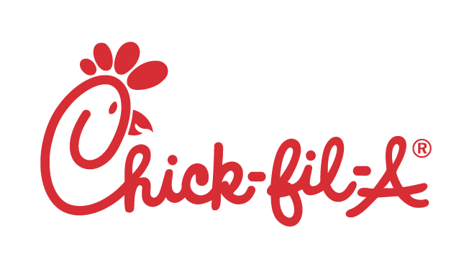

**DISCIPLINE NOTICE**

**Chick-fil-A, Inc.-Operated Restaurant (“COR”)**

Team Member’s name: «Name»

Interim Manager’s name: «IM» COR location: «Location»

Documentation of (check one): Verbal warning Written warning Suspension

Summary of the issue/incident *(include date, location, and description of incident/issue)*:

On «Date» «Name» «Late»

Name(s) of witness(es) to issue/incident, *if any*:

Did the Team Member violate a written Chick-fil-A, Inc. policy? X Yes No

*If Yes*, relevant Chick-fil-A, Inc. policy: Attendance and Punctuality

*If Yes*, describe how: On «Date» «Name» «Late»

Has the Team Member received prior warnings on this subject? Yes No

*If Yes*, how many and what kind?

Describe the corrective action to be taken by the Interim Manager and/or Team Member:

Show up to all scheduled shifts on time or find coverage

Consequences of failure to improve performance or correct behavior could lead to further discipline, including, but not limited to:

Suspension or Termination

Team Member statement:

**I have read and understand the information provided in this Discipline Notice. I also understand that further violations/issues could lead to additional discipline, up to and including termination.**

Team Member Signature: Date:

Interim Manager Signature: Date:

Discipline Notice Witness Signature: Date:

# Updated 2016

# For use in Chick-fil-A, Inc.-Operated Restaurant (“COR”) locations only