Assignment 11

Description:

Assignment 11 will compile the Linux input subsystem module on Raspberry pi. The input module could intercept the USB keyboard signal and print out the keyboard character on the console.

The input subsystem is part of Linux kernel that manages the varies of input devices(such as keyboard, mice, joysticks, tablets, touchscreen, etc). The input subsystem is an abstraction layer between the HW input device and the input handler.

Input device work flow:

- User typed the input device(keyboard, mice, etc), HW sends out signal.

- Drivers will register its input to Input Device Driver layers, Registration will taken place on two ways depending on whether we designed driver as Event driven input device or polled input device(Explanation is at the bottom). The main function of the InputDeviceDriver layer are requesting of interrupts, registering the interrupt handler. Allocating a input device structure,registering the input device.

- After the InputDeviceDrivers next layer is Input Core, the main layer of the Input Subsystem. The main functionality of the input sub system is, this layer will take the input from the InputDeviceDriver layer and generates an event

More Info about Input Subsystem: http://www.linuxjournal.com/article/6396
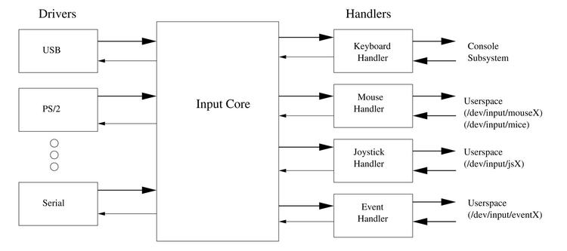
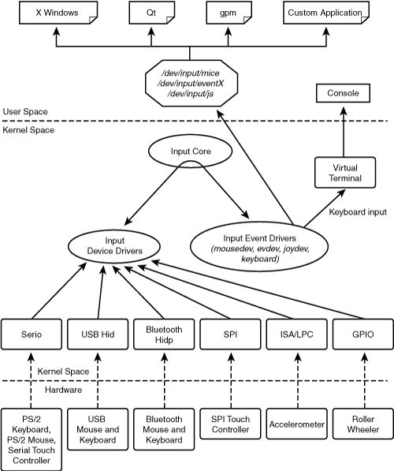

Procedure:

- Create a C file named input.c

/*
* SVU Intro to Embedded Systems Lab>
*/

/*
* This program is free software; you can redistribute it and/or modify
* it under the terms of the GNU General Public License as published by
* the Free Software Foundation; either version 2 of the License, or
* (at your option) any later version.
*
* This program is distributed in the hope that it will be useful,
* but WITHOUT ANY WARRANTY; without even the implied warranty of
* MERCHANTABILITY or FITNESS FOR A PARTICULAR PURPOSE. See the
* GNU General Public License for more details.
*
* You should have received a copy of the GNU General Public License
* along with this program; if not, write to the Free Software
* Foundation, Inc., 59 Temple Place, Suite 330, Boston, MA 02111-1307 USA
*/

#include <linux/module.h>
#include <linux/input.h>
#include <linux/init.h>
#include <linux/bitops.h>
#include <linux/mod_devicetable.h>
#include <linux/slab.h>
#include <linux/workqueue.h>
#include <linux/spinlock.h>

MODULE_LICENSE("Dual BSD/GPL");

#define HW_RAW(dev) (test_bit(EV_MSC,dev->evbit) && test_bit(MSC_RAW,dev->mscbit) && ((dev)->id.bustype == BUS_I8042) && ((dev)->id.vendor == 0x0001) && ((dev)->id.product == 0x0001))
#define DEFAULT_SPEED 10
#define MAX_SPEED 50
#define MIN_SPEED 1
struct vms
{
struct input_handler *handler;
struct input_handle *handle;
struct input_dev *dev;
struct work_struct work;
spinlock_t lock;
unsigned int event_code;
int value;
}*vms;

void vms_func(struct work_struct *work)
{
spin_lock(&vms->lock);

switch(vms->event_code)
{

case KEY_S:
printk(KERN_ALERT "S is typed\n");
break;

case KEY_V:
printk(KERN_ALERT "V is typed\n");
break;

case KEY_U:
printk(KERN_ALERT "U is typed\n");
break;
default:
printk(KERN_ALERT "The button you typed is %d, value is %d\n", vms->event_code, vms->value);
break;

}
spin_unlock(&vms->lock);

}

static void vkbd_event(struct input_handle *handle, unsigned int event_type,
unsigned int event_code, int value)
{
if(event_type == EV_KEY)
{
vms->event_code = event_code;
vms->value = value;
schedule_work(&vms->work);
}

}

static int vkbd_connect(struct input_handler *handler, struct input_dev *dev,
const struct input_device_id *id)
{
struct input_handle *handle;
int error;
int i;

for(i = KEY_RESERVED; i < BTN_MISC; i++)
if(test_bit(i,dev->keybit))
break;

if(i == BTN_MISC && !test_bit(EV_SND, dev->evbit))
return -ENODEV;

handle = kzalloc(sizeof(struct input_handle), GFP_KERNEL);
vms->handle = handle;
if(!handle)
return -ENOMEM;

handle->dev = dev;
handle->handler = handler;
handle->name = "vkbd";

error = input_register_handle(handle);
if(error)
goto err_free_handle;

error = input_open_device(handle);
if(error)
goto err_unregister_handle;

printk(KERN_ALERT "vkbd_connect: %s\n", dev->name);
return 0;

err_unregister_handle:
input_unregister_handle(handle);
err_free_handle:
kfree(handle);
return error;
}

static void vkbd_disconnect(struct input_handle *handle)
{
input_close_device(handle);
input_unregister_handle(handle);
kfree(handle);
}

static void vkbd_start(struct input_handle *handle)
{
input_inject_event(handle,EV_LED,LED_CAPSL,0x04);
input_inject_event(handle,EV_SYN,SYN_REPORT,0);
}

static const struct input_device_id vkbd_ids[] =
{
{
.flags = INPUT_DEVICE_ID_MATCH_EVBIT,
.evbit = { BIT_MASK(EV_KEY) },
},
{
.flags = INPUT_DEVICE_ID_MATCH_EVBIT,
.evbit = { BIT_MASK(EV_SND) },
},

{
.flags = INPUT_DEVICE_ID_MATCH_EVBIT,
.evbit = { BIT_MASK(EV_REL) },
},

{
},
};

static struct input_handler vkbd_handler =
{
.event = vkbd_event,
.connect = vkbd_connect,
.disconnect = vkbd_disconnect,
.start = vkbd_start,
.name = "lab_irq",
.id_table = vkbd_ids,
};

int __init vms_init(void)
{
int error;

vms = kzalloc(sizeof(struct vms),GFP_KERNEL);
vms->handler = &vkbd_handler;

/*
* This function will initialize thw workquese, the work quese is essentially a kernel thread
*/

INIT_WORK(&vms->work,vms_func);

spin_lock_init(&vms->lock);

error = input_register_handler(&vkbd_handler);
if(error)
return error;

//init vms_dev
vms->dev = input_allocate_device();
if(!vms->dev)
{
printk(KERN_ALERT "vms: Bad input_allocate_device()\n");
return -1;
}

vms->dev->evbit[0] = BIT_MASK(EV_KEY) | BIT_MASK(EV_REL);
// vms->dev->keybit[BIT_WORD(BTN_LEFT)] = BIT_MASK(BTN_LEFT);

vms->dev->keybit[BIT_WORD(BTN_MOUSE)] = BIT_MASK(BTN_LEFT) |
BIT_MASK(BTN_RIGHT) | BIT_MASK(BTN_MIDDLE);
vms->dev->relbit[0] = BIT_MASK(REL_X) | BIT_MASK(REL_Y);

vms->dev->name = "vms";
vms->dev->phys = "vms";
vms->dev->id.bustype = BUS_I8042;
vms->dev->id.vendor = 0x0002;
vms->dev->id.product = 5;
vms->dev->id.version = 0;

input_register_device(vms->dev);

printk(KERN_ALERT "vms init\n");
return 0;
}

void __exit vms_exit(void)
{
if(vms->dev)
input_unregister_device(vms->dev);
input_unregister_handler(vms->handler);
kfree(vms);
}

module_init(vms_init);
module_exit(vms_exit);

- Create Makefile

DRIVER = input
#This is your kernel archive path.
KERNELDIR=< Your Kernel Path>
CROSS_COMPILE=arm-linux-gnueabi-
#CFLAGS="-march=armv6"
#KERNELDIR=/lib/modules/3.6.11+/kernel
ifneq ($(KERNELRELEASE),)
obj-m := $(DRIVER).o
else
PWD := $(shell pwd)

default:
ifeq ($(strip $(KERNELDIR)),)
$(error "KERNELDIR is undefined!")
else
$(MAKE) -C $(KERNELDIR) M=$(PWD) modules
endif

clean:
rm -rf *~ *.ko *.o *.mod.c modules.order Module.symvers .$(DRIVER)* .tmp_versions

endif

3) Once compiled ok, insmod the driver on raspberry, connect a USB keyboard driver with Raspberry, then typed some keys to see what happened.

