

**Team members:**

Zlatina PlachkovaNikolina GyurovaGeorgi Georgiev  
Bobby KolevTsanko Arabadzhiev - did not participate

**The project:**

Game – “Aliens Killer”

We've made an action game using the Popcorn game as a base.

**The project purpose:**

This game exercises the speed and logic. The player have to kill all aliens for 40 seconds. The project isn’t completely finished, because we have more ideas for collecting points and creating different levels of difficulty.

**Class diagram:**

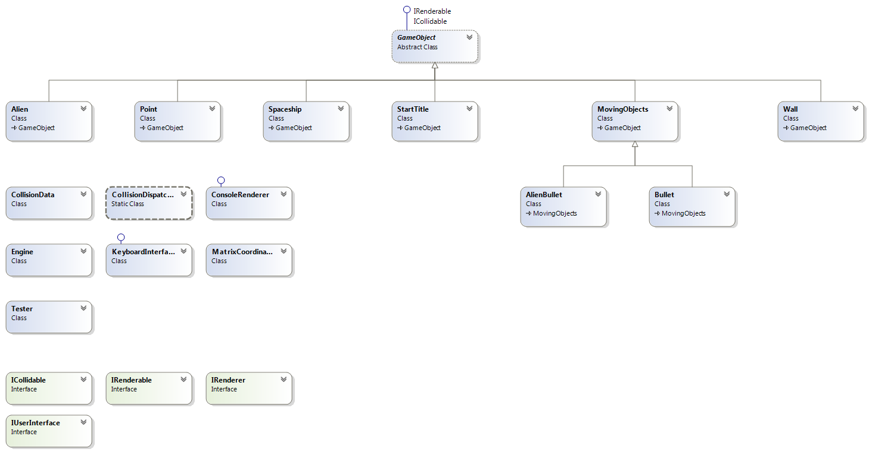

**The URL of TFS repository:**

<https://garfield.visualstudio.com/>

**Other information:**

**(some part of the work submitted by Zlatina Plachkova was made by Georgi Georgiev)**

