Robot Localization and Uncertainty – OOP

In this assignment, we are using a bayes filter to solve a robot localization and uncertainty problem. The problem appears as follows:

Problem1: Rewrite your solution for homework1 by OOP.

1) Create at least one class of the Robot to represent the localization process of Bayes filter. Please name your class as robotBase.

2) Problem2: A new robot (robot2) will be deployed for the same scenario. When under a given control 𝑢𝑡 = 1, the robot2 should move to the next grid (for example, from P0 to P1). However, the motors bring noises, and it may result at:

* With 60% moves to the next grid (P1)
* With 20% stay in the same grid (P0)
* With 20% moves to the grid after the next grid (P2)
* With 0% moves to the yellow grid that is after P3

The robot2 equips a different sensor:

* When face to the wall, the sensor with 60% depicts the wall detected, 40% outputs the door detected
* When face to the door, the sensor with 85% depicts the door detected, 15% outputs the wall detected

Try to figure out how to localize the robot2. Your code of robot2:

1). Must be inherited from the class of robotBase, which you create in problem 1

The inheritance of the classes are structured as so:

With the above classes the following results were obtained:

**bel(x0) => p0 = 0.25, p1 = 0.25, p2 = 0.25, p3 = 0.25,**

**The Probability of the Robot’s Position at Step 0**

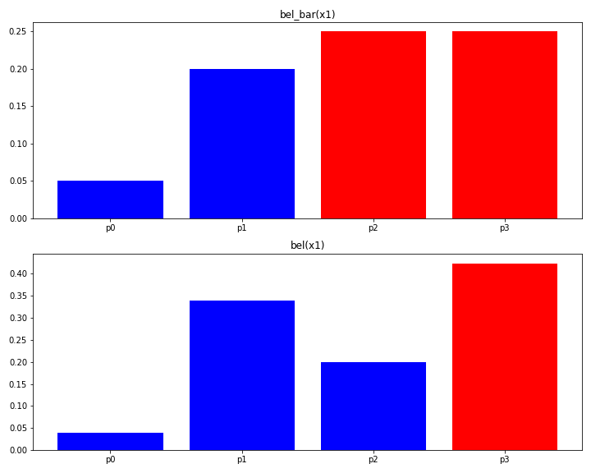

**bel(x1) => p0 = 0.0398, p1 = 0.3308, p2 = 0.1990, p3 = 0.4229**

**The Probability of the Robot’s Position at Step 1**

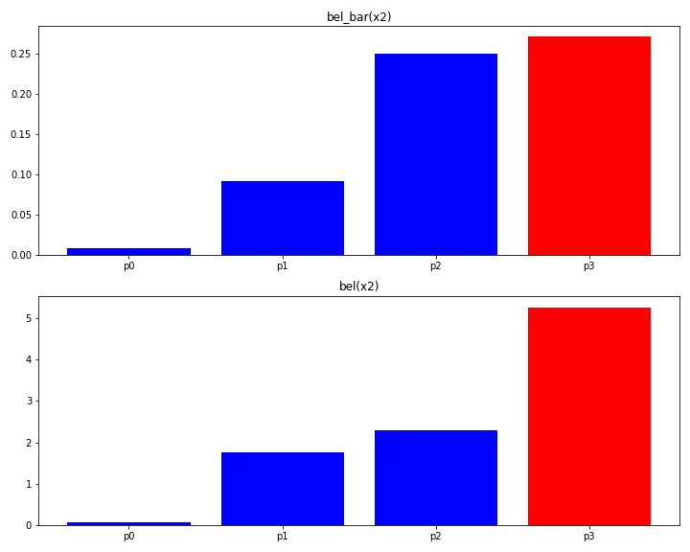

**bel(x2) => p0 = 0.0724, p1 = 0.3711, p2 = 0.4783, p3 = 1.101**

**The Probability of the Robot’s Position at Step 2**

**bel(x3) => p0 = 0.0017, p1 = 0.1019, p2 = 0.1850, p3 = 0.7113**

**The Probability of the Robot’s Position at Step 3**