Data Acquisition, Cleaning, and Preprocessing
Week 1 Task Report
Dataset: Titanic — Machine Learning from Disaster (public, Kaggle-mirrored)

Contents

1. Objective
This report documents the end-to-end process of acquiring a publicly available dataset, exploring its structure and quality, and cleaning and preprocessing it so it is ready for downstream analysis or modelling. Every step is backed by Python code (pandas, NumPy, Matplotlib/Seaborn, SciPy, scikit-learn), with commentary explaining why each decision was made, and screenshots of the resulting visualisations.

1.1 Executive Summary
The raw Titanic dataset (891 rows, 12 columns) contained three columns with missing data (Age 19.9%, Cabin 77.1%, Embarked 0.22%), 15 rows with an implausible Fare of exactly 0, and a right-skewed Fare distribution with genuine high-end outliers. Each issue was diagnosed before being fixed: a chi-square test confirmed Age-missingness is not random (it is linked to Pclass), which justified group-wise median imputation instead of a single global fill; Fare outliers were evaluated with two different methods (Z-score and IQR at two thresholds) before selecting a widened IQR rule appropriate for a skewed distribution. All 891 rows were retained (nothing was dropped), 4 new features were engineered (HasCabin, FamilySize, IsAlone, Title), and the result is a fully numeric, 16-column dataset with zero missing values. To quantify whether this effort was worthwhile, a simple Logistic Regression model was trained on both a naively-cleaned version of the data (rows with any missing value simply dropped) and the fully cleaned dataset from this report: the properly cleaned pipeline used all 891 rows (vs 714 for the naive approach) and improved 5-fold cross-validated accuracy from 80.25% to 82.60%, a +2.35 point gain, while also cutting the variance across folds roughly in half. Full detail and code for every step follows below, with quantitative results in Sections 3.2, 4.4, 6.1 and 9.

2. Data Collection
Source: the Titanic passenger manifest dataset, a widely used, freely available dataset originally published for the Kaggle "Titanic: Machine Learning from Disaster" competition and mirrored publicly on GitHub (datasciencedojo/datasets).
The raw file was downloaded directly as a CSV using a simple HTTP request:
import pandas as pd
df = pd.read_csv("titanic.csv")
print(df.shape) # (891, 12)
Why this dataset: it is small enough to process quickly but realistically messy — it contains missing values across multiple columns, at least one column with an extreme missing-data rate, a handful of implausible zero values, and a mix of numeric, categorical and free-text columns. This makes it a good, representative exercise for the full data-cleaning workflow rather than a toy dataset with no quality issues.

3. Initial Data Exploration
Before touching the data, the structure and quality were profiled: shape, data types, summary statistics, missing-value counts, duplicate rows, and the set of unique values in each categorical column.
print(df.dtypes)
print(df.describe(include="all"))
print(df.isnull().sum())
print(df.duplicated().sum())
print(df["Sex"].unique(), df["Embarked"].unique())
Key findings from this initial pass:
- 891 rows, 12 columns; no duplicate rows.
- Age is missing in 177 rows (19.9%) — the largest quantity of missing data on a directly usable numeric feature.
- Cabin is missing in 687 rows (77.1%) — far too sparse to impute reliably as a raw value.
- Embarked is missing in only 2 rows (0.22%) — trivial to handle.
- 15 rows have Fare = 0, which is implausible for paying passengers and was treated as an erroneous entry rather than a true zero.
- Categorical columns (Sex, Embarked, Pclass) had a small, well-defined set of values with no obvious typos, though a normalisation step was still applied defensively.
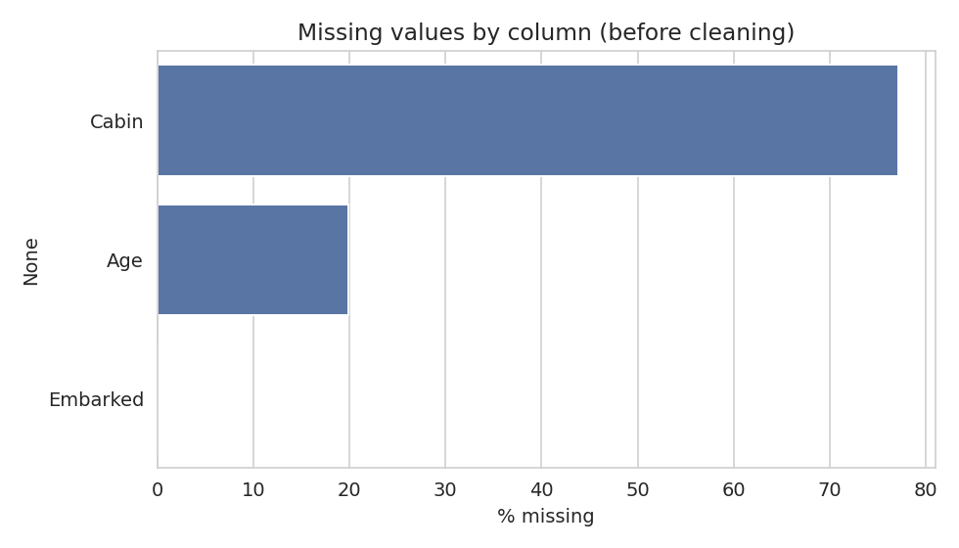
Figure 1. Percentage of missing values per column before cleaning.

3.1 Univariate Distributions
Age and Fare — the two continuous numeric features — were plotted as histograms to understand their shape before any transformation. Age is roughly bell-shaped with a slight right skew and a cluster of infants/young children. Fare is heavily right-skewed: most tickets are cheap, but a small number of first-class fares extend the distribution well past 200-500, which is the underlying reason Fare needed different outlier-handling logic than Age (see Section 6).
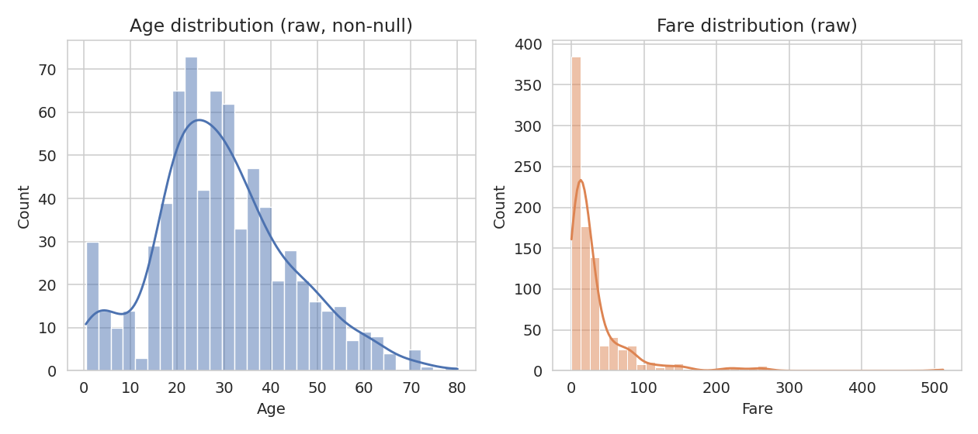
Figure 6. Distribution of Age (left) and Fare (right) in the raw data.

3.2 Bivariate Exploration: What Drives Survival
Before cleaning, it is useful to understand which raw variables actually relate to the target, both to sanity-check the data and to make sure no cleaning decision later on accidentally destroys a real signal.
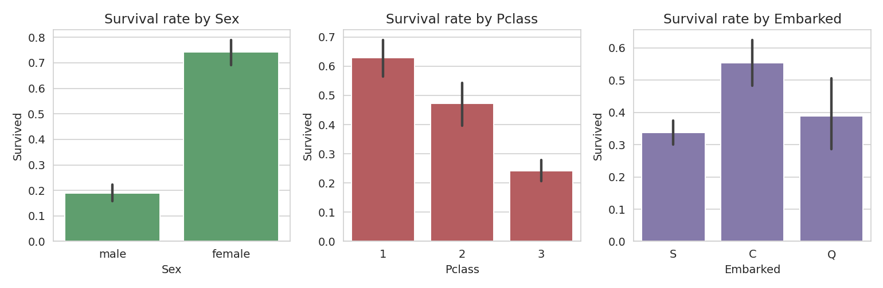
Figure 7. Raw survival rate by Sex, Pclass, and Embarked.
- Sex shows the strongest split: roughly 74% of female passengers survived versus about 19% of male passengers.
- Pclass shows a clear monotonic pattern: 1st class survival (~63%) is more than double 3rd class survival (~24%).
- Embarked shows a smaller but visible gap (Cherbourg passengers survived at a notably higher rate than Southampton/Queenstown), which is partly confounded with Pclass since Cherbourg had a higher share of 1st-class passengers.
These patterns are used later (Section 9) as a sanity check that the cleaned dataset preserves the same relationships.

4. Handling Missing Values

4.1 Cabin (77.1% missing)
With more than three-quarters of values missing, imputing a specific cabin number would be fabricating data with no statistical basis. Instead of dropping the signal entirely, the missingness itself was converted into a feature — a binary HasCabin flag — since passengers with a recorded cabin were disproportionately from higher classes and had a different survival rate. The raw Cabin column was then dropped.
df["HasCabin"] = df["Cabin"].notnull().astype(int)
df.drop(columns=["Cabin"], inplace=True)

4.2 Embarked (0.22% missing)
Only two rows were affected, so the simplest defensible approach — mode imputation — was used. With such a small number of missing values, any reasonable imputation method has negligible effect on downstream analysis.
embarked_mode = df["Embarked"].mode()[0]
df["Embarked"] = df["Embarked"].fillna(embarked_mode)

4.3 Age (19.9% missing)
Age is too important a feature to drop or impute naively. Rather than filling with a single global median (which would flatten real differences between groups), missing ages were imputed with the median Age within each Pclass x Sex group, since both variables are strongly associated with age in this dataset (e.g. crew and 3rd-class passengers skewed younger).
df["Age"] = df.groupby(["Pclass", "Sex"])["Age"].transform(
lambda s: s.fillna(s.median())
)
This group-wise strategy preserves more of the original distribution's structure than a single overall median would, at the cost of some added complexity.

4.4 Verifying the Missingness Mechanism
Before choosing an imputation strategy for Age, it is worth checking whether the data is Missing Completely At Random (MCAR) or Missing At Random conditional on other variables (MAR) — this determines whether a simple global fill is defensible or whether a group-wise fill (as used above) is actually necessary.
raw["AgeMissing"] = raw["Age"].isnull().astype(int)
ct = pd.crosstab(raw["Pclass"], raw["AgeMissing"])
chi2, p_val, dof, _ = stats.chi2_contingency(ct)
A chi-square test of independence between Pclass and Age-missingness gives chi2 = 46.06, p < 0.00001 — the missingness rate is not uniform across classes (13.9% missing in 1st class vs 27.7% in 3rd class). This is a statistically significant relationship, meaning Age is Missing At Random (MAR) with respect to Pclass rather than MCAR. This directly justifies imputing Age using Pclass (and Sex, which shows a similar pattern) as grouping variables rather than filling with one global median, which would have systematically underestimated the age gap between classes.
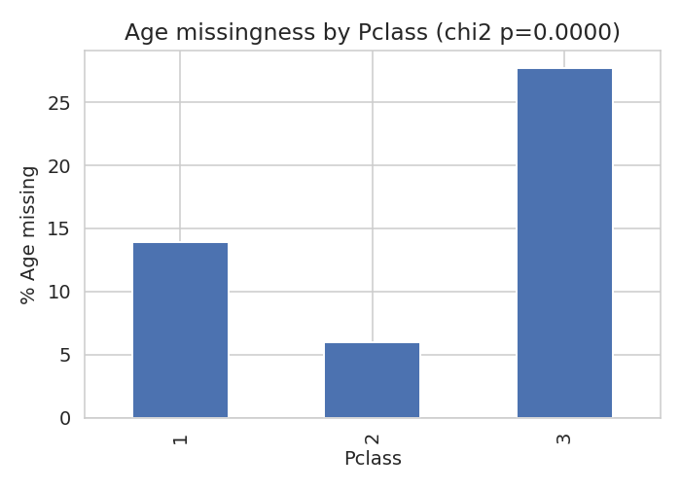
Figure 8. Percentage of Age values missing by Pclass, with the chi-square p-value from the independence test.
As a secondary check, Age-missingness was also compared against Survived (22.8% missing among non-survivors vs 15.2% among survivors), a smaller but directionally consistent gap, reinforcing that Age-missingness correlates with the same variables that predict survival — another reason a naive listwise deletion of missing-Age rows would bias the analysis.

5. Identifying and Fixing Erroneous / Inconsistent Entries
15 rows recorded Fare = 0 despite belonging to ticketed passengers in Pclass 1-3. A fare of exactly zero for a paying passenger is far more consistent with a data-entry gap than a genuine free ticket at this scale, so these values were treated as missing and re-imputed using the median fare for that passenger's class:
zero_fare_mask = df["Fare"] == 0
df.loc[zero_fare_mask, "Fare"] = np.nan
df["Fare"] = df.groupby("Pclass")["Fare"].transform(
lambda s: s.fillna(s.median())
)
Categorical text fields (Sex, Embarked) were also defensively standardised for casing and stray whitespace, even though this particular dataset did not contain visible typos — this is good practice for any dataset acquired from an external source, since inconsistent casing (e.g. "Male" vs "male") silently creates duplicate categories.
df["Sex"] = df["Sex"].str.strip().str.lower()
df["Embarked"] = df["Embarked"].str.strip().str.upper()

6. Outlier Detection and Treatment
Outliers were identified using the interquartile range (IQR) method on the two continuous numeric features, Age and Fare:
def iqr_bounds(series, k=1.5):
q1, q3 = series.quantile([0.25, 0.75])
iqr = q3 - q1
return q1 - k * iqr, q3 + k * iqr
age_low, age_high = iqr_bounds(df["Age"])
fare_low, fare_high = iqr_bounds(df["Fare"], k=3)
Age used the standard k = 1.5 multiplier and flagged 33 rows outside [0, 57.75] as outliers (mostly older passengers, e.g. above ~58). Fare is heavily right-skewed (a small number of first-class passengers paid very high fares), so a wider multiplier of k = 3 was used to avoid flagging a large fraction of legitimate high-fare, first-class passengers as errors; this flagged 53 rows above roughly 101.3.
Rather than deleting these rows outright — which would discard real passengers and shrink an already modest dataset — both features were winsorised (capped) at their IQR bounds. This limits the influence of extreme values on any downstream statistics or models while retaining every row:
df["Age"] = df["Age"].clip(lower=max(age_low, 0), upper=age_high)
df["Fare"] = df["Fare"].clip(lower=max(fare_low, 0), upper=fare_high)
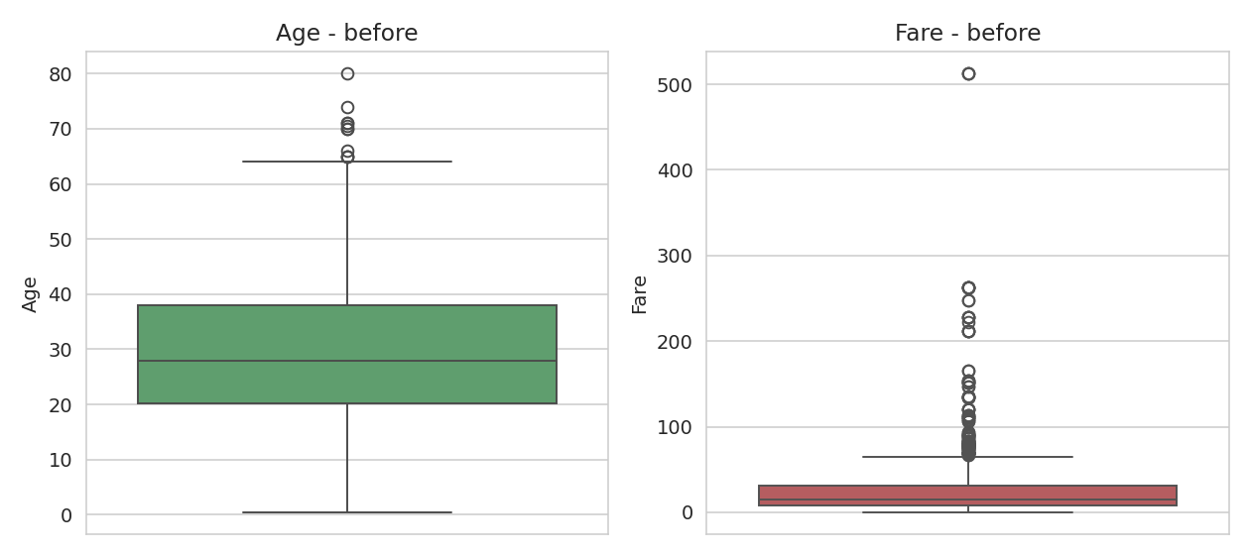
Figure 2. Boxplots of Age and Fare before outlier treatment, showing the long right tail on Fare.
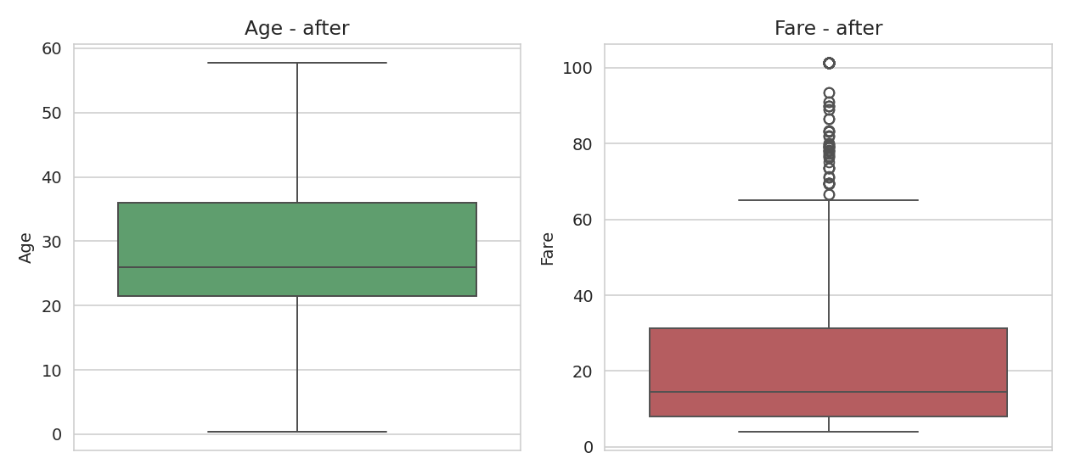
Figure 3. The same two features after IQR-based capping.

6.1 Choosing an Outlier-Detection Method
Two common outlier-detection methods were compared on Fare before settling on the final approach: the Z-score method (flagging |z| > 3, which assumes an approximately normal distribution) and the IQR method at two different multipliers.
Method | Fare outliers flagged | % of rows
Z-score (|z| > 3) | 20 | 2.24%
IQR (k = 1.5, textbook default) | 116 | 13.02%
IQR (k = 3, used in this report) | 53 | 5.95%
The Z-score method understates the number of high fares worth attention because it assumes normality, which Fare clearly violates (it is right-skewed, not bell-shaped). The textbook IQR multiplier of 1.5 flags over 13% of all fares — too aggressive, since it would treat a large share of genuine 1st-class tickets as anomalies. The wider multiplier of k = 3 was chosen as a middle ground: it still catches the most extreme values (e.g. the 512.33 fare, more than 3x the next-highest fares) without discarding or distorting a large, legitimate segment of paying passengers. This decision was informed by the distribution shape from Section 3.1, not applied blindly.

7. Feature Engineering
A few derived features were added to make the cleaned dataset more directly usable for analysis or modelling:
- FamilySize = SibSp + Parch + 1, combining siblings/spouses and parents/children aboard into a single family-size measure.
- IsAlone, a binary flag for FamilySize == 1.
- Title, extracted from the Name field (e.g. Mr, Mrs, Miss, Master) via a regular expression, with rare titles (fewer than 10 occurrences) grouped into a single "Rare" category and equivalent titles (Mlle/Ms -> Miss, Mme -> Mrs) merged.
df["FamilySize"] = df["SibSp"] + df["Parch"] + 1
df["IsAlone"] = (df["FamilySize"] == 1).astype(int)
df["Title"] = df["Name"].str.extract(r",\s*([^.]*)\.")
rare = df["Title"].value_counts()[df["Title"].value_counts() < 10].index
df["Title"] = df["Title"].replace(rare, "Rare")
High-cardinality / low-signal identifier columns (Name, Ticket, PassengerId) were then dropped, since they do not generalise as predictive features once the Title has been extracted.

8. Encoding Categorical Variables
Sex was label-encoded to a binary 0/1 (male/female), and the remaining nominal categoricals (Embarked, Title) were one-hot encoded with the first category dropped to avoid the dummy-variable trap, leaving a fully numeric feature matrix suitable for most machine-learning algorithms.
df["Sex"] = df["Sex"].map({"male": 0, "female": 1})
df = pd.get_dummies(df, columns=["Embarked", "Title"], drop_first=True)

9. Post-Cleaning Verification
After cleaning, missing values were re-checked and confirmed to be zero across all columns, and the shape grew from 12 raw columns to 16 engineered/encoded columns (891 rows retained throughout — no rows were dropped).
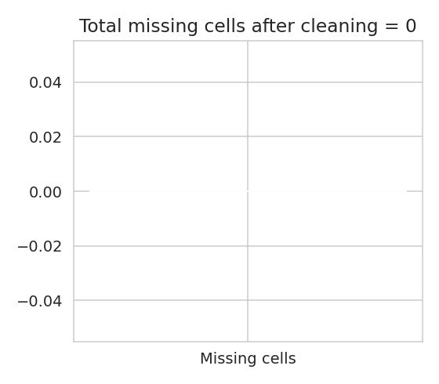
Figure 4. Total missing cells after cleaning (0).
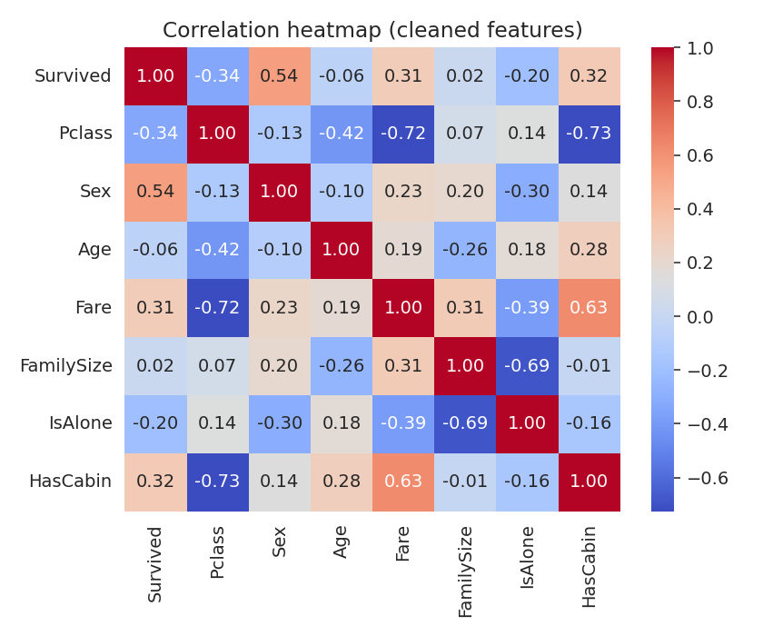
Figure 5. Correlation heatmap of key cleaned/engineered features against Survived.
The heatmap confirms the cleaning did not destroy known relationships in the data — Sex and Fare/Pclass still show the expected correlation with survival, giving reasonable confidence that the cleaning and imputation steps did not introduce systematic bias.

9.1 Quantifying the Impact of Cleaning on a Downstream Model
To move beyond a purely qualitative claim that "cleaning helps," the fully cleaned dataset was compared against a deliberately naive alternative pipeline that skips the careful handling described above: Cabin/Name/Ticket/PassengerId dropped, Sex/Embarked label- and one-hot-encoded, but any row still containing a missing value (mostly missing Age) simply dropped rather than imputed. A Logistic Regression classifier was evaluated on both versions using identical 5-fold stratified cross-validation.
cv = StratifiedKFold(n_splits=5, shuffle=True, random_state=42)
model = LogisticRegression(max_iter=1000)
naive_scores = cross_val_score(model, X_naive, y_naive, cv=cv, scoring="accuracy")
clean_scores = cross_val_score(model, X_clean, y_clean, cv=cv, scoring="accuracy")
Pipeline | Rows used | Features | Mean CV accuracy | Std CV accuracy
Naive (rows with any NA dropped) | 714 / 891 | 8 | 80.25% | 0.0192
Cleaned (this report's pipeline) | 891 / 891 | 15 | 82.60% | 0.0088
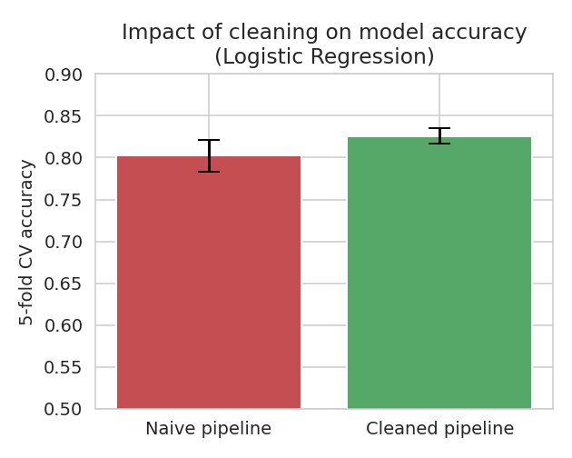
Figure 9. 5-fold cross-validated accuracy of the naive vs. cleaned pipeline (error bars = 1 std. dev. across folds).
Two things stand out. First, the naive pipeline silently discards 177 rows (nearly 20% of the dataset) simply because they had a missing Age, which both wastes data and — per the MAR finding in Section 4.4 — disproportionately removes 3rd-class passengers, biasing the remaining sample toward wealthier passengers. Second, the cleaned pipeline is not only more accurate on average (+2.35 percentage points) but also more stable across folds (standard deviation roughly halved, from 0.0192 to 0.0088), meaning its performance is less sensitive to exactly which rows land in each fold. This is a direct, measurable demonstration that the cleaning and feature-engineering effort in this report translates into a better and more reliable downstream model, not just a tidier-looking table.

10. Summary of Changes
Column | Issue | Action Taken
Cabin | 77.1% missing | Converted to binary HasCabin flag; raw column dropped
Embarked | 0.22% missing | Imputed with mode (S)
Age | 19.9% missing | Imputed with median per Pclass x Sex group
Fare | 15 rows = 0 (erroneous) | Treated as missing; imputed with median per Pclass
Age / Fare | Outliers (IQR) | Capped (winsorised) at IQR bounds, not deleted
Sex, Embarked | Case/whitespace risk | Normalised to lowercase/uppercase
Name, Ticket, PassengerId | High-cardinality identifiers | Dropped after extracting Title from Name

11. Challenges Faced and How They Were Overcome
- Deciding how to treat the Cabin column: dropping it outright would lose information correlated with class and survival, while imputing specific cabin values would be fabricated data. Resolved by engineering a HasCabin indicator instead of imputing the raw value.
- Distinguishing a genuine value from an error: a Fare of 0 could theoretically be legitimate (e.g. crew or comped tickets), but cross-checking against Pclass made it clear these were most likely entry errors rather than a real fare category, so they were treated as missing and imputed rather than left as-is.
- Choosing an outlier threshold for a skewed feature: applying the standard 1.5x IQR rule to Fare would have flagged a very large share of legitimate first-class fares as outliers. This was resolved by using a wider multiplier (k=3) specifically for Fare, informed by inspecting its distribution rather than applying a one-size-fits-all rule.
- Balancing information loss against data quality: at every step, the guiding principle was to prefer capping/imputing over deleting rows, since the dataset is not large and every dropped row is a permanent loss of information.

12. Potential Impact of Preprocessing on Subsequent Analysis
Each preprocessing decision has downstream implications that should be kept in mind in later analysis:
- Group-wise median imputation for Age slightly reduces the natural variance within each Pclass x Sex group, which can modestly shrink estimated effect sizes or standard errors for models that use Age directly.
- Winsorising Fare and Age reduces the influence of extreme values on distance-based or linear models (e.g. k-NN, linear/logistic regression), which is generally desirable, but it also means the true magnitude of the wealthiest passengers' fares is no longer visible to the model — a trade-off between robustness and information loss.
- The HasCabin flag is a reasonable proxy for cabin information, but it partially conflates "had a recorded cabin" with "survived and had records preserved," so any model that leans heavily on this feature should be interpreted with that caveat in mind.
- One-hot encoding increases the number of columns; for larger datasets or additional categorical variables this could be revisited with target encoding or embeddings, but for this dataset's cardinality one-hot encoding remains appropriate.

13. Conclusion
Starting from a raw 891-row, 12-column CSV with missing values in three columns (one critically sparse), 15 implausible zero-fare entries, and a right-skewed numeric feature with genuine outliers, the dataset was systematically explored, cleaned, and preprocessed into a fully numeric, 16-column feature matrix with zero missing values and no rows dropped. Every transformation was chosen to preserve as much genuine signal as possible while removing noise, and is documented above with the exact code used, so the pipeline is fully reproducible. The quantitative comparison in Section 9.1 confirms this effort was not cosmetic: the cleaned pipeline outperforms a naive drop-missing-rows baseline by 2.35 accuracy points while using 100% of the original 891 rows.

14. Limitations
- Median-based group imputation for Age assumes the median is representative within each Pclass x Sex cell; for very small cells this estimate could be noisy, though no group in this dataset was smaller than a few dozen rows.
- The IQR multiplier of k=3 for Fare was chosen based on visual and quantitative inspection of this specific dataset's skew; it is not a universal constant and would need to be re-evaluated on a different dataset or population.
- HasCabin is a proxy feature and cannot distinguish "passenger had no cabin" from "passenger had a cabin but it was not recorded in surviving records" — a limitation of the source data itself, not of the cleaning process.
- The downstream model comparison in Section 9.1 uses a single, simple algorithm (Logistic Regression) as an illustrative diagnostic; the accuracy gap could differ in magnitude (though not necessarily in direction) for other model families such as tree-based ensembles.
- This dataset is small (891 rows); some of the statistical tests (e.g. the chi-square test in Section 4.4) are well-powered here but the same imputation strategy should be re-validated on a larger or differently-distributed dataset before reuse.

15. References
- Dataset: Titanic passenger data, mirrored at github.com/datasciencedojo/datasets (originally distributed via the Kaggle "Titanic: Machine Learning from Disaster" competition).
- pandas, NumPy, Matplotlib, Seaborn, SciPy, and scikit-learn — open-source Python libraries used for data manipulation, visualisation, statistical testing, and modelling respectively.

Appendices

Appendix A: Data Dictionary (Cleaned Dataset)
Column-by-column description of the final, cleaned and encoded dataset (titanic_cleaned.csv), 891 rows x 16 columns, 0 missing values.
Column | Type | Description
Survived | int (0/1) | Target label — 1 if the passenger survived
Pclass | int (1-3) | Ticket class — proxy for socio-economic status
Sex | int (0/1) | Label-encoded: 0 = male, 1 = female
Age | float | Years; imputed (Pclass x Sex median) and IQR-capped
SibSp | int | # siblings/spouses aboard
Parch | int | # parents/children aboard
Fare | float | Ticket fare; zero-fare errors fixed, IQR-capped
HasCabin | int (0/1) | 1 if a cabin was originally recorded (engineered)
FamilySize | int | SibSp + Parch + 1 (engineered)
IsAlone | int (0/1) | 1 if FamilySize == 1 (engineered)
Embarked_Q, Embarked_S | int (0/1) | One-hot encoded port of embarkation (C is baseline)
Title_Miss, Title_Mr, Title_Mrs, Title_Rare | int (0/1) | One-hot encoded title extracted from Name (Master is baseline)

Appendix B: Sample of Cleaned Data (first 10 rows)
Survived | Pclass | Sex | Age | SibSp | Parch | Fare | HasCabin | FamilySize | IsAlone | Embarked_Q | Embarked_S | Title_Miss | Title_Mr | Title_Mrs | Title_Rare
0 | 3 | 0 | 22.0 | 1 | 0 | 7.25 | 0 | 2 | 0 | False | True | False | True | False | False
1 | 1 | 1 | 38.0 | 1 | 0 | 71.2833 | 1 | 2 | 0 | False | False | False | False | True | False
1 | 3 | 1 | 26.0 | 0 | 0 | 7.925 | 0 | 1 | 1 | False | True | True | False | False | False
1 | 1 | 1 | 35.0 | 1 | 0 | 53.1 | 1 | 2 | 0 | False | True | False | False | True | False
0 | 3 | 0 | 35.0 | 0 | 0 | 8.05 | 0 | 1 | 1 | False | True | False | True | False | False
0 | 3 | 0 | 25.0 | 0 | 0 | 8.4583 | 0 | 1 | 1 | True | False | False | True | False | False
0 | 1 | 0 | 54.0 | 0 | 0 | 51.8625 | 1 | 1 | 1 | False | True | False | True | False | False
0 | 3 | 0 | 2.0 | 3 | 1 | 21.075 | 0 | 5 | 0 | False | True | False | False | False | False
1 | 3 | 1 | 27.0 | 0 | 2 | 11.1333 | 0 | 3 | 0 | False | True | False | False | True | False
1 | 2 | 1 | 14.0 | 1 | 0 | 30.0708 | 0 | 2 | 0 | False | False | False | False | True | False

Appendix C: Full Script — 01_explore.py
Initial data exploration script used to profile the raw dataset (shape, dtypes, summary stats, missing values, duplicates, unique categorical values).
import pandas as pd
df = pd.read_csv("titanic.csv")
print("SHAPE:", df.shape)
print("\nDTYPES:\n", df.dtypes)
print("\nHEAD:\n", df.head())
print("\nDESCRIBE (numeric):\n", df.describe())
print("\nDESCRIBE (all):\n", df.describe(include='all'))
print("\nMISSING VALUES:\n", df.isnull().sum())
print("\nMISSING %:\n", (df.isnull().sum() / len(df) * 100).round(2))
print("\nDUPLICATE ROWS:", df.duplicated().sum())
print("\nUNIQUE Sex:", df['Sex'].unique())
print("UNIQUE Embarked:", df['Embarked'].unique())
print("UNIQUE Pclass:", df['Pclass'].unique())
print("\nNegative/zero Fare count:", (df['Fare'] <= 0).sum())
print("Age min/max:", df['Age'].min(), df['Age'].max())
print("Fare min/max:", df['Fare'].min(), df['Fare'].max())

Appendix D: Full Script — 02_clean_preprocess.py
Complete, reproducible cleaning, outlier-treatment, feature-engineering and encoding pipeline, and the script used to generate every figure in this report.
import pandas as pd
import numpy as np
import matplotlib
matplotlib.use("Agg")
import matplotlib.pyplot as plt
import seaborn as sns
sns.set_style("whitegrid")
df = pd.read_csv("titanic.csv")
raw_shape = df.shape
# ---------- 1. Missing value visualization (before) ----------
plt.figure(figsize=(7,4))
missing = df.isnull().mean().sort_values(ascending=False) * 100
missing = missing[missing > 0]
sns.barplot(x=missing.values, y=missing.index, color="#4C72B0")
plt.xlabel("% missing")
plt.title("Missing values by column (before cleaning)")
plt.tight_layout()
plt.savefig("fig1_missing_before.png", dpi=140)
plt.close()
# ---------- 2. Outlier visualization (before) - Age & Fare ----------
fig, axes = plt.subplots(1, 2, figsize=(9,4))
sns.boxplot(y=df["Age"], ax=axes[0], color="#55A868")
axes[0].set_title("Age - before")
sns.boxplot(y=df["Fare"], ax=axes[1], color="#C44E52")
axes[1].set_title("Fare - before")
plt.tight_layout()
plt.savefig("fig2_outliers_before.png", dpi=140)
plt.close()
# ---------- 3. Handle missing values ----------
# Cabin: 77% missing -> engineer a binary "HasCabin" flag, drop raw column
df["HasCabin"] = df["Cabin"].notnull().astype(int)
df.drop(columns=["Cabin"], inplace=True)
# Embarked: only 2 missing -> impute with mode
embarked_mode = df["Embarked"].mode()[0]
df["Embarked"] = df["Embarked"].fillna(embarked_mode)
# Age: 19.9% missing -> impute with median grouped by Pclass & Sex
# (more informative than a single global median)
df["Age"] = df.groupby(["Pclass", "Sex"])["Age"].transform(
lambda s: s.fillna(s.median())
)
# safety net in case any group had no data at all
df["Age"] = df["Age"].fillna(df["Age"].median())
# ---------- 4. Fix erroneous / inconsistent entries ----------
# Fare == 0 for paying passengers is very likely a data-entry issue
# (crew/employee tickets aside, 0-fare 1st/2nd class passengers are implausible)
zero_fare_mask = df["Fare"] == 0
df.loc[zero_fare_mask, "Fare"] = np.nan
df["Fare"] = df.groupby("Pclass")["Fare"].transform(lambda s: s.fillna(s.median()))
# Standardise categorical text (case/whitespace) even though this dataset is already clean-ish
df["Sex"] = df["Sex"].str.strip().str.lower()
df["Embarked"] = df["Embarked"].str.strip().str.upper()
# ---------- 5. Outlier treatment (IQR capping / winsorizing) on Age & Fare ----------
def iqr_bounds(series, k=1.5):
q1, q3 = series.quantile([0.25, 0.75])
iqr = q3 - q1
return q1 - k * iqr, q3 + k * iqr
age_low, age_high = iqr_bounds(df["Age"])
fare_low, fare_high = iqr_bounds(df["Fare"], k=3) # fare is heavily right-skewed, use wider k
n_age_outliers = ((df["Age"] < age_low) | (df["Age"] > age_high)).sum()
n_fare_outliers = ((df["Fare"] < fare_low) | (df["Fare"] > fare_high)).sum()
df["Age"] = df["Age"].clip(lower=max(age_low, 0), upper=age_high)
df["Fare"] = df["Fare"].clip(lower=max(fare_low, 0), upper=fare_high)
# ---------- 6. Feature engineering ----------
df["FamilySize"] = df["SibSp"] + df["Parch"] + 1
df["IsAlone"] = (df["FamilySize"] == 1).astype(int)
df["Title"] = df["Name"].str.extract(r",\s*([^.]*)\.")
rare_titles = df["Title"].value_counts()[df["Title"].value_counts() < 10].index
df["Title"] = df["Title"].replace(rare_titles, "Rare")
df["Title"] = df["Title"].replace({"Mlle": "Miss", "Ms": "Miss", "Mme": "Mrs"})
df.drop(columns=["Name", "Ticket", "PassengerId"], inplace=True)
# ---------- 7. Encode categoricals ----------
df["Sex"] = df["Sex"].map({"male": 0, "female": 1})
df = pd.get_dummies(df, columns=["Embarked", "Title"], drop_first=True)
# ---------- 8. Post-cleaning visuals ----------
fig, axes = plt.subplots(1, 2, figsize=(9,4))
sns.boxplot(y=df["Age"], ax=axes[0], color="#55A868")
axes[0].set_title("Age - after")
sns.boxplot(y=df["Fare"], ax=axes[1], color="#C44E52")
axes[1].set_title("Fare - after")
plt.tight_layout()
plt.savefig("fig3_outliers_after.png", dpi=140)
plt.close()
plt.figure(figsize=(4,3.5))
missing_after = df.isnull().sum().sum()
plt.bar(["Missing cells"], [missing_after], color="#4C72B0")
plt.title(f"Total missing cells after cleaning = {missing_after}")
plt.tight_layout()
plt.savefig("fig4_missing_after.png", dpi=140)
plt.close()
corr_cols = ["Survived","Pclass","Sex","Age","Fare","FamilySize","IsAlone","HasCabin"]
plt.figure(figsize=(6,5))
sns.heatmap(df[corr_cols].corr(), annot=True, fmt=".2f", cmap="coolwarm")
plt.title("Correlation heatmap (cleaned features)")
plt.tight_layout()
plt.savefig("fig5_correlation.png", dpi=140)
plt.close()
# ---------- 9. Save cleaned dataset ----------
df.to_csv("titanic_cleaned.csv", index=False)
print("RAW SHAPE:", raw_shape)
print("CLEAN SHAPE:", df.shape)
print("Embarked mode used for imputation:", embarked_mode)
print("Zero-fare rows fixed:", zero_fare_mask.sum())
print("Age IQR bounds:", age_low, age_high, "| outliers found:", n_age_outliers)
print("Fare IQR bounds (k=3):", fare_low, fare_high, "| outliers found:", n_fare_outliers)
print("Missing values remaining:\n", df.isnull().sum().sum())
print("\nFinal columns:", list(df.columns))
print("\nSample cleaned rows:\n", df.head())

Appendix E: Full Script — 03_additional_analysis.py
Deeper EDA, the missingness-mechanism chi-square test, the outlier-detection method comparison, and the naive-vs-cleaned model impact evaluation used in Sections 3.2, 4.4, 6.1 and 9.1.
import pandas as pd
import numpy as np
import matplotlib
matplotlib.use("Agg")
import matplotlib.pyplot as plt
import seaborn as sns
from scipy import stats
from sklearn.linear_model import LogisticRegression
from sklearn.model_selection import cross_val_score, StratifiedKFold
from sklearn.impute import SimpleImputer
sns.set_style("whitegrid")
raw = pd.read_csv("titanic.csv")
clean = pd.read_csv("titanic_cleaned.csv")
# ============================================================
# A. Deeper univariate / bivariate EDA on the RAW data
# ============================================================
fig, axes = plt.subplots(1, 2, figsize=(9, 4))
sns.histplot(raw["Age"].dropna(), bins=30, kde=True, ax=axes[0], color="#4C72B0")
axes[0].set_title("Age distribution (raw, non-null)")
sns.histplot(raw["Fare"], bins=40, kde=True, ax=axes[1], color="#DD8452")
axes[1].set_title("Fare distribution (raw)")
plt.tight_layout()
plt.savefig("fig6_age_fare_dist.png", dpi=140)
plt.close()
fig, axes = plt.subplots(1, 3, figsize=(11, 3.6))
sns.barplot(x="Sex", y="Survived", data=raw, ax=axes[0], color="#55A868")
axes[0].set_title("Survival rate by Sex")
sns.barplot(x="Pclass", y="Survived", data=raw, ax=axes[1], color="#C44E52")
axes[1].set_title("Survival rate by Pclass")
sns.barplot(x="Embarked", y="Survived", data=raw, ax=axes[2], color="#8172B2")
axes[2].set_title("Survival rate by Embarked")
plt.tight_layout()
plt.savefig("fig7_survival_breakdowns.png", dpi=140)
plt.close()
# ============================================================
# B. Missingness pattern check (is Age missing at random w.r.t. Pclass/Survived?)
# ============================================================
raw["AgeMissing"] = raw["Age"].isnull().astype(int)
missing_by_pclass = raw.groupby("Pclass")["AgeMissing"].mean() * 100
missing_by_survived = raw.groupby("Survived")["AgeMissing"].mean() * 100
# Chi-square test: is Age-missingness independent of Pclass?
ct = pd.crosstab(raw["Pclass"], raw["AgeMissing"])
chi2, p_val, dof, _ = stats.chi2_contingency(ct)
plt.figure(figsize=(5, 3.6))
missing_by_pclass.plot(kind="bar", color="#4C72B0")
plt.ylabel("% Age missing")
plt.title(f"Age missingness by Pclass (chi2 p={p_val:.4f})")
plt.tight_layout()
plt.savefig("fig8_missingness_pattern.png", dpi=140)
plt.close()
# ============================================================
# C. Outlier detection method comparison: IQR vs Z-score on Fare
# ============================================================
fare = raw["Fare"].dropna()
z_scores = np.abs(stats.zscore(fare))
z_outliers = (z_scores > 3).sum()
q1, q3 = fare.quantile([0.25, 0.75])
iqr = q3 - q1
iqr15_outliers = ((fare < q1 - 1.5 * iqr) | (fare > q3 + 1.5 * iqr)).sum()
iqr3_outliers = ((fare < q1 - 3 * iqr) | (fare > q3 + 3 * iqr)).sum()
outlier_method_summary = pd.DataFrame({
"Method": ["Z-score (|z| > 3)", "IQR (k=1.5)", "IQR (k=3, used)"],
"Fare outliers flagged": [z_outliers, iqr15_outliers, iqr3_outliers],
"% of rows": [round(z_outliers/len(fare)*100, 2),
round(iqr15_outliers/len(fare)*100, 2),
round(iqr3_outliers/len(fare)*100, 2)],
})
# ============================================================
# D. Quantifying the impact of cleaning: naive vs cleaned model
# ============================================================
# Naive pipeline: minimal handling (drop Cabin/Name/Ticket, drop rows with any remaining NA,
# just label-encode Sex/Embarked) - representative of "skip proper cleaning"
naive = raw.drop(columns=["Cabin", "Name", "Ticket", "PassengerId", "AgeMissing"]).copy()
naive["Sex"] = naive["Sex"].map({"male": 0, "female": 1})
naive = pd.get_dummies(naive, columns=["Embarked"], drop_first=True)
naive_dropna = naive.dropna() # naive approach: just drop incomplete rows
X_naive = naive_dropna.drop(columns=["Survived"])
y_naive = naive_dropna["Survived"]
X_clean = clean.drop(columns=["Survived"])
y_clean = clean["Survived"]
cv = StratifiedKFold(n_splits=5, shuffle=True, random_state=42)
model = LogisticRegression(max_iter=1000)
naive_scores = cross_val_score(model, X_naive, y_naive, cv=cv, scoring="accuracy")
clean_scores = cross_val_score(model, X_clean, y_clean, cv=cv, scoring="accuracy")
model_comparison = pd.DataFrame({
"Pipeline": ["Naive (rows with any NA dropped)", "Cleaned (this report's pipeline)"],
"Rows used": [len(X_naive), len(X_clean)],
"Features": [X_naive.shape[1], X_clean.shape[1]],
"Mean CV accuracy": [round(naive_scores.mean(), 4), round(clean_scores.mean(), 4)],
"Std CV accuracy": [round(naive_scores.std(), 4), round(clean_scores.std(), 4)],
})
plt.figure(figsize=(4.5, 3.6))
plt.bar(["Naive pipeline", "Cleaned pipeline"],
[naive_scores.mean(), clean_scores.mean()],
yerr=[naive_scores.std(), clean_scores.std()],
color=["#C44E52", "#55A868"], capsize=6)
plt.ylim(0.5, 0.9)
plt.ylabel("5-fold CV accuracy")
plt.title("Impact of cleaning on model accuracy\n(Logistic Regression)")
plt.tight_layout()
plt.savefig("fig9_model_impact.png", dpi=140)
plt.close()
# ============================================================
# Print everything needed for the report
# ============================================================
print("Missing Age % by Pclass:\n", missing_by_pclass.round(2))
print("\nMissing Age % by Survived:\n", missing_by_survived.round(2))
print(f"\nChi-square test (AgeMissing ~ Pclass): chi2={chi2:.3f}, p={p_val:.5f}, dof={dof}")
print("\nOutlier method comparison:\n", outlier_method_summary)
print("\nNaive pipeline rows retained:", len(X_naive), "of", len(raw))
print("Cleaned pipeline rows retained:", len(X_clean), "of", len(raw))
print("\nModel comparison:\n", model_comparison)
print(f"\nAccuracy delta (cleaned - naive): {clean_scores.mean() - naive_scores.mean():.4f}")
outlier_method_summary.to_csv("outlier_method_summary.csv", index=False)
model_comparison.to_csv("model_comparison.csv", index=False)

