Exploratory Data Analysis and Visualization
Week 2 Task Report
Dataset: Titanic — Machine Learning from Disaster (public, Kaggle-mirrored); cleaned dataset carried over from Week 1

Contents

1. Objective
This report performs a structured exploratory data analysis (EDA) on the Titanic passenger dataset using Pandas, Matplotlib, and Seaborn, with the goal of extracting meaningful, well-supported insights about who survived the disaster and why. It builds directly on the Week 1 report: the same dataset is used, already cleaned (zero missing values, outliers capped, categorical variables encoded), so this week's effort is focused entirely on analysis and visualization rather than data quality.

1.1 Executive Summary
Across 891 passengers, the overall survival rate was 38.4%. Univariate analysis shows the dataset is dominated by 3rd-class (55%), male (65%) passengers who mostly boarded at Southampton (72%). Bivariate analysis reveals three consistent, strong drivers of survival: Sex (women survived at roughly 74% vs 19% for men), Passenger Class (1st class 63% vs 3rd class 24%), and, to a smaller extent, port of embarkation and fare paid. Multivariate analysis shows these effects compound rather than cancel out — a 1st-class woman had a 97% survival rate, while a 3rd-class man had only 14% — and that within every class, children had a meaningfully higher survival rate than adults, consistent with a "women and children first" evacuation pattern. Thirteen annotated visualizations and two aggregation tables support these findings, each interpreted below with a discussion of the likely underlying cause.

2. Dataset and Approach
The analysis uses titanic_cleaned.csv, the fully cleaned and encoded dataset produced in the Week 1 report (891 rows, 0 missing values, outliers capped via IQR, categorical variables one-hot/label encoded). For readability in charts, a working copy re-attaches human-readable labels (e.g. "Male"/"Female" instead of 0/1, port names instead of one-hot columns) without altering any underlying value.
df = clean.copy()
df["Sex_label"] = df["Sex"].map({0: "Male", 1: "Female"})
df["Embarked_label"] = np.select(
[df["Embarked_Q"] == 1, df["Embarked_S"] == 1],
["Queenstown", "Southampton"],
default="Cherbourg",
)
df["Survived_label"] = df["Survived"].map({0: "Died", 1: "Survived"})
Two additional derived groupings were created specifically to support this week's analysis: AgeGroup (5 bins: Child, Teen, Adult, Middle Age, Senior) and FareBand (quartile-based: Low/Medium/High/Very High), used throughout the bivariate section below.
df["AgeGroup"] = pd.cut(
df["Age"], bins=[0, 12, 18, 35, 60, 100],
labels=["Child (0-12)", "Teen (13-18)", "Adult (19-35)", "Middle Age (36-60)", "Senior (60+)"]
)
df["FareBand"] = pd.qcut(df["Fare"], 4, labels=["Low", "Medium", "High", "Very High"])

3. Initial Analysis — Basic Statistics
Summary statistics were reviewed first to ground the rest of the analysis in concrete numbers.
print(df[["Age", "Fare", "FamilySize", "Pclass"]].describe().round(2))
print("Survival rate overall: {:.1f}%".format(df["Survived"].mean() * 100))
Statistic | Age | Fare | FamilySize
Mean | 28.89 | 27.59 | 1.90
Std Dev | 12.73 | 27.45 | 1.61
Min | 0.42 | 4.01 | 1
25% | 21.50 | 7.92 | 1
Median | 26.00 | 14.50 | 1
75% | 36.00 | 31.28 | 2
Max (capped) | 57.75 | 101.32 | 11
Overall survival rate: 38.4% (342 of 891 passengers). Passenger composition: 55% travelled 3rd class, 65% were male, and 72% boarded at Southampton — none of these splits are balanced, which matters when interpreting later group comparisons (e.g. a small group's survival rate is statistically noisier than a large group's).

4. Univariate Analysis
Univariate analysis looks at each variable in isolation, to understand the shape of the data before relating variables to one another.
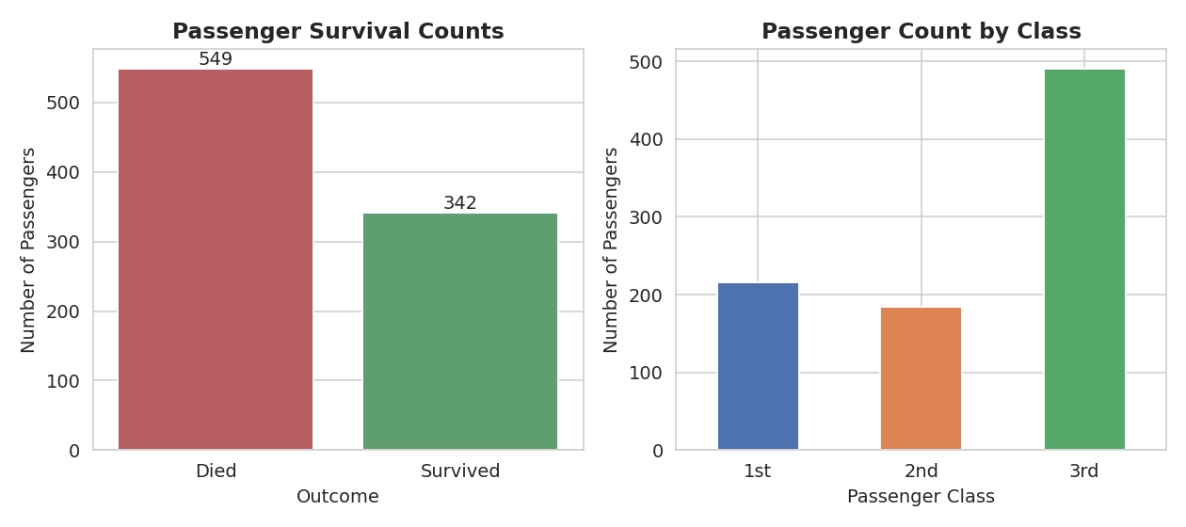
Figure 1. Survival counts (left) and passenger counts by class (right).
Interpretation: more passengers died (549) than survived (342), consistent with the historical death toll of the disaster. 3rd class was the largest group by a wide margin (491 passengers, 55% of the total) — a fact that will matter when Section 5 shows 3rd class also had the lowest survival rate, since it means the majority of passengers were in the group least likely to survive.
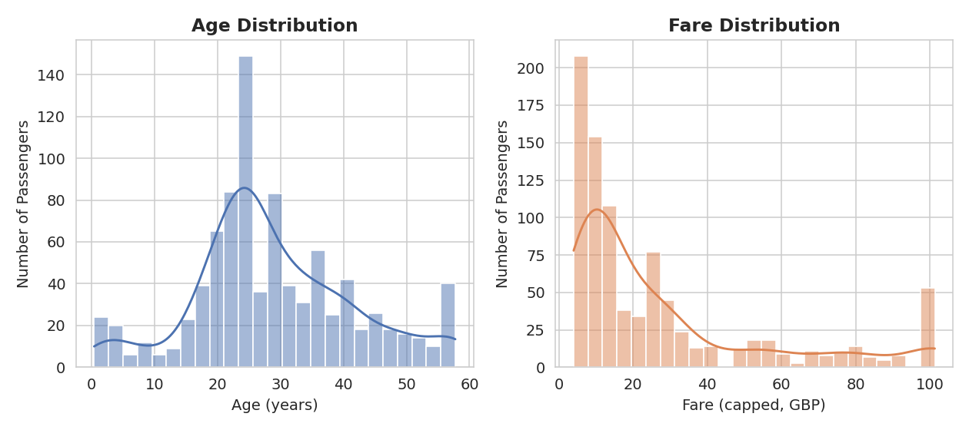
Figure 2. Distribution of Age (left) and Fare (right).
Interpretation: Age is unimodal and roughly bell-shaped, centered in the 20s-30s, with a visible secondary bump for young children. Fare is heavily right-skewed even after Week 1's outlier capping — most tickets cost under 30, with a long tail of more expensive 1st-class fares, which is expected given how ticket pricing scaled with cabin class and amenities.
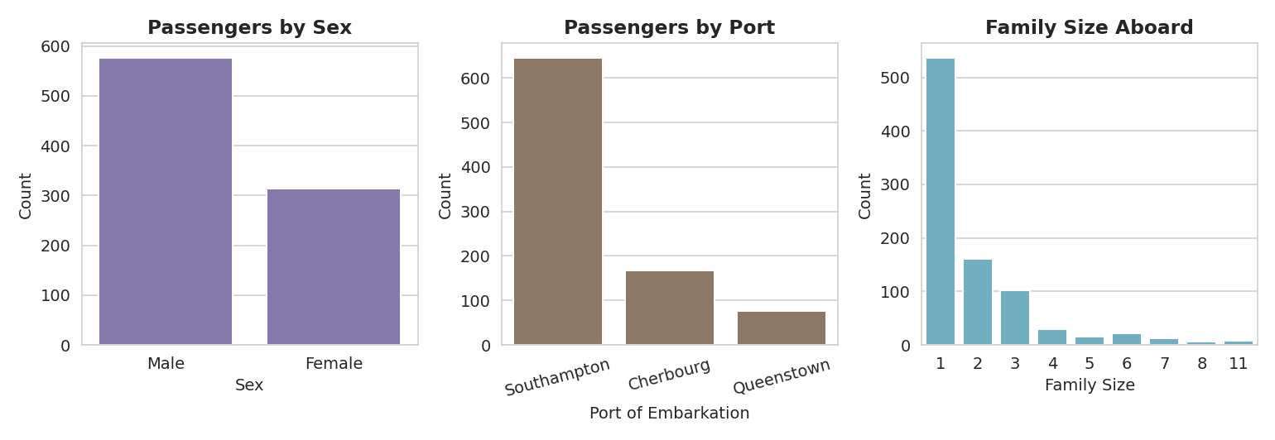
Figure 3. Passenger counts by Sex (left), Port of Embarkation (middle), and Family Size (right).
Interpretation: the ship carried nearly twice as many men as women (577 vs 314). The large majority boarded at Southampton, the ship's origin port, with far fewer joining at Cherbourg and Queenstown. Most passengers (over 500) travelled alone (FamilySize = 1); larger families (5+) were rare, which will limit how much can be concluded about very large families in Section 6.

5. Bivariate Analysis — Relationship with Survival
This section relates each variable to the target outcome, Survived, to identify which factors were actually associated with a passenger's chances.

5.1 Sex and Passenger Class
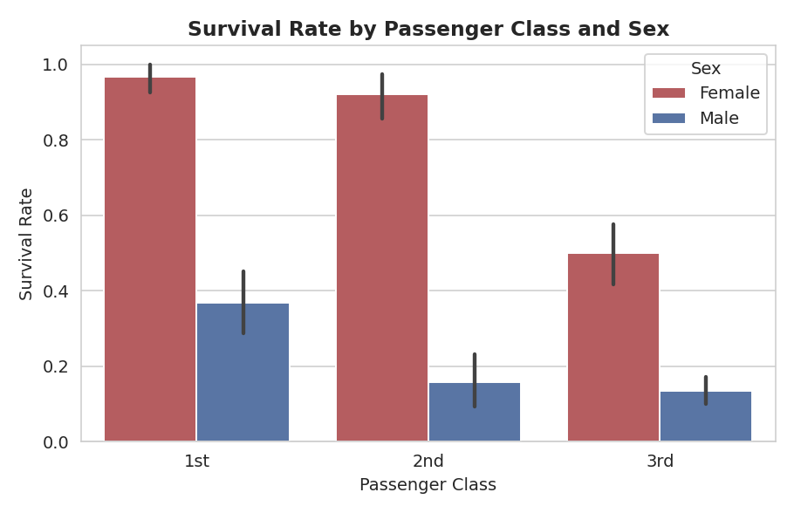
Figure 4. Survival rate by Passenger Class and Sex, with 95% confidence interval error bars.
This is the single strongest pattern in the dataset. Within every class, women survived at a dramatically higher rate than men — 97% vs 37% in 1st class, 92% vs 16% in 2nd class, and 50% vs 14% in 3rd class. This is strong visual evidence of a "women and children first" evacuation protocol, and it holds consistently across all three classes rather than being an artifact of one group.

5.2 Age
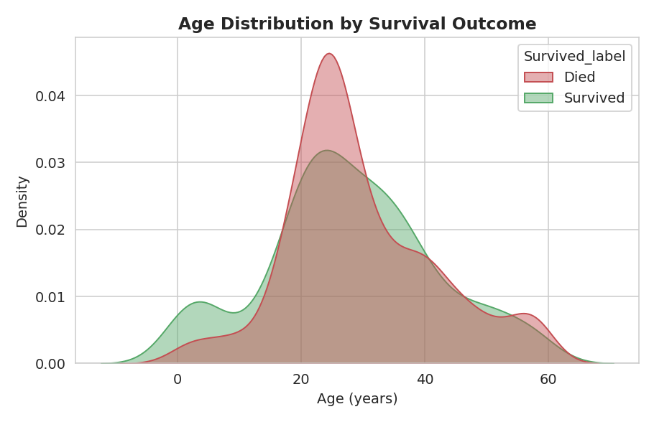
Figure 5. Age distribution (density) split by survival outcome.
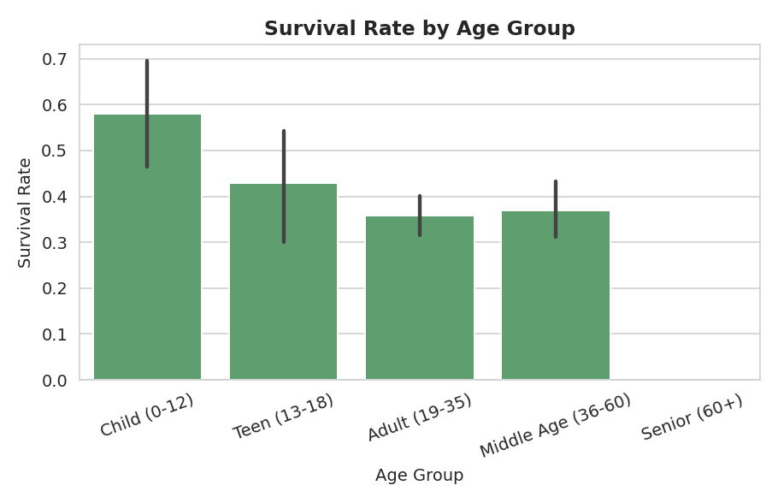
Figure 6. Survival rate by age group.
Interpretation: the density plot shows survivors skew slightly younger than non-survivors, and the age-group bar chart makes this concrete — children (0-12) had a distinctly higher survival rate than teens, adults, or middle-aged passengers, again consistent with a priority-boarding policy for children. Note that no "Senior (60+)" passengers appear: Week 1's outlier-capping step (Section 6 of the Week 1 report) capped Age at 57.75 to control the influence of extreme values, which removed the small number of elderly passengers from this particular grouped view — a direct, visible consequence of last week's preprocessing choice that is worth keeping in mind when generalizing this finding.

5.3 Fare
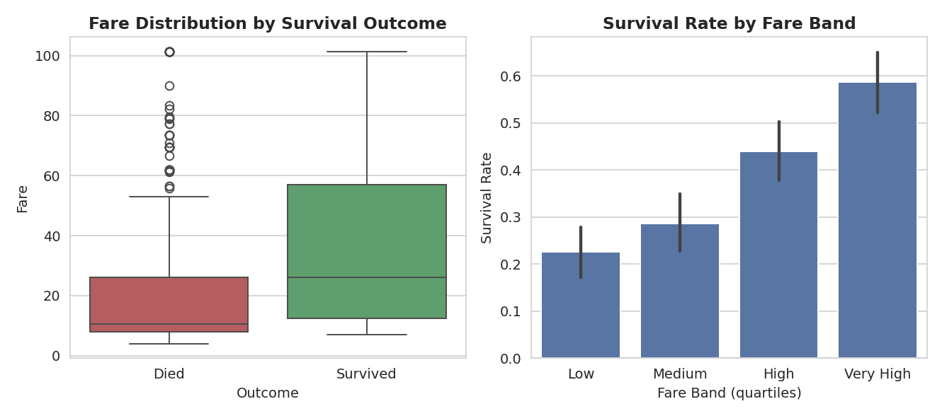
Figure 7. Fare distribution by outcome (left) and survival rate by fare quartile (right).
Interpretation: survivors paid a noticeably higher median fare than non-survivors, and survival rate rises steadily from the "Low" fare quartile to the "Very High" quartile. Since fare is closely tied to passenger class (Section 8 correlation heatmap confirms a strong negative correlation between Fare and Pclass), this is largely the same class effect seen in Section 5.1, viewed through a different variable rather than a fully independent cause.

5.4 Family Size
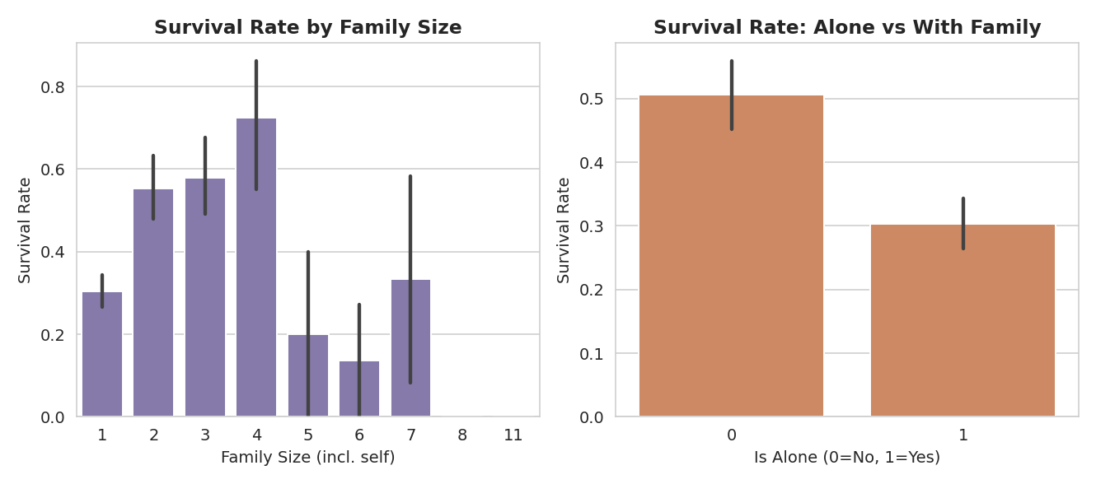
Figure 8. Survival rate by family size (left) and by travelling alone vs. with family (right).
Interpretation: passengers with a small family (2-4 total members) survived at a higher rate than those travelling completely alone or in very large families (6+). A plausible explanation is that solo travellers were disproportionately young men in 3rd class (already a lower-survival group), while very large families may have struggled to stay together and reach lifeboats in time; small families, by contrast, may have been better able to coordinate without being overwhelmed by size.

5.5 Port of Embarkation and Title
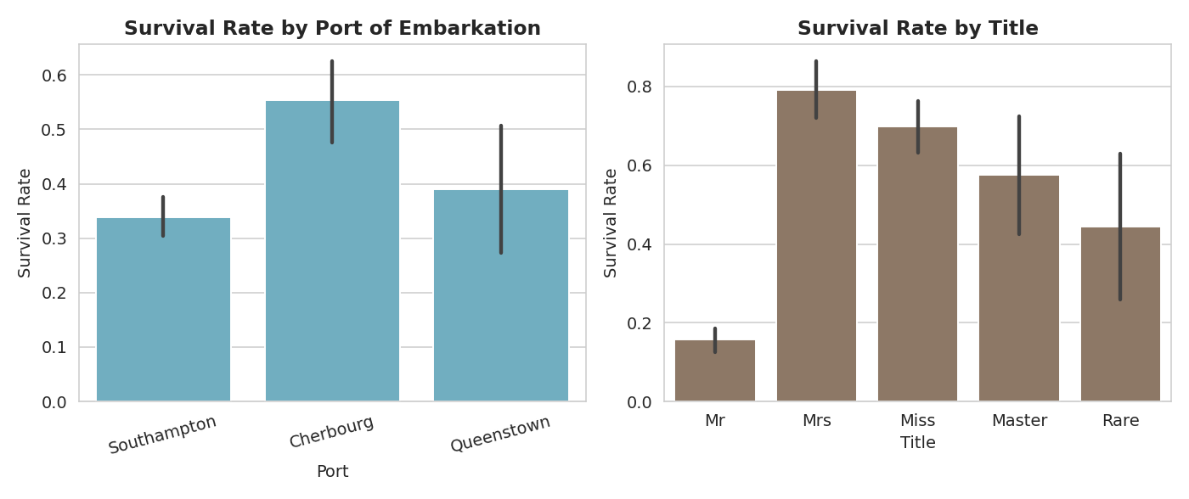
Figure 9. Survival rate by port of embarkation (left) and by title extracted from passenger name (right).
Interpretation: Cherbourg passengers had the highest survival rate (55%) of the three ports — the groupby aggregation in Section 7 shows this port also had by far the highest share of 1st-class passengers (50.6%, vs under 20% for the other two ports) and the highest average fare, so this is best explained as a class effect rather than the port itself having any causal influence. The title breakdown mirrors the Sex finding directly: "Mrs" and "Miss" (female titles) show high survival, "Mr" (adult male) shows the lowest, and "Master" (young boys) sits well above "Mr", again reflecting the age and sex effects already identified.

6. Data Transformations and Aggregations
Two groupby aggregations were computed to quantify patterns that the charts above show visually.
agg1 = df.groupby(["Pclass", "Sex_label"]).agg(
Passengers=("Survived", "size"),
SurvivalRate=("Survived", "mean"),
AvgAge=("Age", "mean"),
AvgFare=("Fare", "mean"),
).round(2)
Pclass | Sex | Passengers | Survival Rate | Avg Age | Avg Fare
1 | Female | 94 | 0.97 | 34.52 | 78.00
1 | Male | 122 | 0.37 | 40.18 | 54.21
2 | Female | 76 | 0.92 | 28.70 | 21.97
2 | Male | 108 | 0.16 | 30.42 | 20.58
3 | Female | 144 | 0.50 | 21.64 | 16.12
3 | Male | 347 | 0.14 | 25.98 | 12.75
This table is the clearest single summary in the report: survival rate ranges from a low of 14% (3rd-class men) to a high of 97% (1st-class women) — a 7x difference driven almost entirely by the combination of two variables.
agg2 = df.groupby("Embarked_label").agg(
Passengers=("Survived", "size"),
SurvivalRate=("Survived", "mean"),
AvgFare=("Fare", "mean"),
Pct1stClass=("Pclass", lambda s: (s == 1).mean() * 100),
).round(2)
Port | Passengers | Survival Rate | Avg Fare | % 1st Class
Cherbourg | 168 | 0.55 | 43.36 | 50.60%
Queenstown | 77 | 0.39 | 13.28 | 2.60%
Southampton | 646 | 0.34 | 25.20 | 19.97%
This table supports the interpretation in Section 5.5: Cherbourg's high survival rate lines up almost perfectly with its high share of 1st-class passengers, rather than suggesting anything special about the port itself.

7. Multivariate Analysis
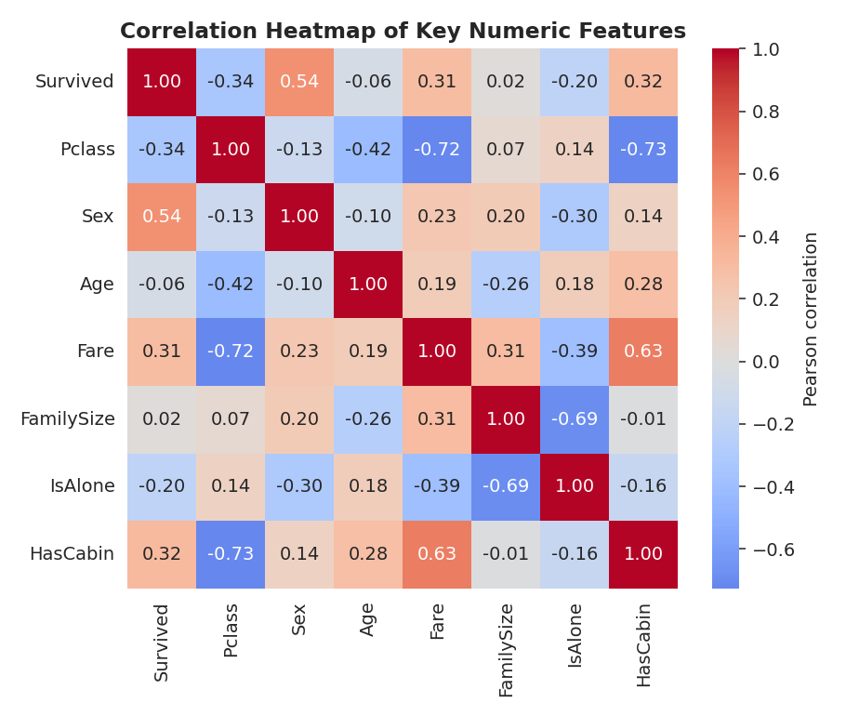
Figure 10. Correlation heatmap of key numeric features.
Interpretation: Sex shows the strongest correlation with Survived (0.54), followed by Fare (0.31, positive) and Pclass (-0.34, negative — recall higher Pclass number means a lower/cheaper class). Fare and Pclass are strongly negatively correlated (-0.72), confirming these two variables largely capture the same underlying "wealth/class" signal seen throughout Section 5.
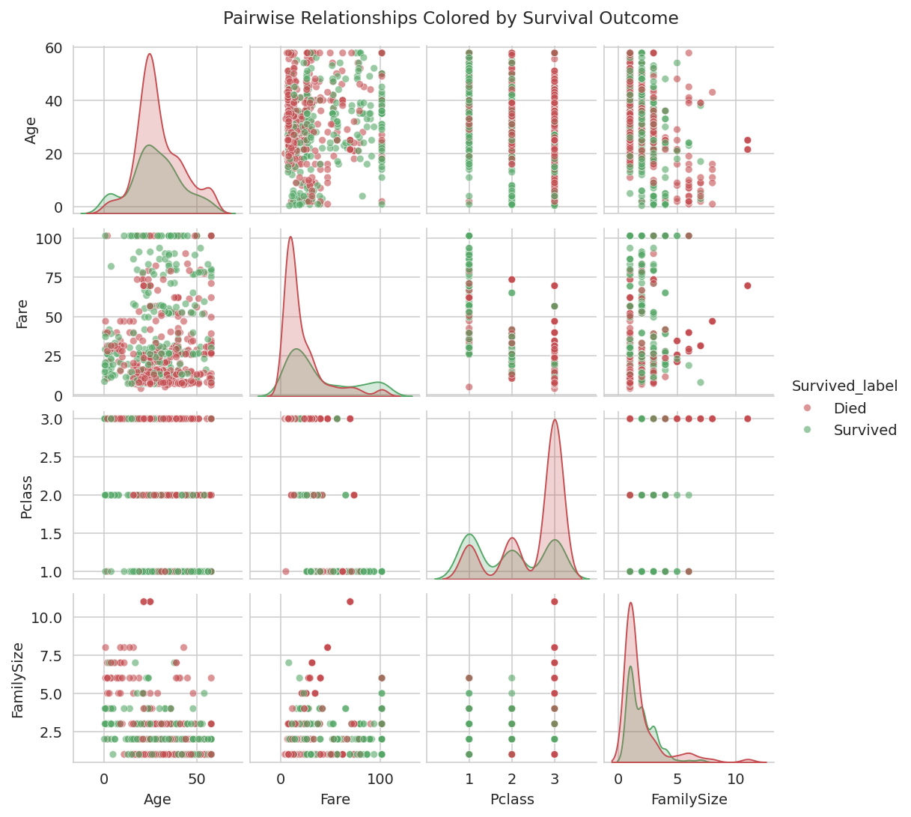
Figure 11. Pairwise scatter/density plots of Age, Fare, Pclass, and FamilySize, colored by survival outcome.
Interpretation: no single pair of numeric variables cleanly separates survivors from non-survivors on its own — the green (survived) and red (died) points overlap substantially in every scatter panel. This confirms that survival in this dataset is driven by a combination of factors (chiefly Sex and Class, which are categorical and not shown in this numeric pairplot) rather than by any one continuous variable in isolation.
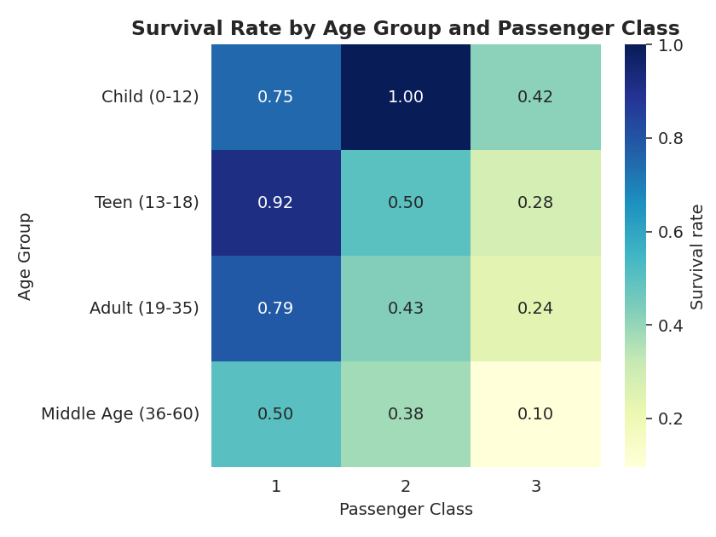
Figure 12. Survival rate by Age Group and Passenger Class (grouped heatmap).
Interpretation: this heatmap makes the compounding effect explicit. Reading across each row, survival rate drops sharply from 1st to 3rd class within every age group (e.g. children: 75% in 1st class vs 42% in 3rd class). Reading down each column shows children consistently survived more often than middle-aged passengers within the same class. The two effects are additive rather than one dominating the other.
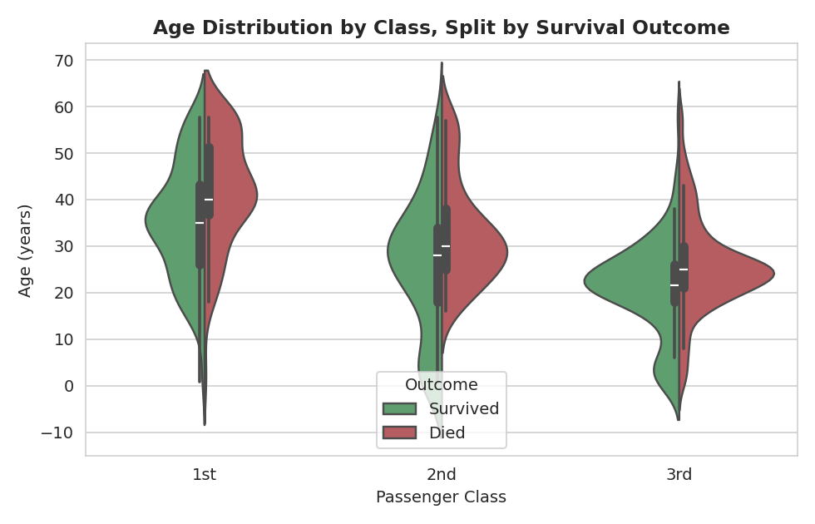
Figure 13. Age distribution by Passenger Class, split by survival outcome (violin plot).
Interpretation: within each class, the "Survived" half of the violin is shifted toward younger ages compared to the "Died" half, most visibly in 1st and 2nd class. In 3rd class the two distributions are more similar in shape, suggesting age mattered somewhat less as a protective factor once a passenger was already in the lowest survival-rate class.

8. Discussion — Why These Patterns Likely Exist
- Sex: the large, consistent gap across every class strongly suggests a "women and children first" evacuation policy was followed and had a real, measurable effect.
- Class / Fare: 1st-class cabins were physically closer to the boat deck and lifeboats, and wealthier passengers may have received faster or more attentive crew assistance — both plausible mechanisms behind the strong class effect, alongside general social dynamics of the era.
- Age: children being prioritized for lifeboat seats is consistent with the higher child survival rate observed within every class.
- Family size: a small family may have helped members find and stay with each other during the evacuation, while very large families or solo travellers may have faced coordination difficulties or lacked someone to help them react quickly.
- Port of embarkation: the apparent effect is best explained as a confound with class composition (Cherbourg boarded proportionally more 1st-class passengers) rather than a direct effect of the port itself.

9. Key Insights Summary
- Sex was the single strongest predictor of survival in this dataset (74% female vs 19% male overall).
- Passenger class showed a clear, monotonic relationship with survival (63% -> 47% -> 24% from 1st to 3rd class).
- The two effects compound: 1st-class women survived at 97%, 3rd-class men at only 14% — a 7x gap.
- Children had a survival advantage within every class, most visible when comparing age groups inside the same Pclass.
- Fare and port-of-embarkation effects are largely explained by their strong association with passenger class rather than being independent causal drivers.
- Family size shows a mild non-linear relationship: small families (2-4) outperformed both solo travellers and very large families.

10. Conclusion
This EDA moved from simple counts and distributions to compounding, multivariate relationships, using thirteen annotated visualizations and two aggregation tables to build an evidence-based picture of survival on the Titanic. The analysis consistently points to the same conclusion from multiple angles (bar charts, violin plots, a correlation heatmap, and a grouped heatmap all agree): Sex and Passenger Class, and their interaction, are the dominant drivers of survival in this dataset, with Age contributing a smaller but consistent secondary effect, and Fare/Embarked acting mostly as proxies for class rather than independent factors.

Appendix

Appendix A: Full Script — eda_analysis.py
Complete, reproducible script used to generate every statistic, figure, and aggregation table in this report.
import pandas as pd
import numpy as np
import matplotlib
matplotlib.use("Agg")
import matplotlib.pyplot as plt
import seaborn as sns
sns.set_style("whitegrid")
plt.rcParams["axes.titlesize"] = 12
plt.rcParams["axes.titleweight"] = "bold"
# Use the cleaned dataset produced in Week 1, plus the raw file for a couple of
# human-readable categorical labels (Embarked letters, Sex text) that are more
# intuitive to visualize than the one-hot-encoded Week 1 output.
raw = pd.read_csv("titanic.csv")
clean = pd.read_csv("titanic_cleaned.csv")
# Rebuild a "readable" analysis frame: cleaned numeric quality (no missing values,
# outliers capped) but with human-readable category labels for plotting.
df = clean.copy()
df["Sex_label"] = df["Sex"].map({0: "Male", 1: "Female"})
df["Embarked_label"] = np.select(
[df["Embarked_Q"] == 1, df["Embarked_S"] == 1],
["Queenstown", "Southampton"],
default="Cherbourg",
)
df["Survived_label"] = df["Survived"].map({0: "Died", 1: "Survived"})
df["AgeGroup"] = pd.cut(
df["Age"], bins=[0, 12, 18, 35, 60, 100],
labels=["Child (0-12)", "Teen (13-18)", "Adult (19-35)", "Middle Age (36-60)", "Senior (60+)"]
)
df["FareBand"] = pd.qcut(df["Fare"], 4, labels=["Low", "Medium", "High", "Very High"])
print("========== 1. BASIC STATISTICS ==========")
print(df.shape)
print(df[["Age", "Fare", "FamilySize", "Pclass"]].describe().round(2))
print("\nSurvival rate overall: {:.1f}%".format(df["Survived"].mean() * 100))
print("\nValue counts - Pclass:\n", df["Pclass"].value_counts())
print("\nValue counts - Sex:\n", df["Sex_label"].value_counts())
print("\nValue counts - Embarked:\n", df["Embarked_label"].value_counts())
print("\nValue counts - AgeGroup:\n", df["AgeGroup"].value_counts())
# ============================================================
# UNIVARIATE ANALYSIS
# ============================================================
# Fig 1: Survival count + rate
fig, axes = plt.subplots(1, 2, figsize=(9, 4))
sns.countplot(x="Survived_label", data=df, ax=axes[0], palette=["#C44E52", "#55A868"])
axes[0].set_title("Passenger Survival Counts")
axes[0].set_xlabel("Outcome")
axes[0].set_ylabel("Number of Passengers")
for c in axes[0].containers:
axes[0].bar_label(c)
df["Pclass"].value_counts().sort_index().plot(
kind="bar", ax=axes[1], color=["#4C72B0", "#DD8452", "#55A868"]
)
axes[1].set_title("Passenger Count by Class")
axes[1].set_xlabel("Passenger Class")
axes[1].set_ylabel("Number of Passengers")
axes[1].set_xticklabels(["1st", "2nd", "3rd"], rotation=0)
plt.tight_layout()
plt.savefig("eda1_survival_class_counts.png", dpi=140)
plt.close()
# Fig 2: Age & Fare distributions
fig, axes = plt.subplots(1, 2, figsize=(9, 4))
sns.histplot(df["Age"], bins=25, kde=True, ax=axes[0], color="#4C72B0")
axes[0].set_title("Age Distribution")
axes[0].set_xlabel("Age (years)")
axes[0].set_ylabel("Number of Passengers")
sns.histplot(df["Fare"], bins=25, kde=True, ax=axes[1], color="#DD8452")
axes[1].set_title("Fare Distribution")
axes[1].set_xlabel("Fare (capped, GBP)")
axes[1].set_ylabel("Number of Passengers")
plt.tight_layout()
plt.savefig("eda2_age_fare_dist.png", dpi=140)
plt.close()
# Fig 3: Categorical breakdown - Sex, Embarked, FamilySize
fig, axes = plt.subplots(1, 3, figsize=(11, 3.8))
sns.countplot(x="Sex_label", data=df, ax=axes[0], color="#8172B2")
axes[0].set_title("Passengers by Sex")
axes[0].set_xlabel("Sex"); axes[0].set_ylabel("Count")
sns.countplot(x="Embarked_label", data=df, ax=axes[1], color="#937860",
order=["Southampton", "Cherbourg", "Queenstown"])
axes[1].set_title("Passengers by Port")
axes[1].set_xlabel("Port of Embarkation"); axes[1].set_ylabel("Count")
axes[1].tick_params(axis='x', rotation=15)
sns.countplot(x="FamilySize", data=df, ax=axes[2], color="#64B5CD")
axes[2].set_title("Family Size Aboard")
axes[2].set_xlabel("Family Size"); axes[2].set_ylabel("Count")
plt.tight_layout()
plt.savefig("eda3_categorical_counts.png", dpi=140)
plt.close()
# ============================================================
# BIVARIATE ANALYSIS (relationship with Survived)
# ============================================================
# Fig 4: Survival rate by Sex and Pclass (grouped bar with legend)
fig, ax = plt.subplots(figsize=(6.5, 4.2))
sns.barplot(x="Pclass", y="Survived", hue="Sex_label", data=df, ax=ax,
palette={"Male": "#4C72B0", "Female": "#C44E52"})
ax.set_title("Survival Rate by Passenger Class and Sex")
ax.set_xlabel("Passenger Class")
ax.set_ylabel("Survival Rate")
ax.set_xticklabels(["1st", "2nd", "3rd"])
ax.legend(title="Sex")
plt.tight_layout()
plt.savefig("eda4_survival_by_class_sex.png", dpi=140)
plt.close()
# Fig 5: Age distribution split by survival outcome
fig, ax = plt.subplots(figsize=(6.5, 4.2))
sns.kdeplot(data=df, x="Age", hue="Survived_label", fill=True, common_norm=False,
palette={"Died": "#C44E52", "Survived": "#55A868"}, alpha=0.45, ax=ax)
ax.set_title("Age Distribution by Survival Outcome")
ax.set_xlabel("Age (years)")
ax.set_ylabel("Density")
plt.tight_layout()
plt.savefig("eda5_age_by_survival.png", dpi=140)
plt.close()
# Fig 6: Survival rate by Age Group
fig, ax = plt.subplots(figsize=(6.5, 4.2))
order = ["Child (0-12)", "Teen (13-18)", "Adult (19-35)", "Middle Age (36-60)", "Senior (60+)"]
sns.barplot(x="AgeGroup", y="Survived", data=df, order=order, ax=ax, color="#55A868")
ax.set_title("Survival Rate by Age Group")
ax.set_xlabel("Age Group")
ax.set_ylabel("Survival Rate")
ax.tick_params(axis='x', rotation=20)
plt.tight_layout()
plt.savefig("eda6_survival_by_agegroup.png", dpi=140)
plt.close()
# Fig 7: Fare vs Survival (boxplot) + Fare band survival rate
fig, axes = plt.subplots(1, 2, figsize=(9.5, 4.2))
sns.boxplot(x="Survived_label", y="Fare", data=df, ax=axes[0],
palette=["#C44E52", "#55A868"])
axes[0].set_title("Fare Distribution by Survival Outcome")
axes[0].set_xlabel("Outcome"); axes[0].set_ylabel("Fare")
sns.barplot(x="FareBand", y="Survived", data=df, ax=axes[1], color="#4C72B0",
order=["Low", "Medium", "High", "Very High"])
axes[1].set_title("Survival Rate by Fare Band")
axes[1].set_xlabel("Fare Band (quartiles)"); axes[1].set_ylabel("Survival Rate")
plt.tight_layout()
plt.savefig("eda7_fare_survival.png", dpi=140)
plt.close()
# Fig 8: Survival by FamilySize / IsAlone
fig, axes = plt.subplots(1, 2, figsize=(9.5, 4.2))
sns.barplot(x="FamilySize", y="Survived", data=df, ax=axes[0], color="#8172B2")
axes[0].set_title("Survival Rate by Family Size")
axes[0].set_xlabel("Family Size (incl. self)"); axes[0].set_ylabel("Survival Rate")
sns.barplot(x="IsAlone", y="Survived", data=df, ax=axes[1], color="#DD8452")
axes[1].set_title("Survival Rate: Alone vs With Family")
axes[1].set_xlabel("Is Alone (0=No, 1=Yes)"); axes[1].set_ylabel("Survival Rate")
plt.tight_layout()
plt.savefig("eda8_family_survival.png", dpi=140)
plt.close()
# Fig 9: Survival by Port of Embarkation and Title
title_cols = [c for c in df.columns if c.startswith("Title_")]
df["Title"] = df[title_cols].idxmax(axis=1).str.replace("Title_", "")
df.loc[df[title_cols].sum(axis=1) == 0, "Title"] = "Master" # baseline dropped column
fig, axes = plt.subplots(1, 2, figsize=(10, 4.2))
sns.barplot(x="Embarked_label", y="Survived", data=df, ax=axes[0], color="#64B5CD",
order=["Southampton", "Cherbourg", "Queenstown"])
axes[0].set_title("Survival Rate by Port of Embarkation")
axes[0].set_xlabel("Port"); axes[0].set_ylabel("Survival Rate")
axes[0].tick_params(axis='x', rotation=15)
sns.barplot(x="Title", y="Survived", data=df, ax=axes[1], color="#937860",
order=["Mr", "Mrs", "Miss", "Master", "Rare"])
axes[1].set_title("Survival Rate by Title")
axes[1].set_xlabel("Title"); axes[1].set_ylabel("Survival Rate")
plt.tight_layout()
plt.savefig("eda9_port_title_survival.png", dpi=140)
plt.close()
# ============================================================
# MULTIVARIATE ANALYSIS
# ============================================================
# Fig 10: Correlation heatmap (numeric features)
corr_cols = ["Survived", "Pclass", "Sex", "Age", "Fare", "FamilySize", "IsAlone", "HasCabin"]
fig, ax = plt.subplots(figsize=(6.5, 5.5))
sns.heatmap(df[corr_cols].corr(), annot=True, fmt=".2f", cmap="coolwarm", center=0, ax=ax,
cbar_kws={"label": "Pearson correlation"})
ax.set_title("Correlation Heatmap of Key Numeric Features")
plt.tight_layout()
plt.savefig("eda10_correlation_heatmap.png", dpi=140)
plt.close()
# Fig 11: Pairplot (Age, Fare, Pclass, FamilySize) colored by Survived
pp = sns.pairplot(
df[["Age", "Fare", "Pclass", "FamilySize", "Survived_label"]],
hue="Survived_label", palette={"Died": "#C44E52", "Survived": "#55A868"},
plot_kws={"alpha": 0.6, "s": 25}, diag_kind="kde", height=1.9
)
pp.fig.suptitle("Pairwise Relationships Colored by Survival Outcome", y=1.02)
pp.savefig("eda11_pairplot.png", dpi=140)
plt.close()
# Fig 12: Heatmap of survival rate across Pclass x AgeGroup (multivariate crosstab)
pivot = df.pivot_table(index="AgeGroup", columns="Pclass", values="Survived", aggfunc="mean", observed=False)
fig, ax = plt.subplots(figsize=(6, 4.5))
sns.heatmap(pivot, annot=True, fmt=".2f", cmap="YlGnBu", ax=ax, cbar_kws={"label": "Survival rate"})
ax.set_title("Survival Rate by Age Group and Passenger Class")
ax.set_xlabel("Passenger Class")
ax.set_ylabel("Age Group")
plt.tight_layout()
plt.savefig("eda12_agegroup_class_heatmap.png", dpi=140)
plt.close()
# Fig 13: Violin plot - Age by Class, split by Survival
fig, ax = plt.subplots(figsize=(7, 4.5))
sns.violinplot(x="Pclass", y="Age", hue="Survived_label", data=df, split=True, ax=ax,
palette={"Died": "#C44E52", "Survived": "#55A868"})
ax.set_title("Age Distribution by Class, Split by Survival Outcome")
ax.set_xlabel("Passenger Class")
ax.set_ylabel("Age (years)")
ax.set_xticklabels(["1st", "2nd", "3rd"])
ax.legend(title="Outcome")
plt.tight_layout()
plt.savefig("eda13_violin_age_class_survival.png", dpi=140)
plt.close()
# ============================================================
# AGGREGATIONS / GROUPBY TABLES
# ============================================================
agg1 = df.groupby(["Pclass", "Sex_label"], observed=False).agg(
Passengers=("Survived", "size"),
SurvivalRate=("Survived", "mean"),
AvgAge=("Age", "mean"),
AvgFare=("Fare", "mean"),
).round(2).reset_index()
print("\n========== GROUPBY: Pclass x Sex ==========\n", agg1)
agg2 = df.groupby("Embarked_label", observed=False).agg(
Passengers=("Survived", "size"),
SurvivalRate=("Survived", "mean"),
AvgFare=("Fare", "mean"),
Pct1stClass=("Pclass", lambda s: (s == 1).mean() * 100),
).round(2).reset_index()
print("\n========== GROUPBY: Embarked ==========\n", agg2)
agg1.to_csv("agg_pclass_sex.csv", index=False)
agg2.to_csv("agg_embarked.csv", index=False)
print("\nDone. Figures and aggregation tables saved.")

