Unsupervised Learning and Clustering Analysis
Segmenting the UCI Wine Dataset with K-Means and Hierarchical Clustering
Week 3 Task — Unsupervised Learning and Clustering Analysis

1. Introduction and Objective
This report applies unsupervised learning to segment a publicly available dataset into meaningful clusters and analyzes the characteristics of each segment. The workflow covers dataset selection, preprocessing, clustering with K-Means (validated against Hierarchical/Agglomerative clustering), visualization via PCA, and an in-depth interpretation of the resulting clusters along with their practical implications.

2. Dataset Selection
Dataset: UCI Wine Recognition Dataset (built into scikit-learn as load_wine).
- 178 samples of wine grown in the same region of Italy, derived from three different cultivars.
- 13 continuous chemical features: alcohol, malic acid, ash, alkalinity of ash, magnesium, total phenols, flavanoids, nonflavanoid phenols, proanthocyanins, color intensity, hue, OD280/OD315 of diluted wines, and proline.
- No missing values; all features numeric — well suited to distance-based clustering.
This dataset was chosen because it has genuine multi-dimensional structure (13 correlated chemical measurements), a known ground-truth grouping (3 cultivars) that is deliberately withheld from the clustering algorithm and used only afterward for external validation, and a realistic analogue to product/customer segmentation problems where a business wants to discover natural groupings in numeric measurement data.

3. Methodology

3.1 Preprocessing
The 13 features are on very different scales (e.g., proline ranges 278-1680, while hue ranges 0.48-1.71). Distance-based algorithms like K-Means and Ward-linkage hierarchical clustering are scale-sensitive, so all features were standardized (zero mean, unit variance) using scikit-learn's StandardScaler before clustering.
from sklearn.datasets import load_wine
from sklearn.preprocessing import StandardScaler
data = load_wine()
X = pd.DataFrame(data.data, columns=data.feature_names)
scaler = StandardScaler()
X_scaled = scaler.fit_transform(X)

3.2 Choosing the Number of Clusters
Two complementary diagnostics were used to select k: the Elbow Method (within-cluster sum of squares / inertia) and the Silhouette Score (how well-separated and cohesive clusters are, ranging from -1 to 1).
from sklearn.cluster import KMeans
from sklearn.metrics import silhouette_score
inertias, sil_scores = [], []
for k in range(2, 10):
km = KMeans(n_clusters=k, random_state=42, n_init=10)
labels = km.fit_predict(X_scaled)
inertias.append(km.inertia_)
sil_scores.append(silhouette_score(X_scaled, labels))
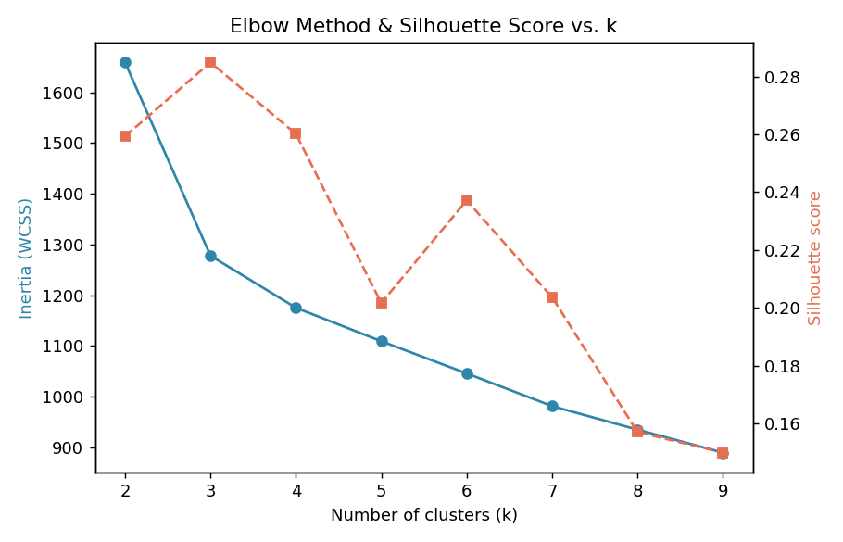
Figure 1. Elbow curve (inertia) and silhouette score across k=2..9.
The silhouette score peaks at k=3 (0.285), and the elbow curve shows a visible bend around k=3, after which inertia reduction flattens. k=3 was therefore selected — conveniently, this also matches the three known wine cultivars, which is used later purely as an independent sanity check, not as an input to the algorithm.

4. Clustering Results

4.1 K-Means (k=3)
kmeans = KMeans(n_clusters=3, random_state=42, n_init=10)
cluster_labels = kmeans.fit_predict(X_scaled)
sil_avg = silhouette_score(X_scaled, cluster_labels)
# sil_avg = 0.285
Because the data has 13 dimensions, Principal Component Analysis (PCA) was used purely for 2-D visualization (not for the clustering itself). The first two principal components together explain 55.4% of total variance (PC1: 36.2%, PC2: 19.2%).
from sklearn.decomposition import PCA
pca = PCA(n_components=2, random_state=42)
X_pca = pca.fit_transform(X_scaled)
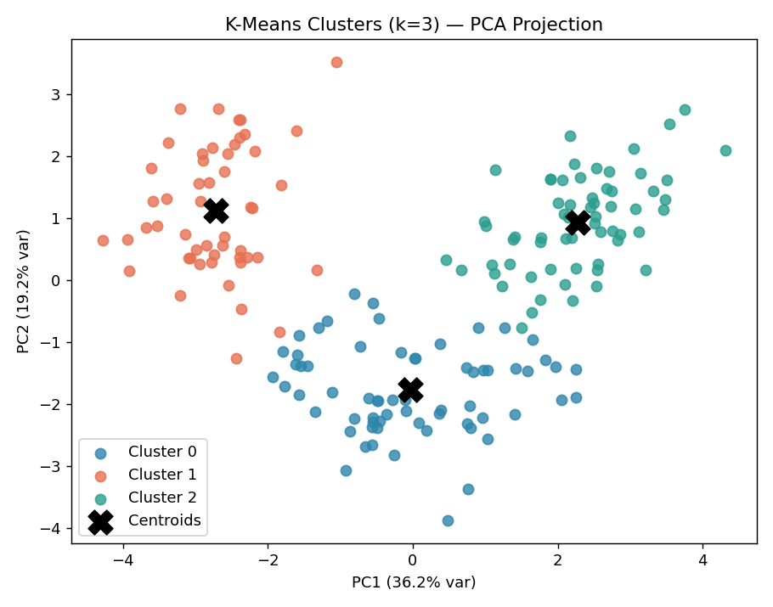
Figure 2. K-Means clusters (k=3) projected onto the first two principal components, with centroids marked.
The three clusters form visibly distinct, mostly non-overlapping regions in the PCA plane, indicating well-separated groups in the original 13-dimensional feature space.

4.2 Silhouette Diagnostics
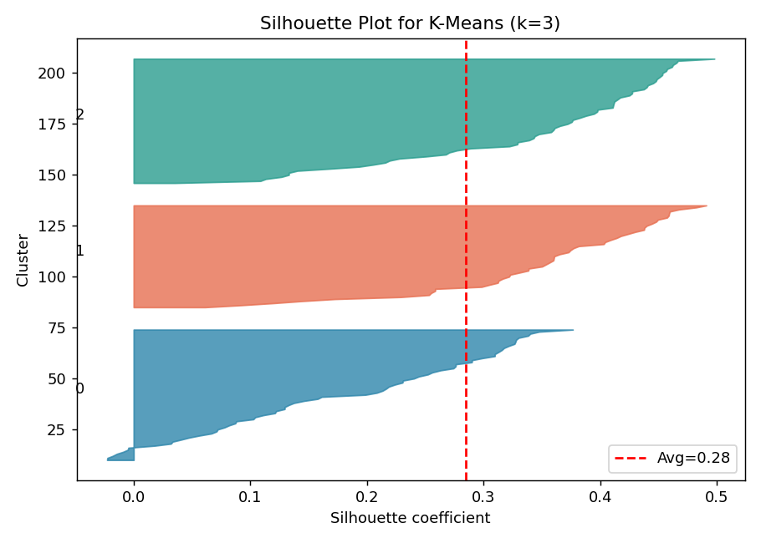
Figure 3. Per-sample silhouette plot for the k=3 K-Means solution. Most samples score above the average (red dashed line), indicating solid cluster cohesion.

4.3 Hierarchical (Agglomerative) Clustering — Cross-Validation of Structure
To verify that the K-Means result was not an artifact of the algorithm's initialization or assumptions, agglomerative hierarchical clustering with Ward linkage was also applied to the same standardized data.
from scipy.cluster.hierarchy import dendrogram, linkage
from sklearn.cluster import AgglomerativeClustering
Z = linkage(X_scaled, method='ward')
agg = AgglomerativeClustering(n_clusters=3, linkage='ward')
agg_labels = agg.fit_predict(X_scaled)
# agglomerative silhouette = 0.277
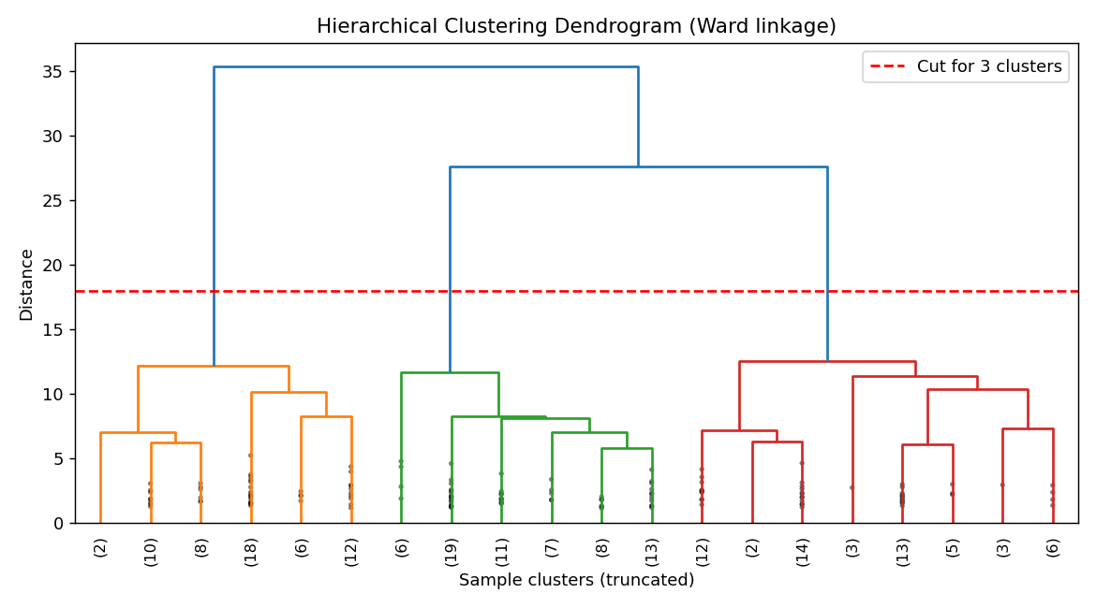
Figure 4. Ward-linkage dendrogram (truncated to last 20 merges). Cutting at the marked height yields 3 clusters.
K-Means and Agglomerative clustering agreed on 169 of 178 samples (95%), giving confidence that the 3-cluster structure is a genuine property of the data rather than an artifact of one particular algorithm.

5. Cluster Profiling and Interpretation
Mean values (original units) of the most distinguishing chemical features per K-Means cluster:
Feature | Cluster 0 (n=65) | Cluster 1 (n=51) | Cluster 2 (n=62)
Alcohol | 12.25 | 13.13 | 13.68
Malic acid | 1.90 | 3.31 | 2.00
Total phenols | 2.25 | 1.68 | 2.85
Flavanoids | 2.05 | 0.82 | 3.00
Color intensity | 2.97 | 7.23 | 5.45
Hue | 1.06 | 0.69 | 1.07
OD280/OD315 | 2.80 | 1.70 | 3.16
Proline | 510.17 | 619.06 | 1100.23

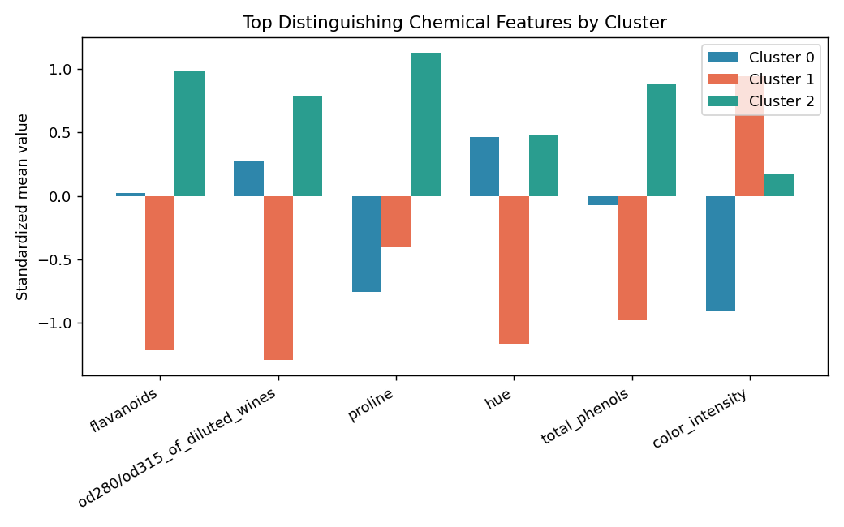
Figure 5. Standardized mean values of the six most discriminating features across the three clusters.

Cluster 0 — "Light-bodied, low-alcohol wines" (n=65)
- Lowest alcohol (12.25) and lowest color intensity (2.97).
- Moderate phenols/flavanoids and the lowest proline (510) — consistent with a lighter wine style.
- Likely corresponds to a cultivar producing lighter, more delicate wines.

Cluster 1 — "High acidity, deep color, low phenolic wines" (n=51)
- Highest malic acid (3.31) and by far the highest color intensity (7.23).
- Lowest flavanoids (0.82) and lowest total phenols (1.68), with the lowest hue (0.69) — suggesting a more tannic/acidic, deeply colored profile with less flavanoid richness.
- This is the most chemically distinct group, driving much of the separation seen in the PCA plot.

Cluster 2 — "Full-bodied, high-phenolic premium wines" (n=62)
- Highest alcohol (13.68), highest flavanoids (3.00), highest total phenols (2.85), and by far the highest proline (1100.23).
- High OD280/OD315 (3.16), indicating high protein/phenolic content and likely better resistance to oxidation.
- Profile consistent with a richer, higher-quality, longer-aging wine style.

6. External Validation Against Known Cultivars
Although cultivar labels were never used during clustering, comparing the unsupervised clusters to the 3 known cultivars afterward provides an independent check on cluster quality.
from sklearn.metrics import adjusted_rand_score, normalized_mutual_info_score
ari = adjusted_rand_score(data.target, cluster_labels) # 0.897
nmi = normalized_mutual_info_score(data.target, cluster_labels) # 0.876
Metric | Value | Interpretation
Silhouette Score (k=3) | 0.285 | Reasonable, well-separated structure for 13-dim chemical data
Adjusted Rand Index vs. true cultivar | 0.897 | Very high agreement with the 3 known wine cultivars
Normalized Mutual Information | 0.876 | Confirms clusters capture most of the true grouping information
Agglomerative vs. K-Means agreement | 169/178 (95%) | Two independent algorithms converge on nearly the same partition

An Adjusted Rand Index of 0.897 (1.0 = perfect match, 0 = random) shows that the purely unsupervised clustering recovered the true cultivar grouping almost perfectly, without ever seeing the labels — strong evidence that the discovered clusters reflect real, meaningful structure in the chemistry of the wines rather than noise.

7. Discussion: Business and Research Implications
- Quality/style segmentation: A winery or distributor could use these clusters to tier products (e.g., "light table wine" vs. "high-phenolic premium/aging wine"), informing pricing and marketing without manual tasting panels.
- Quality control: New batches can be scored on the same 13 features and assigned to a cluster automatically, flagging batches whose chemistry doesn't match any established cluster for further review.
- Cultivar/origin verification: Because clusters align closely with cultivar identity (ARI = 0.897), this pipeline could support provenance or blend-verification use cases using only lab-measurable chemistry.
- General applicability: The same pipeline (scale → reduce dimensionality for visualization → cluster → validate with a second algorithm → profile clusters) generalizes directly to customer segmentation, product categorization, or sensor-based anomaly grouping in other domains.
Limitations: The dataset is modest in size (178 samples) and specific to one region's cultivars, so the exact cluster boundaries may not generalize to other wine-growing regions. PCA visualization retains only 55% of variance, so some structure is not visible in the 2-D plot even though it is used by the clustering algorithm on the full 13-dimensional space. Silhouette scores around 0.28, while acceptable, indicate some cluster overlap consistent with natural chemical variation within cultivars.

8. Conclusion
K-Means clustering (k=3), selected using the elbow method and silhouette score and cross-validated with Ward-linkage hierarchical clustering, uncovered three chemically distinct, well-separated wine segments from the UCI Wine dataset. The clusters were profiled in terms of alcohol, phenolic content, color intensity, and proline, and independently validated against the true cultivar labels (ARI = 0.897), confirming that the unsupervised approach recovered meaningful, real-world structure. The methodology — standardization, k-selection via elbow/silhouette, PCA visualization, dual-algorithm validation, and feature-level cluster profiling — is directly transferable to customer segmentation and other clustering problems in industry.

