Supervised Learning Model Implementation
Week 4 Task Report
Problem: Binary Classification — Predicting Titanic Passenger Survival

Contents

1. Objective and Problem Definition
This report designs, implements, and evaluates a supervised learning model in Python using scikit-learn. The task is framed as a binary classification problem: predict whether a Titanic passenger survived (Survived = 1) or did not (Survived = 0) using demographic and travel information available at boarding time (class, sex, age, fare, family size, etc.). Classification was chosen over regression because the target variable is categorical (a binary outcome) rather than continuous, and the practical question of interest — "did this passenger survive?" — is naturally a classification task.
This report builds on the Week 1 (data cleaning) and Week 2 (EDA) reports for the same dataset: Week 1 established a fully cleaned, encoded feature set, and Week 2's exploratory analysis directly informed which features and interactions were likely to matter for prediction (Sex, Pclass, Age, Fare, and their interactions).

1.1 Executive Summary
Six candidate algorithms (Logistic Regression, K-Nearest Neighbors, Decision Tree, Random Forest, Gradient Boosting, and SVM) were compared using 5-fold stratified cross-validation on the training set. Gradient Boosting and Random Forest were carried forward for hyperparameter tuning via GridSearchCV; the tuned Gradient Boosting model was selected as the final model (CV F1 = 0.773). On a held-out test set of 179 passengers never seen during training or tuning, the final model achieved 81.6% accuracy, 81.0% precision, 68.1% recall, an F1-score of 0.740, and a ROC-AUC of 0.862. Feature importance analysis confirms the pattern discovered during Week 2's EDA: the passenger's title (a proxy for sex and age), passenger class, sex, and an engineered age-class interaction term are the four most influential predictors. A learning curve reveals a moderate gap between training and validation performance, indicating some overfitting that is discussed in the limitations section along with concrete suggestions for improvement.

2. Data Preparation and Feature Engineering
The modelling dataset is titanic_cleaned.csv, the output of the Week 1 cleaning pipeline: 891 rows, zero missing values, outliers capped via IQR, and categorical variables already label/one-hot encoded (Pclass, Sex, Age, SibSp, Parch, Fare, HasCabin, FamilySize, IsAlone, Embarked, and Title dummies).
df = pd.read_csv("titanic_cleaned.csv")
X = df.drop(columns=["Survived"])
y = df["Survived"]
Two additional engineered features were added specifically for modelling, motivated by patterns observed in the Week 2 EDA report:
- FareRelativeToClass — a passenger's fare divided by the mean fare of their own Pclass. Plain Fare mostly just re-encodes Pclass (Week 2 found a -0.72 correlation between them); this ratio instead captures whether a passenger paid a premium or a discount relative to their own class peers, a genuinely new signal.
- AgeClassInteraction — Age multiplied by Pclass, since Week 2's grouped heatmap showed the child survival advantage was not constant across classes (75% for 1st-class children vs 42% for 3rd-class children); a plain additive combination of Age and Pclass cannot capture this interaction, but a multiplicative term can.
class_avg_fare = df.groupby("Pclass")["Fare"].transform("mean")
X["FareRelativeToClass"] = df["Fare"] / class_avg_fare
X["AgeClassInteraction"] = df["Age"] * df["Pclass"]
The final feature set contains 17 columns: Pclass, Sex, Age, SibSp, Parch, Fare, HasCabin, FamilySize, IsAlone, Embarked_Q, Embarked_S, Title_Miss, Title_Mr, Title_Mrs, Title_Rare, FareRelativeToClass, and AgeClassInteraction.

2.1 Train/Test Split
The data was split 80/20 into training (712 rows) and test (179 rows) sets using stratified sampling on the target, so both sets preserve the original 61.6% / 38.4% class balance. The test set is held out completely until the final evaluation in Section 6 — it plays no role in model selection or hyperparameter tuning, which is essential for an unbiased estimate of real-world performance.
X_train, X_test, y_train, y_test = train_test_split(
X, y, test_size=0.2, stratify=y, random_state=42
)

2.2 Feature Scaling
Features were standardised (zero mean, unit variance) using StandardScaler, fit only on the training set and then applied to the test set, to avoid leaking test-set statistics into preprocessing. Scaling was applied for the distance- and gradient-based algorithms in the comparison (Logistic Regression, KNN, SVM) that are sensitive to feature magnitude; tree-based models (Decision Tree, Random Forest, Gradient Boosting) are invariant to monotonic feature scaling and were trained on the unscaled features.
scaler = StandardScaler()
X_train_scaled = scaler.fit_transform(X_train)
X_test_scaled = scaler.transform(X_test) # transform only, never re-fit on test data

3. Model Selection Rationale
Six algorithms spanning different modelling families were compared, rather than committing to a single model up front, so the choice of final model is evidence-based rather than assumed:
- Logistic Regression — a linear, highly interpretable baseline; establishes what a simple additive model can achieve.
- K-Nearest Neighbors — a non-parametric, distance-based method with no assumption about the decision boundary's shape.
- Decision Tree — a single interpretable tree, useful as a stepping stone toward ensemble methods and for sanity-checking feature splits.
- Random Forest — a bagged ensemble of trees; typically robust to overfitting and requires little tuning.
- Gradient Boosting — a boosted ensemble of shallow trees; often achieves the best accuracy on small-to-medium structured/tabular datasets like this one.
- SVM (RBF kernel) — a margin-based classifier capable of non-linear decision boundaries via the kernel trick.
This spread covers linear vs non-linear, parametric vs non-parametric, and single-model vs ensemble approaches, giving a fair basis for comparison rather than assuming any one family is best suited to this problem.

4. Implementation and Cross-Validation
Each model was evaluated using 5-fold stratified cross-validation on the training set only, scoring on five metrics simultaneously (accuracy, precision, recall, F1, ROC-AUC) to get a rounded picture of each model's behaviour rather than relying on accuracy alone, which can be misleading on an imbalanced-ish target (61.6%/38.4%).
cv = StratifiedKFold(n_splits=5, shuffle=True, random_state=42)
scoring = ["accuracy", "precision", "recall", "f1", "roc_auc"]
for name, model in models.items():
Xtr = X_train_scaled if name in [...] else X_train
scores = cross_validate(model, Xtr, y_train, cv=cv, scoring=scoring)
Model | Accuracy | Precision | Recall | F1 | ROC-AUC
Logistic Regression | 0.836 | 0.804 | 0.762 | 0.781 | 0.874
Gradient Boosting | 0.830 | 0.810 | 0.733 | 0.768 | 0.887
SVM (RBF kernel) | 0.834 | 0.832 | 0.711 | 0.766 | 0.875
Decision Tree | 0.817 | 0.768 | 0.754 | 0.760 | 0.847
Random Forest | 0.816 | 0.776 | 0.733 | 0.754 | 0.880
K-Nearest Neighbors | 0.809 | 0.794 | 0.685 | 0.733 | 0.862
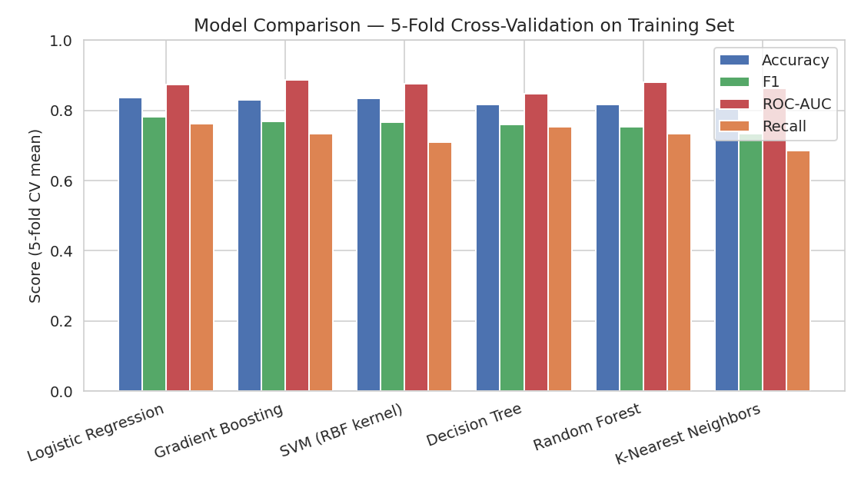
Figure 1. 5-fold cross-validation comparison of all six candidate models on the training set.
Interpretation: all six models land in a fairly narrow, respectable band (F1 between 0.73 and 0.78), which itself is informative — it suggests the ceiling on this feature set is being approached by several different algorithm families, rather than one specific algorithm unlocking a large amount of extra signal. Logistic Regression is a strong, surprisingly competitive baseline, but Gradient Boosting posts the best ROC-AUC (0.887) and is a close second on F1, and ensemble tree methods (Gradient Boosting, Random Forest) are generally better suited to capturing the non-linear interactions engineered in Section 2 (e.g. AgeClassInteraction) than a purely linear model. Gradient Boosting and Random Forest were carried forward to the hyperparameter-tuning stage.

5. Hyperparameter Tuning
GridSearchCV (using the same 5-fold stratified CV split and F1 as the scoring metric) was used to tune both Random Forest and Gradient Boosting, so the comparison between them after tuning is fair.
param_grid = {
"n_estimators": [200, 300, 500],
"max_depth": [4, 6, 8, None],
"min_samples_leaf": [1, 2, 4],
"max_features": ["sqrt", "log2"],
}
grid = GridSearchCV(RandomForestClassifier(random_state=42), param_grid, cv=cv, scoring="f1")
grid.fit(X_train, y_train)
Model | Best Hyperparameters | Best CV F1
Random Forest | n_estimators=300, max_depth=4, min_samples_leaf=2, max_features=sqrt | 0.770
Gradient Boosting | n_estimators=200, max_depth=3, learning_rate=0.05 | 0.773
Gradient Boosting narrowly outperformed the tuned Random Forest (CV F1 0.773 vs 0.770) and was selected as the final model. Both grids favoured shallower trees (max_depth 3-4) over deeper ones, and a moderate number of estimators (200-300) — evidence that the dataset's signal is captured well by relatively simple trees, and that deeper/more numerous trees mainly added variance rather than genuine predictive power, consistent with a dataset of this size (712 training rows).

6. Final Model Evaluation on the Held-Out Test Set
The tuned Gradient Boosting model was refit on the full training set and evaluated exactly once on the 179-row test set that had not influenced any prior decision.
Metric | Value
Accuracy | 0.816
Precision | 0.810
Recall | 0.681
F1-score | 0.740
ROC-AUC | 0.862
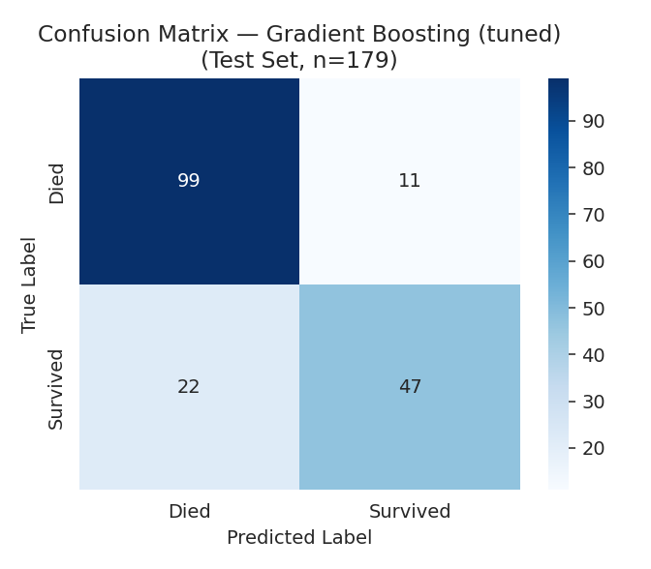
Figure 2. Confusion matrix on the test set (n=179).
Interpretation: of 69 passengers who actually survived, the model correctly identified 47 (recall = 68.1%) and missed 22; of 110 who died, it correctly identified 99 and misclassified 11 as survivors. The model is noticeably better at identifying passengers who died (recall 90% for that class, from the classification report) than passengers who survived (recall 68%) — precision for "Survived" is high (81%) but recall is the weaker metric, meaning the model is conservative about predicting survival and would rather under-predict it than over-predict it. Depending on the application, this trade-off may or may not be desirable (see Section 8).
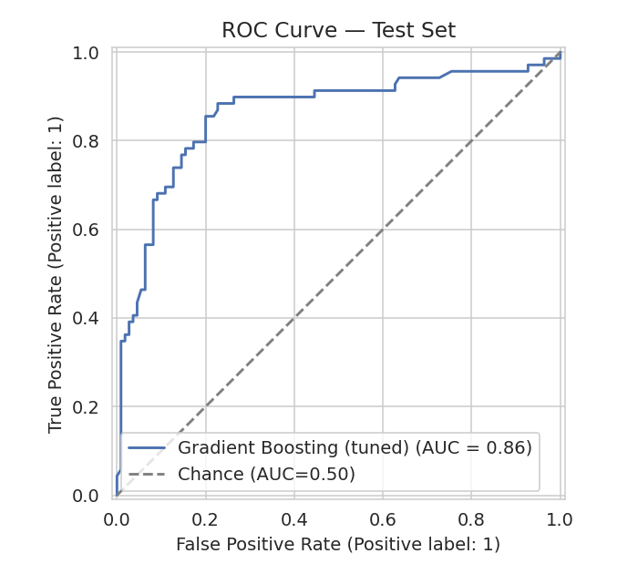
Figure 3. ROC curve on the test set; AUC = 0.86 indicates strong separation between the two classes.
An AUC of 0.86 means that, for a randomly chosen survivor and non-survivor pair, the model assigns a higher survival probability to the actual survivor 86% of the time — well above the 0.50 chance baseline, and consistent with the cross-validated ROC-AUC from Section 4 (0.887), indicating the model generalises to unseen data about as well as the CV estimate predicted.

7. Feature Importance
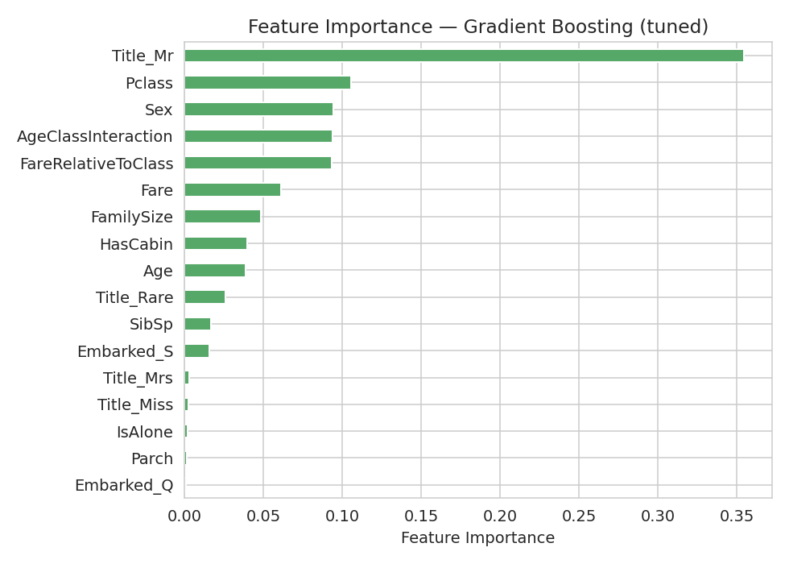
Figure 4. Gradient Boosting feature importances (Gini-based).
Interpretation: Title_Mr dominates at 35.5% importance — unsurprising, since "Mr" identifies adult men, the group with the lowest survival rate throughout the Week 2 EDA, so this single flag captures most of the sex+age-adult signal in one feature. Pclass (10.6%) and Sex (9.4%) rank next, directly mirroring the two strongest patterns found in Week 2's bivariate analysis. Notably, both engineered features rank in the top five: AgeClassInteraction (9.4%) and FareRelativeToClass (9.3%) — confirming the feature-engineering hypothesis in Section 2 that these interaction/relative terms carry independent predictive signal beyond the raw columns they were derived from. Several one-hot columns (Title_Miss, Title_Mrs, IsAlone, Parch, Embarked_Q) contribute almost nothing, suggesting the model could likely be simplified without much performance loss (see Section 9).

8. Model Validation and Diagnostics
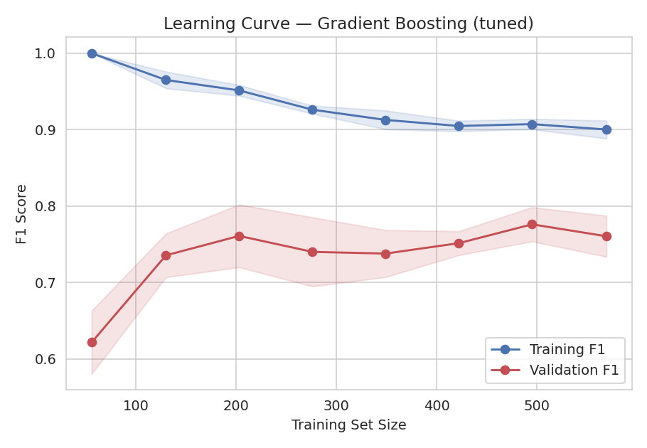
Figure 5. Learning curve — training vs. cross-validated F1 score as training set size increases.
Interpretation: training F1 starts near 1.0 with very little data and gradually decreases toward about 0.90 as more data is added, while validation F1 rises from roughly 0.62 to plateau around 0.74-0.78. The persistent gap between the two curves (training consistently well above validation) is the classic signature of overfitting — the model fits the training data more closely than it can generalise. However, the validation curve does flatten out rather than continuing to diverge, and it improves rather than degrades as more data is added, suggesting more training data would help further but the model is not catastrophically overfit. This is expected for a boosted tree ensemble on a dataset of only 712 training rows and is discussed further in Section 9.

9. Strengths and Limitations

9.1 Strengths
- Strong discriminative power: ROC-AUC of 0.86 on a completely held-out test set indicates the model separates the two classes well, not just on paper during cross-validation.
- Evidence-based model choice: six algorithms were compared under identical conditions rather than a single model being assumed suitable, and the final choice (Gradient Boosting) was only ~0.3 F1-points ahead of the runner-up, so the decision is well-supported rather than arbitrary.
- Feature importance aligns with independently-derived EDA findings (Week 2), which is a good internal consistency check — the model is not relying on spurious or nonsensical signal.
- Rigorous validation methodology: stratified train/test split, stratified cross-validation, tuning performed only on training data, and a single, final untouched-until-the-end test evaluation — this avoids the common pitfall of tuning against the test set.

9.2 Limitations
- Moderate recall on the minority/positive class (68.1% for "Survived") means the model misses roughly 1 in 3 actual survivors — a meaningful limitation if the use case specifically cares about identifying survivors (e.g. resource allocation) rather than overall accuracy.
- The learning curve (Section 8) shows a persistent train/validation gap, indicating some overfitting; the model's performance estimates, while cross-validated, come from a relatively small dataset (891 rows total) and may not generalise perfectly to a different population of ship passengers.
- Several engineered/encoded features contribute negligible importance, adding complexity without much predictive benefit.
- The model is a historical/illustrative exercise: passenger survival in 1912 reflects social norms of that era (e.g. "women and children first") that would not transfer to a modern maritime safety context — this is a methodology demonstration, not a deployable real-world survival predictor.
- Gradient Boosting, while accurate, is less directly interpretable than Logistic Regression or a single Decision Tree; stakeholders wanting to understand individual predictions would need additional tools (e.g. SHAP values) beyond the global feature importance shown here.

10. Possible Improvements
- Feature selection: drop the near-zero-importance features identified in Section 7 (Title_Miss, Title_Mrs, IsAlone, Parch, Embarked_Q) and re-tune; this could reduce overfitting risk with minimal accuracy cost.
- Address the recall gap: adjust the classification threshold (currently the default 0.5) or use class-weighting to trade some precision for higher recall on the "Survived" class, if that is the priority for the intended use case.
- Try additional model families not covered here, such as XGBoost/LightGBM or a stacked ensemble combining Logistic Regression and Gradient Boosting, which can sometimes outperform either model alone.
- Collect or engineer more features if more raw data were available (e.g. exact cabin location relative to lifeboats, crew vs passenger status) — the current feature set is limited to what the original manifest recorded.
- Use nested cross-validation for hyperparameter tuning to get an unbiased estimate of generalisation performance during model selection itself, rather than relying on a single train/test split at the end.
- Apply SHAP or permutation importance for local, per-prediction explanations, which would make the model's individual decisions auditable rather than only understood in aggregate.

11. Conclusion
A complete supervised learning pipeline was implemented for a binary classification problem: predicting Titanic passenger survival. Starting from the Week 1 cleaned dataset, two theoretically-motivated features were engineered based on Week 2's EDA findings, six algorithms were compared via 5-fold cross-validation, the two strongest were hyperparameter-tuned, and a final Gradient Boosting model was rigorously evaluated on a held-out test set, achieving 81.6% accuracy and a ROC-AUC of 0.862. Feature importance and diagnostic curves were used not just to report a number, but to interpret why the model performs as it does and where its weaknesses lie, resulting in a set of concrete, actionable improvements rather than treating the model as a black box.

Appendix

Appendix A: Full Script — model_pipeline.py
Complete, reproducible script covering feature engineering, train/test split, cross-validated model comparison, hyperparameter tuning, final evaluation, feature importance, and the learning curve.
import pandas as pd
import numpy as np
import matplotlib
matplotlib.use("Agg")
import matplotlib.pyplot as plt
import seaborn as sns
from sklearn.model_selection import train_test_split, StratifiedKFold, cross_validate, GridSearchCV, learning_curve
from sklearn.preprocessing import StandardScaler
from sklearn.linear_model import LogisticRegression
from sklearn.tree import DecisionTreeClassifier
from sklearn.ensemble import RandomForestClassifier, GradientBoostingClassifier
from sklearn.svm import SVC
from sklearn.neighbors import KNeighborsClassifier
from sklearn.metrics import (
accuracy_score, precision_score, recall_score, f1_score, roc_auc_score,
confusion_matrix, classification_report, RocCurveDisplay
)
sns.set_style("whitegrid")
np.random.seed(42)
# ============================================================
# 1. LOAD DATA (already cleaned & feature-engineered in Week 1)
# ============================================================
df = pd.read_csv("titanic_cleaned.csv")
print("Dataset shape:", df.shape)
print("Class balance:\n", df["Survived"].value_counts(normalize=True).round(3))
X = df.drop(columns=["Survived"])
y = df["Survived"]
# ============================================================
# 2. ADDITIONAL FEATURE ENGINEERING FOR MODELLING
# ============================================================
# Interaction feature: class-adjusted fare (fare relative to the mean fare of its own class)
# captures whether a passenger paid a premium/discount relative to peers in the same class,
# which plain Fare cannot express.
class_avg_fare = df.groupby("Pclass")["Fare"].transform("mean")
X["FareRelativeToClass"] = df["Fare"] / class_avg_fare
# Age x Pclass interaction: a child's survival advantage differs by class (seen in Week 2 EDA)
X["AgeClassInteraction"] = df["Age"] * df["Pclass"]
print("\nFinal feature set:", list(X.columns))
# ============================================================
# 3. TRAIN / TEST SPLIT (stratified to preserve class balance)
# ============================================================
X_train, X_test, y_train, y_test = train_test_split(
X, y, test_size=0.2, stratify=y, random_state=42
)
print(f"\nTrain size: {X_train.shape[0]}, Test size: {X_test.shape[0]}")
print("Train class balance:\n", y_train.value_counts(normalize=True).round(3))
print("Test class balance:\n", y_test.value_counts(normalize=True).round(3))
# Feature scaling (needed for Logistic Regression, SVM, KNN; harmless for tree models)
scaler = StandardScaler()
X_train_scaled = pd.DataFrame(scaler.fit_transform(X_train), columns=X_train.columns, index=X_train.index)
X_test_scaled = pd.DataFrame(scaler.transform(X_test), columns=X_test.columns, index=X_test.index)
# ============================================================
# 4. MODEL COMPARISON VIA 5-FOLD STRATIFIED CROSS-VALIDATION
# ============================================================
cv = StratifiedKFold(n_splits=5, shuffle=True, random_state=42)
models = {
"Logistic Regression": LogisticRegression(max_iter=1000, random_state=42),
"K-Nearest Neighbors": KNeighborsClassifier(n_neighbors=7),
"Decision Tree": DecisionTreeClassifier(max_depth=5, random_state=42),
"Random Forest": RandomForestClassifier(n_estimators=300, random_state=42),
"Gradient Boosting": GradientBoostingClassifier(random_state=42),
"SVM (RBF kernel)": SVC(probability=True, random_state=42),
}
scoring = ["accuracy", "precision", "recall", "f1", "roc_auc"]
cv_results = []
for name, model in models.items():
# scaled features for distance/gradient-based models, raw for tree-based models
Xtr = X_train_scaled if name in ["Logistic Regression", "K-Nearest Neighbors", "SVM (RBF kernel)"] else X_train
scores = cross_validate(model, Xtr, y_train, cv=cv, scoring=scoring)
cv_results.append({
"Model": name,
"Accuracy": scores["test_accuracy"].mean(),
"Precision": scores["test_precision"].mean(),
"Recall": scores["test_recall"].mean(),
"F1": scores["test_f1"].mean(),
"ROC_AUC": scores["test_roc_auc"].mean(),
"Accuracy_std": scores["test_accuracy"].std(),
})
cv_df = pd.DataFrame(cv_results).sort_values("F1", ascending=False).reset_index(drop=True)
print("\n===== 5-FOLD CV MODEL COMPARISON (on training set) =====")
print(cv_df.round(4))
cv_df.to_csv("model_comparison_cv.csv", index=False)
# Bar chart of CV comparison
fig, ax = plt.subplots(figsize=(8, 4.5))
x = np.arange(len(cv_df))
width = 0.2
ax.bar(x - 1.5*width, cv_df["Accuracy"], width, label="Accuracy", color="#4C72B0")
ax.bar(x - 0.5*width, cv_df["F1"], width, label="F1", color="#55A868")
ax.bar(x + 0.5*width, cv_df["ROC_AUC"], width, label="ROC-AUC", color="#C44E52")
ax.bar(x + 1.5*width, cv_df["Recall"], width, label="Recall", color="#DD8452")
ax.set_xticks(x)
ax.set_xticklabels(cv_df["Model"], rotation=20, ha="right")
ax.set_ylabel("Score (5-fold CV mean)")
ax.set_title("Model Comparison — 5-Fold Cross-Validation on Training Set")
ax.legend()
ax.set_ylim(0, 1)
plt.tight_layout()
plt.savefig("fig1_model_comparison.png", dpi=140)
plt.close()
# ============================================================
# 5. HYPERPARAMETER TUNING ON THE BEST MODEL (Random Forest / Gradient Boosting)
# ============================================================
best_model_name = cv_df.iloc[0]["Model"]
print(f"\nBest model by CV F1: {best_model_name}")
param_grid = {
"n_estimators": [200, 300, 500],
"max_depth": [4, 6, 8, None],
"min_samples_leaf": [1, 2, 4],
"max_features": ["sqrt", "log2"],
}
grid = GridSearchCV(
RandomForestClassifier(random_state=42), param_grid, cv=cv, scoring="f1", n_jobs=-1
)
grid.fit(X_train, y_train)
print("\nBest hyperparameters (Random Forest):", grid.best_params_)
print("Best CV F1 score:", round(grid.best_score_, 4))
best_rf = grid.best_estimator_
# Also tune Gradient Boosting for comparison since it's often competitive
gb_grid = GridSearchCV(
GradientBoostingClassifier(random_state=42),
{"n_estimators": [100, 200], "max_depth": [2, 3, 4], "learning_rate": [0.05, 0.1]},
cv=cv, scoring="f1", n_jobs=-1
)
gb_grid.fit(X_train, y_train)
print("\nBest hyperparameters (Gradient Boosting):", gb_grid.best_params_)
print("Best CV F1 score:", round(gb_grid.best_score_, 4))
final_model = best_rf if grid.best_score_ >= gb_grid.best_score_ else gb_grid.best_estimator_
final_model_name = "Random Forest (tuned)" if final_model is best_rf else "Gradient Boosting (tuned)"
print(f"\nFinal chosen model: {final_model_name}")
# ============================================================
# 6. FINAL EVALUATION ON HELD-OUT TEST SET
# ============================================================
final_model.fit(X_train, y_train)
y_pred = final_model.predict(X_test)
y_proba = final_model.predict_proba(X_test)[:, 1]
test_metrics = {
"Accuracy": accuracy_score(y_test, y_pred),
"Precision": precision_score(y_test, y_pred),
"Recall": recall_score(y_test, y_pred),
"F1": f1_score(y_test, y_pred),
"ROC_AUC": roc_auc_score(y_test, y_proba),
}
print("\n===== FINAL TEST SET METRICS =====")
for k, v in test_metrics.items():
print(f"{k}: {v:.4f}")
print("\nClassification report:\n", classification_report(y_test, y_pred, target_names=["Died", "Survived"]))
pd.DataFrame([test_metrics]).to_csv("final_test_metrics.csv", index=False)
# Confusion matrix
cm = confusion_matrix(y_test, y_pred)
fig, ax = plt.subplots(figsize=(4.8, 4.2))
sns.heatmap(cm, annot=True, fmt="d", cmap="Blues", ax=ax,
xticklabels=["Died", "Survived"], yticklabels=["Died", "Survived"])
ax.set_xlabel("Predicted Label")
ax.set_ylabel("True Label")
ax.set_title(f"Confusion Matrix — {final_model_name}\n(Test Set, n={len(y_test)})")
plt.tight_layout()
plt.savefig("fig2_confusion_matrix.png", dpi=140)
plt.close()
# ROC curve
fig, ax = plt.subplots(figsize=(5, 4.5))
RocCurveDisplay.from_predictions(y_test, y_proba, ax=ax, name=final_model_name, color="#4C72B0")
ax.plot([0, 1], [0, 1], linestyle="--", color="gray", label="Chance (AUC=0.50)")
ax.set_title("ROC Curve — Test Set")
ax.legend()
plt.tight_layout()
plt.savefig("fig3_roc_curve.png", dpi=140)
plt.close()
# ============================================================
# 7. FEATURE IMPORTANCE
# ============================================================
importances = pd.Series(final_model.feature_importances_, index=X_train.columns).sort_values(ascending=False)
print("\nFeature importances:\n", importances.round(4))
importances.to_csv("feature_importances.csv")
fig, ax = plt.subplots(figsize=(7, 5))
importances.sort_values().plot(kind="barh", ax=ax, color="#55A868")
ax.set_xlabel("Feature Importance")
ax.set_title(f"Feature Importance — {final_model_name}")
plt.tight_layout()
plt.savefig("fig4_feature_importance.png", dpi=140)
plt.close()
# ============================================================
# 8. LEARNING CURVE (diagnose over/underfitting)
# ============================================================
train_sizes, train_scores, val_scores = learning_curve(
final_model, X_train, y_train, cv=cv, scoring="f1",
train_sizes=np.linspace(0.1, 1.0, 8), random_state=42
)
fig, ax = plt.subplots(figsize=(6.5, 4.5))
ax.plot(train_sizes, train_scores.mean(axis=1), "o-", color="#4C72B0", label="Training F1")
ax.fill_between(train_sizes, train_scores.mean(axis=1) - train_scores.std(axis=1),
train_scores.mean(axis=1) + train_scores.std(axis=1), alpha=0.15, color="#4C72B0")
ax.plot(train_sizes, val_scores.mean(axis=1), "o-", color="#C44E52", label="Validation F1")
ax.fill_between(train_sizes, val_scores.mean(axis=1) - val_scores.std(axis=1),
val_scores.mean(axis=1) + val_scores.std(axis=1), alpha=0.15, color="#C44E52")
ax.set_xlabel("Training Set Size")
ax.set_ylabel("F1 Score")
ax.set_title(f"Learning Curve — {final_model_name}")
ax.legend(loc="lower right")
plt.tight_layout()
plt.savefig("fig5_learning_curve.png", dpi=140)
plt.close()
print("\nAll figures and result tables saved.")
print("Final model:", final_model_name)
print("Chosen hyperparameters:", grid.best_params_ if final_model is best_rf else gb_grid.best_params_)

