Introduction

The global community has committed to reducing greenhouse gas emissions to limit global temperature rise to 1.5°C above pre-industrial levels. While the actions that drive emissions increases or reductions are widely studied, they are also deeply interconnected across sectors. Integrated Assessment Models (IAMs) help explore these complex dynamics by projecting alternative climate futures based on different socioeconomic assumptions and policy interventions. Drawing on harmonized inputs, these models generate diverse scenarios that reflect a range of mitigation pathways. This research takes a descriptive approach, using scenarios from the AR6 Scenario Explorer to investigate which sectoral trends are most strongly associated with scenarios that meet the 1.5°C target.

Focusing on the broad sectoral categories of AFOLU, Industry, Residential & Commercial Buildings, Electricity, and Transportation, this research follows in the footsteps of similar work which leveraged explainable machine learning techniques to offer descriptive pathways based on regional disaggregation(Li et al., 2023). However, existing IAM interpretability work has focused on regional disaggregation (Li et al., 2023) or relied on a single method applied to a specific technology (Jaxa-Rozen & Trutnevyte, 2021), evincing a need for an exploration of sectoral patterns across multiple scenario contexts.

Data

The AR6 Scenario Explorer contains over 3000 scenarios derived from 188 unique modelling frameworks and 95+ model families. It is available for exploration online or for download in bulk (AR6 Scenario Explorer and Database Hosted by IIASA, n.d.). AR6 Working Group III also published categorizations of each scenario, ranging from C1 to C8 (See Figure 1). By aligning the general scenario database with these categorizations and their associated temperature targets, a baseline was achieved from which a model could learn the relationship between given variables and the temperature outcomes.
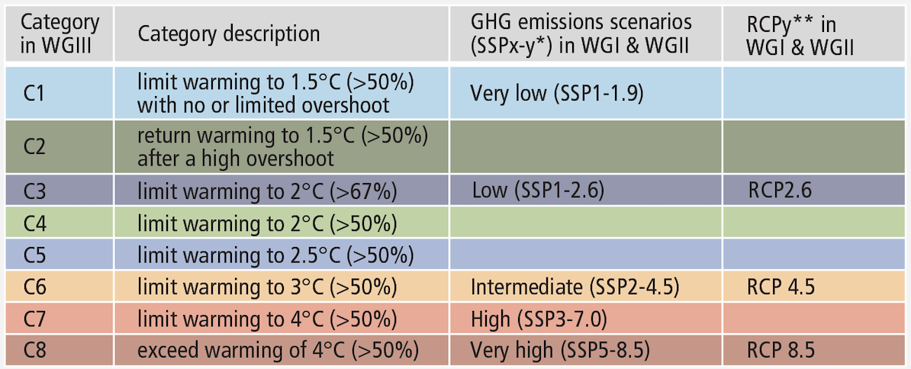
Figure 1. AR6 categorizations and their associated temperature buckets (IPCC, 2025)

Methods

This study combines systematic variable filtering with multiple interpretable machine learning techniques to identify sectoral metrics most predictive of 1.5°C-aligned climate pathways. The analysis pipeline includes four main phases: (1) variable pre-processing, (2) correlation-constrained sectoral sampling, (3) scenario classification using PRIM, SHAP, logistic regression, and clustering, and (4) aggregation of variable importance across multiple runs.

Core to this approach was the idea that scenarios associated with different temperature buckets could be differentiable given a subset of the variables initially used to define them. This differentiability is visualized in three dimensions in Figure 2. Although the actual dimensionality is impossible to visualize as it existed in as many dimensions as there were selected features for a given run.

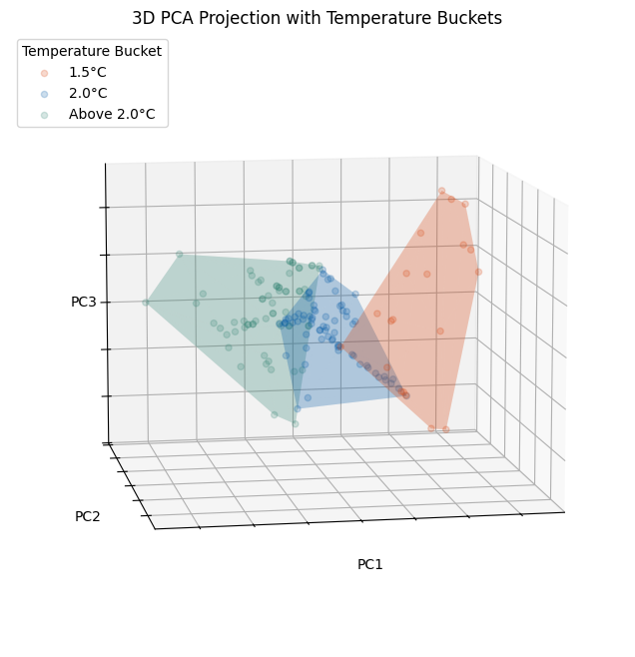
Figure 2. Projection of scenarios in 3D space delineated by associated temperature buckets

- Variable Pre-Processing
The initial stage of the analysis involved transforming the raw scenario data into a structured, sectorally-tagged dataset suitable for interpretable machine learning. To enable sectoral analysis, variables were manually and programmatically assigned to one of five broad sectors: Electricity, Transport, Industry, Residential & Commercial Buildings, and AFOLU (Agriculture, Forestry, and Other Land Use). This was achieved using a keyword-based matching algorithm, supported by sectoral vocabularies (e.g., “cement”, “steel”, “manufacturing” → Industry; “passenger”, “freight”, “vehicle” → Transport). Assignments were subsequently validated through manual inspection of ambiguous variables. Variables unrelated to any of the five core sectors (e.g., aggregate global indicators or region-specific labels without clear sectoral ties) were excluded.

- Correlation-Constrained Sectoral Sampling
Having identified a pool of sectorally assigned variables, a further subset was taken to balance sectoral representation, data availability, and statistical independence (low multicollinearity) in the selected inputs. Low multicollinearity is particularly important when performing a patient rule induction method (PRIM) analysis because the model focuses on the differences between input variable ranges in define ‘boxes’ with unusually high concentrations of target-class observations. If those variables are highly correlated, it may lead to a creation of artificially well-performing boxes (Friedman & Fisher, 1999).

For each modelling run, a variable combination was drawn from the pool of variables using a two-stage process: (1) Stratified Sectoral Sampling: Randomly selected a base set of variables, sampling between 2 and 3 variables per sector from the filtered pool. This ensured that each of the five focal sectors—Electricity, Transport, Industry, Buildings, and AFOLU—was represented in every modelling run. This base set typically included 10–15 variables. (2) Expansion Under Correlation Constraint: Expansion of the base set to a final combination of 25–30 variables by adding further candidates from each sector’s variable pool. A candidate variable $v$ was added to the current set $V$ only if the absolute Pearson correlation between $v$ and all existing variables $v'∈V$ was below a fixed threshold $ρmax=0.8$. This ensures that the final input matrix is well-conditioned for both regression-based and rule-based interpretable methods.
To ensure temporal consistency and relevance for medium-term policy analysis, only those variables with sufficient coverage in the target years of 2030 and 2050 were retained. A variable was considered to have “sufficient coverage” if non-null values were present for at least 80% of scenarios across both years.
The full sampling process was repeated stochastically 5,000 times, as there are various variable combinations which met the prescribed constraints. Ultimately, 10 versions were retained (see Appendix 1), heretofore referred to as ‘runs.’ Each run retained between 150 and 300 scenarios.
- Scenario Classification using PRIM, SHAP, Logistic Regression, and Clustering
Four interpretable classification approaches were applied: the Patient Rule Induction Method (PRIM), SHapley Additive exPlanations (SHAP), logistic regression, and unsupervised clustering with post hoc decision tree classification. PRIM identifies constrained input ranges linked to the target outcome; SHAP attributes local prediction importance to input features; logistic regression quantifies the global effect of each variable; and clustering reveals emergent scenario groupings later interpreted via classification trees. Collectively, these approaches allow us to triangulate on robust sectoral signals (Figure 3).

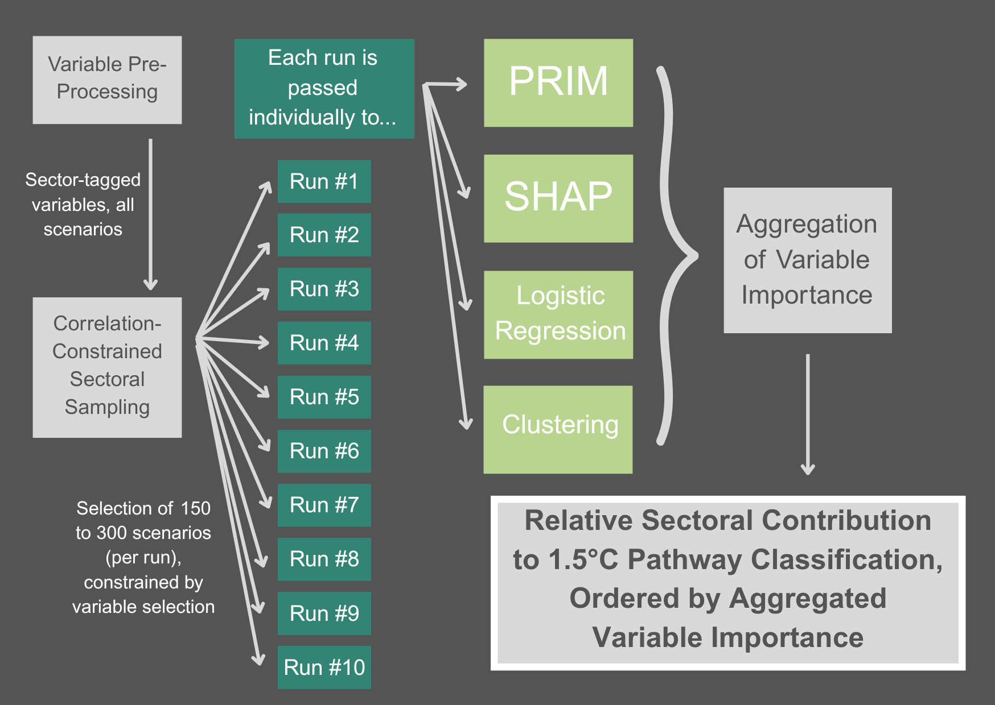
Figure 3. The methodological structure of this research

  - PRIM

PRIM works by iteratively “peeling” away slices of the input space along the dimension that yields the greatest increase in the density of the target class (in this case 1.5 scenarios) within the remaining subspace. This process continues until a stopping criterion is met. The resulting region, or “box,” is then expanded back to improve coverage without sacrificing density, resulting in options trading density for coverage. Each box is defined by upper and lower bounds on a subset of variables, representing a constrained region of input space where the probability of the target outcome is significantly higher than in the overall dataset.

Unlike univariate feature attribution methods, PRIM enables joint reasoning over multiple variables. Rather than identifying individual variables that are marginally associated with temperature outcomes, PRIM facilitates statements of the form: “When variable $X$ lies between $W$ and $Z$, and variable $Y$ lies between $U$ and $V$, scenarios are much more likely to be 1.5°C-consistent.”

  - SHAP

SHapley Additive Explanations (SHAP) is a game-theoretic method that assigns each feature an importance value based on its marginal contribution to a model’s prediction. It was used to evaluate the relative contribution of each input variable to scenario classification. SHAP values were derived from an XGBoost classifier trained to predict whether a given scenario was 1.5°C-consistent (target class = 0) or not (target class = 1), based on the input variables selected for each run. The classifier was trained on a stratified 70/30 train-test split, using balanced class weights and log-transformed, standardized variables.

  - Logistic Regression

Logistic regression quantifies the direction and magnitude of association between each input variable and the probability of a scenario being 1.5°C-consistent. A standard binary logistic model was fit for each run. Inputs were log-transformed and standardized. The model returned one coefficient per variable, with positive values indicating association with higher-warming scenarios and negative values indicating alignment with 1.5°C consistency. Absolute coefficient magnitudes were used to assess variable importance across runs.

Unlike PRIM and SHAP, which capture non-linear interactions or conditional thresholds, logistic regression offers a globally interpretable, directionally explicit baseline against which more flexible methods can be compared.

  - Clustering

Clustering was used to explore whether scenarios naturally grouped into distinct classes based on variables and independent of explicit temperature labels. Using a k-means algorithm, a decision tree classifier was trained to predict cluster membership from the original input variables. The most frequently used decision rules were recorded as indicators of which variables most reliably separated scenario types. Although the clustering was unsupervised, results were evaluated by comparing the cluster assignments to each scenario’s associated temperature outcome.

This method differs from supervised approaches by surfacing emergent patterns in the scenario dataset rather than prescribed ones.

- Aggregation of Variable Importance across Multiple Runs

In addition to being assessed and discussed as distinct methods (see Results and Discussion), we also wanted an aggregate conclusion that considered each of the methodological approaches together.

Because the feature selection couldn’t include the entire variable space, in order to avoid multicollinearity, ten runs were performed. Running more iterations allowed for more durable conclusions about sector-general impacts on IAM scenarios, rather than conclusions tied to specific variables within a single sector.

For each run, the outputs of PRIM, SHAP, logistic regression, and clustering were normalized and averaged to generate a single, orderable list of variables and their importance. There are tradeoffs to this approach. For example, some of the multivariate nuance from PRIM is lost in the averaging process. However, the aggregation allows for a simplified final result, and those finer details can still be discussed along the way. These averaged importances were also assigned to a sector based on their associated variable, which allowed for comparisons of total importance among the five sectors.

After ten runs, the importance of each sector across the runs was used to draw final conclusions on sectoral implications for 1.5°C pathways.

Results
- PRIM

PRIM yielded high-performing boxes in all 10 runs, with each box achieving a precision (density) of 1.0, indicating perfect purity of 1.5°C-consistent scenarios within the selected subspace (See Table 1). Coverage (recall) values ranged from 0.753 to 0.926 and refers to the proportion of all 1.5°C-consistent scenarios in the dataset that are captured within the PRIM-defined box. This means each PRIM box, across runs, included only 1.5°C-consistent scenarios but the recall figure indicates the number of 1.5°C-consistent scenarios that also existed outside that box. The higher the recall score is, the better. Corresponding F1 scores are a combination of precision and recall, giving a measure of overall performance. These too were consistently high, from 0.859 to 0.962.

The number of restricted dimensions used to define the boxes ranged from 3 to 8, suggesting that relatively few input variables were sufficient to identify high-density regions of 1.5°C scenarios.

Among the ten runs, run #10 achieved the strongest performance, identifying a box with 92.6% coverage and an F1 score of 0.962 while restricting only three input dimensions. This result suggests that, in some cases, a highly compact set of variable constraints is sufficient to isolate nearly all 1.5°C-consistent scenarios with perfect purity. Run 6 also stood out with an F1 score of 0.932, and a relatively low restriction burden of 4 dimensions, making it another candidate for deeper interpretation.

Run | Precision (Density) | Recall (Coverage) | F1 Score | Restricted Dimensions
1 | 1.0 | 0.767 | 0.868 | 7
2 | 1.0 | 0.823 | 0.903 | 5
3 | 1.0 | 0.832 | 0.908 | 5
4 | 1.0 | 0.766 | 0.868 | 6
5 | 1.0 | 0.753 | 0.859 | 6
6 | 1.0 | 0.873 | 0.932 | 4
7 | 1.0 | 0.8 | 0.889 | 4
8 | 1.0 | 0.786 | 0.88 | 8
9 | 1.0 | 0.798 | 0.888 | 7
10 | 1.0 | 0.926 | 0.962 | 3
Table 1. Results of PRIM analysis across 10 runs

The boxes associated with run #10 and run #6 illustrate the kinds of sectoral constraints most predictive of 1.5°C-consistent scenarios (see Figure 4).

In run #10, the PRIM box was defined by just three variables, all from the electricity sector. Notably, the variable Cumulative Capacity of Biomass with CCS was nearly unconstrained, while Δ Water Consumption for Dry Cooling and Δ Cumulative Capacity of Gas with CCS were both tightly restricted. In this discussion, and further discussions, the Δ symbol represents a change in that variable between 2030 and 2050. Variables without the Δ symbol represent the magnitude of the given variable in 2030.

Run #6 featured four variables drawn from electricity and industry. While the box achieved slightly lower coverage, it included tighter constraints on Capacity of Biomass Electricity, Industrial Liquid Fuel Use, and CH₄ Emissions from Industry. The box also includes Δ Investment in Biomass Electricity without CCS.

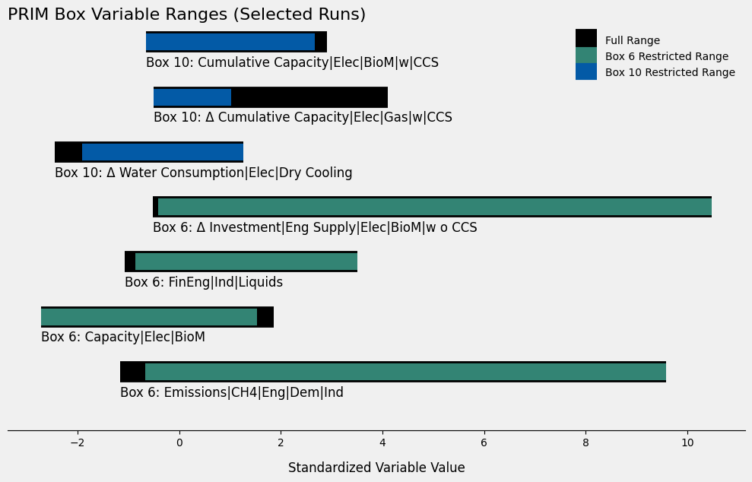
Figure 4. PRIM Box Variable Ranges (Selected Runs)

- SHAP

Across all runs, the XGBoost classifiers performed very well, achieving a mean F1 score of 0.944 and a mean accuracy of 0.909. This indicates that the models being interpreted via SHAP were highly effective at distinguishing 1.5°C-consistent scenarios from others.
The number of variables needed to account for 80% of total SHAP importance ranged from just 5 to 18, with a median of 15 and a mean of 13.8 (See Table 2). While SHAP does not explicitly restrict dimensionality, a relatively small subset of variables typically dominated model behavior.

Two runs stood out as particularly sparse in their explanations. (1) Run 6: only 6 variables accounted for 80% of SHAP importance, with a strong F1 of 0.962. (2) Run 10: only 5 variables crossed the same threshold, with the highest F1 of all runs at 0.973. These two runs also stood out in the PRIM analysis, delivering the highest-performing and most well-constrained boxes.

Run | F1 Score | # of Variables accounting for 80% Coverage
1 | 0.96 | 17
2 | 0.89 | 16
3 | 0.89 | 17
4 | 0.91 | 14
5 | 0.89 | 18
6 | 0.96 | 6
7 | 0.93 | 15
8 | 0.95 | 15
9 | 0.97 | 15
10 | 0.96 | 5
Table 2. SHAP results on XGBoost Classifier across ten runs

There is also some overlap in variables across runs and methods. In run #10 (see Table 3), for example, the Cumulative Capacity of Biomass with CCS is the most important SHAP feature, and one of the three dimensions used to define the corresponding PRIM box. Similarly, the variable Δ Water Consumption for Dry Cooling is restricted in the PRIM box and ranks among the top SHAP contributors. This agreement between methods strengthens the case that electricity-sector infrastructure variables are key predictors of 1.5°C-consistent scenarios in this subset of runs.

Variable | SHAP Importance
Cumulative Capacity|Elec|BioM|w|CCS | 1.701049
Δ Water Withdrawal|Elec|BioM|w o CCS | 0.432847
FinEng|Trans|Pass|Elec | 0.347212
Δ FinEng|Trans|Freight|Liquids|Oil | 0.279967
Cumulative Capacity|Elec|Gas|w|CCS | 0.271051
Water Withdrawal|Elec|BioM|w o CCS | 0.155476
Δ FinEng|ResCom|Res|Liquids | 0.151211
Δ Water Consumption|Elec|Dry Cooling | 0.149186
Δ FinEng|ResCom|Solids|BioM | 0.110652
CSe|CCS|Foss|Eng|Dem|Ind | 0.071656
Δ FinEng|Trans|Freight|H2 | 0.048767
Δ FinEng|ResCom|Solids|Coal | 0.031977
Table 3. Run #10 Variables with a SHAP Importance above Zero

- Logistic Regression
As a benchmark interpretable model, logistic regression was used to assess the ability of a linear classifier to separate 1.5°C-consistent scenarios from others based on standardized sectoral variables. All runs achieved high classification performance, with F1 scores ranging from 0.92 to 0.99 and test set accuracies from 92% to 99%. This suggests that a relatively simple linear combination of variables is sufficient to reliably distinguish 1.5°C-consistent scenarios in this dataset.

These results further support the findings from PRIM and SHAP by showing that a relatively low-dimensional and interpretable classifier can achieve high performance. The strong agreement between logistic regression and more complex approaches (like XGBoost + SHAP) provides confidence in the robustness of the variable relationships identified through this analysis.

Run | F1 Score
1 | 0.98
2 | 0.98
3 | 0.95
4 | 0.98
5 | 0.96
6 | 0.95
7 | 0.92
8 | 0.94
9 | 0.95
10 | 0.96
Table 4. Logistic regression results across 10 runs

The strong agreement between logistic regression and more complex approaches (XGBoost + SHAP; PRIM) provides confidence in the robustness of the variable relationships identified through this analysis. For example, in run #10, Δ Cumulative Capacity|Elec|BioM|w|CCS is the most predictive positive coefficient in the logistic regression. This variable, albeit not the Δ version but rather the base 2030 value, was also the most important variable in the SHAP analysis for run #10. Similarly, for run #6, we see Δ FinEng|Ind|Liquids as the fourth largest variable in the negative direction, a variable that is closely related to one of the restricted dimensions in the PRIM box for the same run, FinEng|Ind|Liquids.

A full discussion of the similarities and differences between each of these models would be more granular than it is useful. For now, it is sufficient to recognize these broad patterns, which will be discussed more in the Results section and serve to underlie the ultimate acceptance of certain variables and sectors as more descriptive of 1.5°C-consistent scenarios than others.
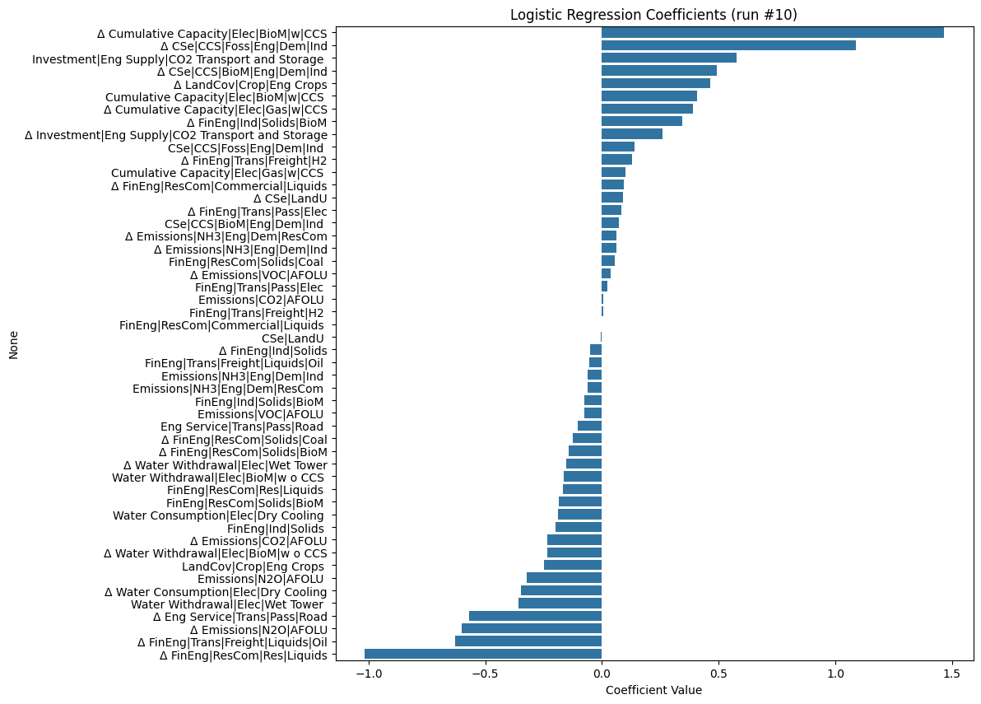
Figure 5. Logistic Regression Coefficients for run #10
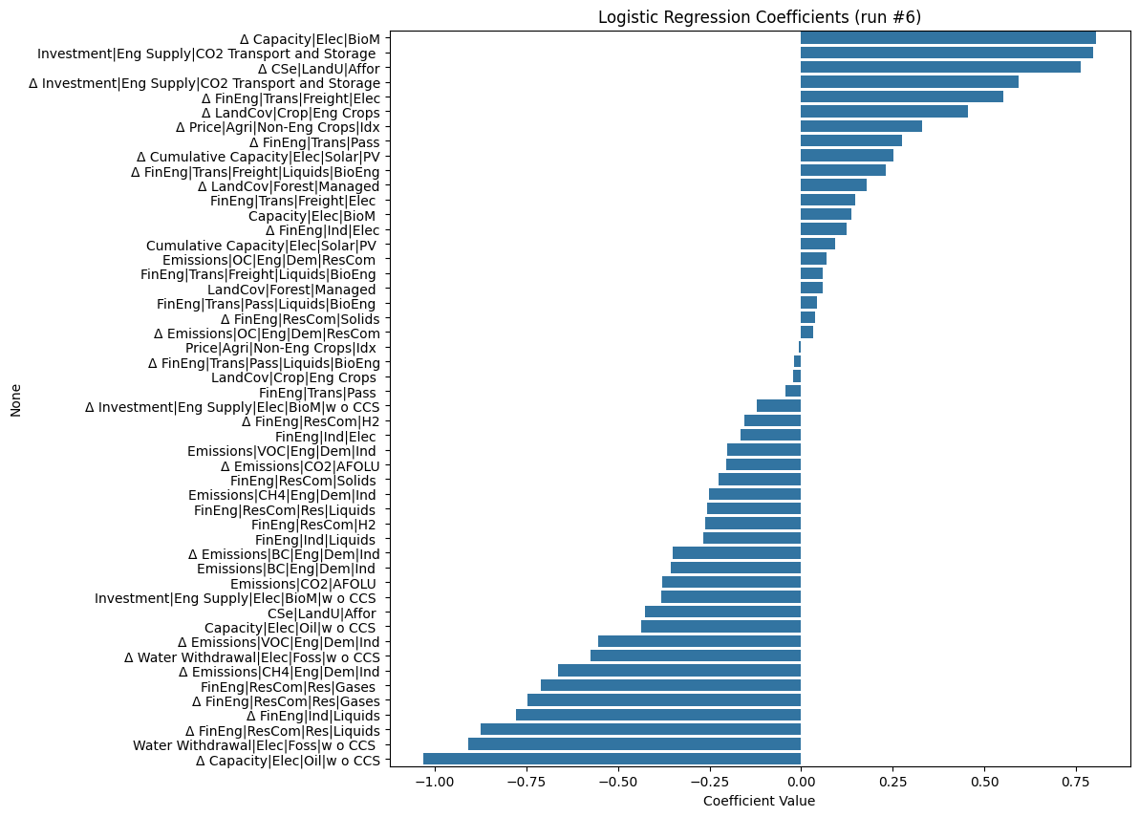
Figure 6. Logistic Regression Coefficients for run #6

- Clustering
To be completed

- Overall

To synthesize findings across the four modelling approaches and ten scenario runs, an aggregate variable importance score was used. For each run, the outputs from PRIM, SHAP, logistic regression, and clustering-based classification trees were normalized and averaged to yield a unified importance score per variable. These scores were then mapped to their corresponding sectors, enabling sector-level comparisons.

Sectoral importance was assessed by ranking each sector from 1 (most important) to 5 (least important) based on the highest-ranking variables per sector in each run. When considering all ten runs (See Figure 8), Electricity emerged as the most consistently important sector in distinguishing 1.5°C-consistent scenarios, followed by AFOLU and Industry. In contrast, Residential & Commercial Buildings tended to rank lower across runs, though it did exhibit a few mid-range outliers.

To test the robustness of these findings, we repeated the analysis using only the five runs with the highest Jaccard similarity in selected variables. These represent cases where the variable selection process converged most strongly, suggesting higher internal consistency (See Figure 9). Electricity further solidified its position as the dominant sector, with Industry taking a clear second place. In this filtered subset, AFOLU dropped slightly in rank, and Buildings continued to exhibit low explanatory weight.

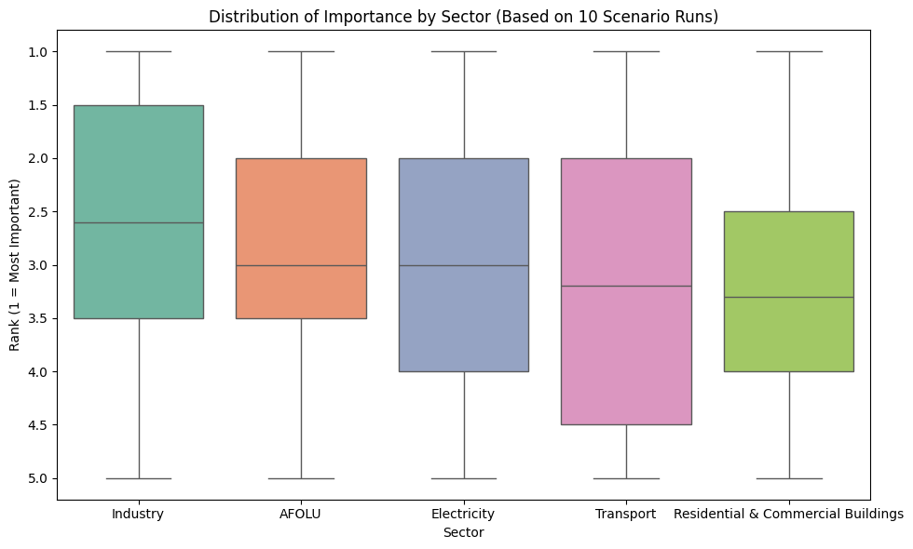
Figure 8. Distribution of Importance by Sector (Based on 10 Scenario Runs)

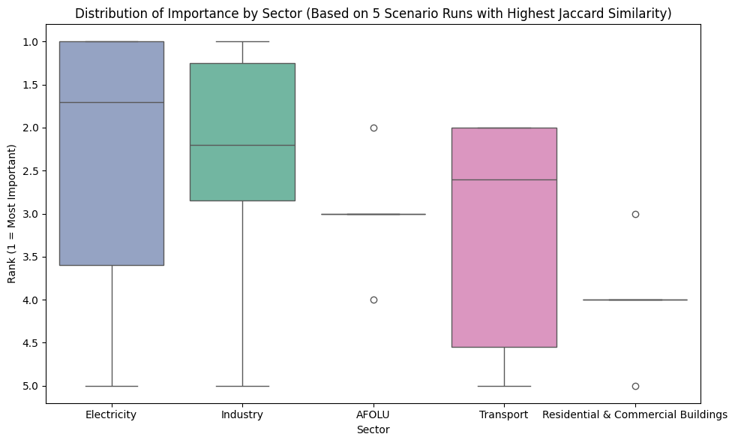

Figure 9. Distribution of Importance by Sector (Based on 5 Scenario Runs with Highest Jaccard Similarity)

Discussion

By triangulating across four interpretable machine learning techniques, a clear picture begins to emerge of those sectoral variables which have the strongest impact on final pathway alignment. The combination of triangulation and aggregation across ten variable sets, gives a credence to these results sometimes absent in explainable AI literature. Through this process, the electricity-sector variables emerged as the most consistent predictors of 1.5°C-aligned scenarios. This is not only reflected in the aggregate sector rankings (See Figures 8 and 9), but also in the individual importance scores of variables that repeatedly emerged in top positions.

For example, when speaking about logistic regression for run #6, the variable’s change which is most positively correlated with 1.5°C-alignment is the change in electric capacity with biomass (Δ Capacity|Elec|BioM). On the other end of the spectrum, the variable most negatively correlated with 1.5°C-alignment is the change in electric capacity from oil without CCS (Δ Capacity|Elec|Oil|w o CCS). While this result may seem obvious, it underlies the general alignment of the model with accepted decarbonization indicators, therefore giving credence to some of the other variables we see amid the plot. Near the center of the plot, there are transport-related features like the change in Final Energy for passenger and freight travel, changes in emissions from residential and commercial sectors, and even some land and AFOLU variables. Their near-zero coefficients suggest they are more weakly or inconsistently correlated with temperature outcomes, either because their variation is not strongly differentiated between scenario categories, or because they interact with other variables in more complex, nonlinear ways. The middle of the distribution is a useful reminder that not all variables carry equal weight, and that many mitigation levers may be important but not decisive when considered in isolation.

PRIM findings show that not only do electricity and industry matter, but they matter in patterned, conditional ways. In run #10, for instance, the PRIM box isolates a region of the input space where the change in Gas with CCS must stay below 100 GW, and the change in Water Consumption for Dry Cooling must be modest (under ~1 km³). Notably, the third variable, Cumulative Electric Capacity of Biomass with CCS, is left unconstrained, suggesting that scenarios within this box do not depend on biomass deployment reaching a specific level but rather its consistent inclusion. Together, these constraints capture over 92% of all 1.5°C-consistent scenarios, with perfect purity. In other words: if gas growth is limited, water use from dry cooling is kept in check, and biomass electricity is invested in, scenarios are very likely to be 1.5°C-aligned. This points not only to the predictive strength of electricity-sector variables, but also to the possibility that a narrow set of infrastructure constraints may serve as reliable indicators of high-ambition pathways.

In run #6, the picture is slightly more complex but equally revealing. Here, the PRIM box includes constraints on Biomass Electricity Capacity (≥100 GW), CH₄ Emissions from Industry (≤100 Mt CO₂-eq), and near-zero levels of Industrial Liquid Fuel Use. The fourth dimension, the change in Investment in Biomass Electricity without CCS, is relatively unconstrained. So again, the critical thresholds are concentrated in a few variables: if methane emissions and industrial liquid fuel use are both suppressed, and biomass electricity scales up meaningfully, we are firmly in 1.5°C territory. A picture begins to emerge, across PRIM, logistic regression, and two separate runs of the importance of electricity with biomass.

This pattern carries through to the SHAP analysis as well. In run #10, cumulative electric biomass capacity with CCS emerges as the single most important feature (See Table 3). That highlights two things. First, increased electric biomass capacity crucially underwrites existing 1.5°C-aligned scenarios. Importantly, this research does not prescribe that as essential for mitigating warming. Rather, it indicates that within the current portfolio of scenarios which do imagine ways the world might mitigate warming, high levels of electric capacity from biomass are presumed. Second, the prominence of this variable across methods demonstrates meaningful alignment between the different approaches. This kind of triangulated agreement adds weight to the finding, offering a degree of cross-method validation that strengthens confidence in the results.

While the role of cumulative electric biomass capacity with CCS stands out most clearly across methods, several other variables appear repeatedly enough across runs to warrant attention. Water-related infrastructure constraints, particularly the change in Water Consumption for Dry Cooling and the change in Water Withdrawal from fossil electricity, show up in both PRIM boxes and are ranked with moderate importance in SHAP and logistic regression. This suggests that cooling-related infrastructure plays a subtle but consistent role in shaping 1.5°C-consistent pathways. Similarly, changes in residential liquid fuel use (Δ Final Energy|ResCom|Res|Liquids) emerge as negatively associated with 1.5°C alignment in both SHAP and logistic regression, reinforcing the relevance of decarbonization in buildings even if it isn’t a top driver in isolation. Freight transport also recurs: reductions in liquid oil use for freight are moderately important in SHAP and repeatedly carry negative coefficients in logistic regression.

Confident in the relative alignment of PRIM, SHAP, clustering, and logistic regression, the final comparison was an amalgamation of their outputs. Electricity stands out as the most consistently important sector across all ten runs, underscoring its central role in climate mitigation across a diverse range of modelling assumptions. This strong performance of is intuitive, given that decarbonizing the power sector is a foundational step in most mitigation pathways. Electrification of end uses like transport and buildings amplifies the influence of the electricity sector, making its decarbonization a prerequisite for achieving broader emissions reductions. Moreover, electricity variables are often better reported and more consistent across IAMs, which may contribute to their dominance in both selection frequency and predictive value.

Industry emerges as the second strongest contributor to pathway differentiation. Unlike electricity, which has long been treated as the centerpiece of decarbonization strategies, industrial systems are often treated as harder-to-abate, more inertial, and highly heterogeneous. Yet across multiple methods and runs, industry variables surfaced as nontrivial drivers of 1.5°C consistency. In the PRIM analysis for run #6, for example, both CH₄ emissions from industry and industrial liquid fuel use were tightly constrained, suggesting that sharp reductions in these areas are common features of successful mitigation scenarios. Similarly, in the logistic regression plots, industry-related variables often appear near the extremes of the coefficient distributions, implying strong directional influence. One possible explanation is that while electricity transitions are a given in nearly all 1.5°C pathways, variation in how industrial emissions are tackled plays a critical role in differentiating more ambitious pathways from those that fall short. Industry’s prominence in the analysis therefore also points to its role as a potential bottleneck or accelerant in broader decarbonization trajectories.

AFOLU (Agriculture, Forestry, and Other Land Use) emerged as a consistently important sector across the scenario runs, ranking third overall in aggregate importance. Although its prominence was somewhat less than electricity and industry, several AFOLU-related variables appeared repeatedly across methods, suggesting a meaningful, if slightly less dominant, role in distinguishing 1.5°C-consistent pathways. In the logistic regression analyses for both run #6 and run #10, land-use related variables such as change in land cover from energy crops and change in land cover from managed forest displayed nontrivial coefficient magnitudes, indicating their directional influence on temperature outcomes. SHAP results reinforced AFOLU’s moderate importance by highlighting carbon sequestration through afforestation and emissions from organic carbon as features.

Transport and Residential & Commercial Buildings consistently ranked lowest across the sectoral aggregation, with few variables from either sector appearing in top positions across PRIM, SHAP, or logistic regression. In the case of transport, some features, such as changes in final energy use for freight (Δ FinEng|Trans|Freight|Liquids|Oil) and investment in passenger electric transport, do appear sporadically with moderate importance or negative regression coefficients. However, these variables typically reside closer to the middle of the coefficient distributions or fail to show consistent influence across runs. One plausible explanation is that decarbonization of transport may be more linear and less decisive in terms of defining overall temperature outcomes.

A similar story emerges for Residential & Commercial Buildings. The variable from this sector appearing most consistently in different analyses was the change in liquid fuels in buildings (Δ Final Energy|ResCom|Res|Liquids). It was negatively associated with 1.5°C alignment in multiple SHAP and regression runs, suggesting that continued reliance on liquid fuels in buildings remains a sign of higher-emissions scenarios. Yet overall, the sector showed relatively little explanatory power. This could be due to the way building-sector changes are spread thinly across many smaller, diffuse variables (e.g., heating fuels, efficiency upgrades, demand-side behaviors), none of which dominate individually. It’s also possible that buildings are more tightly coupled to decarbonization in electricity and less influential in their own right.

Taken together, these results suggest that while all sectors contribute to mitigation, some are more consistently discriminative of low-temperature pathways within current IAM scenario structures. Electricity and industry emerge as especially critical sectors for near-term policy attention, both because of their intrinsic emissions and because of their predictive value in distinguishing 1.5°C scenarios from the rest.

Further Research
When considering interconnections between sectors, one notable ambiguity concerns the treatment of energy crops. Variables related to biomass electricity consistently rank among the most important predictors of 1.5°C-consistent scenarios across SHAP, PRIM, and logistic regression. However, AFOLU variables such as the change in land cover for energy crops rank far lower in importance. This discrepancy may suggest a degree of internal inconsistency in how models allocate and link land use to energy system outcomes. In theory, large-scale biomass deployment for electricity should be accompanied by correspondingly strong land-use signals, particularly in scenarios that assume limited availability of waste biomass or advanced bioenergy technologies. One useful next step would be to analyze the envelope of assumptions within specific models that feature high biomass deployment, to see whether land-use implications are being realistically and consistently incorporated. It is these pathways for further investigation that this research can help elucidate.

References
AR6 Scenario Explorer and Database hosted by IIASA. (n.d.). Retrieved April 2, 2025, from https://data.ene.iiasa.ac.at/ar6/#/workspaces
Friedman, J. H., & Fisher, N. I. (1999). Bump hunting in high-dimensional data. Statistics and Computing, 9(2), 123–143. https://doi.org/10.1023/A:1008894516817/METRICS
IPCC. (2025). LR Cross-Section Box.2, Figure 1 (b): Scenarios and pathways across AR6 Working Group reports. In IPCC AR6 Synthesis Report.
Jaxa-Rozen, M., & Trutnevyte, E. (2021). Sources of uncertainty in long-term global scenarios of solar photovoltaic technology. Nature Climate Change, 11(3), 266–273. https://doi.org/10.1038/S41558-021-00998-8;SUBJMETA=2787,2790,4077,639,682,704,844;KWRD=CLIMATE-CHANGE+MITIGATION,ENERGY+MODELLING,SOCIOECONOMIC+SCENARIOS
Li, P. H., Pye, S., Keppo, I., Jaxa-Rozen, M., & Trutnevyte, E. (2023). Revealing effective regional decarbonisation measures to limit global temperature increase in uncertain transition scenarios with machine learning techniques. Climatic Change, 176(7), 1–23. https://doi.org/10.1007/S10584-023-03529-W/FIGURES/7

Appendix 1: Selected Variables
Run #1
Variable | Sector
Secondary Energy|Electricity|Solar | Electricity
Secondary Energy|Electricity | Electricity
Secondary Energy|Electricity|Fossil | Electricity
Final Energy|Transportation|Freight|Electricity | Transport
Final Energy|Transportation|Passenger | Transport
Final Energy|Transportation|Freight|Hydrogen | Transport
Emissions|VOC|Energy|Demand|Industry | Industry
Final Energy|Industry|Electricity | Industry
Emissions|BC|Energy|Demand|Industry | Industry
Emissions|NOx|Energy|Demand|Residential and Commercial | Buildings
Emissions|NH3|Energy|Demand|Residential and Commercial | Buildings
Emissions|OC|Energy|Demand|Residential and Commercial | Buildings
Price|Agriculture|Non-Energy Crops and Livestock|Index | Industry
Emissions|N2O|AFOLU|Agriculture | Agriculture
Emissions|CH4|AFOLU | Agriculture
Secondary Energy|Electricity|Gas | Electricity
Secondary Energy|Electricity|Geothermal | Electricity
Final Energy|Transportation|Passenger|Electricity | Transport
Final Energy|Transportation|Freight|Liquids|Bioenergy | Transport
Carbon Sequestration|CCS|Biomass|Energy|Demand|Industry | Industry
Carbon Sequestration|CCS|Fossil|Energy|Demand|Industry | Industry
Price|Final Energy|Residential and Commercial|Residential|Electricity | Buildings
Final Energy|Residential and Commercial|Solids|Coal | Buildings
Land Cover|Cropland|Irrigated | Agriculture
Carbon Sequestration|Land Use|Afforestation | Buildings

Run #2
Variable | Sector
Secondary Energy|Electricity|Biomass|w|CCS | Electricity
Secondary Energy|Electricity|Coal|w|CCS | Electricity
Final Energy|Transportation|Passenger|Liquids|Bioenergy | Transport
Final Energy|Transportation|Freight | Transport
Final Energy|Industry|Gases | Industry
Final Energy|Industry|Solids|Biomass | Industry
Final Energy|Residential and Commercial|Liquids | Buildings
Final Energy|Residential and Commercial|Solids|Coal | Buildings
Emissions|OC|AFOLU | Agriculture
Price|Agriculture|Non-Energy Crops and Livestock|Index | Industry
Secondary Energy|Electricity|Geothermal | Electricity
Secondary Energy|Electricity|Renewables (incl. Biomass) | Electricity
Secondary Energy|Electricity|Fossil | Electricity
Final Energy|Transportation|Freight|Liquids|Bioenergy | Transport
Investment|Energy Supply|CO2 Transport and Storage | Transport
Final Energy|Transportation|Passenger|Electricity | Transport
Emissions|CH4|Energy|Demand|Industry | Industry
Final Energy|Industry|Liquids | Industry
Emissions|VOC|Energy|Demand|Industry | Industry
Final Energy|Residential and Commercial|Commercial|Liquids | Buildings
Final Energy|Residential and Commercial|Commercial | Buildings
Emissions|CO2|Energy|Demand|Residential and Commercial|Residential | Buildings
Emissions|CO2|AFOLU | Agriculture
Carbon Sequestration|Land Use | Agriculture
Food Demand|Livestock | Agriculture

Run #3
Variable | Sector
Emissions|CO2|Energy|Supply|Electricity | Electricity
Secondary Energy|Electricity|Renewables (incl. Biomass) | Electricity
Final Energy|Transportation|Freight | Transport
Final Energy|Transportation|Passenger | Transport
Final Energy|Industry|Heat | Industry
Final Energy|Industry|Hydrogen | Industry
Emissions|CO2|Energy|Demand|Residential and Commercial|Commercial | Buildings
Final Energy|Residential and Commercial|Residential|Liquids | Buildings
Emissions|N2O|AFOLU | Agriculture
Land Cover|Other Land | Agriculture
Capacity|Electricity|Solar|PV | Electricity
Secondary Energy|Electricity|Solar|CSP | Electricity
Secondary Energy|Electricity|Gas | Electricity
Final Energy|Transportation|Freight|Other | Transport
Final Energy|Transportation|Passenger|Liquids|Bioenergy | Transport
Final Energy|Transportation|Freight|Liquids|Bioenergy | Transport
Emissions|VOC|Energy|Demand|Industry | Industry
Emissions|CH4|Energy|Demand|Industry | Industry
Final Energy|Industry|Solids|Biomass | Industry
Final Energy|Residential and Commercial|Commercial | Buildings
Price|Final Energy|Residential and Commercial|Residential|Electricity | Buildings
Final Energy|Residential and Commercial|Commercial|Solids | Buildings
Emissions|CO2|AFOLU | Agriculture
Land Cover|Cropland|Energy Crops | Agriculture
Food Demand|Livestock | Agriculture

Run #4
Variable | Sector
Investment|Energy Supply|Electricity|Oil|w|CCS | Electricity
OM Cost|Fixed|Electricity|Biomass|w o CCS | Electricity
Final Energy|Transportation|Freight|Liquids | Transport
Final Energy|Transportation|Passenger | Transport
Final Energy|Industry|Other | Industry
Emissions|NH3|Energy|Demand|Industry | Industry
Emissions|Sulfur|Energy|Demand|Residential and Commercial | Buildings
Final Energy|Residential and Commercial|Solids|Biomass | Buildings
Land Cover|Other Land | Agriculture
Price|Agriculture|Non-Energy Crops and Livestock|Index | Industry
Capacity Additions|Electricity|Biomass|w|CCS | Electricity
Capacity Additions|Electricity|Wind | Industry
Secondary Energy|Electricity|Gas|w o CCS | Electricity
Final Energy|Transportation|Freight|Liquids|Bioenergy | Transport
Investment|Energy Supply|CO2 Transport and Storage | Transport
Final Energy|Transportation|Passenger|Liquids|Bioenergy | Transport
Emissions|CO2|Energy|Demand|Industry | Industry
Emissions|BC|Energy|Demand|Industry | Industry
Final Energy|Industry|Solids|Biomass | Industry
Price|Final Energy|Residential and Commercial|Residential|Electricity | Buildings
Emissions|NOx|Energy|Demand|Residential and Commercial | Buildings
Final Energy|Residential and Commercial|Solids|Coal | Buildings
Emissions|CO2|AFOLU | Agriculture
Land Cover|Cropland|Energy Crops | Agriculture
Emissions|N2O|AFOLU|Agriculture | Agriculture

Run #5
Variable | Sector
Investment|Energy Supply|Electricity|Gas | Electricity
OM Cost|Fixed|Electricity|Hydro | Electricity
Final Energy|Transportation|Freight|Electricity | Transport
Final Energy|Transportation|Passenger | Transport
Final Energy|Industry|Hydrogen | Industry
Emissions|OC|Energy|Demand|Industry | Industry
Emissions|NOx|Energy|Demand|Residential and Commercial | Buildings
Emissions|CO|Energy|Demand|Residential and Commercial | Buildings
Land Cover|Cropland|Irrigated | Agriculture
Food Demand|Livestock | Agriculture
Secondary Energy|Electricity|Solar | Electricity
Capital Cost|Electricity|Solar|PV | Electricity
Capacity|Electricity|Biomass | Electricity
Final Energy|Transportation|Passenger|Electricity | Transport
Final Energy|Transportation|Freight|Liquids|Bioenergy | Transport
Final Energy|Transportation|Passenger|Liquids|Bioenergy | Transport
Final Energy|Industry|Gases | Industry
Final Energy|Industry|Liquids | Industry
Emissions|BC|Energy|Demand|Industry | Industry
Final Energy|Residential and Commercial|Commercial|Liquids | Buildings
Price|Final Energy|Residential and Commercial|Residential|Solids|Biomass | Buildings
Final Energy|Residential and Commercial|Liquids | Buildings
Land Cover|Forest|Managed | Buildings
Land Cover|Other Land | Agriculture
Emissions|N2O|AFOLU|Agriculture | Agriculture

Run #6
Variable | Sector
Investment|Energy Supply|Electricity|Biomass|w o CCS | Electricity
Cumulative Capacity|Electricity|Solar|PV | Electricity
Investment|Energy Supply|CO2 Transport and Storage | Transport
Final Energy|Transportation|Freight|Electricity | Transport
Final Energy|Industry|Liquids | Industry
Final Energy|Industry|Electricity | Industry
Final Energy|Residential and Commercial|Hydrogen | Buildings
Final Energy|Residential and Commercial|Residential|Liquids | Buildings
Land Cover|Cropland|Energy Crops | Agriculture
Emissions|CO2|AFOLU | Agriculture
Capacity|Electricity|Oil|w o CCS | Electricity
Capacity|Electricity|Biomass | Electricity
Water Withdrawal|Electricity|Fossil|w o CCS | Electricity
Final Energy|Transportation|Passenger | Transport
Final Energy|Transportation|Passenger|Liquids|Bioenergy | Transport
Final Energy|Transportation|Freight|Liquids|Bioenergy | Transport
Emissions|BC|Energy|Demand|Industry | Industry
Emissions|CH4|Energy|Demand|Industry | Industry
Emissions|VOC|Energy|Demand|Industry | Industry
Final Energy|Residential and Commercial|Solids | Buildings
Emissions|OC|Energy|Demand|Residential and Commercial | Buildings
Final Energy|Residential and Commercial|Residential|Gases | Buildings
Price|Agriculture|Non-Energy Crops|Index | Industry
Land Cover|Forest|Managed | Buildings
Carbon Sequestration|Land Use|Afforestation | Buildings

Run #7
Variable | Sector
Capacity|Electricity|Coal|w|CCS | Electricity
OM Cost|Fixed|Electricity|Solar|PV | Electricity
Final Energy|Transportation|Freight | Transport
Final Energy|Transportation|Passenger|Liquids|Bioenergy | Transport
Final Energy|Industry|Solids|Biomass | Industry
Emissions|NH3|Energy|Demand|Industry | Industry
Price|Final Energy|Residential and Commercial|Residential|Electricity | Buildings
Price|Final Energy|Residential and Commercial|Residential|Solids|Biomass | Buildings
Carbon Sequestration|Land Use|Afforestation | Buildings
Agricultural Demand|Livestock|Food | Agriculture
Final Energy|Transportation|Electricity | Transport
Capacity Additions|Electricity|Coal|w|CCS | Electricity
Capacity Additions|Electricity|Oil|w o CCS | Electricity
Final Energy|Transportation|Passenger|Electricity | Transport
Final Energy|Transportation|Passenger | Transport
Energy Service|Transportation|Passenger|Road | Transport
Carbon Sequestration|CCS|Fossil|Energy|Demand|Industry | Industry
Final Energy|Industry|Solids|Coal | Industry
Emissions|BC|Energy|Demand|Industry | Industry
Price|Final Energy|Residential and Commercial|Residential|Solids|Coal | Buildings
Emissions|OC|Energy|Demand|Residential and Commercial | Buildings
Final Energy|Residential and Commercial|Gases | Buildings
Land Cover|Forest|Natural Forest | Buildings
Food Demand|Livestock | Agriculture
Land Cover|Other Land | Agriculture

Run #8
Variable | Sector
Capacity Additions|Electricity|Solar|PV | Electricity
OM Cost|Fixed|Electricity|Coal|w|CCS | Electricity
Final Energy|Transportation|Passenger | Transport
Energy Service|Transportation|Passenger|Road | Transport
Final Energy|Industry|Solids|Biomass | Industry
Final Energy|Industry|Solids|Coal | Industry
Emissions|OC|Energy|Demand|Residential and Commercial | Buildings
Final Energy|Residential and Commercial|Solids|Coal | Buildings
Emissions|NH3|AFOLU | Agriculture
Land Cover|Cropland|Irrigated | Agriculture
Investment|Energy Supply|Electricity|Biomass|w o CCS | Electricity
Capacity Additions|Electricity|Gas|w o CCS | Electricity
Lifetime|Hydrogen|Electricity | Electricity
Investment|Energy Supply|CO2 Transport and Storage | Transport
Final Energy|Transportation|Freight | Transport
Final Energy|Transportation|Passenger|Liquids|Bioenergy | Transport
Emissions|NOx|Energy|Demand|Industry | Industry
Final Energy|Industry|Heat | Industry
Emissions|BC|Energy|Demand|Industry | Industry
Emissions|NOx|Energy|Demand|Residential and Commercial | Buildings
Final Energy|Residential and Commercial|Liquids | Buildings
Emissions|NH3|Energy|Demand|Residential and Commercial | Buildings
Emissions|BC|AFOLU | Agriculture
Land Cover|Forest|Afforestation and Reforestation | Buildings
Carbon Sequestration|Land Use|Afforestation | Buildings

Run #9
Variable | Sector
Capacity Additions|Electricity|Solar|CSP | Electricity
Cumulative Capacity|Electricity|Coal | Electricity
Final Energy|Transportation|Freight|Hydrogen | Transport
Final Energy|Transportation|Freight | Transport
Carbon Sequestration|CCS|Fossil|Energy|Demand|Industry | Industry
Emissions|OC|Energy|Demand|Industry | Industry
Price|Final Energy|Residential and Commercial|Residential|Liquids|Oil | Buildings
Final Energy|Residential and Commercial|Solids|Coal | Buildings
Land Cover|Cropland|Energy Crops | Agriculture
Land Cover|Cropland | Agriculture
Capital Cost|Electricity|Wind|Onshore | Industry
Lifetime|Electricity|Solar|PV | Electricity
Capacity Additions|Electricity|Coal | Electricity
Final Energy|Transportation|Passenger|Liquids|Bioenergy | Transport
Final Energy|Transportation|Passenger|Electricity | Transport
Investment|Energy Supply|CO2 Transport and Storage | Transport
Emissions|BC|Energy|Demand|Industry | Industry
Final Energy|Industry|Solids|Coal | Industry
Carbon Sequestration|CCS|Biomass|Energy|Demand|Industry | Industry
Final Energy|Residential and Commercial|Liquids | Buildings
Emissions|NOx|Energy|Demand|Residential and Commercial | Buildings
Emissions|NH3|Energy|Demand|Residential and Commercial | Buildings
Carbon Sequestration|Land Use|Afforestation | Buildings
Emissions|CO2|AFOLU | Agriculture
Carbon Sequestration|Land Use | Agriculture

Run #10
Variable | Sector
Cumulative Capacity|Electricity|Biomass|w|CCS | Electricity
Cumulative Capacity|Electricity|Gas|w|CCS | Electricity
Final Energy|Transportation|Freight|Hydrogen | Transport
Final Energy|Transportation|Freight|Liquids|Oil | Transport
Carbon Sequestration|CCS|Fossil|Energy|Demand|Industry | Industry
Final Energy|Industry|Solids|Biomass | Industry
Final Energy|Residential and Commercial|Solids|Coal | Buildings
Emissions|NH3|Energy|Demand|Residential and Commercial | Buildings
Emissions|N2O|AFOLU | Agriculture
Carbon Sequestration|Land Use | Agriculture
Water Withdrawal|Electricity|Biomass|w o CCS | Electricity
Water Withdrawal|Electricity|Wet Tower | Electricity
Water Consumption|Electricity|Dry Cooling | Electricity
Investment|Energy Supply|CO2 Transport and Storage | Transport
Final Energy|Transportation|Passenger|Electricity | Transport
Energy Service|Transportation|Passenger|Road | Transport
Final Energy|Industry|Solids | Industry
Emissions|NH3|Energy|Demand|Industry | Industry
Carbon Sequestration|CCS|Biomass|Energy|Demand|Industry | Industry
Final Energy|Residential and Commercial|Solids|Biomass | Buildings
Final Energy|Residential and Commercial|Commercial|Liquids | Buildings
Final Energy|Residential and Commercial|Residential|Liquids | Buildings
Land Cover|Cropland|Energy Crops | Agriculture
Emissions|VOC|AFOLU | Agriculture
Emissions|CO2|AFOLU | Agriculture

