PLAYWRIGHT

SETUP PROJECT

1. Start by typing “npm init” in terminal and hit enter until you type “yes” it will create package.json

//to verify it was successfully installed, package.json will be generated

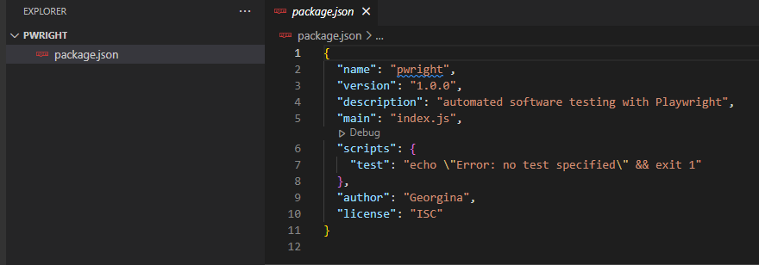

//To keep your code clean and organize, type in “npm install prettier” and hit enter



2. Installing Playwright

Type in “npm install @playwright/test” and hit enter

3. This will install all the browser supports Playwright

Type in “npx playwright install” and hit enter

First Playwright Test

1. Create a new folder from the root folder and name it “tests”

1. Then under the [tests] folder, create new file “example.spec.ts”

Note: we will be using TypeScript by default

1. Import Test Runner and Assertions from Playwright test package to get access to all the functions while running the test

import { test, expect } from '@playwright/test'

//To create a test

test("Simple test", async({page})=>{

    await page.goto('https:www.example.com')

    const pageTitle= await page.locator('h1')

    await expect(pageTitle).toContainText('Example Domain')

})

1. To run the test runner, type in “ npx playwright test”

